VOLUNTEERS ESTABLISH PRAIRIE AND WOODLAND PLANTS ON CAMPUS

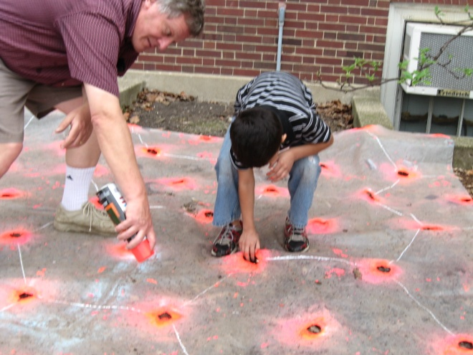 | 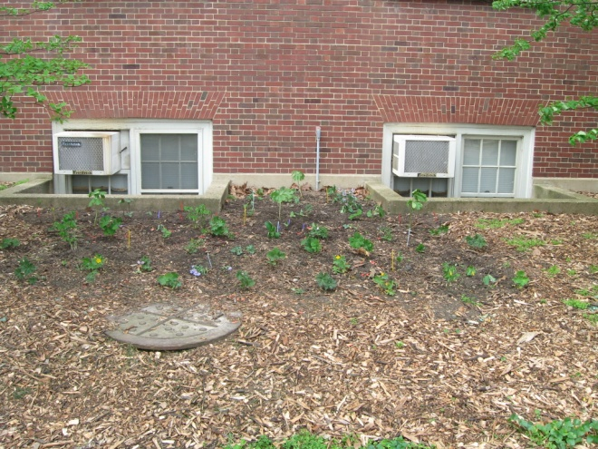
Paint spayed over holes in a plastic sheet mark future plant locations at the Natural Resources Building (NRB) on campus. | Twenty species of woodland wildflowers were planted in five plots in front of the NRB.
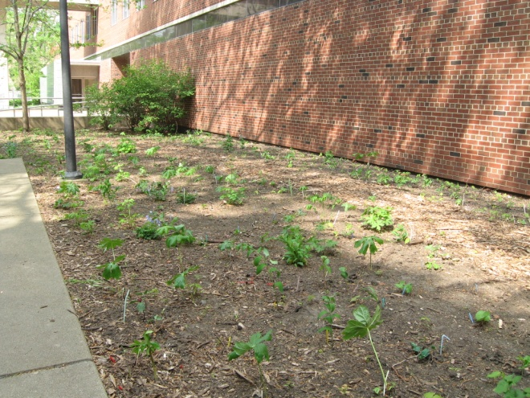 | 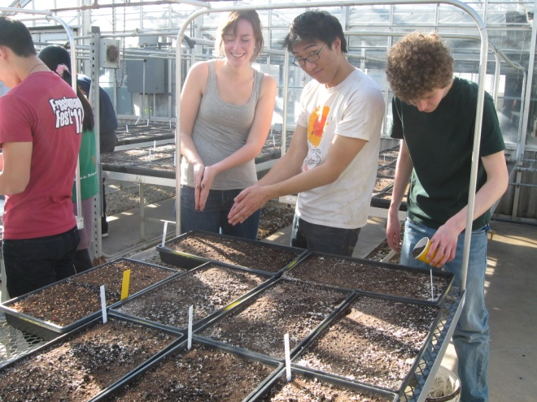
More woodland wildflowers are between the two entrances to Burrill Hall near the Quad. | SECS and Red Bison started prairie seeds in the Turner Hall greenhouse.
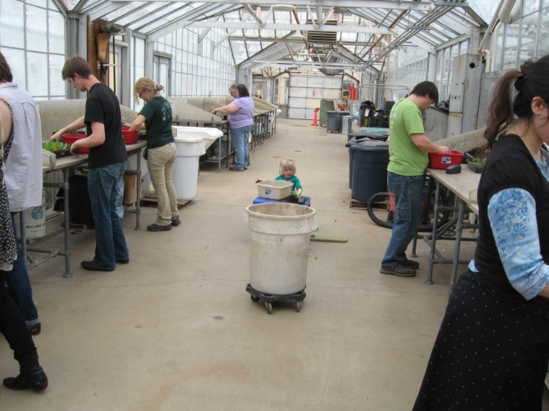 | 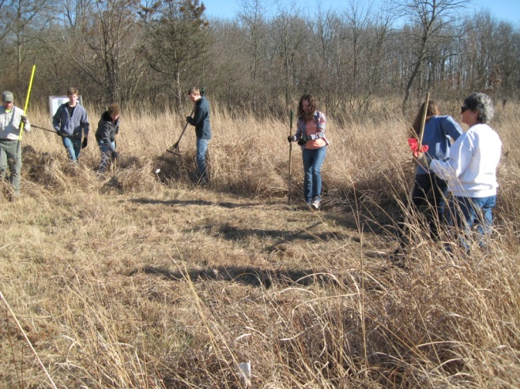
Volunteers ranging in age from 4 to 70+ transplanted seedlings to small pots. | Meanwhile Allerton Allies and students cleared 4 large circles in the Allerton Park prairie.

 | 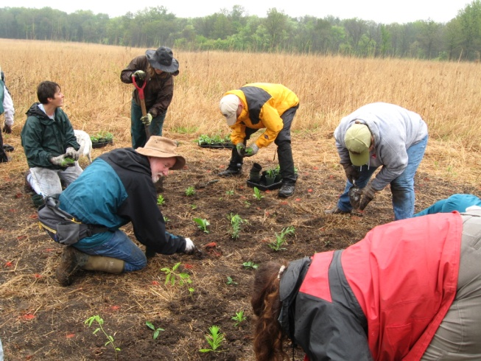
The Allerton prairie has few species of forbs so the intent of the project is to establish a variety of species. | On a rainy April day about 1600 plants were placed in the circles. Most survived the drought and deer predation.
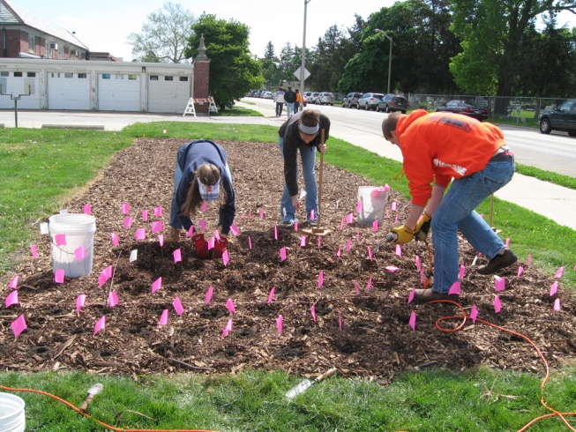 | 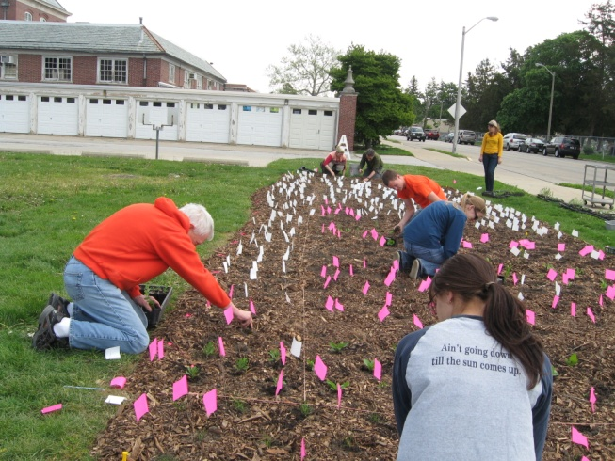
Students and other volunteers drilled holes for 600 prairie plants behind the NRB. | Colored flags were used to guide the placement of plants.
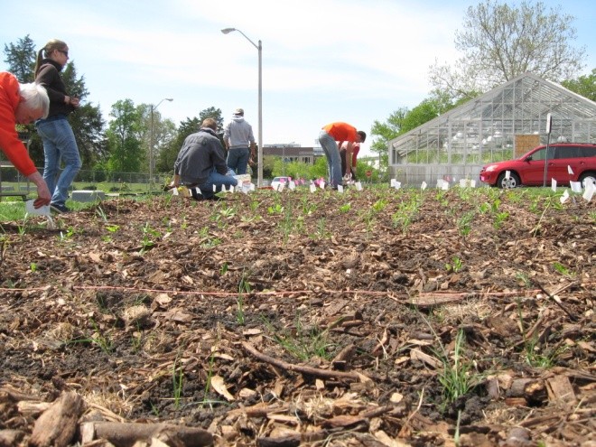 | 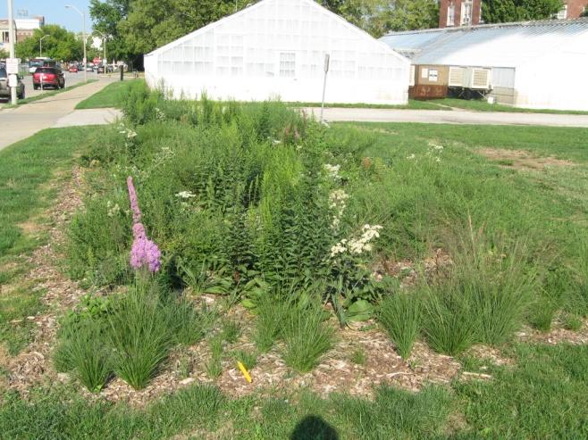
On April 22 seedlings dot the plot which is visible from Pennsylvania Avenue. | Volunteers watered the plot and the plants were doing well in this September photo.

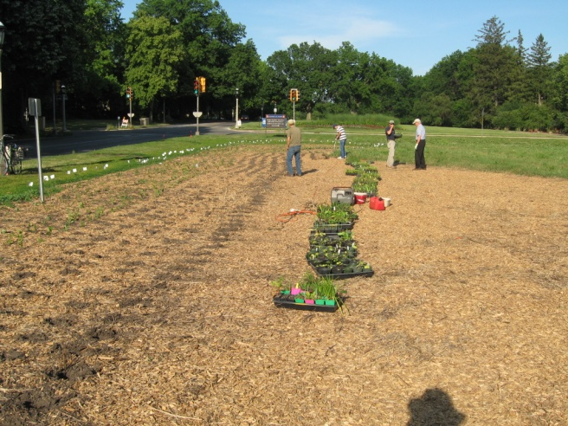 | 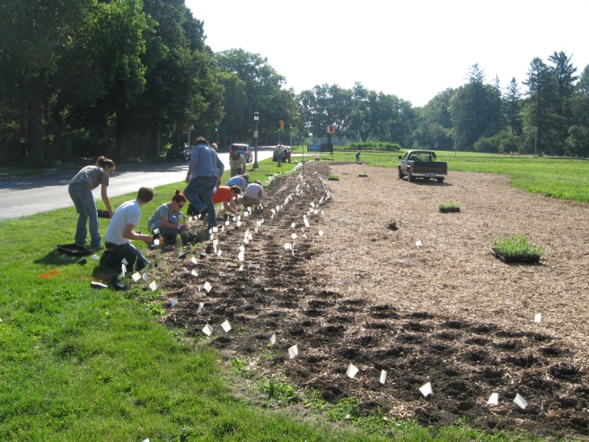
U of I Facilities and Services placed chips on part of the Florida – Orchard prairie field for replanting by volunteers in May. | Volunteers drilled about 6000 holes to receive seedlings grown by students in the greenhouse.
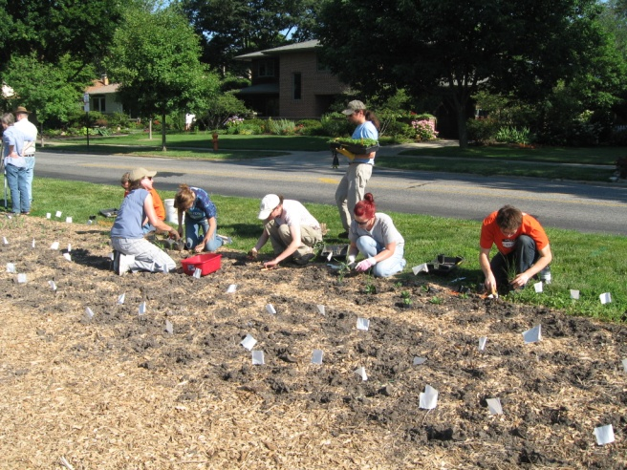 | 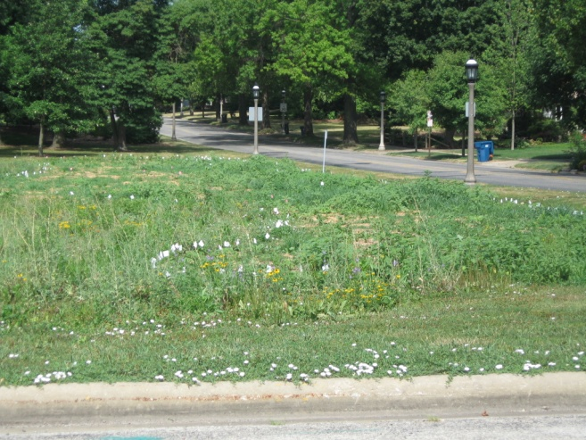
Over 100 volunteers from campus and the community participated at the site over the spring and summer. | Weeds, especially crab grass, took advantage of the drought and soon dominated much of the area.
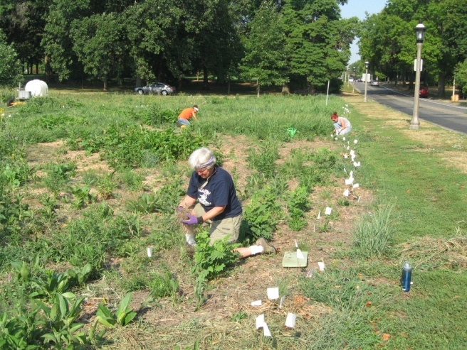 | 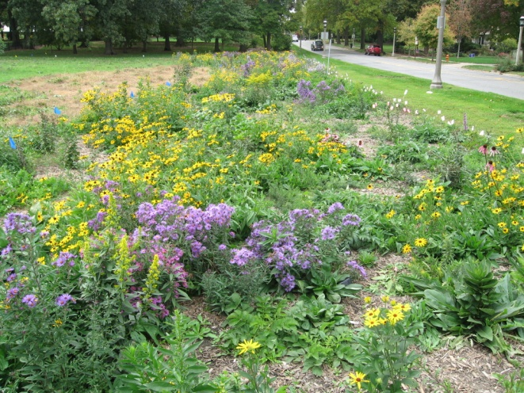
Volunteers and GPF interns spent many hours weeding in 90 degree heat. Limited watering was done from a borrowed tank. | By late September many plants were in bloom along Florida Ave. Volunteers are needed to help established the prairie.

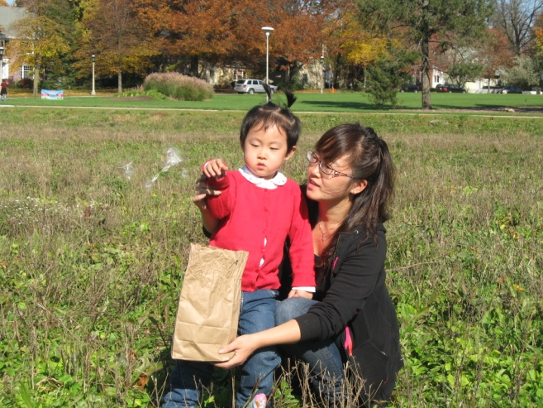 | 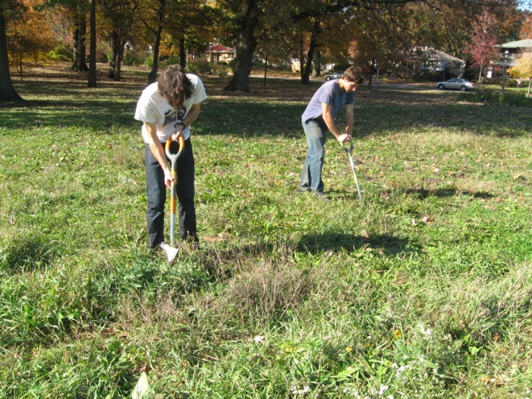
Orchard Downs residents Scattering seeds. | Red Bison weeding at Florida -- Orchard

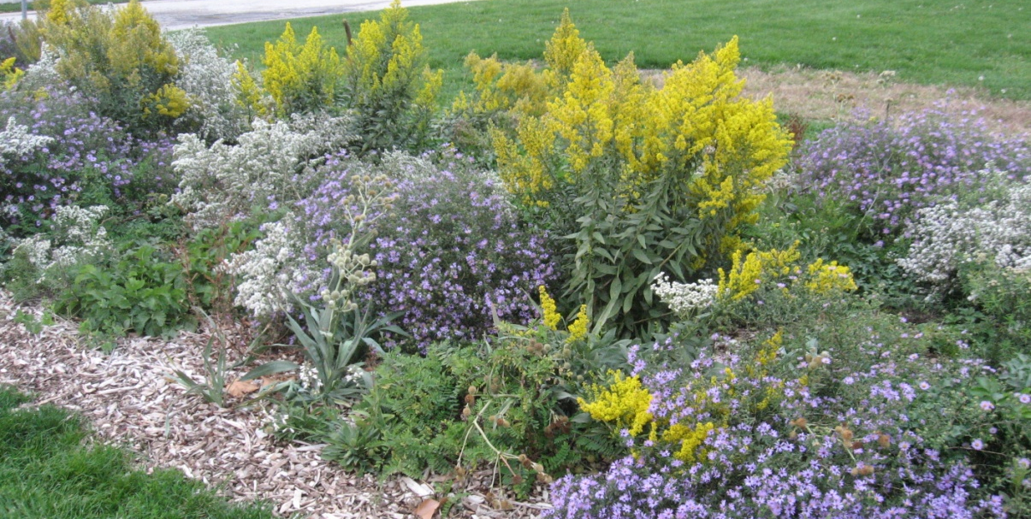
NRB prairie plot in bloom in October.
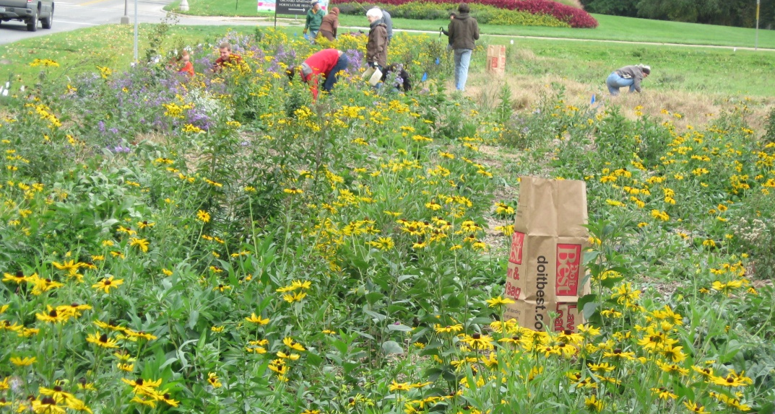
Florida – Orchard work day in October.

