Memorandum of Understanding for Financing by the Student Sustainability Committee at the University of Illinois at Urbana-Champaign

Project: Student Weatherization Program
Amount: $20,000
Receiving Campus Unit: Facilities & Services
Funding Source: Student Sustainability Committee
Primary Contact Person:
Email: Phone:
Secondary Contact Person:
Email: Phone:
Financial Officer Contact Information:
Email: Phone:

Project Description:
This pilot program will take place in the Spring 2011 and Fall 2011 semesters with the objective of creating and sustaining a student weatherization program. The program will involve assessments of campus buildings, which will be performed and reported by teams of trained University of Illinois students. Facilities & Services will receive these weatherization reports and use them internally for project assessment and discussion with relevant teams. A letter of support from Facilities & Services is attached to this memorandum.

Students will be trained to complete audits in order to obtain baseline data and make recommendations for weatherization improvements to Facilities & Services. Audit data will be entered into Excel spreadsheets, for example, to allow for of quantitative and qualitative analysis of results.

Audit areas will include building envelope, lighting, water, and waste. Follow up audits will be conducted to evaluate the program’s success. Information from these audits will create a valuable body of information to guide future sustainability initiatives.

Details in this plan are drawn from similar successful programs at the University of California at Berkeley and Colorado University at Boulder.

The Student Sustainability Committee (SSC) will provide $20,000 in funding in order to:
- Provide for a student intern to assist Facilities & Services in running the program.
- Pay student teams to conduct assessments.
- Meet miscellaneous costs, as needed, including expenses to assess successfulness of implemented recommendations, tools, equipment, etc.

Facilities & Services will provide:
- A member of either the Maintenance or Energy Services division to supervise and provide resources to the intern coordinating the program.
- Workers and materials necessary to implement improvements.

Projected Budget:

Student Intern:
Rate: $12/hour
Commitment: Up to approximately 350 hours per semester
Total: $4,200

Assessment Team Incentives:
Rate: $500 per team
Number of teams: 5
Total: $2,500

Miscellaneous Expenses:
$3,300

Semester Total:
$10,000

Term of Funding
2 semesters

Grand Total:
$20,000

Any unspent funds will be returned to the Student Sustainability Committee.

Program Components:

- Organization

A student intern will be hired at a rate of $12 per hour to conduct the majority of tasks needed for the weatherization program. This position will involve up to approximately $4,200 of paid time. A Facilities & Services employee will supervise the intern; the two to three hour a week commitment will involve checking in with the intern and providing information, access to buildings, and assistance in navigating the University system and interacting with necessary stakeholders to accomplish the project.

The Student Sustainability Committee will also provide resources and guidance to the intern as necessary, and will require that the intern attends a weekly meeting with the committee.

An announcement to hire the intern will be posted on the University of Illinois Student Employment Virtual Job Board on November 15th, 2010. Resumes will be accepted through November 30, 2010. Interviews will take place in the period of December 4th through December 11th, and an offer will be extended by December 18th, 2010. The committee is willing to carry out the hiring and screening for Facilities & Services, if desired.

After the program’s first semester, the new intern could be selected from the student assessment teams. These participants will possess training and background knowledge which will allow them to efficiently run the program.

Student teams from Registered Student Organizations (RSO’s) will conduct the assessments. The program will seek to utilize five teams of approximately five students each, with an approximate 10-20 hours of work from each member. To provide incentive, teams will receive $500 in their RSO account, which may be spent however the RSO chooses, in accordance with University guidelines. New RSO’s may be formed to take advantage of this program.

- Training

The Building Research Council’s weatherization program will provide students with the training necessary to conduct assessments free of charge. A letter of support from the Building Research Council is attached to this memorandum.

- Building Selection
The focus in the first stage of this program will be converted residential units on campus. These are frame structures and one to three story masonry buildings. Some examples of such buildings follow:

- Two converted houses east of University High on Springfield
- The converted house on the northwest corner of Green and Goodwin
- The converted house southeast of ISR on the north side of Illinois
- Converted houses along Nevada between Matthews and Goodwin (608 S. Matthews, 708 S. Matthews)
- Converted units along Oregon between Matthews and Goodwin
- Converted units on the south side of Nevada west of Lincoln Avenue

These buildings will be good candidates for several reasons:
- They are below the radar of F&S’s formal retro-commissioning efforts.
- These buildings will be easy to manage due to their size.
- Simple improvements that student assessors will identify can make a significant difference in the energy usage of these buildings.

- Focal Areas

Audits will assess building envelope/heating and insulation, lighting, water, and waste.

An envelope audit will note the following, listed in general order of highest to least return. (If necessary, the list could be limited to the first two items, which yield the greatest energy savings for the effort.):

- Any open ducts, doors, windows, leaky weather stripping, etc.
- The model number, year, and efficiency of all hot water heaters and furnaces
- The R-value of insulation in the attics (if insulation is present)
- The R-value of the insulation in the building floors
- The R-value of the exterior wall insulation
- The presence or absence of double-pained windows in any room

The building envelope assessment may primarily examine the common problem areas diagramed below:

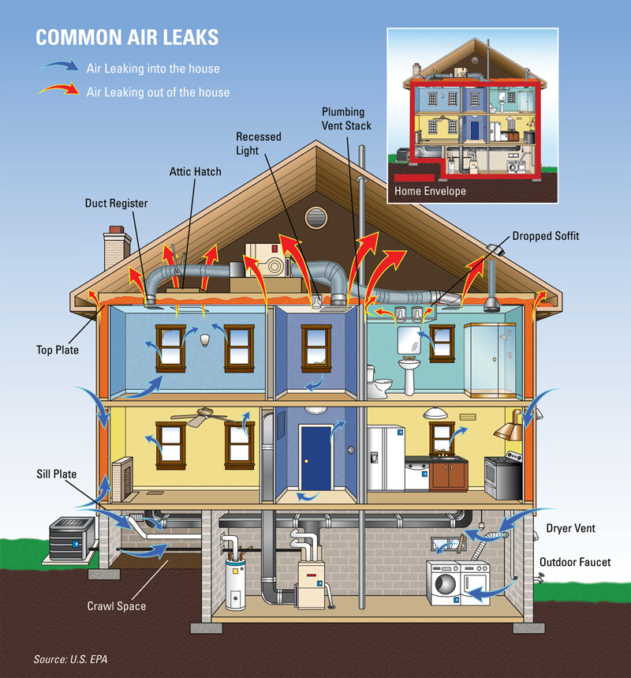

A lighting audit will note:
- The energy usage of all the lighting fixtures in a particular building or part of a building
- Fixture, bulb, and usage type to quantitatively measure energy consumption
- The quality and amount of light during the audit period

A water audit will note:
- An estimate of water usage in a building’s restrooms

A waste audit will note:
- Weight of garbage generated
- Categorization of the different types of trash found in representative samples, possibly noting opportunities for separation, composting, etc

The following are examples of improvements the audits will aim to identify. These improvements generally can be easily, safely, and effectively implemented.

- Weather stripping, sealing gaps in doors and windows, addressing common air leaks
- Caulking storm windows
- Installing low flow plumbing and water-saving faucet aerators
- Replacing light bulbs
- Installing door sweeps and door jambs
- Insulating steam pipes
- Adding smart power strips on computers

- Implementation

Facilities & Services will allocate a portion of the building maintenance budget to implement recommendations that are deemed cost effective.

- Results Assessment

If possible, data on energy use for each building should be obtained prior to improvements so that information can be compared to identify cost and carbon savings.

For more immediate assessment of results, a blower door and thermal imaging camera will be used to display the improvement in the building envelope. The registered student organization Students for Environmental Concerns (SECs) possesses this equipment and is willing to collaborate with the weatherization program to utilize these tools for assessments of improvements. A letter of support from SECs accompanies this proposal.

Conclusion:
By providing information to facilitate weatherization improvements, the Student Weatherization Program will help campus meet the iCAP goal to reduce energy usage. Not only does this program address a University priority, but it will also provide student assessors with valuable knowledge, skills, and experiences in weatherization.

In order to ensure that effort to obtain data through these assessments will provide increase campus sustainability, this memorandum is accompanied by a letter of support from Facilities & Services, committing to the implementation of cost effective recommendations.

Based on the results of this one-year program, the Student Sustainability Committee will work with Facilities & Services to determine how to move forward with future weatherization projects.

