Campus Building Sustainability
Training Manual
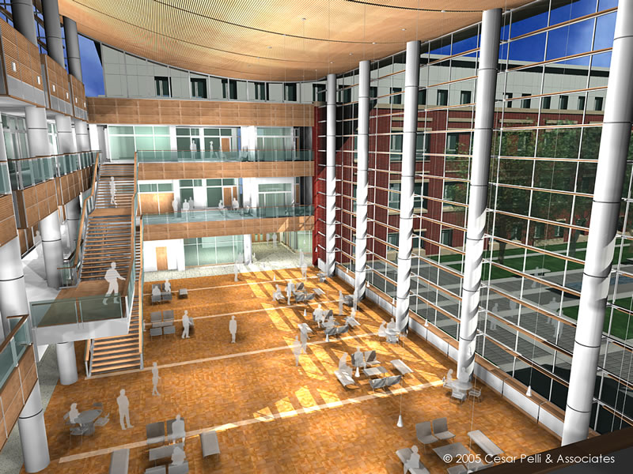
University of Illinois at Champaign-Urbana
Spring 2011
Suhail Barot – Student Sustainability Committee, Chair
Jennifer Koys – Student Sustainability Committee, Treasurer
James Hoffer – Student Sustainability Committee, Weatherization Intern
Table of Contents
BACKGROUND Page 3
Objective Statement
Basics
Training
Materials
ASSESSMENTS Page 5
Process
What We Collect Information On
Why These Steps Are Taken
What We Will Do With It
HOW TO Page 15
Information On How to Perform Each Step
DATA Page 25
Physical Maps (Floor Plans)
Room Tables
Whole Building
SAMPLE ASSESSMENTS FORMS Page 27
Whole Building
Room Chart
Floor Plan

Background

Objective
The University of Illinois is attempting to implement a program that will not only raise awareness of the issues involving building energy use, sustainability and weatherization but incorporate students into the solution to these problems. This program will involve training student assessment teams on how to identify components that could be improved. The information collected in these assessments will be given to Facilities & Services who will use it internally to improve the efficiency at which the buildings operate. This program will not only focus on the immediate impact of the energy improvements, but will also teach students useful knowledge that they can use in the future to make long term impacts.
Basics
For this program to run successfully there are some things to consider:
Funding – the program is currently being funded by the student sustainability fees paid every semester.
Number of Students Required – 5 people per team is recommended. The amount of teams needed is determined by buildings that are being assessed and funding.
Management – The program will need ???????

Training
Training will take place over 2 separate days:
Day 1 – this meeting will be used to discuss the training manual, materials needed for assessments, and any questions about how the assessments will be conducted. Teams will also participate in a pilot assessment.
Day 2 – this meeting will be used meet with the Building Resource Council to train teams in the use of a Blower door and other necessary steps.
Additional meetings may be added as needed.

Materials

Item Amount Use
Assessment Form 1 Recording data by building
Room Chart # of Rooms Recording data by room
Floor Plan 5 Thermostat mapping, room labels, other damages, etc.
Training Manual 1 Assessment information
Clipboard/Notebook 1
Camera 2 Taking pictures of labels, serial numbers, damages, etc.
Stop Watch 1
Flashlight 2
Thermometer 2 Taking water temperatures
Blower Door 1 Testing infiltration rate
Thermal Camera 1 Finding leaks in building envelop
Smoke Pen 1 Finding leaks in building envelop

Assessments

Process
- The first thing every team should do before the start of an assessment is locate someone in the building who knows the building and will be able to answer questions you have during the assessment (you may want to email in advance). The questions will be focused on building operation and occupant comfort. Also try to obtain any written information you can on the building.
- An important thing to remember while going through the assessment process is that pictures can be very useful. Teams are advised to take pictures of anything and everything. While it may be confusing to get information from a name plate or model number, a picture in the hands of an experienced person can be very useful.
- Locate the heating system in the building (it may be outdoors). Determine what type of system it is and what type of fuel it uses. Next, determine and record how many space heaters are being used in the building.
- If it is a forced air heating system locate the furnace and determine when the furnace filter was last changed. You may have to inquire with the operator of the building. Also determine who is responsible for changing the filter and how often they change it. Record all information, including if the filter changing responsibility has not been delegated to anyone.
- Locate the cooling system and determine what type it is. It may be in multiple locations (window AC unit). Also determine how often the windows are opened to help cool the building.
- Locate the water heater. If it has the efficiency label record all necessary information. Note if there is insulation on the pipe leading from it.
- Record the hot water temperatures of a faucet near the water heater and far from the water heater.
- Determine if the boiler and pipes have insulation on them.
- Look for clogged, blocked or dirty ducts, filters and air intake or exhaust vents.
- Locate all air vents and baseboards. Record the location and cleanliness of each one and if it is obstructed at the time of the visit. Also record if there is a situation where the placement of furniture in the room obstructs the flow of air. Determine from the building operator whether or not the vents are used to control the heating/cooling of a space (opened and closed as necessary).
- Count the number of lights in each room. Note what type of lights they are and what wattage they use. Also note if any lights need to be replaced. Find out which lights are on timers and which are left on after the building is closed, or when the building is not in use.
- Locate the thermostat and record what type it is. If it is a programmable thermostat determine whether or not the building operator understands how to use it. Also inquire as to how often the temperature is changed and when it is changed. Ask what the preferred day and night temperatures are and if there are frequently disagreements over the thermostat setting.
- On one of the floor plans, record where the thermostat operating units are. If possible, determine which areas of the building are controlled by which operating box.
- Based on feeling and inquiry, determine which rooms in the building are hardest to heat or draftiest. This may be easier to do while running the blower door test.
- If possible, determine what type of insulation is in the walls and roof. Also, attempt to determine where there are major holes. This may be easier to do during the blower door test and with the use of a thermal camera.
- Blower Door Test - BRC
- Determine the dominant type of window and window frame in the building (record material properties). Locate what you consider the draftiest rooms of the building (if any). Check to see if weather stripping is used on any/all of the windows. Record the type and location of weather stripping, and if any needs to be replaced. Also check with the building operator if the windows are locked when they are closed. Record if any windows need to be replaced. Windows should only be replaced if they are missing glass or broken.
- Determine the dominant type of door and door frame in the building. Check if weather stripping has been applied on any/all of the doors and mark their location. Record if any doors or weather stripping needs to be replaced.
- Note all appliances that use water. On each faucet check for a faucet aerator. Also attempt to determine the age of each faucet. Note which faucets have motion sensors. Note any toilets that are running constantly (you should be able to hear them). Also determine sizes and flush rates when possible.
- Refrigerators are one of the biggest energy users. Locate any refrigerators. Note if they have a top mounted or a side mounted freezer. Also note if they have a water and ice dispenser on the door. Record the model and year, and the temperatures of both the refrigerator and the freezer.
- List the different electronics in each building. Specifically, count the number of computers and note whether they are left on, turned off or put to sleep when not in use. Note what is connected to a power strip and if it is turned off when the building is not in use.
- On a floor plan or in the room charts mark any other notable damages. This is up to the team to determine.
- Please note that it may (and probably will) take multiple visits to complete an assessment.

What We Collect Information On
- Mechanical
- Heating
  - Furnace Filter
- Cooling
- Water Heater
- Vents / Baseboards
- Lighting
- Thermostat
- Drafts / Leaks
- Blower Door Test
- Insulation
- Windows
- Doors
- Water Use
- Appliance / Electronics
- Other Damages

- MECHANICAL
- Check types of systems
- Check locations of systems (AC, heat, water heater)
- Do the boiler and pipes have insulation on them
- Note duct location (interior, exterior) and insulation
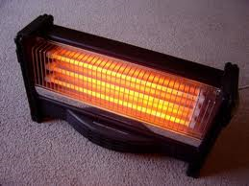
HEATING SYSTEM
Things to consider:
- Type of System
- Type of fuel used
- The location of the system
- How many space heaters are used in the building
Recommendations:
- During the winter keep curtains on south facing walls open during the day and closed at night.
- Do not use multiple space heaters. It is more efficient to turn up the temperature of the central heat.
Why these steps are taken:
Space heaters are less efficient than central heating systems and can be a fire hazard. It is more energy efficient to turn up the central heating than use multiple thermostats.
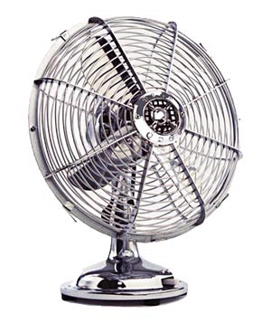
COOLING SYSTEM
Things to consider:
- Type of system
- Location of the system
Recommendations:
- In the summer, keep windows closed during the day and open at night.
FURNACE (if applicable)
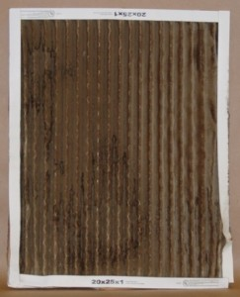
Things to consider:
- Check furnace efficiency label
- When was the filter last changed
- What is the filter size
- How often is the filter changed
- Who is responsible for the changing of the filter
Recommendations:
- Change filter frequently (every three months at a minimum)
Why these steps are taken:
Dirty filters are harder on the furnace, causing it to have to use more energy.
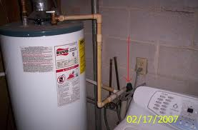
WATER HEATER
Things to consider:
- Where is the water heater located
- Is the pipe leading from the water heater insulated
- The temperatures of the hot water close to the water heater and far from the water heater
- Is the maximum water temperature too hot for use
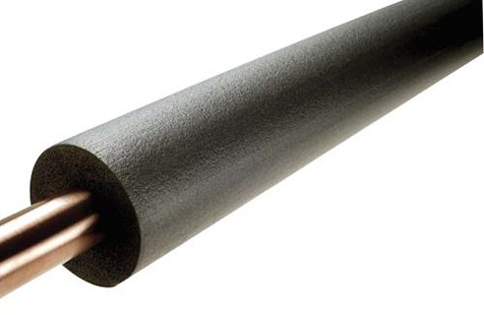
Recommendations:
- Put inexpensive insulation on the few feet of pipe leading from the water heater
- Turn down the temperature on the water heater if maximum temperature is too hot
Why these steps are taken:
Insulating your hot water pipes reduces heat loss and can raise the water temperature 2-4 degrees higher than un-insulated pipes can deliver. It also helps to conserve water by bringing hot water to the usage point more quickly.
AIR VENTS / BASEBOARDS
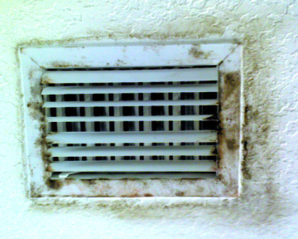
Things to consider:
- Are the vents used to control the air flow volume
- Are the vents or baseboards obstructed
Recommendations:
- Make sure furniture is placed in a way that does not obstruct vents
- Use the vents to control the heating of a space
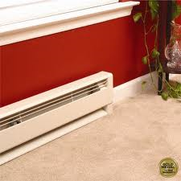
- Make sure vents are clean
Why these steps are taken:
It is more efficient to cool a room by closing a vent than by opening a window.
- LIGHTING
Things to consider:
- Total number of lights
- Dominant type of light
- Wattage used by each light
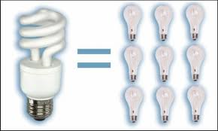
- Are unused lights turned off either manually or by a timer
- How many lights are left on after hours or during off hours
Recommendations:
- Keep light fixtures clean
- Replace lights that appear yellow
Why these steps are taken:
The older and dirtier the light gets, the less efficient it gets. There are also more efficient types of lights.
- THERMOSTAT
Mapping: Mark the location of each operating box and if possible determine which spaces it controls.
Things to consider:
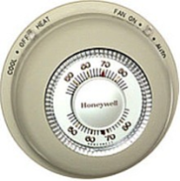
- Type of Thermostat
- Recorded temperature during time of visit
- When and how often is temperature setting changed
- Do the building occupants know how to use the thermostat
- What are the preferred temperatures for the day and the night
- What are the preferred temperatures for the winter and summer
- Are there often disagreements over the thermostat setting
Recommendations:
- Make sure the building occupants know how to use the thermostat
- Turn thermostat down or off when occupants are away from building
Why these steps are taken:
Automating temperature change on the thermostat is one of the easiest ways to cut down on heating costs. Many of the problems in selecting a comfortable temperature arise because the operator is using the wrong operating box.
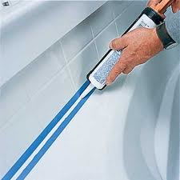
- DRAFTS AND LEAKS
Things to consider:
- Which rooms are hardest to heat
- Locations that are most likely to be drafty are doors, windows, and fireplaces, plumbing penetrations, ducts, vents, fans and electrical outlets.
Recommendations:
- Caulk, seal, and weather-strip all seams, cracks, and openings to outside
- Weather stripping can eliminate drafts on doors and windows
- Close the flue or block the entry to the fireplace when not in use
- Sealing cracks and air leaks is one of the fastest ways to save money on utility bills
Why there steps are taken:
The majority of a buildings heat loss is through seams in the building envelop. It is important to keep a “tight” building.
INSULATION
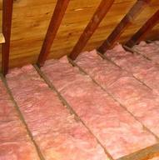
Things to consider:
- What type of insulation is in the walls and roof
- Are there major holes in the insulation placement
Recommendations:
- Replace any insulation as needed, especially in the roof
Why these steps are taken:
A hole in the insulation is comparable to leaving a window open. Heat will dissipate quickly through these holes.
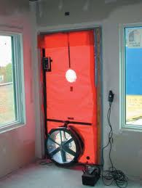
BLOWER DOOR TEST
Things to consider:
- Documenting areas of air leakage with either a thermal camera or smoke pencil
- Record the infiltration rate number
Recommendations:
- Fix any notable leaks with weather stripping, caulk or insulation
Why these steps are taken:
A blower door test is a good way to determine how resistant your building is to leaks and where those leaks are.
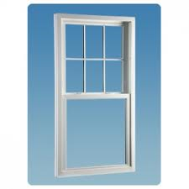
- WINDOWS
Things to consider:
- What are the dominant types of windows in the building
- What are the dominant types of frames in the building
- Are the windows ever left open to compensate for excessive heating or cooling
- Which rooms feel the draftiest
- Is weather stripping used
- Are the windows locked when they are closed
- Are any of the windows damaged severely
Recommendations:
- Make sure closed windows also get locked because it creates a seal that helps eliminate drafts
- Put inexpensive weather stripping on the majority of windows or windows in drafty rooms
- Keep south facing curtains open during the day and closed at night to help heating
- Replace damaged windows
Why these steps are taken:
Many of a building’s leaks will occur around the window seams. It is important to have correctly installed windows.
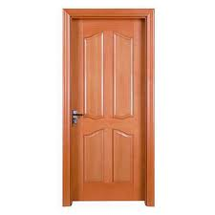
- DOORS
Things to consider:
- What are the dominant types of doors in the building
- What are the dominant types of frames in the building
- Which rooms feel the draftiest
- Is weather stripping used
- Are any of the doors damaged
Recommendations:
- Put inexpensive weather stripping on the majority of doors or doors in drafty rooms
- Replace damaged doors
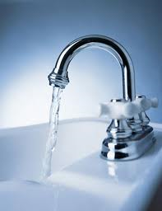
- WATER USE
Things to consider:
- What utilities are using water (Faucets, dishwashers, toilets)
- Are faucet aerators used
- Do any of the toilets leak / run constantly
- What is the type, size, and flush rate of each toilet
- What is the water flow of the other restroom devices
Recommendations:
- Install hot water saving aerators on faucet heads
- Repair leaky toilets
Why these steps are taken:
Water use can be cut down greatly by doing some simple steps such as Installing modern, low-flow faucets, faucet aerators and toilets.
- APPLIANCES / ELECTRONICS
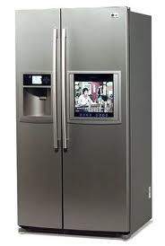
Refrigerator/Freezer
Things to consider:
- What type (Brand, Model) of refrigerator does the building have and how many kW does it take
- Where is the freezer located on it (top mount or side by side)
- Does it have an ice/water dispenser on the door
- What is the temperature of both the refrigerator and the freezer
- Are the gaskets on the refrigerator and freezer tight
- Is it an EPA Energy Star Appliance
Recommendations:
- Set refrigerator and freezer temperatures as low as possible
- Make sure gaskets are tight
- Top mounted is better than side by side
- Ice/Water Dispensers are inefficient
- Replace if from prior to early 90’s

Why are these steps taken:
One of the biggest energy using appliances is a refrigerator. Refrigerators built in the mid 90’s or earlier are some of the only things that should be replaced prior to failure.
Electronics
Things to consider:
- List Types of Electronics used and how many of each
- Which ones are left on overnight
- Which ones were on during visit
- Are computers set to sleep or turned off overnight
- Are power strips unplugged if not in use
Recommendations:
- Unplug unused loads
- Make sure computers are asleep or off when not in use
- Use power strips
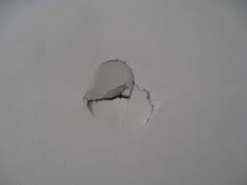
Why these steps are taken:
Appliances and home electronics are responsible for about 20% of the energy use. Turning them off and unplugging them can greatly cut down on your energy use.
- OTHER DAMAGES
- Chipped Paint
- Holes in walls or ceiling
- Broken or missing light bulbs
- Broken or missing windows or doors
- Rust or other corrosion
- Broken, chipped or rotting millwork

What We Will Do With It
The information collected in these assessments will ultimately be given to Facilities and Services. They will use it do make improvements on these buildings as they see necessary. Teams should coordinate with the Student Sustainability Committee Intern to discuss the results of their assessments and create a list of improvements.
How To
- Mechanical
- Heating Systems
  - Furnaces
- Cooling Systems
- Water Heater Temperatures
- Pipe Insulation
- Vents
- Lighting
- Lighting Identification
- Thermostats
- Thermostat Identification
- Thermostat Mapping
- Drafts / Leaks
- Weather Stripping
- Blower Door Tests
- Insulation
- Windows
- Window Types
- Frame Types
- Doors
- Door types
- Frame types
- Water Use
- Faucets
- Toilets
- Appliances / Electronics
- Refrigerators
- Other Damages

Heating Systems
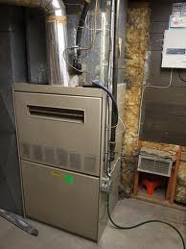
- Forced Air System – this is the most common in homes. Air is heated at the furnace and distributed through ductwork and into rooms through vents. It can be easily identified by the furnace. In this case make sure the furnace filter is clean. The furnace may have an efficiency label. Most modern day furnaces run on 90% efficiency. Fuel sources include natural gas, propane, oil or electricity.

- Radiant Heating System – this can come in a number of different forms (potbelly stove to in-floor hot water tubing). Identified by hot water tubing in floor, radiant panels in ceiling or heating stoves. Uses hot water heated by a boiler which may be heated by natural gas, propane, oil or electricity. Heating stoves use wood or coal.
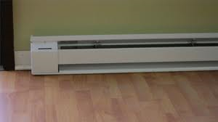
- Hydronic (Hot Water Baseboard) – similar to radiant heating in that it also uses hot water to heat the space. Can be identified by baseboard units mounted along the walls. Fuel sources include natural gas, propane, oil or electricity.
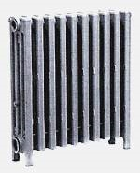
- Steam Radiant Heating – characterized by cast iron upright radiators. Heat is distributed by steam piping and radiator units. Common in buildings attached to steam tunnels.
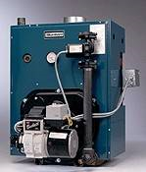
- Boilers – used to produce hot water or steam for other systems. Boilers can use a variety of fuels including natural gas, propane, oil or electricity. Steam boilers are more complex than hot water boilers and have special gauge glass, pressure gauges, blow off valves and automatic feeds.
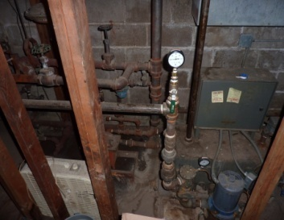
- One of the ways to identify if a building is heated using the steam tunnels is by locating a pressure gage in the mechanical room. Also, if there are exposed pipes leading from the mechanical room they will be insulated in the public areas of the building.

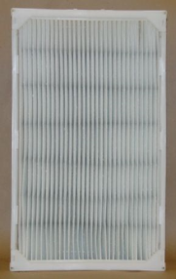
Furnace Filters
- Make sure furnace is turned off. If the furnace is not turned off ask the building operator if it can be or skip step on the checklist.
- Locate the service panel, usually on the lower front or side of the furnace.
- Open the service panel (if no tools are needed).
- Locate the filter. It will be a framed-mesh rectangular light screen near the intake-outtake blower.
- Slide the filter out and check for a brown, dusty buildup on the screen. If this is the case mark as dirty on the checklist.
- Also check for damages in the filter and record the filter size before replacing.

Cooling Systems
- Central Air Conditioning –
- Evaporative Cooler –
- Window AC Unit – these common one room air conditioners, sit in a window or wall opening, with interior controls. Interior air is cooled as a fan blows it over the evaporator. On the exterior the air is heated as a second fan blows it over the condenser. In this process, heat is drawn from the room and discharged to the environment. A large house or building may have several such units, permitting each room be cooled separately.
- None – some older buildings may not have air conditioning.
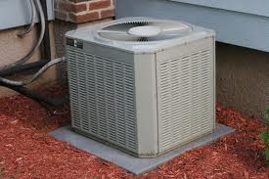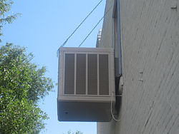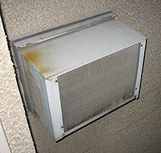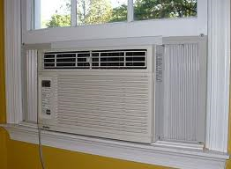
Central AC Evaporative Cooler Through Wall AC Unit Window AC Unit

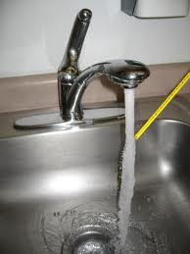
Testing Water Temperatures
- Run the hot water in 2 separate sinks. One as close as possible to the hot water heater and one further away.
- Measure the temperatures by holding the thermometer under the running water for 1 minute.
- Record the temperatures on the “Near faucet/shower ______ degrees and Far from faucet/shower: ______ degrees”
- If either temperature is above 120 degrees F then an adjustment is recommended. Low temperatures or only adjusted based on occupant request.

Pipe Insulation
- Spiral-Wrap Fiberglass Insulation – not very common
- Foam Tubing – most common and inexpensive pipe insulation.
- Fiberglass Shell Pipe Covers – used to protect the foam insulation
The most common pipe cover is foam insulation covered by a light colored fiberglass cover.
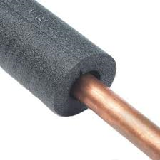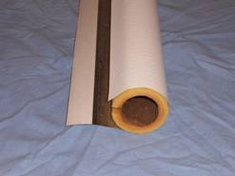
Spiral –Wrap Foam Tubing Fiberglass Shell

Vents
- On each visible wall, ceiling or floor vent determine the cleanliness.
- Clean vents should not have dust or dirt buildup, or visible rust. They should also by unobstructed.
- Record any dirty or obstructed vents you find on the checklist.
- If possible, determine and record what is causing the dirt.
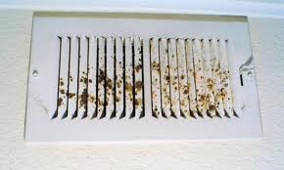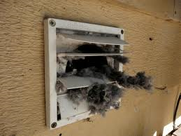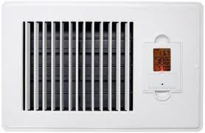
Dirty Vents Clean Vent

Lighting
- Incandescent – most common type of lighting. It is very inefficient.
- LED (light emitting diode)
- HID (high intensity discharge)
- Fluorescent and compact fluorescent (CFL) – most commonly shaped as a long tube.
- Induction
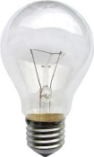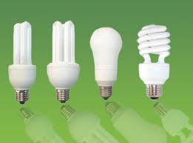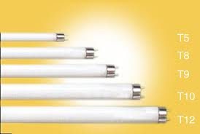
Incandescent Compact Fluorescent Fluorescent Tube

Thermostats
- Analog – oldest and simplest form of a thermostat control box. A person must manually change the temperature with a slide or a rotation.
- Digital (non-programmable) – the temperature must still be changed manually but the operation box is computerized.
- Digital (programmable) – designed to adjust the temperature according to a series of programmed settings that take effect at different times of the day.
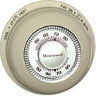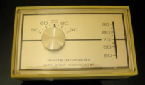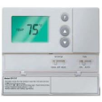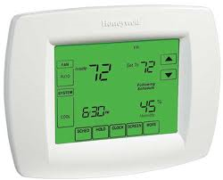
Analog Digital Programmable
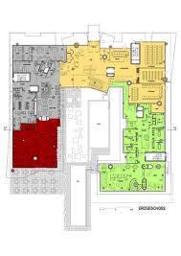
Thermostat Mapping
- Locate the thermostat control boxes and note on a floor plan (there may only be one).
- Identify what type of operation box it is on the room chart.
- If possible, record which rooms are controlled by each box. There may be one box for the entire house, entire floor, or miscellaneous rooms. You may have to ask the building operator for this information.

Weather Stripping
- There are many different kinds of weather strips; Compression Strips, Tubular Gaskets, Adhesive-backed V Strips, and Magnetic Weather Stripping (metal or steel clad doors).
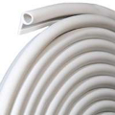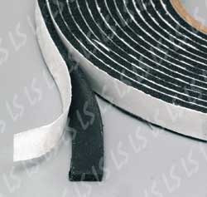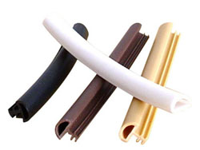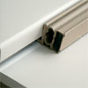
Tubular Gaskets Adhesive Backed Compression Strips Magnetic

- Weather stripping should be applied around the entire perimeter of the opening (for windows) with nails, screws or adhesive (including joints).
- For doors, it should be applied to the top and sides. Other methods are used to stop air flow through the bottom of the doors.

Blower Door Test
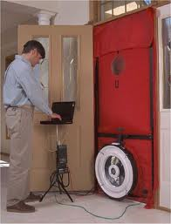
BRC Training

Insulation
Insulation is very difficult to check because it is usually buried in the wall or roof space. There are a couple of different ways to get the insulation type. If there is an attic or above ceiling storage area the insulation may be visible in it. You may be able to view into the wall through a missing outlet panel or a hole in the wall.
- Loose-fill –made up loose fibers or fiber pellets that are blown into building cavities or attics. It is usually more expensive than batt insulation but it fills smaller areas easier, reduces air leakage better, and provides better sound insulation.
- Batt and Blanket –made of mineral fiber and is used to insulate floors, ceilings and walls. It is usually least expensive wall insulation material but requires careful installation for it to be effective.
- Rigid Board –commonly made from fiberglass, polystyrene, or polyurethane and comes in a variety of thicknesses. This type of insulation is used for reproofing work on flat roofs, on basement walls and as perimeter insulation at concrete slab edges.
- Spray Foam –a two-part liquid containing a polymer and a foaming agent. The liquid is sprayed through a nozzle into wall, ceiling, and floor cavities. As it is applied it expands into a solid cellular plastic. Spray foam insulation is commonly used for irregularly shaped areas and around obstructions. Spray foam materials cost more than traditional batt insulation.
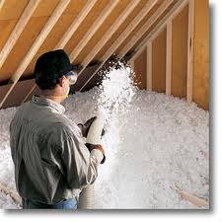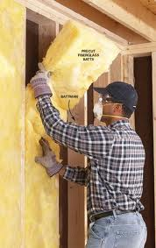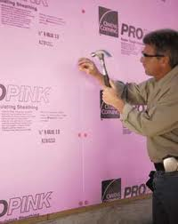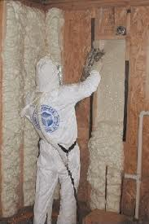
Loose Fill Batt Rigid Board Spray Foam

Windows
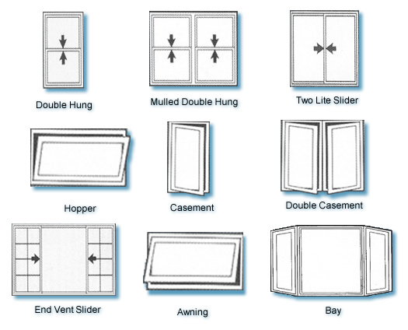
Window Frames
- Aluminum – generally the least expensive and requires very little maintenance. It is both strong and light weight. It is also the least energy efficient. Because it is a good thermal conductor it will experience significant heat loss.
- Fiberglass – combines the strength and durability of aluminum with the insulating properties of wood.
- Vinyl – a more efficient alternative to aluminum. Usually costs about 25% more than aluminum frames but is up to 30% more energy efficient. Vinyl also requires very little maintenance.
- Wood – usually very aesthetically pleasing. Costs 2 to 3 times as much as vinyl and requires more maintenance.
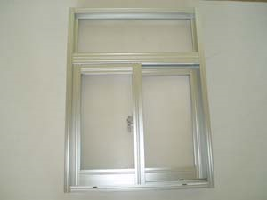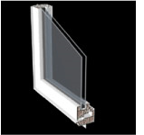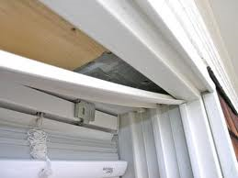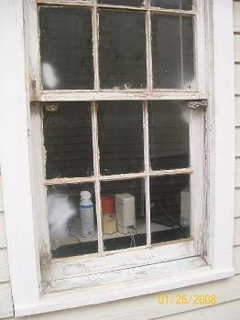
Aluminum Fiberglass Vinyl Wood
Doors (Exterior)
- Steel – often called hollow metal doors. They are the most common types of doors in exterior construction because they are extremely resistant to moister and weather. They are very inexpensive and require very little maintenance. They are also corrosion resistant.
- Fiberglass – extremely resistant to moisture and weather. It has strong insulation properties and is scratch and dent resistant. Usually more expensive than steel.
- Wood – can be manufactured in an almost unlimited number of designs and colors. Usually the most expensive, but also the least likely to become damaged and the easiest to repair. They are easily damaged by weather and moister and usually require a protective coating.
- Aluminum – used mostly on commercial buildings. Popular because of its beautiful shine and modern appeal. It is very good at withstanding the elements and it will not rust or corrode. It is also very durable and long lasting.
- Specialty Construction – most commonly used for the fire rating. The door will usually have a special core inserted that helps maintain fire control. Also used for sound transmission, they can help to damper noise from passing through. May be difficult to identify by observation.
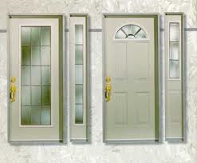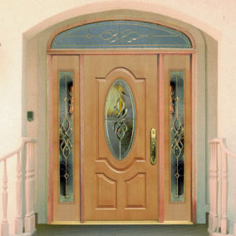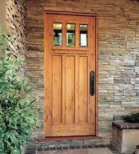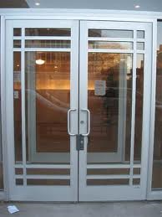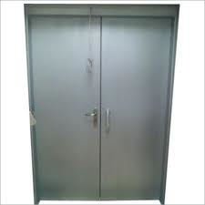
Steel Fiberglass Wood Aluminum Sound Resistant
Doors (Interior)
- Wood – see exterior doors
- Steel – see exterior doors
- Aluminum – see exterior doors
- Glass – Mostly used for aesthetic purposes or for sliding exterior doors.
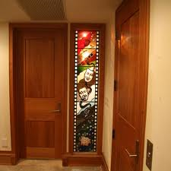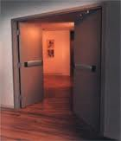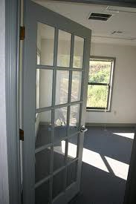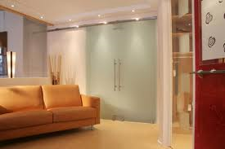
Wood Steel Aluminum Glass
Door Frames
See window frame identification

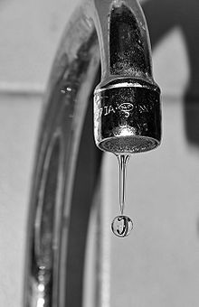
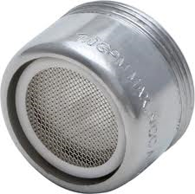
Faucet Aerators
- Faucet aerators will be applied to the end of the faucet where the water comes out. It looks like a small screen.
- Faucet aerators are designed to cut down on the flow of water by adding air bubbles and softening the water flow. Without an aerator it may take double the water to get the same pressure.
- To check if a faucet has an aerator simply attempt to unscrew the end. If it turns there is an aerator there.

Refrigerators
- Determine the model and year the refrigerator us built.
- The two basic types of refrigerators are top and side mounted.
- Note if it has an ice and water dispenser on the door.
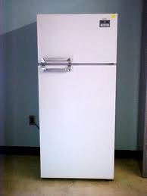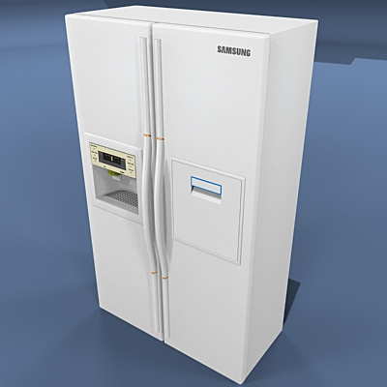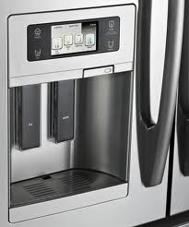
Top Mounted Side Mounted Water Dispenser

Other Damages
This is a very broad section on purpose. This is to space for teams to record anything not covered in the assessment that may be good to have information on or worth looking into fixing.

Assessment Step Time
Heating System 15 minutes
Furnace Filter 15 minutes
Cooling System 15 minutes
Water Heater 15 minutes
Baseboards/Vents 20 minutes
Lighting 20 minutes
Thermostat 30 minutes
Drafts/Leaks 20 minutes
Blower Door Test 45 minutes
Windows 30 minutes
Doors 20 minutes
Water Use 30 minutes
Appliances 20 minutes
Electronics 30 minutes
Other Damages ??? minutes
TOTAL 5 hours 25 minutes

Assessment lengths will vary based on size of building.

Data
The collected data will be organized into a single document and given to Facilities and Services to use internally to do improvements on the assessed buildings.
Data will be collected in 3 different ways:
- Maps (Floor Plans)
Floor plans will be provided for each floor of the buildings your team will assessing. Thermostat mapping, air leak locations, quantities of lights and vents, and other information will be recorded on these.
- Room Charts
Teams should label each room with a letter. After establishing the number of rooms in the building each team should print the corresponding amount of Excel charts to record information on. Each chart should be matched with a room.
- “Whole Building”
Finally, there will be one “whole building” form. This will be used to record things that are general to the entire building such as mechanical system information. This will also have space provided for a replacement list, where teams should record quantities of items that are needed (light bulbs, etc.).

Sample Assessment Forms (next page)
Building Name: __________________________________
Date/Time: ___________________
Address: __________________________________________________________
Team: ___________________
___________________
___________________
___________________
___________________ (circle person completing this form)
Outside air temperature during visit _______ degrees

- MECHANICAL

HEATING SYSTEM:

Fuel: NATURAL GAS / ELECTRIC / OTHER: ____________

Type: FORCED AIR / RADIATOR BASEBOARD / ELECTRIC BASEBOARD/ OTHER

Location: CRAWL / BASEMENT / OUTDOOR CLOSET /OTHER: _____________

Space heaters used? YES / NO How many? ________

Notes:

FURNACE FILTER:

Furnace Location: ________

When was the last time your furnace filter was changed? _______/ DON’T KNOW

Was it changed by your landlord? YES / NO / DON’T KNOW

Is it your landlord’s responsibility to change the furnace filter? YES / NO /DON’T KNOW

Notes:

COOLING SYSTEM:

Type: CENTRAL AC/ EVAPORATIVE COOLER / “WHOLE HOUSE”/WINDOW / NONE

Notes:

WATER HEATER:

Location of water heater: KITCHEN / BASEMENT / CLOSET / OUTSIDE LOCATION

Pipes Insulated? YES / NO

Efficiency rating on label: __________ BTU or THERM/hour _________ Year ______
Picture

Hot water temperatures:

Near heater ______ degrees Far from heater: ______ degrees

Maximum Water Temperature? TOO HOT / OK / TOO COLD

Notes:

AIR VENTS / BASEBOARDS

Air control position at time of visit? OPEN / CLOSED

Vents or baseboard obstructed? YES / NO

Where? : ____________________________________

Did you notice furniture placed in an “inefficient” way?

Notes:

- LIGHTING:

Dimmers Installed? YES? NO Location: __________________________

Indoor

Incandescent currently used: ______ CFLs already used: _______

Outdoor

Incandescent currently used: ______ CFLs already used: _______

Notes:

- THERMOSTAT

Thermostat: ANALOG / DIGITAL, PROGRAMMABLE / DIGITAL, NON- PROGRAMMABLE

Location: ____________________________

How often is temperature changed? ______________________________ /NEVER

Setting at visit time: ______

Preferred day temp: ______ degrees F

Preferred temp night: _______ degrees F

Notes:

- DRAFTS AND LEAKS:

Which rooms are the coldest/hardest to heat? __________________________________________________________________________________________________________________________________________________________________________________________________________________
_________________________________________________________________________________________________________

Check Draft? Location:
Doors YES / NO
Windows YES / NO
Fireplace YES / NO / NA
Other: ________ YES / NO

Notes:

- WINDOWS:

Dominant window type: SINGLE / DOUBLE / STORM

Dominant window frame type: WOOD / ALUMINUM / PLASTIC / OTHER

Where are the windows the draftiest? MOST ROOMS / SOME ROOMS / NO ROOMS

Location: __________________________

Weather-stripping applied? YES / NO Where? _________________________

Were the windows locked at the time of the visit? YES / NO / SOME

Notes:

- DOORS

Dominant door type: SINGLE / DOUBLE / STORM

Dominant door frame type: WOOD / ALUMINUM / PLASTIC / OTHER

Where are the windows the draftiest? MOST ROOMS / SOME ROOMS / NO ROOMS

Location: __________________________

Weather-stripping applied? YES / NO Where? _________________________

Were the windows locked at the time of the visit? YES / NO / SOME

Notes:

- OTHER WATER USE:

Faucets _____ Dishwasher _____ Toilets ____

Toilet leaks? YES / NO

Faucet aerators? YES / NO Location: __________________________

Notes:

- APPLIANCES / ELECTRONICS:

Refrigerator / Freezer

Brand: ____________ Model #: _________________ kW: _______

Freezer: TOP / BOTTOM / SIDE BY SIDE

Refrigerator near stove? NEXT TO / > 2 FT / > 5 FT

Temperature: Refrigerator: ____________ Freezer: ___________

Gaskets: TIGHT / LOOSE

Electronics

Stereos ___ TVs ___ Cable box ___ Laptops ___ Microwaves ___ DVD Player ___ Computers___ Printers ___ Power Strips ___

Computers and laptops set to go to sleep? YES / NO

Unplug chargers when not used? YES / NO

Turn off your power strips when not using what’s plugged in them?

YES / NO / DIDN’T KNOW

Unplug your kitchen appliances with clocks when not used?

YES / NO / DIDN’T KNOW

Notes:

- OTHER DAMAGES:

