Ho Yee Natalie Tse
4/28/2014
NRES 285
The Sustainability of the Photovoltaic Solar Panels
on the Roof of Business Instructional Facility

Project Description
The photovoltaic panels on LEED Platinum certified Business Instructional Facility (BIF) rooftop harvests solar radiation as a clean renewable energy source for the University of Illinois at Urbana-Champaign facility. The solar system has a combined maximum output of 40 kilowatt per hour (kWh), and has an annual production of 60,000 kWh. The system is expected to produce approximately eight percent of the building’s total electricity demand. However, solar panels require unobstructed access to solar radiation for most or all of the day to be effective.
The solar system comprises of 32.76 kilowatt (kW) photovoltaic arrays, which is composed to 24 strings of seven modules each. Each module is rated at 195 watt (W). The system utilizes six 5 kW rated inverters and is connected to the University of Illinois electric grid. The system is provided by and installed by Bodine Electric Champaign and Wilhelm Engineering. The total cost of the system was $245,663, and it was funded by Illinois Clean Energy Community Foundation and the Student Sustainability Committee.
Project Goals
The main focus of this evaluative project is to measure the sustainability of the solar panels. This includes the social sustainability aspect, which will be assessed by the presence or absence of a sustainability education and outreach program specific to the BIF solar panels. An outreach program will ideally help promote a collective social movement that influences community norms and values to become more aware and adapted to the idea of sustainability. There will also be an investigation into whether the solar output produced by the solar photovoltaics meet the expected eight percent contribution to the total electricity demand of BIF. Another goal of this project is to calculate how much money is saved from electricity bills by the creation of solar energy. Furthermore, how much greenhouse gas emissions are prevented from the establishment of the solar panels?
Aside from studying how much the solar panels could save the university, the efficiency of the system will also be assessed. Due to the unpredictable and long winters in the Midwest region, shading could cause a significant loss in the potential energy that the system could produce. This inefficiency caused by shading that makes the system incapable of producing the maximum solar output will be referred to as “shading losses.” Last but not least, an effort to acquire the specific model of the solar panels used will be made to evaluate the sustainability of the panels as a product. Acquiring the photovoltaic model will allow for the study of where the components came from, what they were made of, and the assembling of them to create the panels. The manufacturing site of the panels is also important, because faraway sites would result in higher greenhouse gas emissions due to the transport of the panels to the university. This also applies to how the panels are disposed or recycled at the end of their life cycle, and where the disposal or recycling site is located. Furthermore, knowing the model of the panels would also indicate the design life of the panels, and their degradation rate. Ultimately, the consideration of these factors can help us innovate ways to improve the efficiency and sustainability of the photovoltaic solar panels on BIF’s roof.
Performance Metrics
There are several performance metrics used to evaluate the rooftop photovoltaic solar panels of BIF. First of all, the scale, size, and cost of the photovoltaic system is taken into account. Secondly, the impacts of the components that make up each individual panel, such as the photovoltaic modules, batteries, charge regulator, inverter, wiring, and mounting hardware, are considered. These impacts include the materials that these components are made of, and whether they are being harmfully extracted from the environment or not. In addition, the transport of those materials to the factory that produces the necessary photovoltaic components, and the transport of these photovoltaic components from the factory gate to the site of assembling, where the photovoltaic modules are made, are factored into judging how sustainable the entire photovoltaic system is.
Thirdly, the energy production in the specified installation is taken into account. This solar output factors in shading losses. Another performance metric used focuses on the maintenance and replacement of parts. How many parts require regular maintenance, and how often does the maintenance of the system need to be conducted? Who conducts this process and how expensive is this process? Tying to the idea of maintenance, the design life and degradation rate of the system are important to determining how long the system will function properly until disposal. Lastly, whether the system is disposed or recycled, and the transport of the system to the corresponding disposal or recycling site will need to be taken into account.
Data Collection
The data collected for this project was obtained from five faculty members of the University of Illinois. The faculty members who were interviewed were: 1) Mr. Steve Hess, Director of Office for Information Management, 2) Ms. Carol Young, College of Business Office Administrator, 3) Mr. Joseph Rix, Utility Metering Coordinator, 4) Mr. Mike Marquissee, Director of Planning and Budget Resources, and 5) Mr. Kent Reifsteck, Director of Energy and Utility Services. From them, I was able to retrieve information on the solar panels, specifically the sustainability outreach program catered to them, the installment logistics, the financial statements, and the system’s electrical output. I was also able to calculate the total electricity demand of BIF from the monthly electricity data provided by the faculty members. However, I was unable to acquire the specific model of the solar panels.
The BIF solar panels are used as a sustainability outreach tool by having an electronic presentation of BIF’s energy consumption from the solar system in the main atrium of BIF. Professor Madhu Viswanathan also leads classes, Business Administration 532 and 533, in the university to gain “experience in business and engineering plan development with topics covering sustainable product design, sustainable supply chain management, and design and communication of sustainable value propositions.” One of the projects examined is the solar panels of BIF. These two mediums are beneficial sustainability education and outreach tools for the campus community.
Along with the total cost of $245,663 to implement the rooftop solar system, there is little extra cost needed for maintenance. Only the cooling fans of the inverters will need to be cleaned occasionally, and the university Facilities and Services crew has been trained to maintain the system.
The solar system produces an annual average of 44,939 kWh per year. The average solar output is 123 kWh; however, the maximum output is 235 kWh. Figure 1 shows the daily solar output generated by the BIF solar system between the months of July 2009 and June 2013. Figure 2 displays solar output by day. The red area represents the maximum solar output that could be generated, whereas the black line shows the actual generated output. The system’s inefficiency is most likely caused by shading losses.
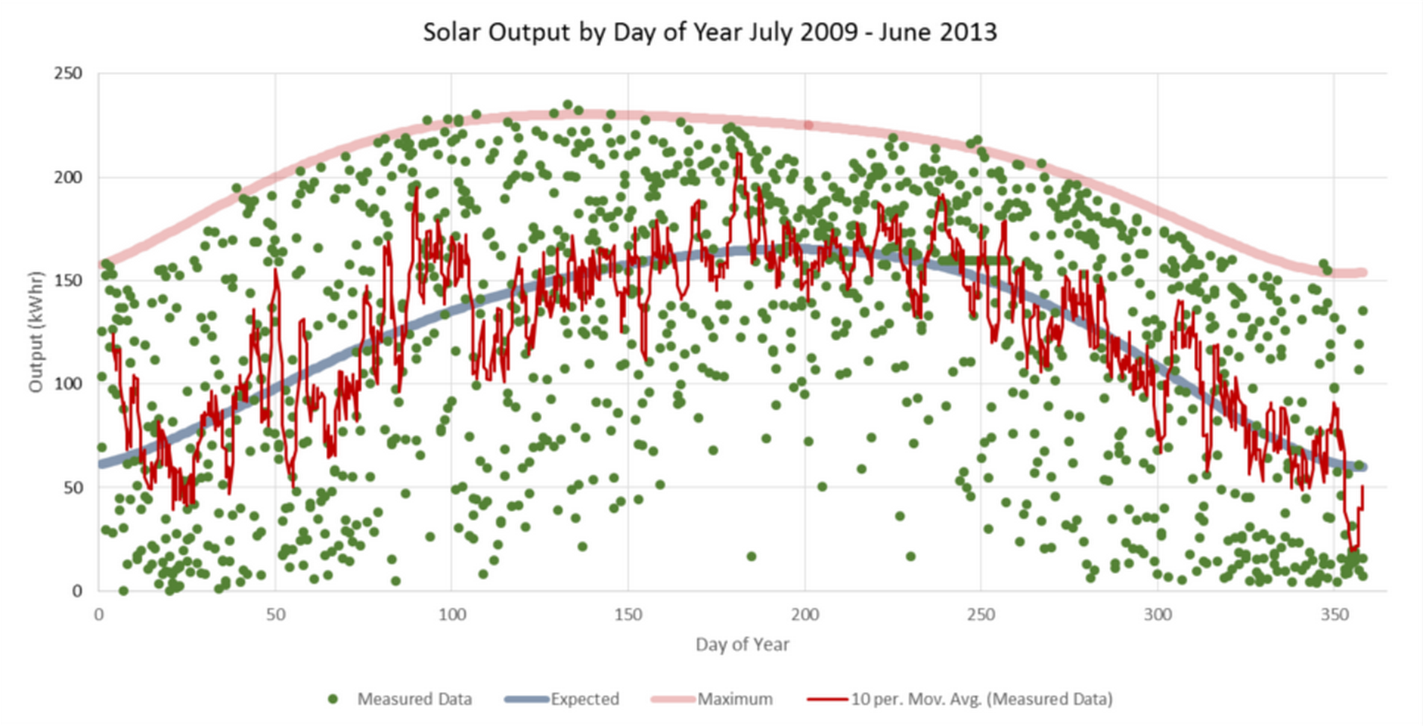
Figure 1. Daily solar output between the months of July 2009 and June 2013
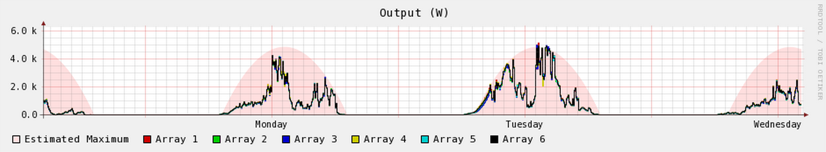
Figure 2. Solar output by day
BIF has a total of three electric meters: 01206-E1, 01206-E2, and 01206-E3D. Meters 01206-E1 and 01206-E2 show BIF’s electricity consumption from the electricity grid. Meter 01206-E3D shows consumption from the photovoltaic panels. Table 1 shows the electricity consumption (kWh) from the panels, and the cost of the electricity (or the money saved by not purchasing that amount of electricity from the university electric grid) from April 2013-April 2014 based on the readings of meter 01206-E3D.
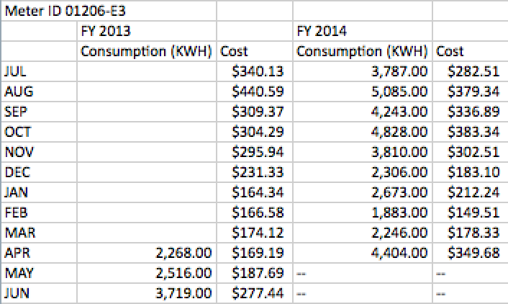
Table 1. 01206-E3D meter reading of BIF electric consumption from April 2013 to April 2014
BIF has an area of 160,000 square feet. The total annual electricity consumption from electric meter 01206-E1 from March 2013 to April 2014 is 904,614 kWh. The total annual electricity consumption from electric meter 01206-E2 from March 2013-April 2014 is 424,811 kWh. Therefore, adding the total readings from all three meters yields BIF’s total electrical consumption in one year, which is 1,370,925 kWh.
The model number of the photovoltaics was not acquired, because none of the interviewed faculty members had that information. They also did not have the name of the Project Manager from Wilhelm Engineering who installed the system; thus, I was unable to personally contact the engineer to ask for the model and base the life cycle analysis on the specific model used. Therefore, I have chosen to take a general approach to analyzing the lifecycle of BIF’s photovoltaic solar panels by conducting online research.
Data Analysis
Prior to the installment of the photovoltaic system, it was expected that the generated solar output would supply 8% of the building’s total electricity demand. The total annual electricity demand of BIF is 1,370,925 kWh, and the annual average solar output from the system is 44,939 kWh. Therefore, the system only contributes to 3.29% of BIF’s total electricity demand, and does not meet the original expectation. Based on Table 1, the total annual monetary savings from the solar panels is approximately $5,649. Once again, there is little extra cost spent on the maintenance of the system.
As stated earlier, the daily maximum output is 235 kWh, yielding the estimated monthly maximum output to be 7,050 kWh (235 kWh * 30 days). Again, based on Table 1, the lowest monthly solar output is 1,883 kWh, which happens in the month of February. Thus, there can be up to 26.7% loss of solar output due to shading. This makes sense because snowfall in Champaign, Illinois is usually the highest in February. Since the daily maximum output data is based on data over the course of four years (2009-2013), while Table 1’s data is based on one year (2013-2014), the shading loss calculated from these two pieces of information is an estimate. It will have a degree of discrepancy from the actual figure. I was incapable of acquiring the solar output readings from electric meter 01206-E3D during the years of 2009 to 2013, because that information required higher authorization to gain access.
Furthermore, since the model of the solar panels was not identified, I have used a general framework for the life cycle analysis of photovoltaic solar panels provided by the state of Oregon and the International Energy Agency. As pictured by Figure 3, the lifecycle of a photovoltaic system includes material and energy inputs and effluents of the following stages: 1) raw material acquisition, 2) material processing, 3) manufacturing, 4) use, 5) decommissioning, 6) treatment or disposal, and 7) recycling.
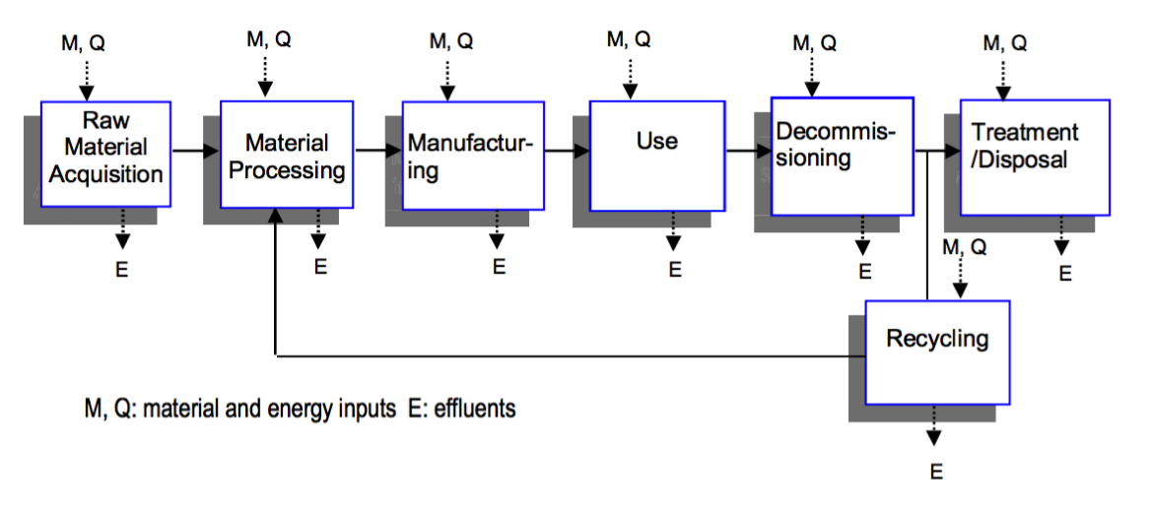
Figure 3. Flow of the lifecycle stages, energy, materials, and effluents for photovoltaic systems
In the stage of material inputs, fossil fuels are used for materials extraction and for transporting those materials to manufacturing plants. The extraction of natural resources, such as quartz, silicon carbide, glass and aluminum can cause habitat disturbances. In the manufacturing and production stage, solid waste production is minimal. However, the fabrication of silicon solar cells requires large volumes of high purity water for silicon wafer cleaning. All wastewater is then treated and monitored prior to discharge. During the use of the photovoltaic system, the system itself does not cause emissions of carbon dioxide or other greenhouse gases. It also does not produce air pollution and require little maintenance. Thus, there is minimal impact during this stage. Lastly, the disposal of photovoltaic systems is safe for landfills, because photovoltaic materials are usually encased in glass or plastic and many are insoluble. Nevertheless, some panels could be classified as hazardous waste due to lead content. If the system is being reused, it takes one-third of the energy to make a solar panel from a recycled one rather than using new materials. Currently, some panel manufacturers are harvesting silicone from recovered computer chips. The majority of manufacturers ofter a 25-year standard solar panel warranty, which means that power output should not be less than 80% of rater power after 25 years.
Over their lifetime, solar photovoltaics generate nine to 17 times the energy required to produce them. The clean energy payback of a photovoltaic system ranges from one to four years. Factoring in the emissions due to the production of solar panels, 87-97% of the energy produced by photovoltaic systems will be free of pollution and greenhouse gas emissions. The production of 1,000 kWh of solar electricity reduces emissions by nearly eight pounds of sulfur dioxide, five pounds of nitrogen oxides, and more than 1,400 pounds of carbon dioxide.
One of the project goals was to quantify how much greenhouse gas emissions the photovoltaic system can cut down. However, in order to convert the solar power consumed in kWh from the photovoltaic system, a carbon dioxide emission factor needs to be applied to the data. Based on the organization, Carbon Monitoring for Action, Abbott Power Plant emits 149,800 tons of carbon dioxide annually. Applying a carbon dioxide emission factor onto the total annual solar output from BIF’s solar panels would allow us to calculate the amount of carbon dioxide (tons of carbon dioxide) the photovoltaic system prevents from emitting every year. However, the carbon dioxide emission factor is based on which type of method the electricity is created. Abbott Power Plant uses natural gas, coal, and steam to generate electricity; thus, the energy production ratio between the three methods needs to be determined to specify the carbon emission factor. It is necessary to apply a carbon emission factor based off the ratio of the three production methods of Abbott Power Plant onto the solar output of the photovoltaic system, because all electricity used by the university is acquired from Abbott if not from the panels. Although it is known that Abbott Power Plant contains three natural gas boilers, three coal boilers, and two heat recovery steam generators, we do not know how much energy is produced from each method and how much of that energy feeds into the university electric grid. Thus, the greenhouse gas savings was not calculated from this project.
Effectiveness
In summary, the photovoltaic system contributes 3.29% of BIF’s total electricity demand, which is lower than the desired 8% contribution. The annual monetary savings of $5,649 will take the system 43 years to pay off the total system cost of $245,663. They system also has up to 26.7% loss of solar output due to shading. This figure is exceptionally high, and it sheds light on the issue of whether or not it is a smart idea to have a rooftop photovoltaic system in Champaign, Illinois, given the long, dark winters. The main lifecycle environmental negative impacts include the energy consumed during panel production and the emissions associated with that energy generation, and water consumption, which is ultimately cleaned and returned to the watershed. Nevertheless, despite these shortcomings, the system does in fact produce zero greenhouse gas emissions during its usage. Furthermore, even when the emissions created from the production of solar panels are emitted, 87-97% of the energy produced by photovoltaic systems is still free of pollution and greenhouse gas emissions. Ultimately, the system is also used as a sustainability education and outreach tool for the local community, and for other universities to aspire to green building design and technology.
Recommendations for Future Projects
It is important to choose a solar panel model that does not require environmentally harmful extraction of materials and long distance transport of components. The geographic location should be chosen wisely with the consideration of shading losses. Finally, there should be constant monitoring of the solar output and how much it contributes to total electricity demand.
Suggestions for Additional Work
If possible, find and contact the Project Manager from Wilhelm Engineering for the solar panel model number. That information can provide a life cycle analysis that is specific to the model used by BIF. This will result in better-identified and more accurate information on the materials and energy inputs and effluents of the components of the system, including the materials that they are made up of, the transportation, and assembling of those components. The specific manufacturing site, system degradation rate and design life, as well as where the disposal and recycling sites are located will also be established. Secondly, find the energy production ratio between coal, natural gas, and steam of Abbott Power Plant to determine the carbon dioxide emission factor. This will enable the calculation of the greenhouse gas savings from the solar panels.

Works Cited
Abram, Tom. "Renewable Energy at the University of Illinois." Smart Energy Design Assistance Center. N.p., n.d. Web. 3 Apr. 2014. http://smartenergy.illinois.edu/pdf%5CPresentations%5CRenewableEnergySummit%5CAbram.pdf.
"BIF Rooftop Solar." ICAP Portal | University of Illinois. Center for a Sustainable Environment, n.d. Web. 3 Apr. 2014. http://icap.sustainability.illinois.edu/project/bif-rooftop-solar.
Bruce, Alex. "The Full Cycle." ETool. N.p., n.d. Web. 3 Apr. 2014. http://etool.net.au/wp-content/uploads/2013/06/ReNew-Solar-PV-Sustainability.pdf.
"Business Instructional Facility: LEED Platinum." ICAP Portal | University of Illinois. Center for a Sustainable Environment, n.d. Web. 3 Apr. 2014. https://icap.sustainability.illinois.edu/project/business-instructional-facility-leed-platinum.
"BIF Sustainable Energy Project." Energy Management. University of Illinois at Urbana-Champaign, n.d. Web. http://www.energymanagement.illinois.edu/bif_sustainableenergyproject.cfm.
"Business Operations." Facilities & Services. University of Illinois at Urbana-Champaign, n.d. Web. http://www.fs.illinois.edu/services/utilities-energy/business-operations.
"Comparison of Lifecycle Greenhouse Gas Emissions of Various Electricity Generation Sources." World Nuclear Organization. N.p., July 2011. Web. <http://www.world-nuclear.org/uploadedFiles/org/WNA/Publications/Working_Group_Reports/comparison_of_lifecycle.pdf>.
"Green Building Facts." College of Business. University of Illinois at Urbana-Champaign, n.d. Web. 3 Apr. 2014. http://business.illinois.edu/instructional_facility/green-facts.html.
Hess, Steve. Personal interview.
Hess, Steve. "Report to the Student Sustainability Committee on the Photovoltaic Array and Green Roof on the Business Instructional Facility." N.p., n.d. Web.
"Life Cycle Inventories and Life Cycle Assessments of Photovoltaic Systems." International Energy Agency. N.p., Oct. 2011. Web. <https://www.bnl.gov/pv/files/pdf/226_Task12_LifeCycle_Inventories.pdf>.
"Life-Cycle Environmental Performance of Silicon Solar Panels." Oregon.gov. N.p., Aug. 2008. Web. <http://www.oregon.gov/ODOT/HWY/OIPP/docs/solar_panel_lifecycle.pdf>.
Marquissee, Mike. Personal interview.
Reifsteck, Kent. Personal interview.
Rix, Joseph. Personal interview.
"Solar Panel Data." College of Business. University of Illinois at Urbana-Champaign, n.d. Web. http://business.illinois.edu/solarpanels/.
"Solar Photovoltaic Installation @ University of Illinois, Urbana-Champaign." The Association for the Advancement of Sustainability in Higher Education. N.p., n.d. Web. 3 Apr. 2014. http://www.aashe.org/resources/campus-solar-photovoltaic-installations/detail/university-of-illinois-urbana-champaign-2008/.
"Sustainability Evaluation of Solar Energy Systems." Sense. N.p., June 2008. Web. <http://www.senseeu.net/fileadmin/user_upload/intern/documents/Results_and_Downloads/SENSE_LCA_results.pdf>.
"University of Illinois Power Plant." CARMA. N.p., 2009. Web. <http://carma.org/plant/detail/100>.
"University of Illinois - Urbana/Champaign." KJWW. N.p., n.d. Web. 3 Apr. 2014. http://www.kjww.com/project?id=C1.0222.50.
"Wolff Landscape Architecture." American Society of Landscape Architects. N.p., n.d. Web. 3 Apr. 2014. https://ilasla.org/content.php?page=University_of_Illinois__Business_Instructional_Facility
Young, Carol. Personal interview.

