Water

The links between energy and water are both explicit and subtle. The explicit ones are those that are involved with steam production, chilled water production and the like. The subtle interconnections are the embedded energy use in water extraction, purification, transportation and wastewater treatment and the embedded water content of electricity. More importantly, water can itself be creatively used as a means for storing, modulating, and transferring energy between different sub-systems. With the above in mind, we would argue that the challenge for the campus is to reduce the use of all inputs – energy, water, and materials – simultaneously, recognizing that such an approach offers the most flexibility to achieve not just GHG reductions but potentially insulate the campus from externalities such as drought, spike in energy prices and the like.

It is also important to recognize that the Campus is a major user of water within the community. Much of this water is drawn from the Mahomet aquifer which serves as the primary water source for many communities in its vicinity. As the flagship institution of higher education in the State, and one of the leading research institutions in the world, it is a moral imperative for the campus to practice responsible stewardship of the natural resources it depends on. A progressive agenda on water conservation and reuse has the potential to create a wider ripple effect in the future through providing a local platform for multi-disciplinary scholarship integrated with practice. This would provide the UIUC campus a competitive advantage in attracting highly qualified staff and students from across the world while advancing solutions to an ever growing global need for potable water.

The 2010 iCAP goals for water had set the following targets:

Reduce potable water usage and its associated emissions from a fiscal year 2008 baseline:

    - 20 percent by 2015
    - 30 percent by 2020
    - 40 percent by 2025.

As a first step to evaluating these goals, an analysis of performance to date was performed. This revealed that the targets set for 2015 reductions had exceeded those of 2010 (Table 1).

From here, there were twoprimary concerns that helped decide necessary updates. The first was to determine how 2010 goals could be reinterpreted to not just address the campus as a whole, but the campus for its constituent parts. Thus, 2010 targets were normalized to account for weighted number of campus users, assuming a growth rate of approximately 1%. An examination of water use per unit of service area was also performed These results, summarized in Table 2, were then compared to water use on other campuses in order to better understand the University's progress. (Figures 1 and 2).

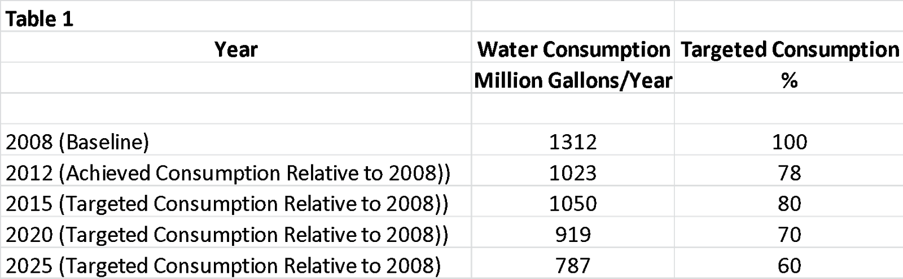
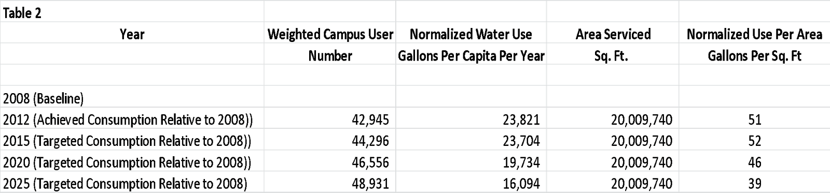
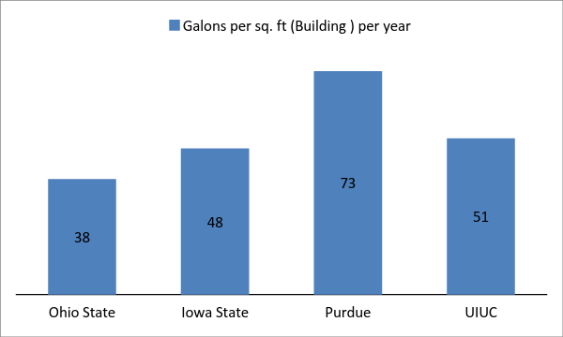

Figure 1 Comparative water use per area serviced among select campuses
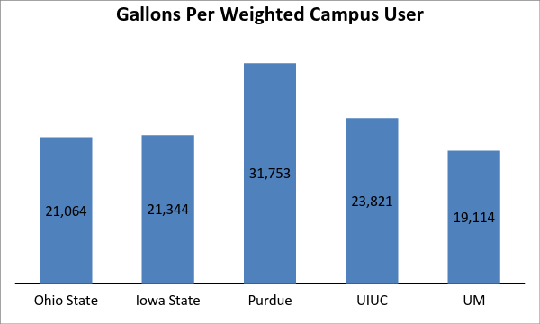
Figure 2 Comparative water use per weighted campus user among select campuses

The second concern was of how stormwater management could be introduced to the iCAP. According to research of the topic and consideration for resources already available on this campus, it was concluded that reducing potable water consumption can be satisfied by maximizing storm water capture and re-use across campus through green infrastructure systems that promote infiltration, passive irrigation, and storage of water for re-use in buildings and facilities.

And so, based on the comparative analyses, the targets set in the 2010 iCAP for 2020 appear eminently achievable. The team recommends that these targets continue to be the goal for campus water reduction with the following additions:

1. Normalized levels of 20,000 gallons per weighted campus user in 2020 and 16500 gallons per weighted campus user by 2025.

2. Normalized levels of 46 gallons per total buildings sq. ft. by 2020 and 39 gallons per sq. ft. in 2025.

3. Increase storm water capture by 25% by 2020, of which 50% will be re-used on campus and 50% will contribute to infiltration/recharge.

The team also recognizes that while the water reductions achieved so far have been impressive, reaching even further reductions is likely to involve greater effort and expense. To this end, the committee recommends adopting the following three strategies for the long term:

Strategies

1. Undertake a bottoms-up approach to estimate consumption by end-use using best practices to determine reductions achievable by water conservation alone.

2. Plan for water reuse to be a major strategy for reducing campus fresh water demand in the present and beyond 2025

3. Integrate the physical and natural elements of campus topography to reduce water demand on campus and facilitate reuse

The team recommends that the following actions, which have been organized into categories, be taken in the short term:

Data collection and Monitoring

1. Make available water quantity and quality data on a publicly accessible site to encourage transparency; encourage instructional use, and campus-wide participation in conservation activities. The site interface may be most effective if modeled after the energy dashboard and could be used in tandem with the energy dashboard.

2. Establish/publicize anticipatory yearly goals for achieving water reduction

Utility and Building Operations

1. Begin utilizing non-potable water, including untreated raw water, sump pump discharge, cooling wastewater, storm water and gray water.

2. Require a review of the water impact of all new construction, modifications, or expansion across all campus units including auxiliaries.

3. Implement recommendations in the SSC sponsored project on water conservation in cooling tower operations

Landscape Design

1. Take inventory of current landscape performance relative to existing pavement and landscape surfaces and features, against the long-term transition toward a water-positive campus environment.

2. Calculate the true cost/benefit of the traditional versus sustainable campus landscape maintenance and operations. Include the current and future economic values of storm water quantities capable of capture with green infrastructure, GHG emissions reductions by re-use of captured storm water, and installation and operation costs of re-use infrastructure.

3. Integrate rainwater capture strategies with other physical campus commitments and objectives such as carbon sequestration.

4. Utilize the Sustainable Sites Initiative (SITES) as a rating systems for all projects on campus, to promote education and assist coordination in developing high-performing sustainable landscape practices

5. Maintain that the campus landscape preserves regional identity by avoiding “off-the-shelf” materials in favor of regionally specific ones.

Education

1. Partner with campus units such as PRI and outside agencies such as Alliance for Water Efficiency, Water Reuse Foundation, AWWA etc to promote water conservation efforts.

2. Provide classroom opportunities to develop water use reduction projects on campus.

3. Require orientation for sustainable water use in dormitories, potentially alongside implementation of more water efficient installations.

