**Energy Displays & Metering Project Final Report**

By Morgan Johnston – September 19, 2015

**Project purpose**

The purpose of this project was to create the infrastructure necessary for real-time energy displays in campus buildings, in support of behavior change efforts. The energy data was previously collected monthly for each building, and available upon request if someone knew where and how to ask. With this project, the data will be real-time rather than monthly for select buildings, and it will be available on a public website. Future efforts will expand the buildings using real-time energy meters and show energy utilization in key campus buildings on public displays.

**Project summary**

This project purchased the InStep dashboard module, which is an additional module in the existing software program that is the energy data historian for campus. The purchase of the software and the first two years of software support was funded by this project for $56,750. The project also funded up to $50,000 in real-time energy meter upgrades, contingent on matching campus funds.

The software module and two years of support were purchased in summer 2011. The dashboard was launched at illinienergy.illinois.edu in December 2011. As of FY15, there are 41 buildings connected to the dashboard, with an additional five in progress. These buildings have at least one real-time energy meter installed and are connected to the Energy Dashboard:

ACES Library

Activites and Recreation Center

Allen Residence Hall

Babcock Hall

Barton Hall

Blaisdell Hall

Busey Hall

Business Instructional Facility

Campus Recreation Center East

Carr Hall

Clark Hall

Davenport Hall

English Building

Everitt ECE Building

Grainger Engineering Library

Henry Administration Building

Illini Union

Krannert Center for the Performing Arts

Main Library

Lincoln Avenue Residence Hall

Loomis Lab

Lundgren Hall

Mechanical Engineering Building

Newmark Civil Engineering Building

Oglesby Hall

Pennsylvania Avenue Residence Hall

Physical Plant Services Building

Psychology Building

Saunders Hall

Scott Hall

Siebel Center

Snyder Hall

Taft Hall

Temple Hoyne Buell Hall

Timothy J. Nugent Hall

Townsend Hall

Trelease Hall

Undergraduate Library

Van Doren Hall

Wardall Hall

Wohlers Hall

These five buildings have new real-time meters installed, for integration into the dashboard site:

Advanced Computation Building, Digital Computer Lab, Lincoln Hall, National Soybean Research Center, and Turner Hall.

**Problems encountered**

There were some issues with the initial funding allocation going to the Environmental Change Institute, when the expenses were coming from Facilities & Services. In 2012, the SSC Program Advisor Mckenzie Beverage helped update the funding agreement to clarify roles and responsibilities.

Also, there are continual issues with the software connections to the meters. There are several connection points and different software programs along the path from the meters to the dashboard, and when there is an issue each connection has to be checked. It is troublesome, but F&S employees work to address it whenever one of the meters stops showing up on the energy dashboard.

Going forward, there was a research project, led by Madhu Viswanathan, to review the Energy Dashboard impacts on behvaior change and make recommendations. The results are posted online at <http://icap.sustainability.illinois.edu/project-update/business-instructional-facility-recommendations>. They recommended a complete revamping of the website design, so F&S is investigating options for a better website system.

**Pictures of finished project**

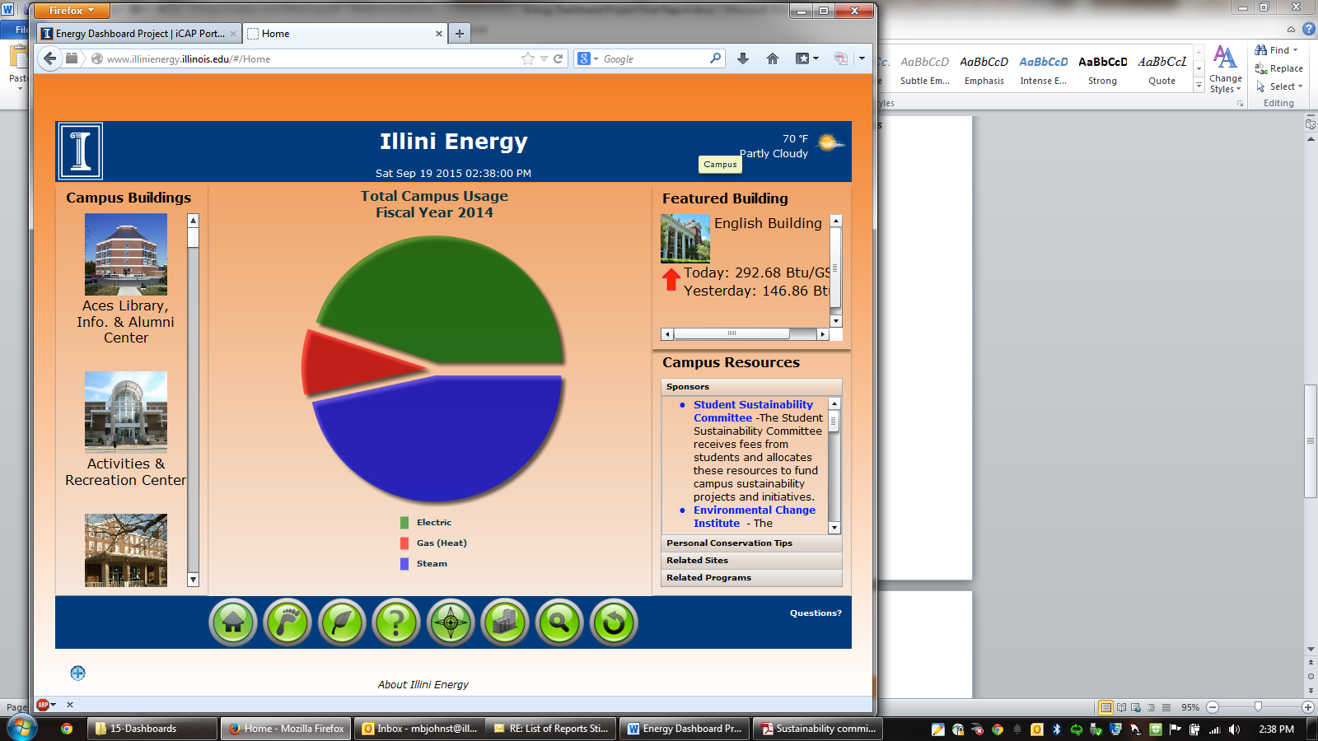 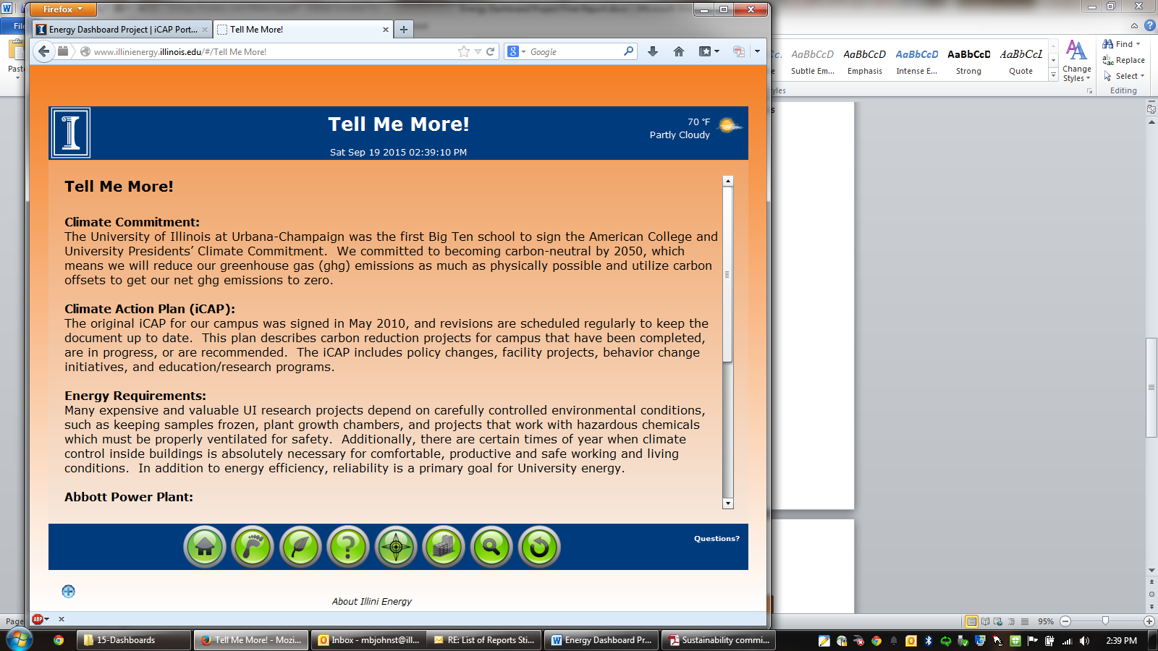

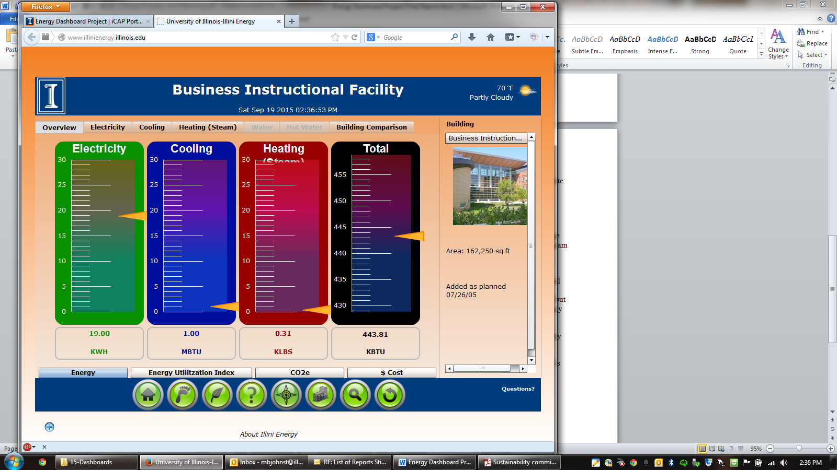

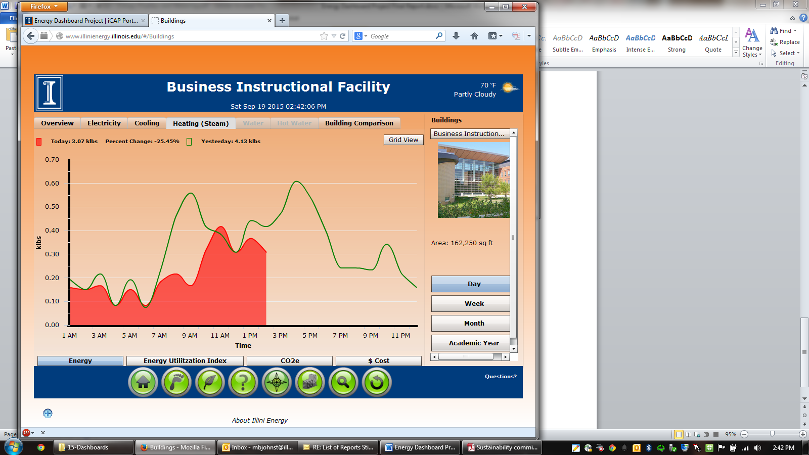

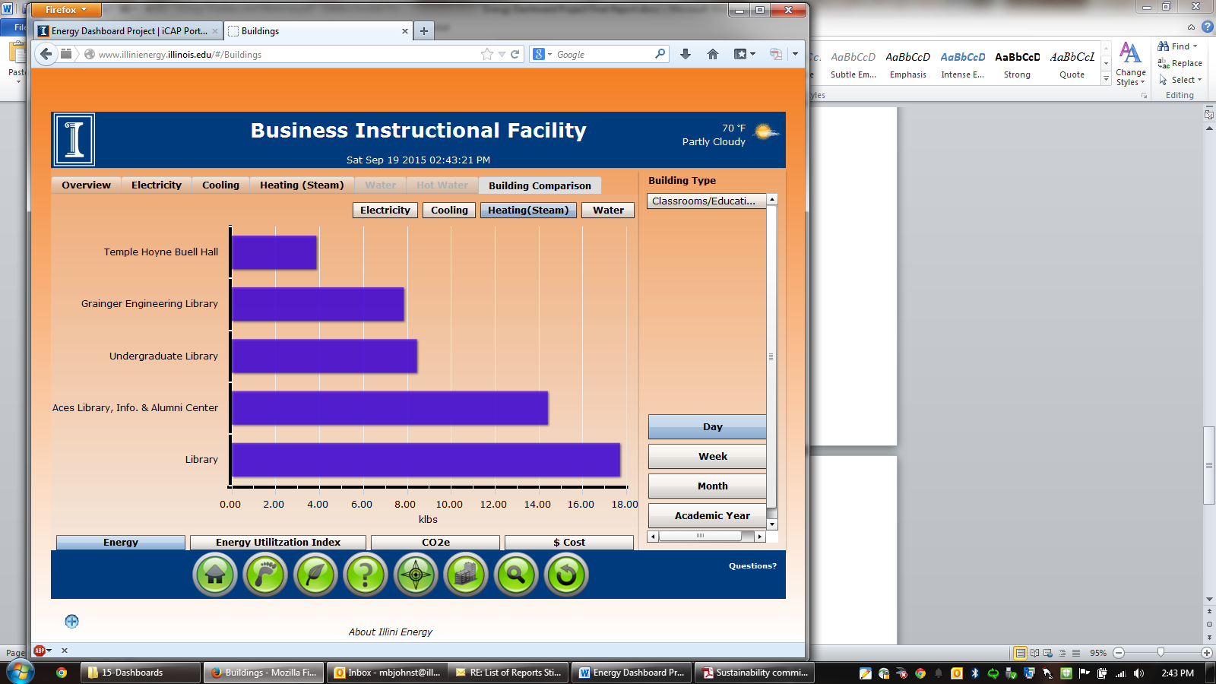

**A financial statement that lists how the funds were specifically utilized**



**Statistics on student involvement/outreach**

There has been a lot of student involvement and outreach for this project. Students helped develop the original proposal, identified the priority buildings, helped promote awareness, evaluated the system, and they can utilize the website.

This program was shared in May 2012 at the IGEN Behavior Change Conference, <http://www.igencc.org/bhc12.speakers>.

The real-time meters have also enabled Housing residents to participate in the annual Campus Conservation Nationals energy reduction competition for colleges. This program is called “Eco-Olympics” on our campus. More info is available at <http://icap.sustainability.illinois.edu/project/campus-conservation-nationals-ccn>.

The student evaluation was rather negative, which is why other web options are being considered for the future. The evaluation is online at <http://icap.sustainability.illinois.edu/project-update/business-instructional-facility-recommendations>.