Submission for the 2015 Illinois Governor's Sustainability Award

May, 2015

University Housing
University of Illinois at Urbana-Champaign

University Housing at the University of Illinois at Urbana-Champaign serves more than 10,000 residents in 25 University-owned residence halls and 1,100 University-owned apartments. We serve more than 4 million meals a year in our on-campus dining halls and in our catering venues. Our full-time staff of more than 650 professionals provides services 24 hours a day, 7 days a week, 365 days a year.
The scale of housing and feeding such a large number of individuals presents a rich opportunity for lasting and meaningful impact on the environment, our budget, and our staff and residents.
University Housing has implemented sustainable efforts across our organization. By working together, we make significant change that also impacts the environment and our bottom line. Our residents and staff benefit from local foods; clean, non-toxic facilities; and gain education and contribute to a sustainable future.
Our sustainability initiatives have resulted in cost savings on raw food, food waste, water, electricity, and chemicals. Our recycling efforts have diverted tons of waste from landfills. And our education efforts help our residents and staff members see how their actions and choices contribute to sustainability efforts.

Description of Activities
Reduce
In addition to money- and resource-saving initiatives such as shared printing centers, default setting for duplex prints, and system-wide sleep modes for computers and kiosks, University Housing is actively reducing its usage of water, chemicals, and electricity in several areas. When we have the failure of a water heater system, we evaluate the repair/replacement to one that uses less energy to provide hot water for shower, hand washing, and cleaning. The large older systems typically contain one or more holding-style storage tanks where large volumes of water are constantly kept hot. We eliminate the tank and are no longer required to keep large amounts of water hot when there is no need. The new instantaneous/semi-instantaneous water heaters supply hot water only when needed. And as we repair and replace showerheads and sink faucets, we install low-flow heads and aerators. In many cases, we are moving from 2.5 or 3.5 gallon per minute flows to 1.5 or as low as .5 when we are assured the service quality is appropriate for our residents.
Trayless Dining
It is an almost unconscious act: an individual enters a dining hall, picks up a tray, and loads that tray with food. In an all-you-care-to-eat dining hall, perhaps an item or two would make its way onto the tray, just for a student to give it one taste. Or the diner’s eyes would be bigger than their stomach, so to speak, and the loaded tray that looked so appealing at the beginning of the meal would largely go uneaten.
Serving more than 24,000 meals per day means that even small changes can have a large impact. In 2007, University Housing began conducting waste audits to determine whether composting would be a feasible option for disposing of food waste. The results of these surveys was staggering. Our consumers were throwing away 23.7 ounces of food per diner per day. Merely composting was not going to solve the issue of food waste.
In August 2008, University Housing opened our first trayless facility. When we realized this had a positive impact on our waste study, we made plans to convert the other dining locations to a trayless system. By 2010, all six of our dining halls had removed trays. Waste studies continued at all locations, each semester through the fall of 2010.
Waste studies showed a drastic reduction in post-consumer food waste, from 23.7 ounces per student per day to just 4.47 ounces per person per day. In addition to the cost and waste savings in regard to food, we also saw a reduction in chemical and water use for washing trays. Chemical purchases fell from 114,654 pounds in 2007 to 98,886 pounds in 2010. This was a 12.9% reduction in usage. By simply removing trays in dining halls, University Housing saves 516 gallons per day or 110,940 gallons of water annually.
Server Virtualization
University Housing began its server virtualization efforts in 2007. As more servers were required to support both new technologies and a robust development and testing environment, server growth had become exponential. Server virtualization technology is a framework of a small number of very powerful servers (physical nodes) attached to central storage (SAN) that can host more than 100 servers. The scalability for virtual server environments provides considerable energy and hardware cost savings. Currently, Housing has 94 virtual servers and 28 physical servers. In addition to saving an estimated $9,269.61 in energy expenses, over $27,000 was saved by not needing to purchase a physical server for each application.
Data Center Cooling
Installation of in-rack cooling in Housing's datacenters was completed in August 2011. This technology provides only the needed cooling for servers directly at their air intake point versus cooling the entire data center space. Savings are more than $7,000 per year.
LeanPath
University Housing is committed to reducing food waste. As part of this effort, we have implemented LeanPath, a food waste reduction system. All food waste is weighed and categorized, including overproduction and trim waste. Each dining facility uses the system-generated reports to hold weekly production team meetings to discuss areas that need to be managed. As a result, we have made simple changes that have had a dramatic impact on waste. One small change was to reduce the pan size on our salad and deli bars, which had a considerable effect on that category. In 2014, we saved 678,255 pounds in food waste as compared to our baseline.

Above: A section of the annual report provided by LeanPath
Lighting Conversion
University Housing has converted virtually all resident rooms from T12 fluorescent lighting to more efficient T8 bulbs. We are currently replacing all common area bulbs. We have converted 2,866 fixtures across our halls at a cost of $195,776. Annual cost savings is $43,112 and 451,911 kWh.
SDRP Lighting Controls Rezoning
In the Student Dining and Residential Programs Building, a 137,000 square foot building, we have subdivided existing lighting zones and added daylight and occupancy sensors. By making the zones smaller and increasing the number of sensors, we have greater control of lighting throughout the building and can make more efficient use of daylight. The cost to retrofit the building was just under $100,000 and is projected to have a 5 year payoff. Annual kWh savings are estimated at 211,158 or $17,505.
Energy Star Equipment
All workstations utilize power supplies that are 85% efficient or better. With the completion of this fiscal year's scheduled workstation replacement, all will be 90% or greater. All server purchases since 2009 have been Energy Star rated. For all peripherals, such as printers, displays and scanners, Technology Services only purchases equipment that is Energy Star rated.
SmartWay
SmartWay is a voluntary program supported by the EPA that helps businesses create more sustainable supply chains. SmartWay also strives to accelerate the prevalence of advanced fuel-efficient technologies. The EPA assists partners in reducing emissions and energy consumption. University Housing has worked with SmartWay in benchmarking, consolidating deliveries, and working with vendors in improving fuel efficiencies, thus reducing emissions, since 2013. The University of Illinois is the first academic institution to participate in the SmartWay Transport Partnership. We encourage our vendors to become SmartWay partners.
We also utilize a prime vendor contract for food purchases, which has reduced the amount of deliveries on campus. The previous model utilized a number of different vendors delivering to a central warehouse on campus, where food was then redistributed by our fleet. Direct delivery to the dining units through a single vendor has allowed us to further consolidate deliveries, thereby reducing the number of trucks on campus. This has had a positive impact on carbon emissions as well as reducing the amount of fuel consumed through distribution.
Green Cleaning
University Housing’s Green Cleaning Policy and Plan reduces the exposure of building occupants and maintenance personnel to potentially hazardous chemical, biological, and particle contaminants, which adversely impact air quality, health, building finishes, building systems, and the environment. The Green Cleaning Initiative officially began in August of 2008 after more than two years of intense study and development. We are committed to providing the highest quality of services for our students, staff, and guests. We are determined in our efforts to continually work toward reducing any negative impact our cleaning practices may present to the environment and/or the health of those who live, work, and visit our facilities and surrounding community. The goals of this program are to reduce the environmental impact of our cleaning practices on our students, staff, guests, and the environment while maintaining our outstanding quality of service. This program will continually be developed, reviewed, and updated as new products, equipment, and procedures become available.
Integrated Pest Management
Integrated Pest Management (IPM) is an effective and environmentally sensitive approach to pest management that relies on a combination of common-sense practices. IPM programs use current, comprehensive information on the life cycles of pests and their interactions with the environment. This information, in combination with available pest control methods, is used to manage pest damage by the most economical means, and with the least possible hazard to people, property and the environment. IPM programs take advantage of all pest management options possible, including the judicious use of pesticides. University Housing’s IPM program is Green Shield certified.
EnviroPure Units
University Housing has installed four EnviroPure units across our seven dining and catering production units. The EnviroPure system is a self-contained, continual feed, organic food digestion system designed to convert food waste into lipid-free grey water. In addition to these units eliminating nearly all food waste coming from the dining halls where they have been installed, facilities maintenance staff members have noticed a significant decrease in the buildup of sludge in municipal sewer system. This has drastically reduced the need for jetting of the sewer lift pumps.
Food Sources
Food purchasing is an integral part of our dining operation. Purchasing is guided by the State Procurement system but is also influenced by the Illinois Climate Action Plan (iCAP) as well as Illinois’ Local Food Farms and Jobs Act. However, University Housing is committed to surpassing the goals that are set and support local producers whenever possible. We work with the University Student Farm, Meat Sciences, and the Pilot Lab on campus. Outside of campus, we use many providers within the state of Illinois, many of which are within 100 miles of campus. By reducing the distance food is transported, we are reducing carbon emissions, and keeping costs lower through lower freight costs. In addition, we are supporting the local economy and local businesses, improving the financial health of our community. Currently, University Housing purchases 25% of food products locally.
Initiative | Metric | Annualized Reduction | Associated Cost Savings
Trayless Dining | Water Savings (gal) | 110,940 | $410.48
Trayless Dining | Cleaning chemicals not purchased (lbs) | 5,256 | $8974.62
Server Virtualization | Electricity Saved (kWh) | 134,419 | $9,269.61
Server Virtualization | Equipment not purchased | n/a | $27,000.00
Data Center Cooling | Electricity Saved (kWh) | 110,263 | $7480.31
Lean Path | Food not produced (lbs) | 678,255 | $692,809
Lighting Conversion | Electricity Saved (kWh) | 451,911 | $43,122.00
SDRP Lighting Controls | Electricity Saved (kWh) | 211,158 | $17,505.00
Shower Heads and Aerators | Water Savings (gal) | 5,317,000 | $19,672.90
Tankless Water Heaters | Gas savings (kBtu) | 82,396 | $28,690.29
Total Cost Savings: |  |  | $854,934.21

Reuse
University Housing carefully evaluates each equipment purchase request, and makes an effort to rebuild and refurbish as much equipment in house as possible. Worn out and broken equipment is brought back to good working condition by our own staff, thus eliminating the need to purchase new equipment or ship it to a manufacturer for repair. In addition, the simple act of dismantling and reusing catering flower arrangements reduces both cost and waste.
Water Filling Stations
Since 2013, University Housing has installed 50 glass fillers, and 4 bottle filling stations throughout our facilities. Glass and bottle filling stations allow residents and staff an easy and efficient way to fill and refill reusable drinking containers. This provides an easier way to encourage residents and staff to modify their behavior and reduce or eliminate the use of plastic bottles of water. By modifying behavior you decrease the greenhouse gas emissions associated with the production, filling, packaging and transport of disposable water containers. Additionally, less ends up in the waste stream and the likelihood of litter associated with one’s water consumption ending up along a sidewalk or roadway.
Zero Percent
Zero Percent is an online solution for donating and distributing surplus food to populations that need assistance. Quantity food production always has a small percentage of overproduction that will occur due to changing eating habits, customer counts, and customer preferences. Zero Percent takes what would otherwise be considered waste and puts it to good use. This system diverts food from less environmentally conscious disposal methods, such as landfills and compost, and delivers it to agencies that can use it. University Housing implemented this food donation system in 2013, and has made a significant impact on our community. Since the startup of this program, we have been able to donate 19,608 pounds of food to charities and organizations around Champaign-Urbana. Donation facilities that have been able to use our surplus include The Salvation Army, The Daily Bread Soup Kitchen, and Restoration Urban Ministries.
Salvage Drive
The salvage drive was started by University Housing in 1995 as a way for students to donate used furniture, clothing, appliances, canned and boxed foods, and electronics at the end of the semester instead of carting these items back home or throwing them in the trash. In 2012, we partnered with the local YMCA and their Dump and Run program to expand the salvage drive to students beyond University Housing. This program has been hugely successful, collecting 14,542 pounds of products on an annual basis (items that might otherwise have gone to a landfill).
Initiative | Metric | Annualized Reduction | Associated Cost Savings
Water Filling Stations | Bottles Saved | 98,000 | N/A
Zero Percent | Pounds of food donated | 11,205 | $126.05
Salvage Drive | Pounds of items collected | 14,542 | $163.60

Recycle
In addition to the items we recycle as part of the campus recycling program (plastics, paper, cardboard, aluminum), our expanded efforts keep tons of materials out of landfills. We take the opportunity to educate our staff about which items they use every day can be recycled, and also provide recycled materials (such as paper for printing) for work use. When employees see themselves as part of the solution, they see how their activities impact the environment and how they can make a difference.
Glass Recycling
In July 2013, University Housing launched a glass recycling program across University Housing. The program encompasses all residential dining halls, University Catering, and Orchard Downs apartments. Since implementation, more than 20,000 pounds of glass have been diverted from the landfill.
Nitrile Gloves
University Housing is expanding on a test program, conducted in partnership with the Illinois Sustainable Technology Center, to collect and recycle nitrile gloves in all University Housing dining units. Implementation of the program required purchasing blue recycling buckets to hang on the side of existing waste receptacles, and procedural changes. This program has the potential to remove 20 metric tons of nitrile gloves from the waste stream on an annual basis. In 2014, we recycled 1,080 pounds of gloves.
Vegetable Oil
In September 2013 University Housing began recycling all used vegetable oil, which is repurposed into animal feeds and bio fuel. Since inception, we have recycled 143,529 pounds of used cooking oil.
Coffee Grounds
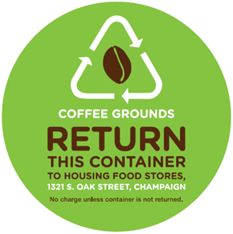
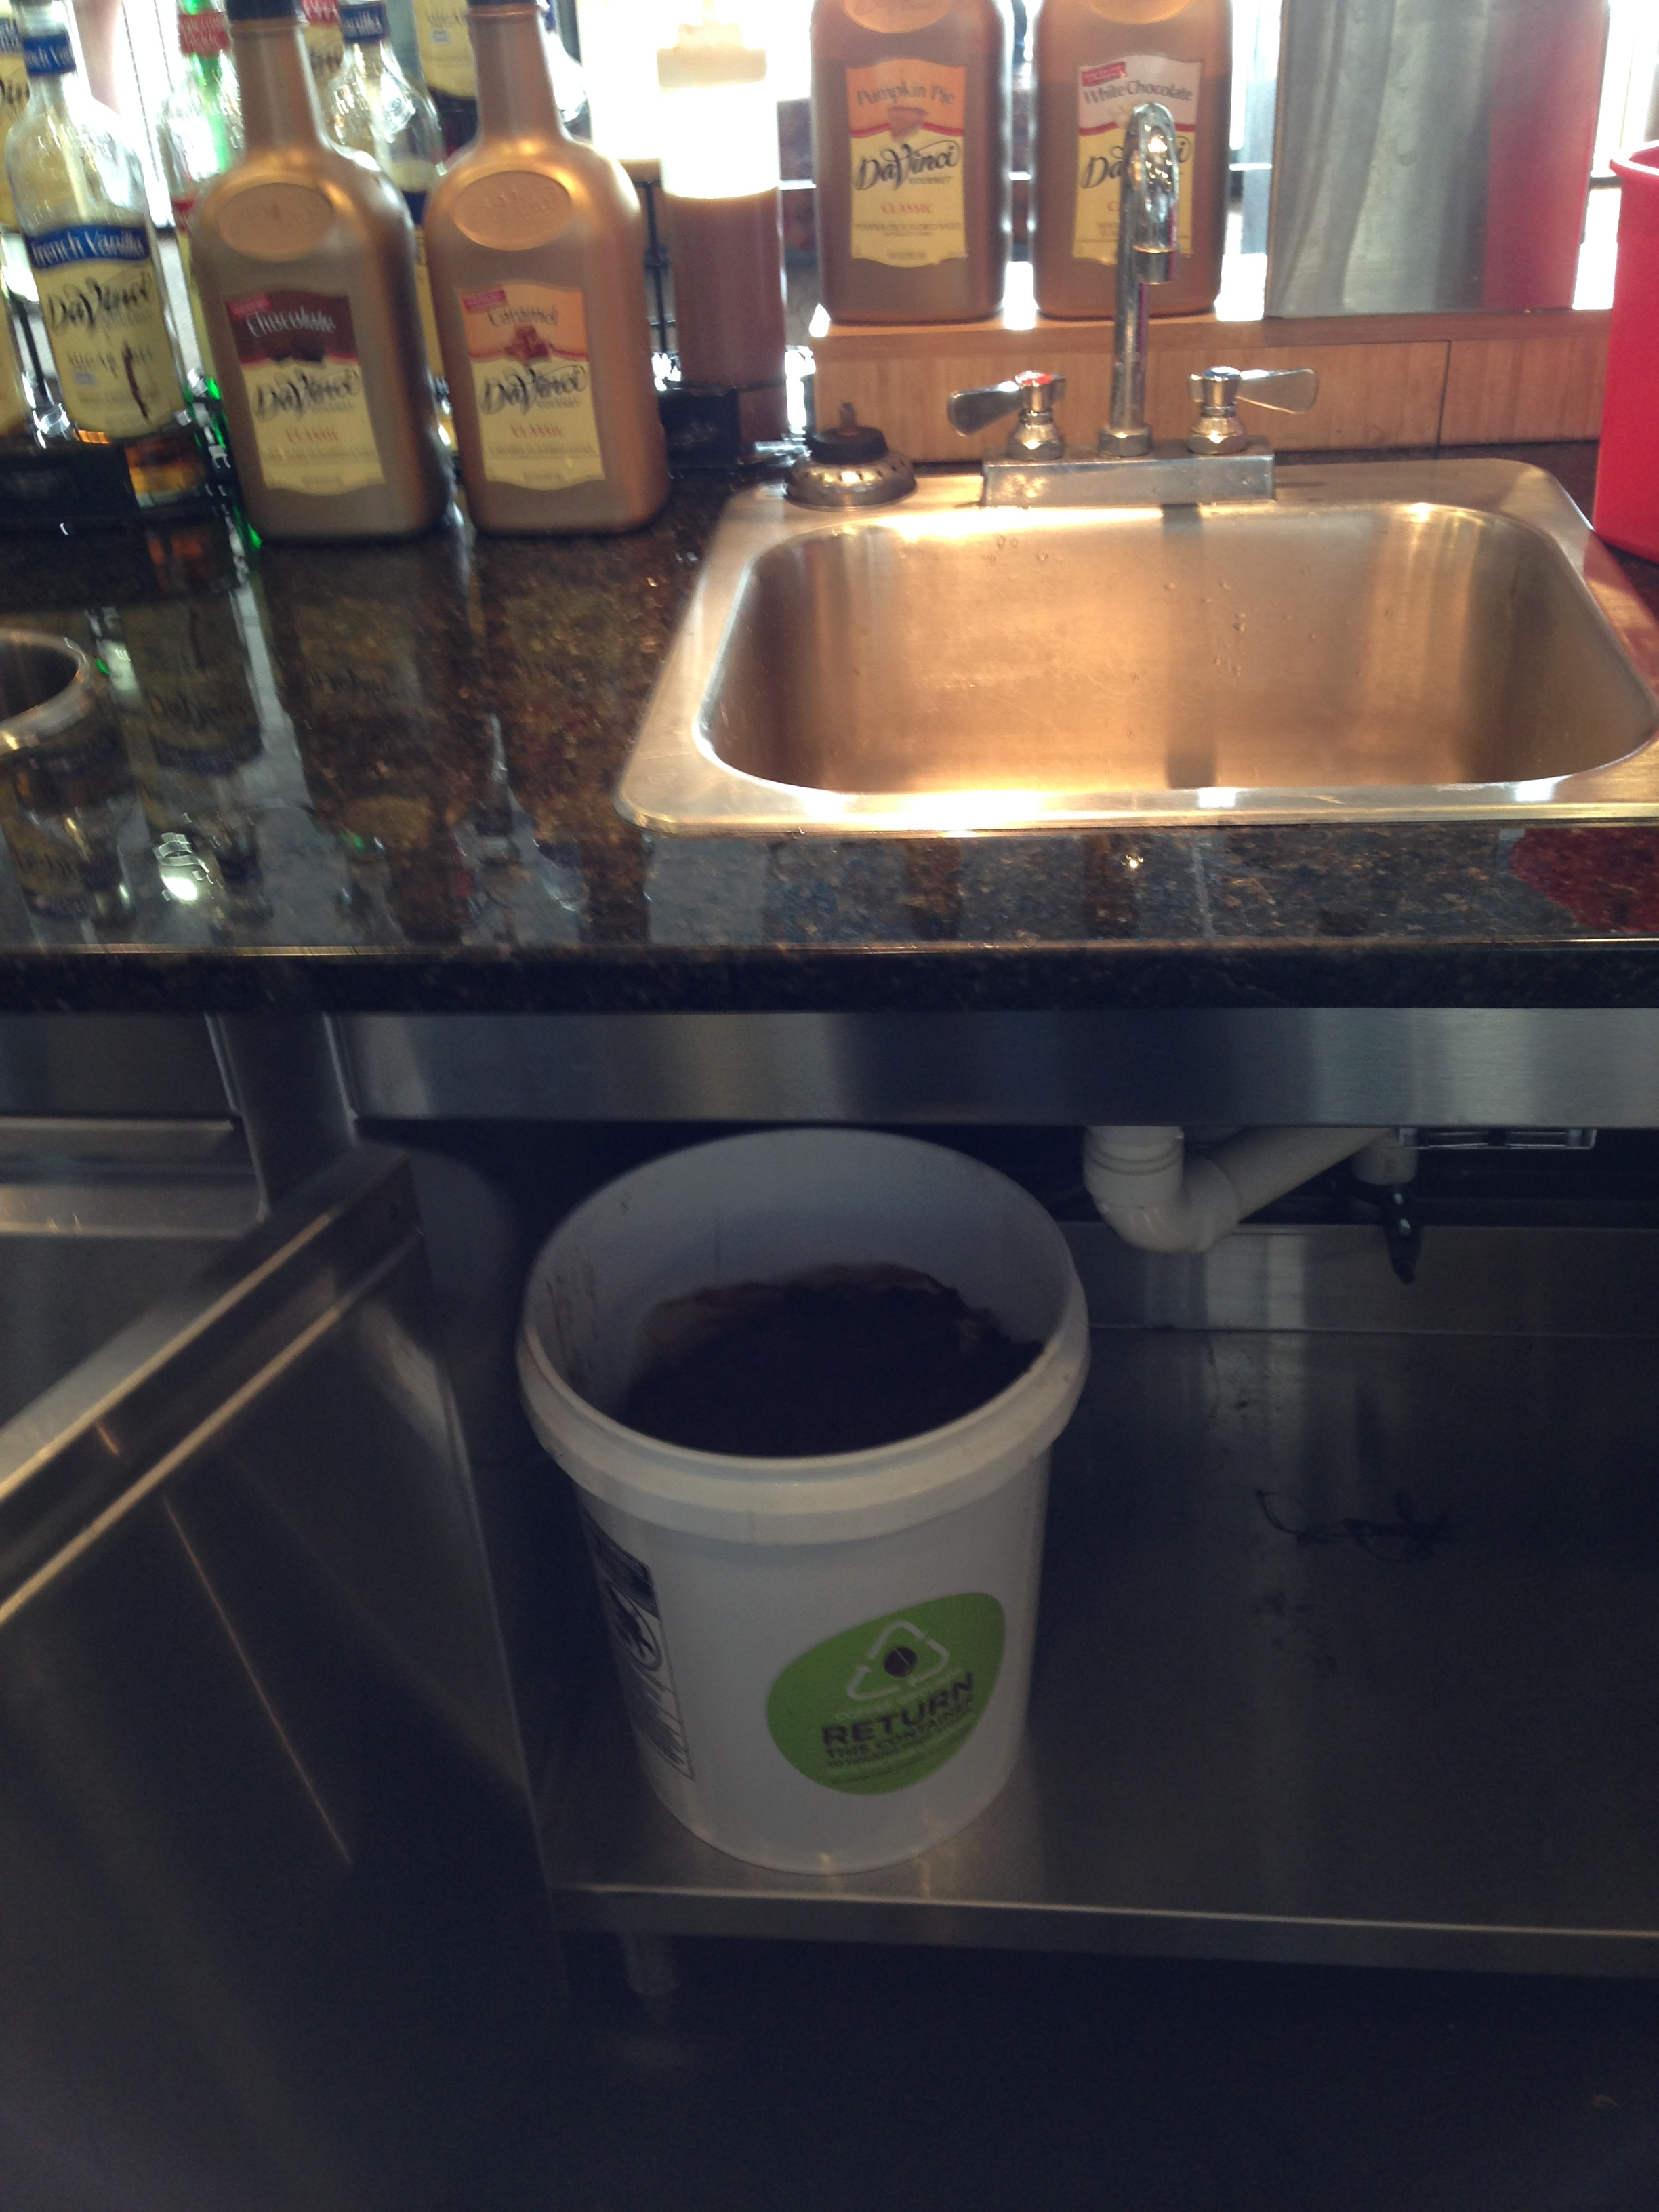
This project was implemented at the start of the fall 2014 semester. With this program, used coffee grounds from all dining and catering operations are collected and stored in five-gallon buckets for redistribution to the Sustainable Student Farm. Faculty, staff, and members of the local community may also place orders for used coffee grounds. Implementation of the project required procedural changes and the purchasing of approximately 300 five-gallon buckets. The program has been so successful that offices across campus have asked to join the program by collecting and giving us their used coffee grounds for redistribution. The Coffee Grounds program cost $2,581.75 to start up. Since the inception of this initiative, 637 five-gallon buckets have been redistributed.

Left: Label created by Housing Marketing staff to be placed on all buckets. Right: Collection point for coffee grounds.
Vermicomposting
With this project, University Housing developed a partnership with the Sustainable Student Farm to accept all pre-consumer produce scraps for their vermicomposting project. Vermicomposting releases less harmful nitrous oxide and methane gasses than its aerobic and anaerobic competitors, making it much more environmentally sustainable. As with the coffee grounds project, procedural changes were required, and existing logistical shipments were utilized to eliminate the need for additional trucks to support the project. For vermicomposting, six storage bins at a total cost of $570 were purchased to launch this project. Presently, 900 pounds a week of produce trimmings are being diverted to the vermicomposting project.

Initiative | Metric | Annualized Reduction | Associated Cost Savings
Glass Recycling | Nonhazardous solid waste – recycled (lb) | 10,909 | $122.73
Nitrile Gloves | Nonhazardous solid waste – recycled (lb) | 40,000 | $450.00
Vegetable Oil | Nonhazardous solid waste – recycled (lb) | 82,017 | $922.69
Coffee Grounds | Nonhazardous solid waste – recycled (lb) | 11,466 | $128.99
Vermicomposting | Nonhazardous solid waste – recycled (lb) | 28,800 | $324.00
Totals: |  | 173,192 | $1948.41

Education
In addition to providing services that are efficient and sustainable, the opportunity to educate 10,000 residents, 1,500 student employees, and 650 full-time staff is not overlooked. University Housing makes an effort to make sure our communities know when we are making changes for the better, and we seek to expand our influence by engaging our residents and customers in our efforts.
Vegetarian and Vegan Options
Meat as a primary energy source is the least efficient use of land and energy. As the world population continues to grow there is a need to shift to a less animal-based diet. University Housing continues to broaden the repertoire of vegan and vegetarian options. We were voted the second most vegan friendly university by PETA in 2015 and continue to develop new and exciting menu options for all students. We operate several venues that are plant centric. We have reduced the portion size on a number of the animal proteins served and always offer a vegan or vegetarian entrée choice in all dining venues.
We promote a “flexitarian” lifestyle to our diners, in which those who eat meat can choose to do so in moderation while enjoying all of the variety that a plant-based diet provides.
Sustainability Living Learning Community
Located in the Lincoln Avenue Residence Halls, the Sustainability Living-Learning community welcomes students to learn about the diverse aspects of sustainability while living among their peers.
Student Groups
University Housing supports several student groups with sustainability focuses, such as Eco-Munity and the Planeteers.
Garden Plots
This is annual garden project hosted on the grounds of the Orchard Downs Apartments. It is a combined campus and community garden area that provides space for apartment dwellers to grow their own produce.
Lending Room
This lending program allows residents to borrow and return basic household items that have been donated by the community and the apartment residents of Orchard Downs. This program helps to keep items out of the trash that could otherwise be reused by an incoming resident.
Campus Conservation Nationals
University Housing has participated in U.S. Green Building Council and Lucid’s Campus Conservations Nationals the past two years. The competition is held every spring and challenges students and staff to conserve energy over a three-week time period. This year 14 different residence halls participated, netting over 53,000 kWh saved during the competition.
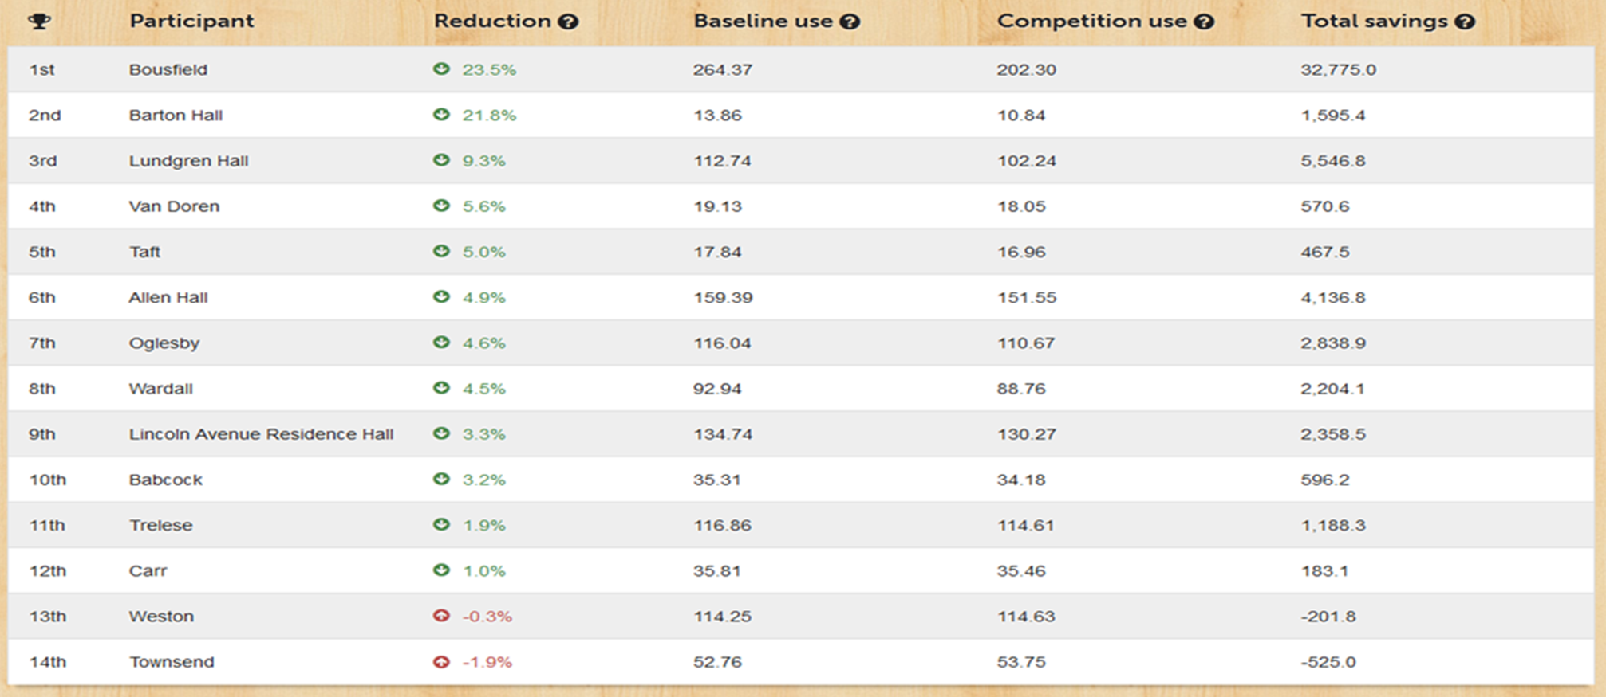

University Housing at the University of Illinois is not subject to an environmental enforcement action or notice of violation from the U.S. EPA or Illinois EPA.

