BUILDING LEVEL ENERGY CONSUMPTION REPORT

Spring 2017
Prepared by Diliya Murtazina for Morgan Johnston
ENVS 491
with the Institute for Sustainability, Energy and Environment (iSEE).

Abstract
The document has two parts. Part one discusses behavior change strategies for energy efficiency from relevant literature. Understanding consumer’s behavior is also included. Part two gives results that were achieved, as well as instructions. Appendix consist of some photos for promoting energy savings.

Main take-away points:

Behavior change strategies
1) Information must be:
- Easy to understand
- Trustable
- Presented in a way that attracts attentions and is remembered
- Delivered as closely as possible –in time and place- to the relevant choice

2) Goal-setting works through:
- Directing attention and effort toward goal-related activities
- Energizing goal pursuers, e.g. higher goals bring higher efforts
- Making the effort persistent
- Motivating individuals for using, applying, and/or learning strategies or knowledge of best accomplishment methods for their goal (indirect impact)

3) Commitment
Could be a self-pledge or a commitment to society. For example, one could make a self-pledge to reduce his or her energy consumption by 5% (personal norm activation) or could follow an announcement in a local newspaper to satisfy expectation of others; in this case social norms play a determinant role.

4) Modeling
Using an “understandable, relevant, meaningful, and rewarding (in terms of positive results)” model could motivate people to follow it.

5) Incentives / Disincentives
It is not necessary for these strategies to be in monetary form. They are mostly useful for shaping efficiency behavior in end-users. For example, giving incentives for utilizing technological innovations such as energy efficient appliances or insulation methods in households could lead to wider usage of them.
An example of nonmonetary incentives could be providing special parking places for fuel-efficient vehicles in cities in order to encourage people to choose them instead of less efficient ones.

Consequence strategies
1) Comparison
Comparing individuals or groups could evoke a sense of competition, social comparison, or social pressure; this feeling could be increased when comparison is made to an important or relevant reference group. Combining comparison with feedback could lead to a more effective strategy

2) Rewards / Penalties
Most of the studies reviewed by Abrahamse et al. (2005) show the positive effects of reward strategies on energy savings in the form of significant difference between those who were offered rewards and those who were not.

It is not necessary for the reward to be monetary; even a nominal award, e.g. an acknowledgement of positive behavior, or game-like awards such as points and levels could promote a sustainable behavior

3) Feedback
Normally, it is hard to motivate people to control their electricity usage. This is mostly because electricity is an “abstract, invisible, and untouchable” product and service. It is not an end product, but a driver for other products and services. Due to the invisibility of electricity, people have almost no direct interaction with it and receive little feedback on their consumption pattern, e.g. only from monthly bills. Eco-feedback is a way to make electricity and its consumption, costs, and environmental impact visible to users.
Overall, the links between attitudes and energy demand are often found not to be strong.

Understanding consumer behavior
1) Price and income
One of the most important factors influencing sustainable consumption is income, with wealthier households far more likely to purchase sustainable products.

2) Personal biases
Consumers may be “locked in” to unsustainable patterns of consumption by social norms or peer pressures which dictate more and higher-priced goods. However, many consumers in OECD countries are becoming environmentally and socially conscious and want to demonstrate this to their peers.

3) Age
Consumption patterns and interest in sustainable consumption differ by age groups. For example, young people between the ages of 18 and 25 tend to be very conscious of the need to reduce environmental pollution, improve human health and increase respect for human rights on a global scale.

4) Gender
Surveys show that women are more likely to be sustainable consumers, e.g. they tend to buy eco-labelled or organic food, have a higher propensity to recycle and place more value on efficient energy than men.
A UK study found that women are more concerned about climate change than men and advocate changes in life-styles and consumption behavior, whereas men favored more technological solutions for mitigating greenhouse gas emissions.

PART I

- STRATEGIES FOR PROMOTING SUSTAINABLE BEHAVIOR
• Antecedent strategies ¹

1) Information
Media campaigns, pamphlets, or informational websites are examples of this widely used strategy.

According to Froehlich et al. (2010), for increasing effectiveness of this method, provided information must have the following characteristics; otherwise, it may only have marginal effects:
• Easy to understand
• Trustable
• Presented in a way that attracts attentions and is remembered
• Delivered as closely as possible –in time and place- to the relevant choice

Studies show that providing information through workshops is more effective compared to mass media campaigns such as newspapers or television programs.

-Another important factor is eliminating unnecessary information and providing users with personalized and relevant data, e.g. by suggesting potential measures of energy saving in a specific household Page 15 after doing an energy audit of it (Geller, 1981; Hutton & McNeill, 1981; Luyben, 1982; Staats et al., 1996; Winett et al., 1982).

2) Goal-setting
This is another strategy that “operates through a comparison of the present and a desirable future situation.” It could be done by individuals, groups, or external agents. (Abrahamse, 2005; Froehlich et al., 2010).

According to Locke and Latham (2002, cited in Froehlich et al., 2010), goal-setting works by four mechanisms:
1. Directing attention and effort toward goal-related activities
2. Energizing goal pursuers, e.g. higher goals bring higher efforts
3. Making the effort persistent
4. Motivating individuals for using, applying, and/or learning strategies or knowledge of best accomplishment methods for their goal (indirect impact)

Study of Becker (1978) shows that setting a high goal, e.g. reducing 20% electricity consumption, has stronger effect and is more useful compared to a low-level goal setting, e.g.
2% reduction, which considered as not being worth the effort. This study along with study of McCalley and Midden (1998) both show that providing feedback alongside with goal setting have high potential for changing the behavior of end-users.

3) Commitment

Expression of commitment, e.g. through a pledge or a promise, increases chances of exhibiting persistent behavior. Commitment could be accompanied by a goal and it could be a self-pledge or a commitment to society. For example, one could make a self-pledge to reduce his or her energy consumption by five percent (personal norm activation) or could follow an announcement in a local newspaper to satisfy expectation of others; in this case social norms play a determinant role (Abrahamse et al., 2005; Gonzales et al., 1988, cited in Froehlich et al., 2010).

The studies by Katzev and Johnson (1983) and Pallak and Cummings (1976) show that using a public and group commitment with a follow-up period strategy could bring about conservative behavior in case of electricity and gas consumption.

4) Modeling

This strategy deals with providing examples of behavior that could be used as a model for others. Using an “understandable, relevant, meaningful, and rewarding (in terms of positive results)” model could motivate people to follow it. A study by Winett et al. (1985) focused on modeling by teaching measures for energy saving through a television program targeted at middle-class homeowners. The result was 10% reduction of electricity use compared to a control group that acted as baseline (cited in Abrahamse, 2005).

5) Incentives / Disincentives

These could be used as a type of antecedent strategy, because they occur before performance of a given behavior; incentives or disincentives are used to motivate or discourage a person or group to perform an action.

It is not necessary for these strategies to be in monetary form. They are mostly useful for shaping efficiency behavior in end-users. For example, giving incentives for utilizing technological innovations such as energy efficient appliances or insulation methods in households could lead to wider usage of them.

An example of nonmonetary incentives could be providing special parking places for fuel-efficient vehicles in cities in order to encourage people to choose them instead of less efficient ones (Froehlich et al., 2010; Stern, 1999).

• Consequence strategies

1) Comparison

Comparing individuals or groups or even self-comparison of a person (e.g. with one’s previous behavior) could be an effective plan in encouraging pro-environmental behavior. Comparing individuals or groups could evoke a sense of competition, social comparison, or social pressure; this feeling could be increased when comparison is made to an important or relevant reference group. Combining comparison with feedback could lead to a more effective strategy (Abrahamse, 2005; Froehlich et al., 2010).

2) Rewards / Penalties

This is another method for motivating responsible behavior. It must be noted that there is a difference between strategies of rewards and penalties and strategies based on incentives and disincentives. As mentioned before, strategies of providing incentives and disincentives are among antecedent strategies, but rewards and penalties are consequence motivating techniques that appear after a behavior. They are mostly useful for shaping curtailment behaviors. (Froehlich et al., 2010; Gardner & Stern, 1996)

Most of the studies reviewed by Abrahamse et al. (2005) show the positive effects of reward strategies on energy savings in the form of significant difference between those who were offered rewards and those who were not.

It is not necessary for the reward to be monetary; even a nominal award, e.g. an acknowledgement of positive behavior, or game-like awards such as points and levels could promote a sustainable behavior (Froehlich et al., 2010).

3) Feedback

It is well established in psychology that providing feedback has positive effects on performance. It could be in the form of low-level feedback or high-level feedback. Low-level feedback provides explicit detail regarding the impact of a behavior while high-level feedback gives general positive or negative comments on a behavior (Froehlich et al., 2010).

Normally, most people are unaware of how they are affecting environment by their daily behaviors such as driving to work or showering. Providing this information to individuals may bridge this “environmental literacy gap”. (Froehlich et al., 2010) According to McCalley and Midden (1998), “it is possible to generate responsible conservation behavior using eco-feedback”.

Eco-feedback is a strategy to engage people in “environmentally responsible behavior”. When people have a measure to relate certain outcomes such as energy savings with their own behavior, they become more motivated and this could be done by utilizing feedback, especially when it is provided immediately after an action (Abrahamse, 2005; Fischer, 2008; Geller, 2002).

Based on studies reviewed by Abrahamse (2005) and Fischer (2008), three important characteristics are recognizable for designing constructive feedback:

• Frequency: it could be continuous, e.g. real-time and constant representation of data, or discontinuous, e.g. provision of data in form of monthly or annually reports.

• Contents: it must be understandable and interesting for users, e.g. giving information regarding costs or amounts of customers’ energy consumption.

• Scaling: it could be comparative, e.g. comparing performance of individuals or groups to others or their own-self (for example comparing with previous performance), or non-comparative, e.g. only representing the current performance

In the case of energy usage, especially electricity, providing a well-designed eco-feedback system could lead to reduction in end-user consumption.

Normally, it is hard to motivate people to control their electricity usage. This is mostly because electricity is an “abstract, invisible, and untouchable” product and service. It is not an end product, but a driver for other products and services. Due to the invisibility of electricity, people have almost no direct interaction with it and receive little feedback on their consumption pattern, e.g. only from monthly bills. Eco-feedback is a way to make electricity and its consumption, costs, and environmental impact visible to users.

Designing of eco-feedback is very important for achieving good performance and results on energy consumption. Fischer (2008) suggests that a successful feedback approach for electricity usage usually has following characteristics:

• “it is given frequently and over a long time;
• provide an appliance-specific breakdown;
• is presented in a clear and appealing way;
• and uses computerized and interactive tools.”

Direct and indirect feedback (bills) from energy suppliers has been, so far, the most successful
in changing consumer behavior and achieve energy savings.
The report suggests that policy makers seem focused more on the instrument itself than on the behavior and consumption practice that needs to be affected.

Today’s utility customer only spends about 9 minutes thinking about their energy consumption each year, so utilities are challenged to make every moment of customer contact matter.

The literature on the so-called “rebound effect” holds that efficiency improvements can paradoxically lead to higher energy use. According to an often used example, if someone invests in more efficient air-conditioning, he keeps his energy bill constant by adjusting the thermostat on the new device.

Overall, the links between attitudes and energy demand are often found not to be strong. Yet, recent studies of the California energy crisis are shedding new light on the role of attitudes as we shall see below. Insofar as the impact of demographic variables on energy consumption can be detached from income influence, empirics suggest that energy consumption varies over the life cycle, between ethnic groups (Poyer et al., 1997) and cultural practices.

Some studies suggest that attitudinal variables are important for deliberate behavior (intentoriented), while socio-economic variables are more important for understanding impact-oriented use of, say, energy. For example, there are studies showing that household energy use is mostly explained by socio-economic, rather than attitudinal, variables. But it is not difficult at all to find exceptions. For example, Carlsson-Kanyama et al. (2003) found, in their analysis of 600 Swedish households, that environmental attitudes and attitudes to energy are important for the use of appliances in households.

Sjöberg and Engelberg (2005) argue, from a psychological research angle, that “Research on energy consumption and conservation shows that attitudes are rarely much affected by campaigns, that attitudes have moderate predictive value, and that behavior is frequently not in line with expressed attitudes.” Furthermore, they also claim that the largest share of the variance of energy consumption can be explained by differences in social habits. In a similar vein, Viklund (2002) concludes his review of the literature with “[there is] no room for psychological factors to explain energy savings behavior”.

Finally, Aune et al. (2002) summarize earlier research (from a socio-technic point of view) on household energy demand by claiming that “Among the results that still hold interest from this period [1973 to 1990], is that information campaigns are less effective than expected, that the link between attitudes and behavior concerning energy is weak...”

2. UNDERSTANDING CONSUMER BEHAVIOUR

Promoting sustainable consumption requires improved understanding of consumer behavior and attitudes. Consumers have different needs with respect to information and their potential to be influenced by instruments and tools varies. Most consumers have a positive but passive view of sustainable consumption. Policy tools and instruments may need to be targeted to different types of households, individuals or groups. Many variables should be taken into account, including income, age, biases, attitudes and gender. To this end, the OECD Environment Policy Committee (EPOC) is conducting a multi-country survey on household behavior and five environmental policy areas: waste generation and recycling, energy use, personal transport choices, food consumption, and water use (OECD, 2008).

- Price and income

If the marketing mix and price of products are within the expected norms of the relevant market, then attributes like sustainability will become attractive to the consumer. For sustainable products such as organic food, dolphin-friendly tuna and Fairtrade coffee which often have a price premium, the price differential has to be within the norm.

Performance and quality are equally important. For example, there has not been a large market for energy-efficient lighting, because consumers perceive these as poorer in design and performance than cheaper tungsten bulbs.

Consumer surveys have tried to isolate the factors influencing purchasing behavior, such as price, quality, and sustainability. These find that, for example, in the United Kingdom, only 5% of the public places ethical or social considerations above all others in purchasing decisions; most food shoppers base their decisions on price, taste and sell-by-date. German consumers rank quality first, then price, followed by look and design, brand, and environmental-friendliness. In the United States, consumers preferred wood with the certification label of the Forest Stewardship Council (FSC) as long as it was the same price as unlabelled plywood (OECD, 2007a).

One of the most important factors influencing sustainable consumption is income, with wealthier households far more likely to purchase sustainable products.

- Personal biases

For example, some consumers may have biases against items manufactured from recycled materials because of concerns about reliability and performance. The word “waste” has a negative connotation and may lead consumers to associate terms such as wastepaper or waste oils with risky or inferior products. There may be fears that recycled paper will jam printers and photocopiers, or that re-refined oils will damage their vehicle engines, even when equivalent in quality and lower in price.

Consumption is also a way of expressing status and identity, causing consumers to be very conscious of how their purchases look to others. Consumers may be “locked in” to unsustainable patterns of consumption by social norms or peer pressures which dictate more and higher-priced goods. However, many consumers in OECD countries are becoming environmentally and socially conscious and want to demonstrate this to their peers.

- Age

Consumption patterns and interest in sustainable consumption differ by age groups. For example, young people between the ages of 18 and 25 tend to be very conscious of the need to reduce environmental pollution, improve human health and increase respect for human rights on a global scale. They believe their generation is consuming too much and want more information on how to reduce the negative ecological and social impacts of their consumption, on which they would likely act (UNEP/UNESCO, 2001)

- Gender

Surveys show that women are more likely to be sustainable consumers, e.g. they tend to buy eco-labelled or organic food, have a higher propensity to recycle and place more value on efficient energy than men (OECD, 2008). They also pay closer attention in their purchases to ethical issues such as child labor and fair trade.

A UK study found that women are more concerned about climate change than men and advocate changes in life-styles and consumption behavior, whereas men favored more technological solutions for mitigating greenhouse gas emissions (WEN, 2007).

3. FOUR METHODS FOR: ATTRACTING ATTENTION
Have you considered that the average person might not find the number of watts saved by a CFL quite as intriguing as you do? A great deal of environmental messaging doesn’t work because it is boring or inaccessible. You need to engage your audience by creating ideas that are attention grabbing and memorable: ideas that are sticky
1) SURPRISE them
Have you considered that the average person might not find the number of watts saved by a CFL quite as intriguing as you do? A great deal of environmental messaging doesn’t work because it is boring or inaccessible. You need to engage your audience by creating ideas that are attention grabbing and memorable: ideas that are sticky
- Talking trash Litter bins which say thank you have been introduced in several European cities including Helsinki and Berlin. The solar panelled trash cans are designed to keep the streets cleaner. They work by breaking schemas: people do not expect rubbish bins to talk, so get a surprise, and this makes them pay more attention to waste disposal. This could easily be applied to recycling bins.

A second way we can use the unexpected is through mystery. By building up curiosity before revealing interesting information, we can not only get attention, but keep it.
2) Paint a PICTURE
Images are easier to understand and more memorable, so focus on impacts that are easy to visualise.
Or actually use images.
In California State University-Northridge, recycling bins were equipped either with signs saying ‘No Trash, Please, Only Recyclables’, or with an image of the President recycling. You can guess which was more effective.
3) Get EMOTIONAL
Psychologists suggest that we all have a rational side and an emotional side If we only target the rational side, there will be no motivation for change. Emotional cues are more likely to illicit action. Emotional triggers vary from person to person, but as a general rule focus on environmental impacts for people and animals, and use case studies: people have more empathy for the story of one suffering child than statistics about 10,000 suffering children. The personal testimony of an island-dweller affected by flooding will be much more effective than projections of 21st century sea level rise.
WARNING: Don’t rely on FEAR... People have a finite pool of worry: they can only handle so much bad news at a time. More immediate concerns about unemployment are likely to replace long term fears of biodiversity loss, so your message will not be remembered on the basis of fear alone. What’s more, fear could actually cause inertia. Individuals respond to threats using problem-focused coping (taking action) or emotion-focused coping (denial/apathy)20. To avoid the latter, people need to feel that they have control.
So:
4) Tell a STORY
Simulation
Stories allow us to play along. This is more than visualisation: we cannot imagine events without evoking the same modules of our brains which are evoked for real events. If we imagine a flashing light, we activate the visual part of our brain. So stories help us to learn. They are the next best thing to practicing21. Tell people a story about cycling to work: the fresh air filling your lungs, the wind brushing your face. Tell them a story about the great bargains you found on a second-hand shopping trip. Tell them how it felt to take part in a climate change rally.

4. NINE STRATEGIES FOR: CHANGING BEHAVIOR

1)Association
2)Reciprocation
3)Scarcity
4)Situational Change
5)Haggling
6)Commitment
7)Prompts
8)Feedback
9)Modeling

Know the audience:

5. CAN FUN THEORY CHANGE THE WAY WE TACKLE ENERGY USE?

Whether it’s common sense or just plain instinct, we are more likely to do something if we consider it fun: this risk/reward strategy is the stimulus we need to do things we’d sooner rather avoid. Can it be applied to anything though? It certainly seems doubtful, but maybe not quite as unrealistic as you might think.

Most adverts we see, for example, focus on attitude change when, really, the stimulus we’re conditioned to respond better to is behavioral change. In other words, tell someone they should recycle and they’ll agree with you, intend to recycle, and then forget. This is because remembering attitudinal change requires effort and thought. However, when that same person has the means to recycle at the point of decision-making, instant behavioral change happens. And it feels good too.

Or would you be more likely to recycle those bottles if the bottle bank was actually an arcade machine?

The theory behind gamification isn’t new – we’ve all been playing into marketers’ intentions for decades; from collecting loyalty cards to accepting that free gift from Netflix – we’re hardwired to enjoy game-based incentives. But now that the practice (and the term) has broken into the mainstream, it has become a serious tool in the mechanics of changing our behavior towards greener energy and other forces for good too.

PART II
Introduction
The report is about behavior change messaging, which lets the occupants of each building see their consumption changes over time and it will motivate them to conserve energy. The goal of the report is to display “past-current-new” patterns of energy conservation change. The result will be a paper with recommendations how to motivate people to be more sustainable.

The data for FY08-FY2016 was used. The scope of the project are 175 buildings at the UIUC campus. Then the pilot project was about the Lincoln Hall. After Lincoln Hall, the work was started with the Soybean National Laboratory and Illini Union.

Instructions
1) Annual Energy Report from University of Pennsylvania (Facilities and Real Estate services) was used as an example, which was given by Dr. Yi, who shared with ECBS SWATeam his campus level building performance research on energy usage modeling. Dr. Yi used BPAT+ Building Performance Assessment Toolkit in his research to calculate total energy consumption of the campus. He identified types of research buildings-labs, offices and education buildings. He also mentioned that the problem was with converting units of energy in various buildings. He identified two main issues for the research-validating the data for the buildings and reporting (what energy type we are using).

2) Using the model for University of Pennsylvania, the same graph was created for UIUC campus.

Information for consumption of electricity, steam and chilled water of Lincoln Hall (July 2015-June 2016) were used.

Electricity consumption was converted from kWh to kBtu, by multiplying kWh by 3.412.

Chilled Water Consumption was converted from MBTU to kBtu, by multiplying MBTU by 1000.

Steam consumption was converted from klbs to kBtu, by multiplying klbs by 1,194.

Gas consumption was converted from THR to kBtu, by multiplying THR by 12.

Target is best 30% of normal range.

Annual energy consumption at UIUC

Here we can see annual consumption in kBtu of gas, steam, chilled water at UIUC campus from 2008 until 2016. Target is best 30% of normal range.

3)179 buildings were analyzed in 2008, 2010, 2011. Since the information for buildings did not match in different years, all buildings were lined up manually in Excel document.

After that, a table was created for these 3 years with total energy consumption (MMBTU).

Graph for 179 buildings (lined up)

Here we can see lined up first 179 buildings at UIUC the with total MMBTU in 2008, 2010, 2011.

4) The pilot building is Lincoln Hall
Notable Energy Events:
- FY09 T-12 to T-8 Lighting Retrofit
- FY11-12 LEED Platinum Renovation
- FY14 Retrocommissioning
- FY15 ECIP winner
- FY16 Illini Lights Out pilot

Electricity, Steam and Chilled water consumption of Lincoln Hall (July 2015-June 2016) were used.

Electricity consumption was converted from kWh to MMBTU, by multiplying kWh by 0.0034;

Steam consumption was converted from klbs to MMBTU, by multiplying klbs by 1.03.

Lincoln Hall, energy consumption from July 2015-June 2016

Here we can see the energy consumption of electricity, steam and chilled water, converted to MMBTU from July 2015 to June 2016.

Then, to get Energy Use Intensity (EUI), MMBTU were converted to kBtu/sf.

First, MMBTU were converted to BTU, by multiplying number to 1,000,000.

FY 2008-2016 Energy Consumption Report was used to get number of MMBTU per each buildings.

The hard-copy message may look like this:
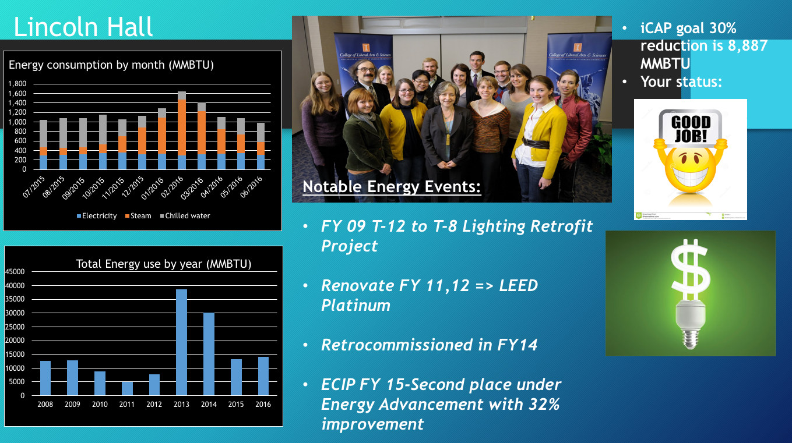

Then, using the information for energy consumption, the 2 graphs were created: total energy use by year and EUI by year:

It is important to note that from 2008 to 2012, gross square footage was 171,121 sf, and at 2013 it became 175,848 sf.

Lincoln Hall, total energy use be year

Here we can see the total energy use by year from 2008 to 2016 in MMBTU at Lincoln Hall. 2013 is a new baseline.
Calculate the specific iCAP goal for this building.

iCAP Objective Status:
- FY20 reduce consumption from FY08 baseline by 30%
- FY08 actual = 12,695 MMBTU
- FY20 goal = 8,887 MMBTU
- FY16 actual = 14,066 MMBTU
- Change from FY08 to FY16 = INCREASED by 10.8%
- FY08, FY20, and FY16 for EUI:
- FY08 actual EUI = 74,187 BTU/GSF
- FY16 actual EUI = 79,990 BTU/GSF
- Change from FY08 to FY16 = INCREASED by 7.8%
- FY20 goal in EUI = 51,931 BTU/GSF = 9,132 MMBTU

EUI by year (BTU/GSF) in Lincoln Hall

Here we can see the difference of EUI by year in BTU/GSF from 2008 until 2016 in Lincoln Hall

5) After Lincoln Hall, the work started with the Soybean National Laboratory and Illini Union

EUI of 4 buildings-started

Here we can see the slight difference in total energy use by year in MMBTU at Soybean National Laboratory from 2008 until 2016

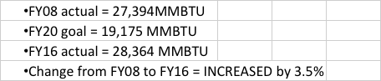

Here we can see the difference of EUI by year in BTU/GSF from 2008 until 2016 at Soybean National Laboratory

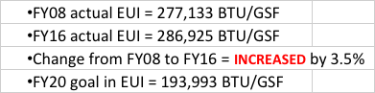

ILLINI UNION

EUI of 4 buildings-started

Here we can see the difference in total energy use by year in MMBTU at Illini Union from 2008 until 2016

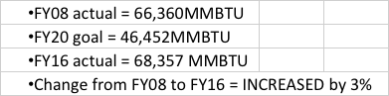

Here we can see the difference of EUI by year in BTU/GSF from 2008 until 2016 at Illini Union

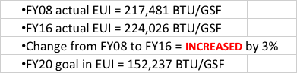

In the iCAP 2015, there is goal of 30% reduction of energy consumption from a baseline year. Current baseline year is 2008 for most buildings, but Lincoln Hall’s square footage was expanded by the major renovation in 2010. Using EUI seems like a better and more fair metric rather than total energy consumption.
“Gross square footage”- is occupied space total. The goal is comparing changes in one building over time, not comparing buildings to each other.
It was suggested to set the baseline after the last renovation of the building, not 2008 year. Lincoln Hall is LEED Certified now and is operating very efficiently. Further reductions in the energy usage of Lincoln Hall, for example, will mostly have to come from occupant behavior.
Using the post-renovation year as the baseline for Lincoln Hall, the new baseline MMBTU is 38,571 in FY13. The 30% reduction goal of 11,571 (0.3*38,571) has been met as of FY15.

APPENDIX

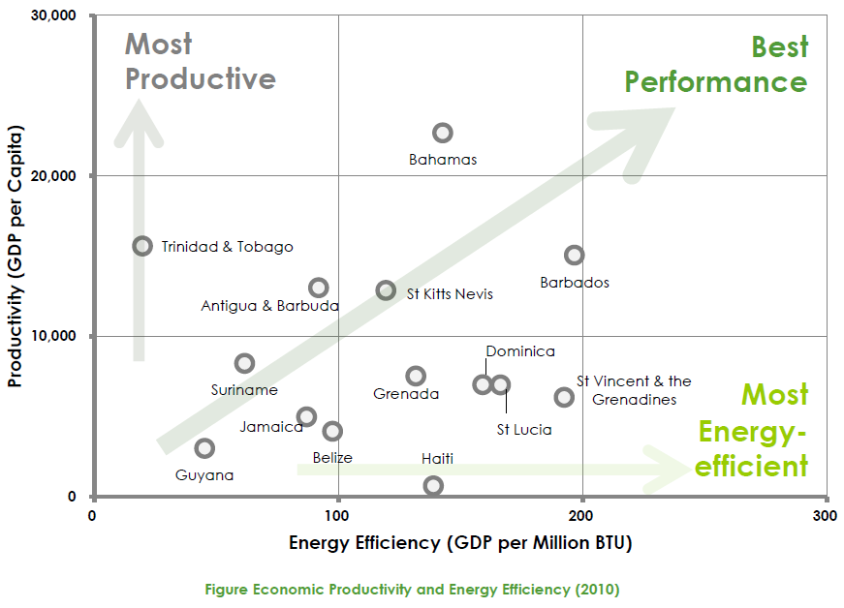
Source : http://caribbeancic.org/energy-efficiency
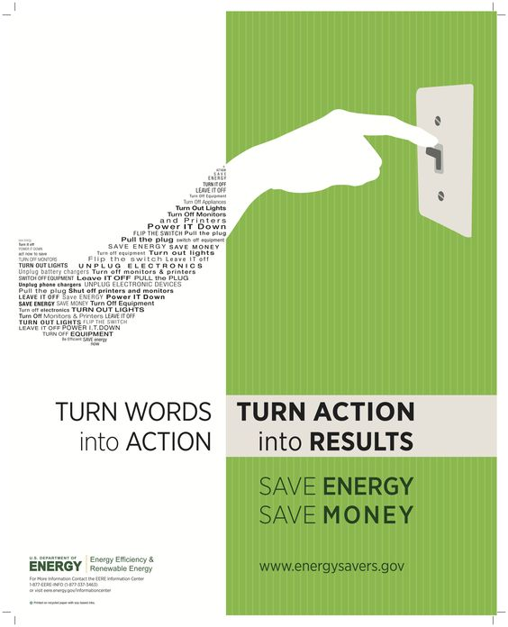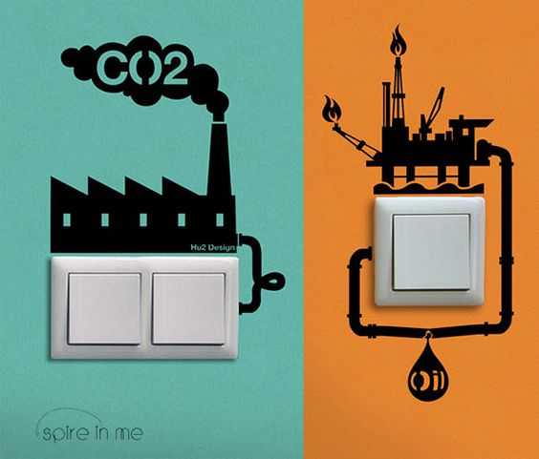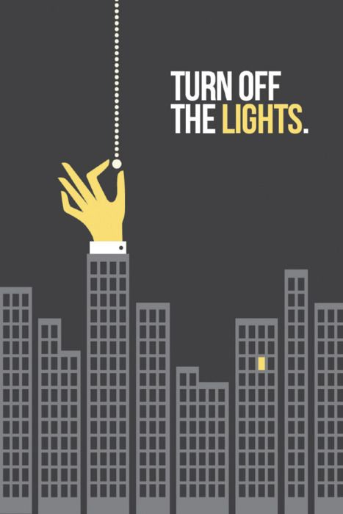

Strategies for promoting sustainable behavior regarding electricity consumption http://www.diva-portal.se/smash/get/diva2:474598/FULLTEXT01.pdf
https://www.oecd.org/environment/consumption-innovation/42183878.pdf
OECD (2008), Environmental Policy and Household Behaviour: Evidence in the Areas of Energy, Food, Transport, Waste and Water
http://www.oecd.org/greengrowth/40317373.pdf
http://sustainability.berkeley.edu/sites/default/files/Promoting_Sustain_Behavior_Primer.pdf
http://edition.cnn.com/2005/TECH/09/27/spark.rubbish/index.html
http://www.energysavingtrust.org.uk/blog/can-fun-theory-change-way-we-tackle-energy-use

