2015

Allerton Park and Retreat Center Allerton Park Bike Share
Project Summary

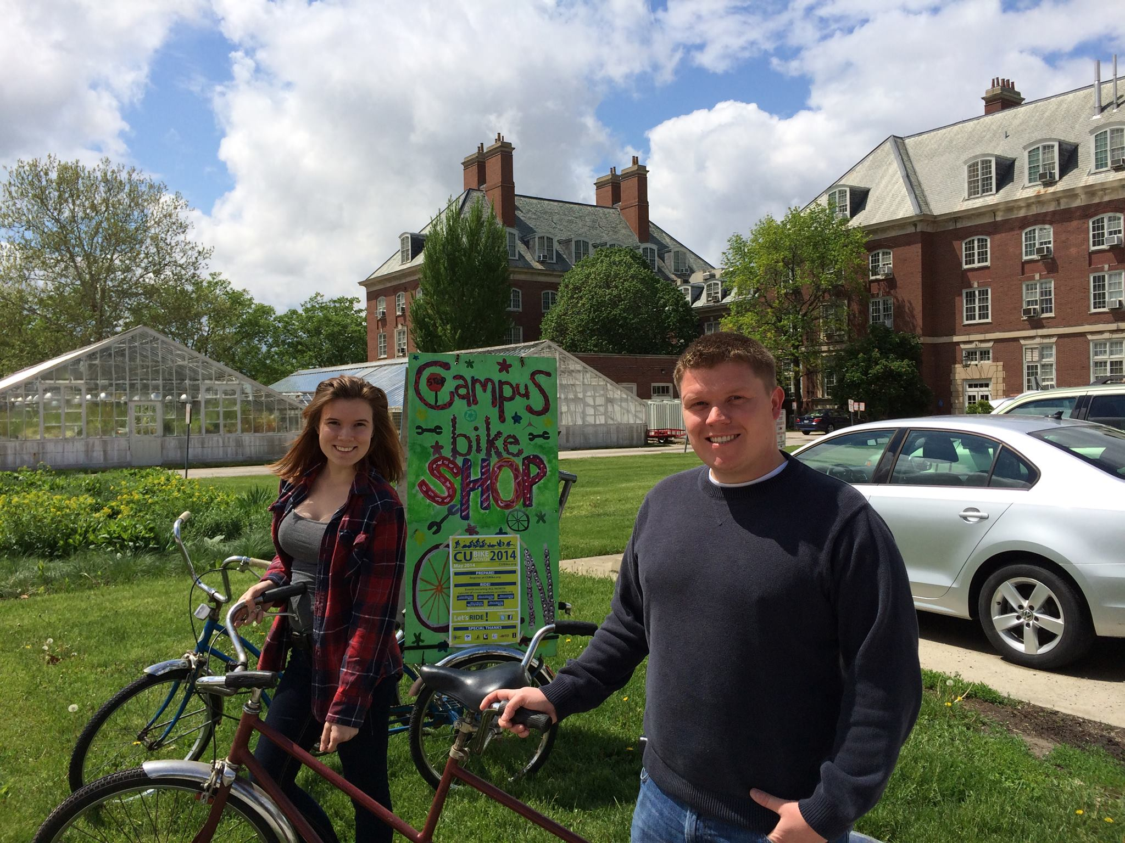
Project Completion Report to the Student Sustainability Committee

2

Project Purpose
The intent of the project is to improve on community property by the installation of a bike share-type system at Allerton Park. Allerton Park is a University of Illinois-owned property that is currently being under-utilized by the student body and community alike. The goal of the project is to increase the value of Allerton Park and generate a larger visitor base including more student involvement at the park. The project will also promote the use of "green" transportation in traveling around the 1,517 acre estate. The desired outcome of this project is to provide Allerton Park with bikes and to set in place a bike rental program that can be used and maintained on the park grounds.

The ‘Allerton Park Bike Share is a continuation of the Park’s efforts to address its stated mission:
- To develop programs for research and education that focus on a comprehensive understanding of nature, landscape and sustainable systems.
- To employ balanced, integrated management techniques that preserve Allerton’s natural and cultural reserves.
- To be good stewards of a natural setting where visitors gain a better understanding of their relationship to nature.

Project Summary
The intent of the project is to improve on community property by the installation of a bike share-type system at Allerton Park. Allerton Park is a University of Illinois-owned property that is currently being under-utilized by the student body and community alike. The goal of the project is to increase the value of Allerton Park and generate a larger visitor base including more student involvement at the park. The project will also promote the use of "green" transportation in traveling around the 1,517 acre estate. The desired outcome of this project is to provide Allerton Park with bikes and to set in place a bike rental program that can be used and maintained on the park grounds.
Resources saved
We are currently monitoring resource, energy, and monetary savings. While this is harder to measure it’s more important to measure the educational and cultural impact this has on our area. By introducing the idea of biking in and around Allerton, the University of Illinois is better serving the surrounding rural communities. We are also looking at how this positively impacts the Allerton Park Climate Action Plan goals.

Budget-
To complete this project the Student Sustainability Committee in the generous amount of $5,000 contributed funding assistance,
Provider | Service | Cost
Champaign Cycle
 | Electra Townie 3i LA Bikes (4) | $ 2199.96
 | Trek T 900 Tandem Bike | $ 1099.99
 | Guard Cables (5) Bells (4) Kickstands (4) Helmets (5) | $ 684.66
 | Trek Care Plus 3 Year Program- $119*4 and $149 * 1 | $ 624.00
 |  | $ 4609.61
Amazon.com
 | Bike Multi Tool/Air Compressor | $ 93.39
Global Industrial
 | Galvanized 5-bike grid racks (2) | $ 297.00
Total |  | $ $5,000
Figure 2: Project Budget Breakdown

Statistics on Student Outreach-
This project was done in partnership with the university’s Learning IN Community class, allowing 19 students to participate in planning and purchasing, but also long term visioning for the bike program at Allerton. We also have been able to offer this opportunity to University of Illinois groups and students when they visit Allerton.

Acknowledgement
Signage recognizing the SSC as a funding partner in this project is available in the bike baskets. We will also be printing signage to be displayed on the bike racks throughout the Park thanking both LINC and the SSC

Special Thanks
Special thanks to the Students for Sustainability Committee for their willingness to be a funding partner with Allerton Park and the Friends of Allerton in the development and installation of this project. Both the SSC and Allerton Park are committed to developing a more sustainable campus and its operations.

