Nathan A. Deppe, Plant Care Facility Coordinator
Office of Research, College of ACES
May 29, 2013
ndeppe@illinois.edu
Energy Shade Curtains-Phase II

Summary/Overview of the Project

The Plant Care Facility is comprised of two greenhouse complexes (Turner Hall and Plant Sciences Laboratory Greenhouses) with 110 specialized rooms for maintaining a diverse array of plants for research and classroom purposes.
The newest complex, the Plant Sciences Laboratory Greenhouse, is the flagship of our operation and contains 65 rooms of which are used to house plants dedicated for more specialized research projects. Curtains were determined a good fit in order to mitigate excessive heat use/loss, minimize cooling and electrical consumption, and to provide optimal levels of natural light to improve research plant material in this complex.
These important factors helped to justify a funding request to the Student Sustainability Committee in 2010. The SSC accepted the proposal and awarded a zero percent interest loan to install 9 curtain systems at PSL. In addition, the SSC was quite interested in determining true savings incurred by deploying curtains. A $5,000 grant was given to procure, acquire, and install utility meters designed to track usage in rooms with and without these systems.
In September 2011, a small scaled experiment was initiated that recorded usage of electricity, hot water (heat), and non-potable water (cooling) for two identical rooms with similar environmental settings: one room employed a curtain system while the other room relied solely on whitewash. Cooling water consumption was reduced by 28.8% while electricity usage was lessened by 32.3% in the room with curtains. During cold months, the curtains would automatically close at night when outside temperatures dropped below 60 degrees (F). This helped trap warm air close to plant canopy and reduced heat loss thru the single-paned glass glazing. The room with curtains used 50% less heat to warm than the room with no curtains, and during night, heat usage was reduced by an average of 75%.
The determination of real-time savings helped bolster our second proposal to the SSC for funding the second phase of curtain installation.
The SSC funded Energy Shade Curtains-Phase II in 2012 in order to continue installation of energy shade curtains at PSL. Twelve curtains were installed with awarded grant funds in early-2013, and their benefits are currently being provided thru optimal shading and cooling offered during warm months.

Project Execution/Deployment

The International Greenhouse Company’s (Danville, Illinois) bid for work was accepted on January 8th, 2013. IGC sub-contracted work to the Total Energy Group (Kalamazoo, Michigan) and work commenced on February 9th.
Notable obstacles for installation were plants, benches, and irrigation systems. Two rooms were released to contractor at one time, which allow us to minimize obstacles in rooms ahead of work. This made work less intensive and stressful for contracted employees as well as the PCF staff.
All electrical components were installed by Facilities and Services in order to ensure the systems would interact with our ARGUS environmental greenhouse program. Additionally, ARGUS programmed rooms in order to deploy these systems as needed. Electrical and programming work was completed by April 5th, 2013.
Curtain installation was completed on April 5th, 2013.

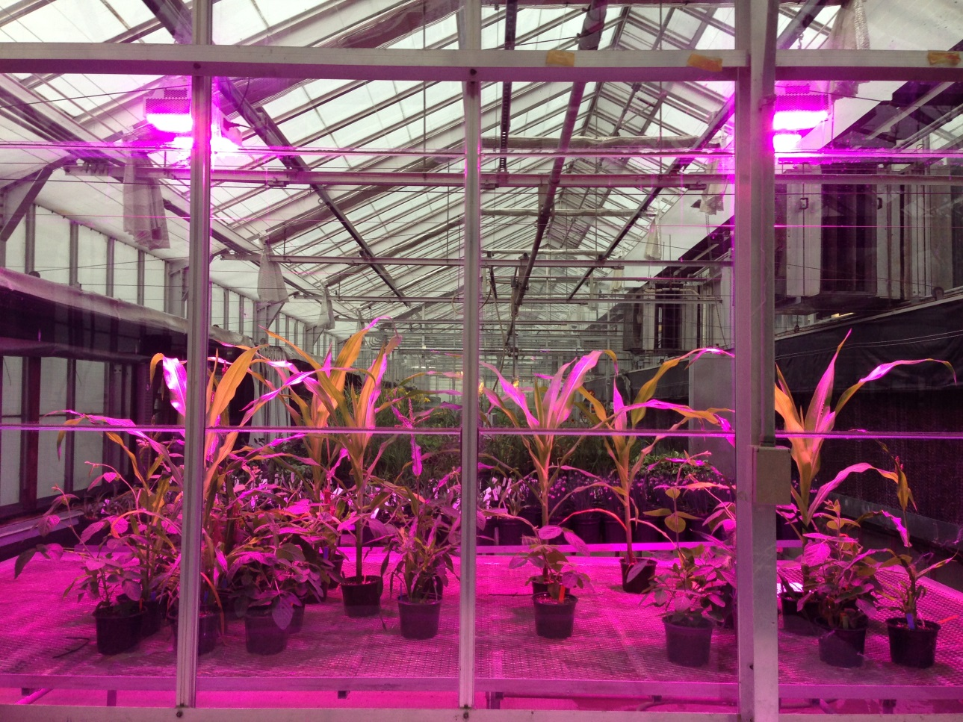

Various agronomic crops under LED fixtures in an energy shade curtain room at PSL

Project Costs/Timeline

PROJECT COSTS
Expenses Installer
$93,708 International Greenhouse Company
$14,404.62 Facilities and Services
$1,400 Argus Control Systems
$109,512.62 TOTAL EXPENSES

TIMELINE (Installation of Curtain Systems)
Installer Start Date End Date
International Greenhouse Company February 9th, 2013 April 5th, 2013
Facilities and Services (electrical) February 4th, 2013 April 5th, 2013

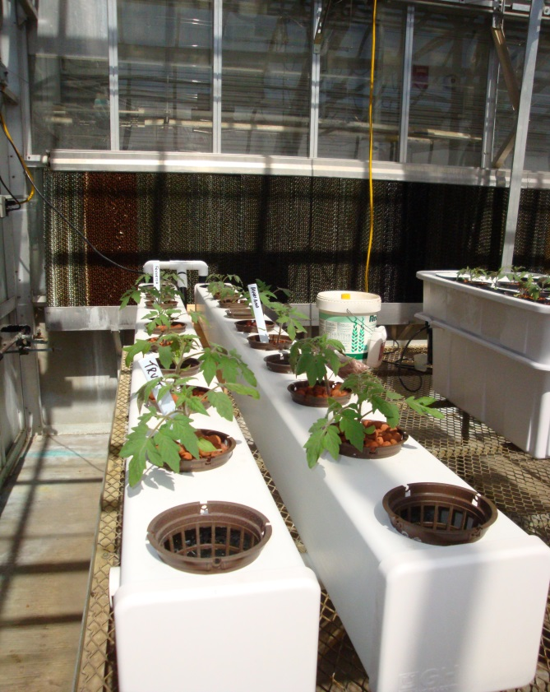
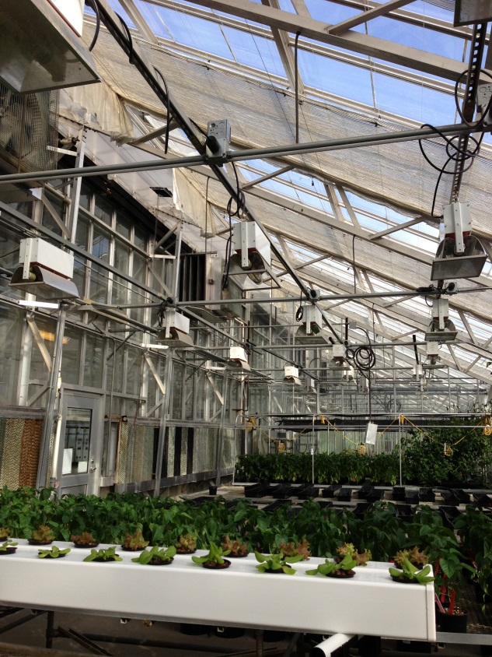Hydroponically cultivated lettuce and tomatoes in rooms with curtain systems

Environmental, Social, and Economic Impact

The environment under curtain systems is much more conducive for plant growth than with no curtain systems. In the warmer months, curtains lessen overheating thru the moderation of air, leaf, and soil temperatures. Also, since curtains open and close based on natural light levels, fewer heat producing supplemental lights require activation to maintain sufficient intensity for plants. In the colder months, however, curtains act as a “thermal blanket” when closed. This is due to the increased insulation factor provided by the glass-air-curtain layering than with no layering.
The economic impact is mainly driven thru the reduction of utilities required to operate greenhouses with these systems. According to estimates by the USDA-Virtual Grower modeling program, curtains can provide substantial savings per year. Figures are affected by many factors including glazing materials, cooling and heating equipment configurations, desired indoor environments, and global location of said facilities. Older greenhouses, or those less energy efficient, might see greater savings than with newer “greener” facilities.
Real-time data captured by utility meters revealed substantial reductions in heat usage and electrical and water consumption. A positive economic impact, in regards to reduced utilities required resulting in lower expenses, should be expected at PSL.

Educational Outreach and Public Engagement

Energy shade curtain systems and their inherent benefits are thoroughly discussed at each tour conducted at the Plant Care Facility. It is a great segue from energy conservation and sustainability to bioenergy crops researched at the University.

Conclusions

I would like to thank the Student Sustainability Committee for awarding grant funds that allowed us to continue phasing this project towards completion.
Twenty-five rooms remain without curtains at PSL. I am confident that thru continued partnership, we will fit all rooms with these systems in the near future. Completing this project will be a monumental milestone and will certainly leave a lasting footprint in regards to implementing sustainable approaches to operating research greenhouse facilities.
I look forward to all future collaborations and endless endeavors with the SSC.

