University of Illinois Reaping the Benefit of Student-Funded Solar Farm
Jackson Schroeder 5 months ago
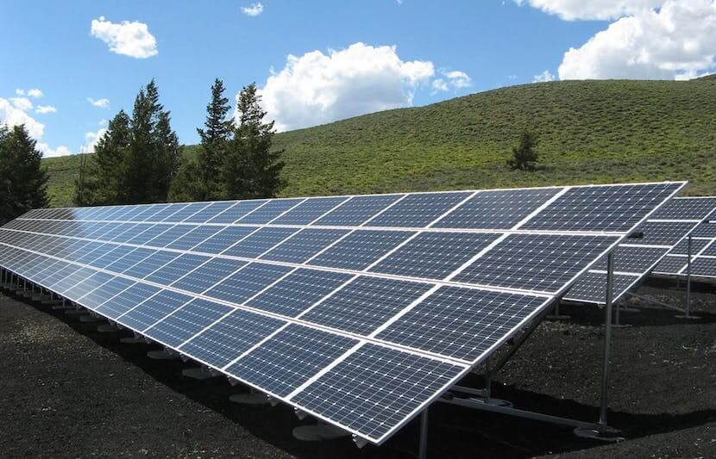
Efforts towards environmental sustainability at the University of Illinois are held at top priority. So, when a student group advocated for a campus wind farm and additional student fees to support a move towards clean energy in 2003, they sparked great interest. Due to a $5 million price tag, however, the request was declined by the Board of Trustees in 2011, but that decline stemmed innovation. Students reached out to the staff at the university’s Facilities and Services (F&S) to search for other renewable energy solutions.
“We immediately started working on the solar farm,” said Morgan Johnston, director of sustainability for F&S. The Solar Farm is a 20-acre piece of land on the southwest edge of the Urbana-Champaign campus, consisting of 18,867 photovoltaic panels, which are projected to generate energy for the next 40 years.
“The Solar Farm project required a first-of-its kind agreement at the university that took the cooperation of many stakeholders across the university to make a reality,” said Johnston. “That persistence and hard work led to an installation that will produce enough electricity yearly to power more than 700 typical U.S. homes and provide energy during the peak of the day and hotter months when it is the most needed.”
A push towards environmentalism depicts the university’s culture. “The University holds sustainability and the good stewardship of our natural resources among our highest priorities,” said Johnston.
To show their dedication to a sustainable future, funds for green initiatives at the university come from two student-based environmental fees. Both fees are initiated and allocated by the students. The students contributed $1.05 million to the Solar Farm. “The support for the installation by students across campus and its associated agreement structures, public-private partnership, is a visible example of our continuous commitment to health and sustainability,” said Johnston.
The Solar Farm has been installed for just over a year and already has replaced 2% of campus energy needs. In 2008, the university made it a goal to be carbon neutral by 2050. This led students, faculty, and staff to create the Illinois Climate Action Plan, which has already generated over 500 projects fighting for clean energy.
“The transition to renewable energy generation is a major advancement for campus,” said Johnston. “The Solar Farm is a significant step in meeting renewable energy goals set forth in the Illinois Climate Action Plan.”
“The Solar Farm was the fifth major completed solar energy project on campus and first utility-scale installation,” said Johnston. Campus sustainability efforts don’t stop there. “The next step in our move toward clean energy is the new ten-year Wind Power Purchase Agreement the university signed with Rail Splitter Wind Farm, LLC.,” she explained. “Also, the university is continuing to incorporate building-specific solar installations into projects for research facilities and residence halls as part of major renovations or new construction.”
Sustainability efforts at the University of Illinois serve as a model to help influence and encourage efforts at other universities. Johnston and her team have given tours and answered questions regarding the solar farm to other universities interested in making clean energy a priority.
“This type of collaboration and impact is an example of what is possible when you work together to achieve sustainability goals,” said Johnston. “It is an example for other universities, communities, and individuals of how to develop and establish a successful large-scale solar project.”

