Year Funding Allocated: | FY10
Funding Amount: | $36,000.00
Anticipated End Date: | November 15, 2011
Project Leader Name: | Morgan Johnston
Project Leader Email/Phone: | mbjohnst@illinois.edu  217-333-2668
Today’s Date: | Nov. 7, 2012

Project Scope
Fill in an executive overview here. Include original project scope and describe progress toward the stated goal. Indicate changes to the scope of the project (previous or anticipated).
The original scope for this project was as follows:
1) that $20,000 will be used to install bike loops on existing concrete or mulch in locations determined by student responses to a campus wide bike survey and approved by the Committee (to be submitted for approval by July 9th, 2010), 2) That one location on mulch be piloted, 3) That $1,500 be used to install an air pump at the Campus Bike Project at Pennsylvania Avenue, 4) That $9,500 be used to provide parking specifically at the Illini Union on permeable concrete (at least 20-25 bike loops) and install an air pump; up to $1,500 of this allocation may be used for the pump 5) That signage for Illini Union parking improvement be approved by the Committee before installation, 6) That all bicycle loops installed bear a decal indicating the Committee’s support of the project, 7) That $5,000 be used for improvements to the bicycle path along Hazelwood Drive, to remove obstacles and install a bicycle crossing at Lincoln Avenue, as well as to install additional signage to increase awareness of the bicycle/foot trail and acknowledge the Committee’s support of the endeavor, 8) That the possibility of adding the trail to the campus map, campus bicycle plan, etc to further increase awareness of the path be investigated,

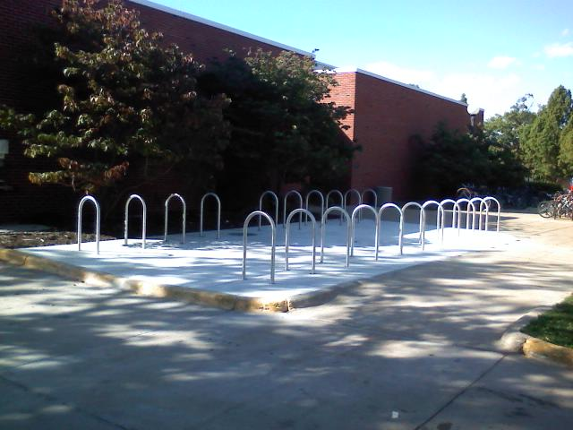
Regarding item #1: The campus wide bike survey was conducted in May 2010. The results were difficult to utilize because the webtools form would only provide a pdf of the results. In fall 2010, Grace Kenney volunteered to convert the pdf results to excel format. The locations with the most requests were then reviewed by Grace and SSC member, Isaac Corzine, and they sketched proposed designs. The designs were then put into AutoCAD, for engineering estimates, and approved by the Architecture Review Committee. Estimates were requested, and then individual departments were contacted to seek a 20% cost share. The Law School agreed to the 20% cost share, and proceeded with installation of a new bike parking area. Those racks were installed in summer and early fall 2011, at a total cost of $16,345. This was split 50/50 with SSC and the Department.

The bike racks at DCL along Mathews Avenue were also installed with this funding. The total cost was $4070, and SSC decided (per Kevin Wolz) they would only provide $180 per loop, or $1800 in this case. DCL agreed to fund the remainder of $2270. These racks were installed December 2011. In January 2012, rust was found to be an issue at the welding marks for these racks on rails. It was determined that the company who welded the racks to the rails used the wrong type of weld. This is a lesson learned for future rack installations.

We also asked Mechanical Engineering and Art and Design if they would share the cost for bike racks at their buildings. Art and Design informed us that they could not afford the share. Mech Engineering didn’t respond. I followed up with them and found out that the contact person at Mech Engineering had moved to a new department. He told me that he would follow up with his replacement and make sure they got back to us. I checked a few more times, but they did not end up replying.

Regarding item #2: The SSC approval letter stated that one location needed to be piloted on mulch, however, this is against campus facility standards. The campus facility standards have evolved over decades to ensure that the UI campus remains a safe, functional, and comfortable space for all users. Mulch is not an option for bike parking areas because of the maintenance required to keep the mulch in place, especially during snow events when the bike parking areas get cleared of snow. This request from SSC did encourage us to try to use permeable pavement under new bike parking areas.

When looking into permeable pavement for bike parking areas, there were a number of details I learned about pavements on campus. First, I learned that the places on campus with pavers also have impermeable concrete under the pavers. This is to keep the pavers in level positions to protect against tripping accidents. It also protects the pavers when heavy machinery is moving over them, such as during construction projects or for emergency service vehicle access. Second, I learned that permeable pavement with water in the pores will be ruined during the winter freeze-thaw cycle. The water trapped in the pores during a thaw gets locked in when the surface freezes. As the ground freezes during the night, the trapped water freezes and expands, ultimately causing the permeable pavement to break apart. To accommodate this issue, permeable pavements in our area have an under-drain to keep the water from being trapped in the pores. These under-drains connect to a storm sewer, so the excess water is routed to the storm sewers. In large pavement areas, like a vehicle parking lot, the under-drain is a back-up to the percolation that occurs throughout the areas, but in small bike parking areas, the under-drain adds a very large expense and does not have a large impact on the quality or quantity of water going to the storm sewer. Therefore, the permeable pavement option was not selected as a good option for most bike parking areas.

Regarding item #3: The $1500 for a bike air pump at the Campus Bicycle Shop was installed and we were able to install a bike fix-it station, rather than just an air pump for this amount. This is also what was installed near the Illini Union. The bike fix-it stations have been a real hit on campus and in the community. The two fix-it stations on campus were installed in fall 2011, at the same time as the one in Urbana, the two in Champaign, and the one at the MTD’s Illinois Terminal. There are some issues that arose, related to maintenance of the air pumps, and solutions for larger maintenance needs. These are being addressed by Amelia Neptune and Ken Sutto, in consultation with the other agencies and cyclists.

Regarding item #4: The Illini Union bike parking was installed on existing concrete, rather than on new permeable pavement. This was the last item completed under this grant. The SSC approved an extension and a change in scope, as follows. The details listed here are accurate for the funding. However, the Grounds department contribution and tree are outside of the scope of this project. The tree is independent of this project, and is not under the authority of my office or the SSC. However, it is my understanding that Grounds does intend to plant a tree in this space, as described below.

SSC is pleased to inform you that the committee has approved your request to use the remainder of the funds in the account for bicycle parking improvements at the southwest corner of the Illini Union. Upgrading this bike parking area will cost approximately $27,275. F&S Grounds will contribute the cost of a new tree in the existing tree planter, covering $3,720 of this cost. There is also a charge to pour concrete in the unused tree planter space, and the Union is willing to pay that cost of $1,180. That leaves $22,375 for the bike parking. There is $20,091.54 left in the SSC grant from FY10, and the Union is willing to fund the remainder to get this accomplished.

Regarding item #5: The signage has not been completed yet, and I will seek approval from the transportation working group. It is my intention to seek approval of the existing SSC funding sticker as used on the previous bike parking installations. This will allow the signage to be consistent throughout campus. I also intend to seek approval of the Bike Fix-it station stickers which will also reflect funding from the SSC.

Regarding item #6: The bike parking sticker decals are made by the F&S sign shop to withstand the elements and adhere firmly to the bike racks. These are an expensive item and while the SSC requested that these be placed on every rack, I intend to place just a few on each of the bike rack areas. However, the funding for the stickers was not included in the budget for this project. I will be talking with the Transportation Working Group to ascertain how to address this funding line item.

Regarding item #7 and 8: The Hazelwood bike path was originally submitted as a separate request to SSC. They chose to include it in this item. The original Hazelwood path was going to extend from Orchard Downs to the Research Park, but the Crop Sciences department has major concerns about encouraging users to run or cycle through the research area between Vet Med and the Research Park. Therefore, the path was only improved from Orchard Downs to Vet Med. With that reduction in scope, Suhail told me to use the funds that had been intended for the path on more bike parking. Thus, the Hazelwood work that was done through the Arboretum was funded separately and there were no SSC funds expended on it.

With the exception of the stickers, this project is complete.

Timeline & Budget
Indicate project timeliness and budget as stated in application. Please indicate if the project is on schedule and within budget.
Schedule item | Planned Date | Actual Date | Variations from Proposed Timeline
Survey | SU 10 | SU 10
Bike parking installations | SP 11 | SU 12 | About one year delay, with extension approved by SSC
Budget item | Expense Amount | Expense Date | Variations from Proposed Budget
Law racks | $8,172 | Sep 2011 | None
DCL racks | $1,800 | Dec 2011
Fix-it Stations | $3,000 | Oct 2011
Illini Union | $20,091.54 | Summer 2012 | Increased with approval from SSC

Project Outreach
Please indicate how the project has been publicized (educational signage, newspaper, poster presentation, etc.). Please list publicity goals that have not yet been accomplished.
The publicity will be through the stickers, and the fact that the racks are installed. We can also put it on the iCAP portal, and we can put include an acknowledgement of SSC funding in our description of the bike parking on campus in the forthcoming campus bicycle master plan.

