

October 28, 2008

Mr. Suhail Barot
Student Sustainability Committee
University of Illinois

Re: Help Your Campus Be More Sustainable—Allerton Park and Retreat Center
Green Allerton --Alternative Energy/ Conservation Project

Dear Suhail,

On behalf of the University’s Allerton Park and Retreat Center, I appreciate the opportunity to submit a grant proposal to the Student Sustainability Committee in the amount of $25,500. The opportunity to research and install this project depends on the generous support from an organization such as the Student Sustainability Committee that share our mission of education, research and respect for the unique natural setting that exists at the Park.

I have attached a revised copy of the ‘Green Allerton—Alternative Energy/Conservation Project’ for the committee’s review. Should you have any questions or require any further information, please contact me by email at bschleic@illinois.edu or by phone (217) 333-3287 x 204. If I am unavailable, please contact Jim Gortner, Associate Director of Allerton Park and Retreat Center, email: gortner@illinois.edu Phone (217)-333-3287 x 111.

Sincerely,

Barbara A. Schleicher
Grant Writer and Landscape Specialist

Attachment

University of Illinois—Allerton Park
Green Allerton—Alternative Energy/Conservation Project

History and Mission Statement
Robert Allerton gave his over 1,500 acres central Illinois estate to the University of Illinois in 1946. Since then it has served as a location for the Champaign-Urbana campus research, professional conferences and retreats, and public outdoor recreation. Administratively, Allerton Park is currently under the auspices of this campus’ Provost Office.
The ‘Green Allerton--Alternative Energy/ Conservation Project’ is a continuation of the Park’s efforts to address its stated mission:
- To develop programs for research and education that focus on a comprehensive understanding of nature, landscape and sustainable systems.
- To employ balanced, integrated management techniques that preserve Allerton’s natural and cultural reserves
- To be good stewards of a natural setting where visitors gain a better understanding of their relationship to nature
The Green Allerton initiative focuses on operational sustainability issues at the Park, including:
- Recycling efforts
- Energy conservation initiatives
- Reduction of Fossil fuel use
- Water conservation initiatives
- Park grounds energy efficient operations
- Facility maintenance and conservation
- Purchasing
- Waste stream management

Project Description
This project’s goal is to bring together University faculty, Park staff and a student scholar to investigate and generate a viable alternative energy heating system solution for several park buildings at the Park. These four buildings are heated using natural gas in units that are 25-50 years. The objectives of the project are to research, design and install a new alternative energy heating system in these structures, which utilizes both the Park’s human ingenuity and renewable natural resources.
The alternative energy heating unit we are proposing to install is an Outdoor Wood-fired Boiler (OWB). The student scholar will be researching the appropriate size and EPA certified OWB. In a winter heating season these buildings use over 13,500 therms in natural gas. The OWB would need to meet similar heating values. In addition the student will be responsible for: selection of the best location to site the OWB, the appropriate smoke stack height for best dispersal of smoke to reduce potential hazards to staff and visitors and specifications for the installation of the boiler, water pipes and storage structure.

Definition of Sustainability
The Green Allerton Initiative is a comprehensive approach to sustainable operations of the Park facilities. We are attempting to operate our facilities in a manner that will meet our needs while preserving the environment so that these needs can be met not only in the present, but in the indefinite future. We are reducing our dependence on fossil fuels by: using electric carts, retrofitting many of the building in the Park to conserve energy in the heating and cooling season, constructing of a straw bale maintence building, using energy efficient lighting, hand dryers and vending machines, recycling paper, wood, and metal and supplementing natural gas heat in two Park greenhouses with an OWB.
For this project, we propose to fuel this system with wood harvested through normal maintenance of the forestland at the Park. Annually, the Park staff removes trees that: have been storm damaged, are a hazard in various parts of the gardens and/or need to be removed due to an improvement project. In 1900 when Robert Allerton first began to develop his estate in Piatt County, the land had been used for agricultural purposes. The 1,500 acres that would eventually become his residential estate was allowed to revert to savannah and forestland. Today, it is primarily an oak, hickory and maple upland and floodplain forest. It has been the policy of the Park to continue to maintain this land as forestland with appropriate forest management techniques that encourages re-growth and removal of exotic species of undergrowth that would interfere with new native tree species.
In the past this harvested wood was gathered is a maintenance yard and periodically burned in an open air pit. Now with the installation of the OWB, this wood and the stored BTU’s can be used to heat four service building at the Park. This renewable resource would replace our use of natural gas. With over 1100 acres of forestland and the sound practices of forest management, the supply of wood fuel could be inexhaustible.
Although the specific location for the OWB has yet to be determined, the four building that would be affected by the new heating system would include the Operation/Environmental Education Building, Visitor Center, Paint Shop and Woodworking Shop. These are located on the north side of the park about a quarter mile from the Retreat Center. The OWB would of course be located close to these buildings.

Budget and Fundraising
Table 1 shows a budget that delineates the costs associated with the research, design and installation of the proposed project. These have been broken down into actual cash expenses and actual in-kind contributions with associated actual cash income.

Table 1. Green Allerton--Alternative Energy and Conservation Project
Actual Cash Expense |  |  |  |  | Actual Cash |  | Actual In-Kind
 |  |  |  |  | Expenses |  | Contribution
Personnel
 | Student Scholar |  |  |  |  |  |  | $4,560
 | Staff |  |  |  |  |  |  | 1,800
Installation
 | Outdoor Woo-fired Boiler and Equipt. |  |  |  |  | 25,500
 | Wood storage structure |  |  |  |  |  |  | 3,000
 | Labor |  |  |  |  |  |  | 2,500
 | Equipment rental |  |  |  |  |  |  | 600
 | Signs |  |  |  |  |  |  | $1,000
Total |  |  |  |  |  | 25,500 |  | $13,460
Actual Cash Income
Student Sustainability Grant |  |  |  |  |  | 25,500
Allerton Park Operations Budget |  |  |  |  |  | 12,460
Other -- Friends of Allerton |  |  |  |  |  | 1,000
Total |  |  |  |  |  | 38,960

In Table 2, this illustrates that the initial research and installation costs would be recouped in year six of the operation. It would probably take several more years to recoup the cost of the OWB.

Table 2. Savings Due To Conversion from a Natural Gas Furnace to an OWB
Year | Initial Cost |  | Gas Price | Wood | Labor | Mainten. | Total | Recoup
 |  |  | (+10%) | Price | (+3%) |  | Savings | Costs
2009 | 12,460 |  | 14,958 | 0 | 11,800 | 3,500 | -12,802
2010 |  |  | 16,454 | 0 | 12,980 | 3,500 | -26
2011 |  |  | 18,899 | 0 | 13,370 | 3,700 | 1,829
2012 |  |  | 19,909 | 0 | 14,707 | 3,700 | 1,502
2013 |  |  | 21,900 | 0 | 15,148 | 3,900 | 2,852
2014 |  |  | 24,090 | 0 | 15,602 | 3,900 | 4,588
2015 |  |  | 26,499 | 0 | 16,070 | 4,100 | 6,329 | 17,100

Fundraising
The funding sources for the project currently consist of the following:

Allerton Park and Retreat Center | Research and design by student scholar and staff supervision. Installation of OWB, water pipes and connections to structures, ventilations, etc. Construction of the wood storage structure
Student Sustainability Committee | Purchase of the OWB
Friends of Allerton Park | Educational signs

As a part of the entire energy conservation plan for the Park, we are attempting to seek sources for funding of all phases. We will be contacting the US Department of Energy, Illinois Clean Energy Community Foundation, Illinois Department of Commerce and Economic Opportunity—Bureau of Energy and Recycling, commercial wind farms, etc. Hopefully, we will be able to tap into some of these resources to expand the monitoring of the emissions of the OWB.

Proposed Project Timeline:

Nov 1, 2008 – January 30, 2009 Begin project: Site condition survey and energy
audit; OWB site selection and drawings. Set up
account with finance office for access for reporting
to SSC

December, 2009 Semester Report to SSC—status report and
accounting information

February 29, 2009 Analysis of survey and audit findings; research on
appropriate LEED standards and research of
alternative fuel heating systems studies

March 31, 2009 Recommendations for heating system; develop
specifications and drawings for system installation

April, 2009 Presentation of poster at Environmental Horizons
conference

April thru June, 2009 Conduct energy efficient repairs to the four buildings

May, 2009 Semester report to SSC—status of project and
accounting information

July – August, 2009 Installation of heating system, water lines and
connection to buildings; Construction of the wood
storage structure.

August, 2009 Semester report to SSC—Status of project and
accounting information

Energy, Environmental, Social and Economic Impact:
In the past, outdoor wood-fired boilers (OWB) have often created serious impacts to the environment and individual’s health. In recent years, with guidance from the U.S. EPA and the wood burning industry, stricter standards on emission controls have been implemented. OWB have become more energy efficient and have reduced harmful emissions associated with wood combustion.
Of primary interest is the amount of particular matter (PM) per lb/million BTU Heat output. The EPA has instituted a Voluntary Partnership agreement (Phase 2) that caps average air emission level to .32 lbs/million BTU heat output. Several of the EPA certified OWBs have been tested and found to .2 lbs/million BTUs of PM or less. These boilers, when properly operated, have the capacity to burn hotter, smaller fires that will burn up the smoke created in the initial combustion. This will help to reduce the emissions of other hazardous gases.
Energy Efficiency Projects
According to the AmerenIP natural gas usage account information for the winter of 2007 and 2008, the four buildings that would benefit from the proposed alternative energy heating system used over 13,250 therms. Using standard calculations for CO2 emissions, over 440,000 lbs. of CO2 were released into the atmosphere during that period of time. The cost to the Park for that natural gases use during that time was $13,598.
Potential indirect costs for the harvesting the fuel or wood for the OWB would not be financial burden or increase fossil fuel transportation costs. The wood that would be harvested for this project is already being collected by the Park’s grounds crew. This wood comes from storm damaged trees, trees removed as a result of park improvement projects and maintenance for the formal gardens. In 2007, it was estimated that over 100 cords of wood (a cord equals 128 cubic ft.) have be harvested by the Park. The projected number of cords that we would need would be about 50 for a heating season. In the past, the wood was placed in piles in a maintenance yard and burned in an open air pit at appropriate times.
Now using this wood as fuel for an energy efficient boiler would produce the same amount of CO2 as the open air burns and quite possibly give less harmful emissions. As stated previously, use of the wood would also simultaneously eliminate CO2 and other emissions that were generated when the natural gas heating units were employed, in this case, 440,000 lbs. of CO2 emission
The supply of wood on an annual basis is secure. The attached aerial photo map illustrates the amount of forestland vs. non-forestland that is available at the Park. Maintenance of over 1100 acres of forestland will provide sufficient renewable fuel sources for the OWB for many years to come.
The Park staff already has experience with an OWB which is located at the Diversified Farm. It was installed for the winter of 2006-2007. The wood necessary for fueling was split primarily by volunteers. As a part of our wildlife management program we have a requirement that hunters must provide the Park with 40 hours of volunteer hours. This has been and will continue to be a volunteer activity.

Environmental Impact
By converting the existing heating system, the Park would not only reduce the direct energy cost of the natural gas to zero but would have a nearly zero increase of the CO2 emissions since wood is carbon neutral whether it decays naturally on the forest floor or is burned in our proposed Outdoor Wood-fired Boiler. Research has show that the amount of CO2 that is taken in by a tree during the growing process will equal the amount of CO2 released during its decomposition, known as the carbon cycle. Figure 1 illustrates the results of the greenhouse gas analysis conducted by the US EPA. Residential wood combustion has the lowest effective greenhouse impact per unit of energy delivered.
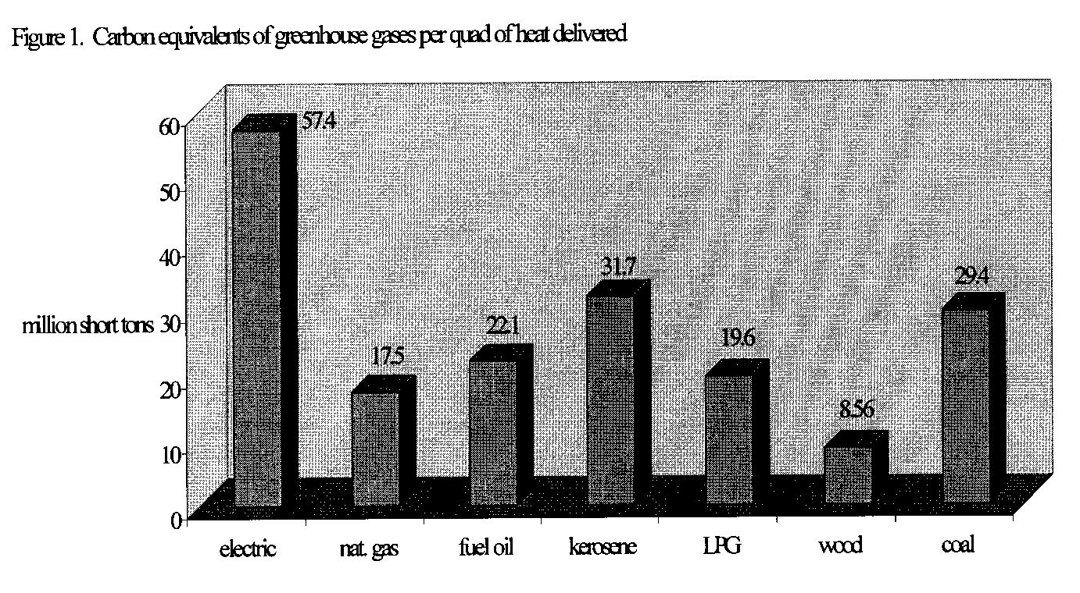
The combustion of wood stoves, furnaces and boilers contain significant levels of particulate matter (PM), carbon monoxide (CO), nitrogen oxide (NOx), and other organic gases. In order to mitigate some of harmful effects of these emissions we propose to do the following:
- Purchase an EPA certified OWB. The Central OWB ECL 2300 model is the type heating unit that we would seriously investigate for this project. Attached are web site links to several documents that have been produced for the EPA on the control and dispersal of emissions by the particular unit. Of primary interest is the amount of particular matter (PM) per lb/million BTU Heat output. The EPA has instituted a Voluntary Partnership agreement (Phase 2) that caps average air emission level to .32 lbs/million BTU heat output. Tests have indicated that the ECL 2300 model emits .2 lbs/million BTUs of PM.
As a comparison, the use of this boiler will represent an average annual emission of about 260 lbs. of PM emissions. This could be considered as the emissions from four 2005 model school buses using regular diesel fuel.
- All structures will be inspected and winterized according to the manufacturer’s recommendations help which will reduce the energy that needed to heat them.
- All wood that is harvested for the OWB will be seasoned, split and stored in a covered shelter. It is recommended that the wood have 20% or less moisture content. This will result in the fire giving off less smoke. Dry wood will also up to 44% more heat.
- Trash, tires, plastics and treated wood will not be burned in this OWB. This will help with possibility of adding contaminants to the air.
- There will be proper installation and regular maintenance of the unit as recommended by the manufacturer. This will aid in keeping the emission levels within and lower that what is required by the EPA.
- The OWB will be located in an area that would not necessarily have much public or staff foot traffic. The furnace will be primarily operational in the winter months when there are fewer visitors to the Park. This will help minimize exposure to these emissions. Staff will be trained in the proper operations and maintenance of the unit.
- The proper height of the smoke stack will be selection to take advantage of the wind for dispersal of any dense smoke especially during start up. Test results regarding the various heights of stacks have been included in the attachments.
Allerton Park and Retreat Center is located on 1500 acres. Over 1100 of these acres are forested. The nearest residence is about two miles from the location of this OWB. The closest community to the Park is Monticello which is about five miles from the Park’s north entrance. The attached aerial photo map of the Park illustrates the possible location of the OWB (red star) and the amount of forest land and no-forest land. The size of boiler we are proposing and the potential for extraordinary pollution effect to a community is negligible due to the expansion of land, the number of residence within a five mile radius and the prevailing wind (about 10-15 mph) that the Park experiences.
Social Impact
The positive social impact would be in the education of the public (visitors and students) regarding the project and its financial benefits to the Park, the reduction of greenhouse gases, and the proper maintenance of a OWB to insure the reduced emissions of hazardous PM and other gases. This would be an opportunity for students and/or service groups to volunteer to assist park employees with preparing and handling the wood fuel for the furnaces.
A potential negative impact would be a health hazard from the emissions from the OWB. Every effort will be made to maintain the OWB within the EPA certified PM emissions levels. Also the location of the OWB and the height of the smoke will be designed to minimize any hazardous health effects to visitors and staff.
Economic Impact
A positive economic impact would be the creation of a job for maintaining the OWB. Any negative effect due to the size of the unit would be negligible.

Outreach and Education
Allerton Park and Retreat Center, although not physically on the University campus has made strident efforts to included students in the various aspects of the planning, design and operations of the Park. The Scholar program works in cooperation with the Departments of Architecture, Landscape Architecture and Natural Resources and
Environmental Sciences. Each summer the Park employees 3-5 interns in various operations of the part including: horticulture, design and park maintenance.
This project will be conducted by the Architecture scholar that works 20 hours at the park per week. The actual installation of the system will be conducted in the summer of 2009 in which the summer interns will be involved in the project as well as the construction of storage structure.
It is envisioned, that the publicity for this project and grant award would be in three phases: grant receipt notification, project progress and the completed project.
Grant receipt notification
- Press release to local media, UI Environmental Council, other appropriate news sources
- Allerton Quarterly Newsletter (700 person mailing list/ 800 email list)
- Allerton Advisory Council
- Local state government representatives, departments
Project progress
- Allerton Park Project Sign—a temporary sign that informs visitors about the project, its importance and any additional funding sources
- Allerton Park Website –Featured item on the website www.allerton.uiuc.edu
- Allerton Quarterly Newsletter—update on progress
- Local state government representatives, departments
- Local news media, etc

Completed project
- Park informational sign—project design, intent, Green Allerton energy Conservation plan, funders. The park receives about 150,000 visitors annually for special events, visits to the formal gardens and walking the 14 miles of trails.
- Invite University and local colleges classes to participate in studies, monitoring, etc of the project and in the Green Allerton EC plan
- Local news media, etc
- Allerton Quarterly newsletter
- Local state government representatives, departments
- Allerton Park Website update
- Green Allerton Park plan and literature
- Where ever the SSC would suggest we publicize our project, research, etc.
This project will be available to the public and especially university classes for study and tours. In the past, we have had classes from the Department of Architecture and Landscape Architecture visit the various energy efficient facilities that are on site and include suggestions for additional designs. It is hoped that information on this project would be highlighted in the University’s energy efficiency program, B.L.U.E. Program.
Allerton Park and Retreat Center has over 150,000 visitors annually. It is important to note to visitors that we are part of the University. It is equally important to demonstrate that the University and the staff of the Park are aware of their roles as educators and innovators in natural areas conservation awareness and energy conservation, not only on campus but to all the units.
The intent of all this publicity would be to explain that Allerton Park is part of the University of Illinois, perhaps not physically on campus but in our united effort to be a more energy efficient public institutions of education and research. This type of information and the fact the SSC was instrumental in the funding of the Green Allerton Alternative Energy/Conservation Project would be conveyed to the public, students, and staff through the avenues of communication listed above. Should the SSC require any specific language to be included in such publicity, we would be more than willing to comply. Finally, we would encourage the SSC to consider using the completed project as an educational resource for energy saving projects that can be accomplished with the funds generated with the student fees.

Attachments

Aerial Photo Map

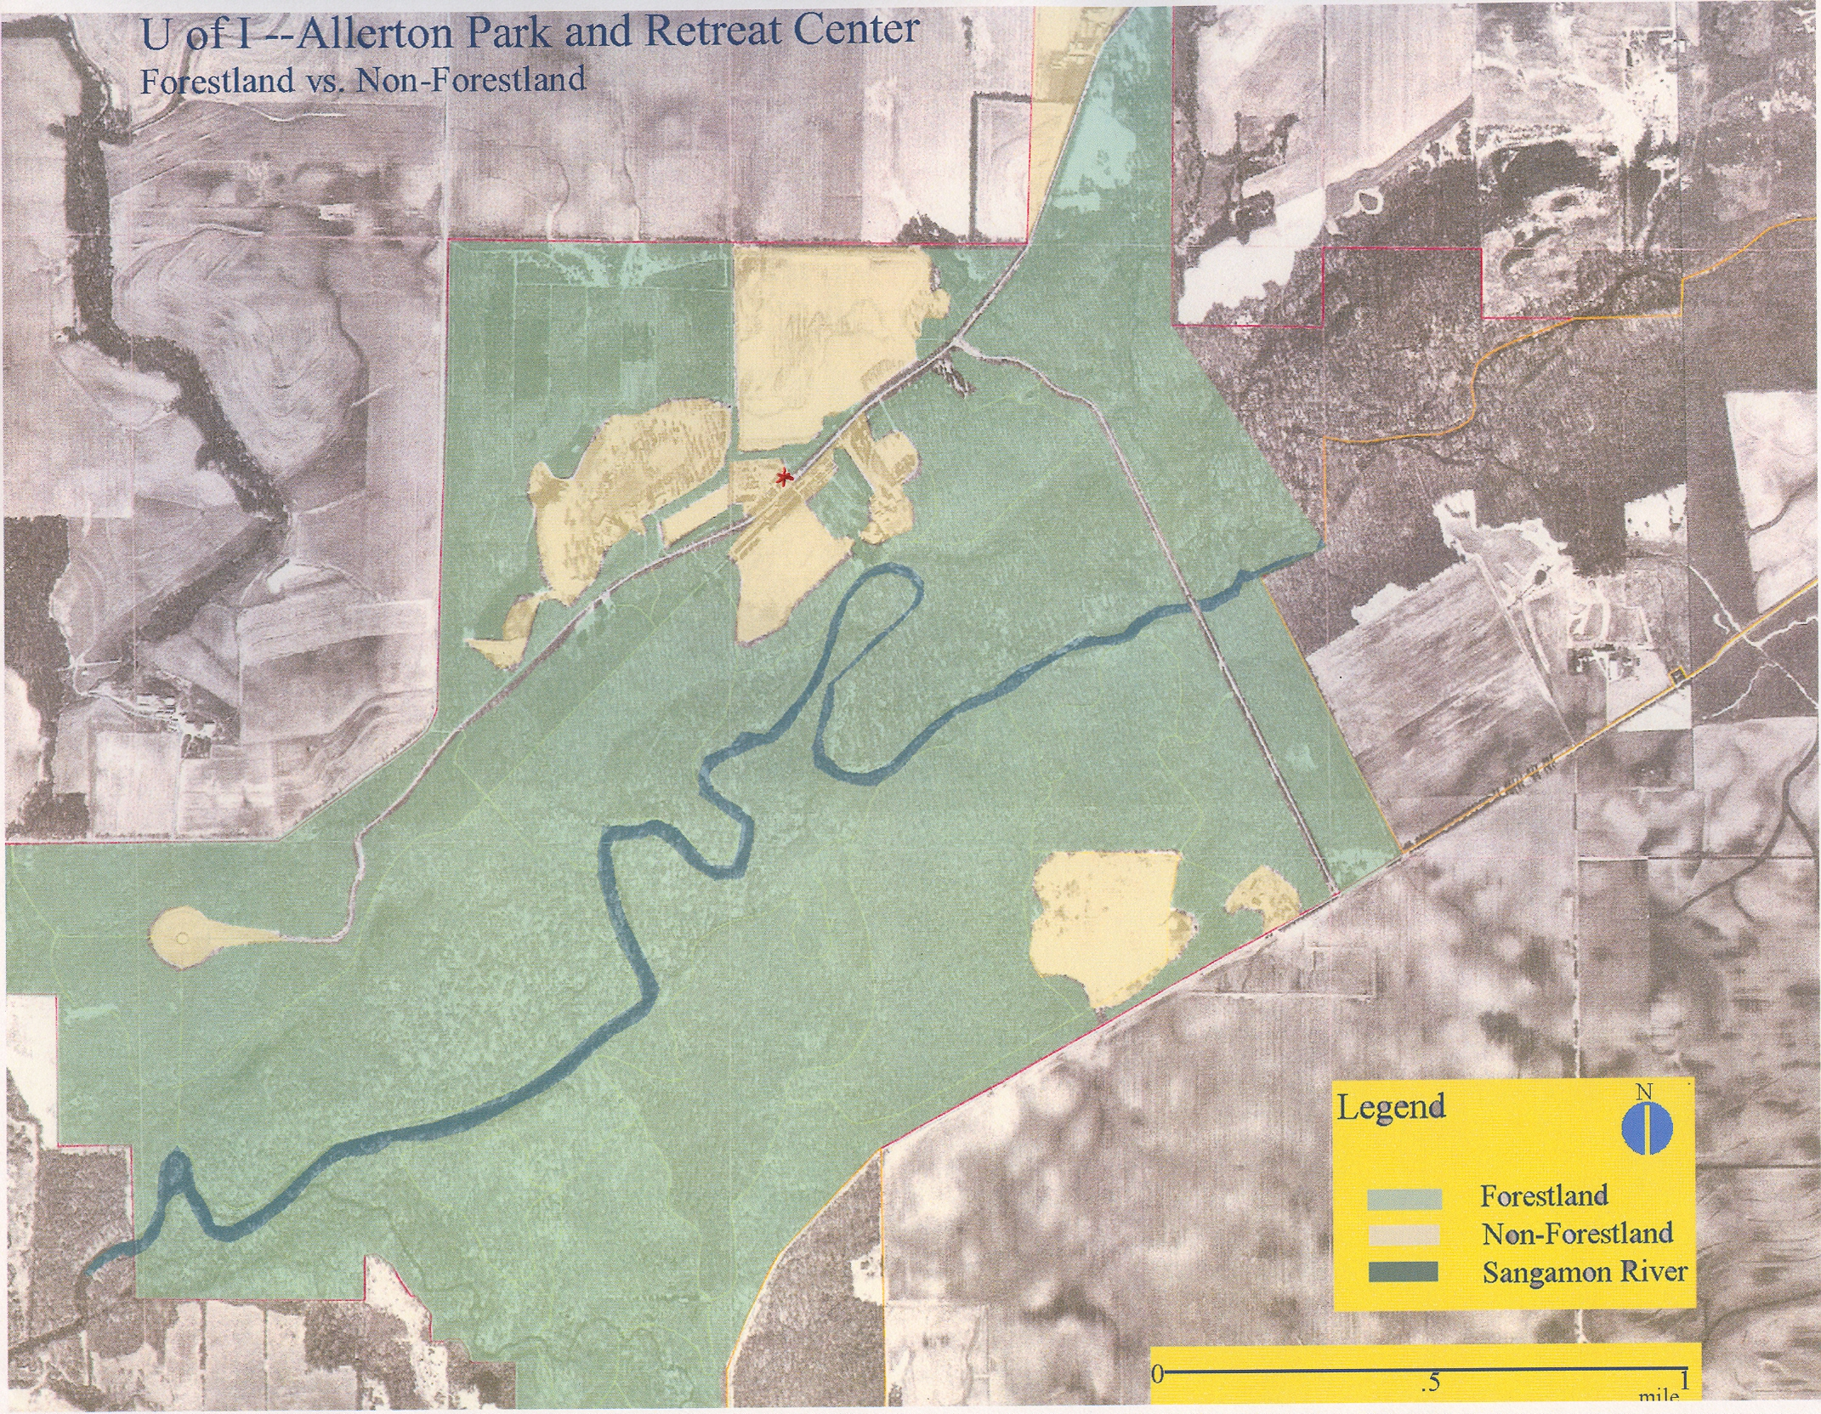

EPA List of Cleaner OWHH 2008
www.epa.gov/woodheaters/models.htm 1-6 pages

Air Quality Report on OWB type Allerton Park is investigating
www.outdoorfurnacefacts.com/wood-corn-heating-facts/emissions-report/

“Air Quality Dispersal Model of Outdoor Wood Boilers” September, 2006 Tech Environment, Inc. Waltham, Ma (29 pages)

Central Boiler Brochure EClassic model 2300 (16 pages)
www.centralboler.com

Allerton Park. Green Allerton Paper. 2007
AmerenIP Account Activity for Visitor Center and Maintenance Buildings. Sept, 2006 thru September, 2008
Estimated annual increase in natural gas cost
Estimated annual cost of living pay increase
Estimated bi-annual cost increase
U.S. EPA Oct. 23, 2008 http://www.epa.gov/woodheaters/pdfs/hangtag2.pdf
EPA List of Cleaner OWHH 2008 and Central Boiler Brochure E Classic model 2300
U.S. EPA Department of Energy. “CO2 Emissions from the Generation of Electric Power” July 2000.
Based on use of Hardwood timber. For example, 1 cord of Osage Orange (a predominant tree that is being removed at the Park) wood is equivalent to 9,029Kwhr or 308 therms. Since the structures use 13,250 therms per heating season, this would mean the use of 43.5 cord of Osage orange wood.
The Proceedings of a U.S. EPA and Air Waste Management Association Conference: Emission Inventory: Living in a Global Environment, V.1,pp 373-384, 1998 James E. Houck and Paul E. Tiegs of OMNI Environmental Services, Inc., Robert C. McCrillis Air and Energy Research Lab U.S. EPA and Carter Keithley and John Crouch Hearth Products Association. “Air Emissions from Residential Heating: The Wood Heating Option Put into Environmental Perspective.”
“Air Quality Dispersal Model of Outdoor Wood Boilers” September, 2006 Tech Environment, Inc. Waltham, Ma (29 pages)
U.S. EPA Oct. 23, 2008 http://www.epa.gov/woodheaters/pdfs/hangtag2.pdf
EPA List of Cleaner OWHH 2008 and Central Boiler Brochure E Classic model 2300
U.S. EPA “The Qualifier” Diesel Emissions Qualifier is an interactive tool to estimate emission reduction and cost effectiveness for clean diesel projects. http://cfpub.epa.gov/quntifiers/view/index.cfm
State of Washington EPA. Air Quality Program “Heating with Wood: Keep it Clean” Publication Number 91-br-022 (rev.9/08) p.1

