Campus Recreation Restroom Water Reduction Report, June 2012
Project Lead Contact Information
Brian Baxter
bbaxtr@illinois.edu
Lead Assistant Director – Fitness Operations/Building Maintenance
Campus Recreation
217.333.2677
201 East Peabody Drive, Champaign, IL 61820, MC-556

- Summary/Overview of the Project
Campus Recreation was interested in reducing the water consumption of its patrons without interfering with their perceived comfort or routine. To accomplish this goal, we proposed replacing the currently installed flush valves with dual flush valves, installing new pint-flow urinals, and motion sensor water faucets in our three largest facilities.
Dual-Flush Valves
All toilet flush valves were retrofitted with a Sloan WES-213 Dual-Flush handle and Diaphragm kit that maintains a 1.1 gallon flush by lifting up for liquid waste and 1.6 gallons per flush by pushing down for solid waste. Campus Recreation retrofitted 64 of these flush valves at the ARC, 25 at CRCE and 16 at the Ice Arena. When this flush valve is initiated upwards it reduces our water volume by 30%. This project has done an excellent job at promoting water reduction within our facilities by making people aware of their water usage and by making them an active participant in the process.
Motion-Sensor Faucets
Restroom sink faucets in all three buildings have been replaced with the Zurn Model Z6915 AquaSense faucets. Campus Recreation replaced 50 - 4” and 8 – 8” faucets at the ARC, 2 – 4” and 24 – 8” faucets at CRCE and 10 – 4” and 6 – 8” faucets at the Ice Arena. These faucets are battery operated with an infrared convergence-type proximity sensor and include a .5 gallon per minute aerator. We feel by combining both the motion sensor fixture with a lower flow aerator, we have maximized our water reduction at the restroom sinks. We promote this water reduction effort by signage in our restrooms.
Low Consumption Urinals
We have replaced a large portion of our urinals with the Zurn Z5758 .125 gpf Ultra Low Consumption Urinal System. This product has provided a reduction in waste water by reducing urinal flow from 1 gpf to .125 gpf. We replaced 15 at the ARC, 6 at CRCE and 11 at the Ice Arena. This 1/8 gallon per flush low flow urinal system should be providing us an 85% water savings over our old 1 gallon per flush urinals.
- Project Execution/Deployment
On February 27th, 2009, Campus Recreation submitted a letter of request for funding to the Student Sustainability Committee for 12 different projects. The Campus Recreation Green Team worked on developing these requests by analyzing our biggest sustainability needs within our facilities and focused on those projects that would generate the fastest payback. On April 25th, 2009, Campus Recreation received an award letter from the Student Sustainability Committee for our Water Conservation Project. Facilities & Services started this work in May of 2009. In August of 2009, Facilities & Services completed this project to reduce the water consumption from the fixtures used in the restroom areas and the Campus Recreation Marketing Team completed all promotional materials. Michael Litchford, Campus Recreation Facilities Coordinator, provided the majority of the research and planning efforts on this project and the plumbers from Facilities & Services performed the labor.

- Project Costs
The overall cost for this water conservation project was $84,834. The project funding was shared between Campus Recreation and the Student Sustainability Committee. The Student Sustainability Committee graciously offered $30,000 to this project, while Campus Recreation covered the remaining $54,834. This project was completed during the Summer of 2009, with the final completion coming in August 2009 before the students returned for the Fall semester. Below is a breakdown of the costs for each project.

Breakdown of Project Cost (Combined ARC, CRCE, Ice Arena)
62 4” spread lavatory faucets
Zurn Model Z6915 Aquasense battery-powered with .5 GPM aerator.
Material = $20,398
Labor = $11,160
Total = $31,558
38 8” spread lavatory faucets
Zurn Model Z6915 Aquasense battery powered with .5 GPM aerator and 8” cover.
Material = $14,098
Labor = $6,840
Total = $20,938

32 Urinals
Zurn Z5758 ultra low consumption urinal system with Ecovantage battery powered flush valve, uses 1/8 GPF with 85% water savings over standard 1 GPF urinal
Material = $15,808
Labor = $7,680
Total = $23,488

105 Water Closets
Sloan Uppercut dual-flush water conservation tune-up kit. Handle is green in color to inform the user it is for water conservation Lift handle up initiates reduced flush (1.1 GPF) pushing handle down initiates normal (1.6 GPF), reduces water volume by up to 30% when activated upwards.
Material = $5,670
Labor = $3,180
Total = $8,850

- Environmental, Social, and Economic Impact
Environmental Impact
Water that we currently use on campus comes from the Mahomet aquifer. We are currently using water from the Mahomet aquifer at an unsustainable rate, so future generations may not be able to benefit from it. Although our efforts may be small in scale, water conservation projects are the responsible thing to do in Campus Recreation facilities due to the amount of water used in restrooms, showers and pools.

Social Impact
This project contributes to the larger campus effort to promote more responsible
water usage. It is a highly visible effort that teaches our patrons the importance of sustainability as it relates to water conservation.

Economic Impact
The reduction of water used in facilities contributes to lower utility costs.

When it comes to seeing the actual reduction in our actual water usage reports, it is very tough to see due to the amount of different variables involved with water usage at our facilities. These variables include changes in participation numbers within the facilities from year to year, no way to separate and measure restroom water usage from the rest of the facilities water usage (pools at both ARC and CRCE, ice at the Ice Arena) and facility seasonal closure changes from year to year between the ARC and CRCE. All of these variables can contribute to increases or decreases in water consumption from year to year and will not allow us to get a true picture in terms of actual water savings in the restroom due to our water reduction project. We feel fairly confident that we are experiencing extensive water reductions in our facilities due to these changes in the restrooms outlined above. Below is a report of our actual water usage at both the ARC and CRCE. This report also indicates our valid card swipes at both of these facilities so you can see the usage within our facilities. We didn’t include card swipe numbers at the Ice Arena as this does not accurately reflect the amount of usage at this facility. You will see the best representation in the water reduction from year to year in regards to the KGL/Valid Card Swipe (FY09 - .0060, FY10 - .0052, FY11 - .0054). One of the reasons we experienced an increase in FY11 at the ARC was because we had maintenance work completed on our indoor pool which required it to be filled an extra time. This increased on water consumption 660,000 gallons for this one pool.
ARC and CRCE Water Consumption (FY09-FY11)
ARC Water Consumption FY09 |  |  |  |  | ARC Water Consumption FY10 |  |  |  |  | ARC Water Consumption FY11
Month | Consumption |  | Cost |  | Month | Consumption |  | Cost |  | Month | Consumption |  | Cost
July | 30.00 | KGL | $43.80 |  | July | 518.00 | KGL | $1,108.52 |  | July | 320.13 | KGL | $889.99
August | 542.00 | KGL | $791.32 |  | August | 432.46 | KGL | $925.46 |  | August | 472.36 | KGL | $1,154.23
September | 979.00 | KGL | $1,429.34 |  | September | 448.42 | KGL | $959.62 |  | September* | 1,074.68 | KGL | $2,625.99
October | 889.00 | KGL | $1,297.94 |  | October | 504.24 | KGL | $1,174.88 |  | October | 493.83 | KGL | $1,206.68
November | 366.00 | KGL | $534.36 |  | November | 396.66 | KGL | $924.22 |  | November | 368.46 | KGL | $900.35
December | 237.00 | KGL | $346.02 |  | December | 361.20 | KGL | $841.60 |  | December | 454.57 | KGL | $1,110.74
January | 198.00 | KGL | $289.08 |  | January | 239.38 | KGL | $557.75 |  | January | 238.87 | KGL | $583.69
February | 330.00 | KGL | $481.80 |  | February | 294.09 | KGL | $685.23 |  | February | 347.7 | KGL | $849.62
March | 409.00 | KGL | $597.14 |  | March | 565.03 | KGL | $1,316.53 |  | March | 509.49 | KGL | $1,244.91
April | 332.00 | KGL | $484.72 |  | April | 379.81 | KGL | $884.96 |  | April | 418.31 | KGL | $1,022.14
May | 409.00 | KGL | $875.26 |  | May | 766.34 | KGL | $2,130.42 |  | May | 785.9 | KGL | $1,920.36
June | 905.00 | KGL | $1,936.70 |  | June | 514.76 | KGL | $1,431.03 |  | June | 669.84 | KGL | $1,636.73
Total | 5,626.00 | KGL | $9,107.48 |  | Total | 5420.39 | KGL | $12,940.22 |  | Total | 6,154.14 | KGL | $15,145.43
Facility Usage - Valid Swipes |  |  | 942,143 |  | Facility Usage - Valid Swipes |  |  | 1,075,549 |  | Facility Usage - Valid Swipes |  |  | 1,115,281
KGL/Valid Swipe |  |  | 0.0060 |  | KGL per Valid Swipe |  |  | 0.0050 |  | KGL/Valid Swipe |  |  | 0.0055
*Refilled ARC Indoor Pool an additional time.
For maintenance - 660,000 gallons extra.

CRCE Water Consumption FY09 |  |  |  |  | CRCE Water Consumption FY10 |  |  |  |  | CRCE Water Consumption FY11
Month | Consumption |  | Cost |  | Month | Consumption |  | Cost |  | Month | Consumption |  | Cost
July | 240.00 | KGL | $350.40 |  | July | 155.00 | KGL | $331.70 |  | July | 109.17 | KGL | $303.50
August | 239.00 | KGL | $348.94 |  | August | 185.15 | KGL | $396.22 |  | August | 111.83 | KGL | $273.27
September | 257.00 | KGL | $375.22 |  | September | 191.04 | KGL | $408.83 |  | September | 104.45 | KGL | $255.21
October | 227.00 | KGL | $331.42 |  | October | 191.17 | KGL | $445.43 |  | October | 274.43 | KGL | $670.57
November | 226.00 | KGL | $329.96 |  | November | 203.41 | KGL | $473.95 |  | November | 80.22 | KGL | $196.03
December | 211.00 | KGL | $308.06 |  | December | 238.29 | KGL | $555.22 |  | December | 213.27 | KGL | $521.13
January | 190.00 | KGL | $277.40 |  | January | 218.72 | KGL | $509.62 |  | January | 195.31 | KGL | $477.24
February | 380.00 | KGL | $554.80 |  | February | 106.76 | KGL | $248.75 |  | February | 176.18 | KGL | $430.50
March | 162.00 | KGL | $236.52 |  | March | 257.27 | KGL | $599.44 |  | March | 260.66 | KGL | $636.92
April | 197.00 | KGL | $287.62 |  | April | 264.60 | KGL | $616.52 |  | April | 264.82 | KGL | $647.09
May | 329.00 | KGL | $704.06 |  | May | 194.61 | KGL | $541.02 |  | May | 216.81 | KGL | $529.76
June | 118.00 | KGL | $252.52 |  | June | 121.10 | KGL | $336.66 |  | June | 130.68 | KGL | $319.31
Total | 2,776.00 | KGL | $4,356.92 |  | Total | 2,327.12 | KGL | $5,463.36 |  | Total | 2,137.83 | KGL | $5,260.53
Facility Usage - Valid Swipes |  |  | 457,643 |  | Facility Usage - Valid Swipes |  |  | 424,390 |  | Facility Usage - Valid Swipes |  |  | 423,373
KGL/Valid Swipe |  |  | 0.0061 |  | KGL per Valid Swipe |  |  | 0.0055 |  | KGL/Valid Swipe |  |  | 0.0050
Overall Water Consumption FY09 |  |  |  |  | Overall Water Consumption FY10 |  |  |  |  | Overall Water Consumption FY11
Month | Consumption |  | Cost |  | Month | Consumption |  | Cost |  | Month | Consumption |  | Cost
Total | 8,402.00 | KGL | $13,464.40 |  | Total | 7,747.51 | KGL | $18,403.58 |  | Total | 8,291.97 | KGL | $20,405.96
Facility Usage - Valid Swipes |  |  | 1,399,786 |  | Facility Usage - Valid Swipes |  |  | 1,499,939 |  | Facility Usage - Valid Swipes |  |  | 1,538,654
KGL/Valide Swipe |  |  | 0.0060 |  | KGL per Valid Swipe |  |  | 0.0052 |  | KGL/Valid Swipe |  |  | 0.0054

- Educational Outreach and Public Engagement
Our Campus Recreation Marketing Department has done an excellent job of promoting all our Sustainability Efforts within our facilities. The marketing material has made the effort to thank the Student Sustainability Committee for their funding for such projects. Marketing has also ensured to use a consistent Green Logo that is placed on all sustainable marketing material and locations. Below are pictures of different marketing efforts that both educate and inform our patrons.

Dual-Flush Valve System

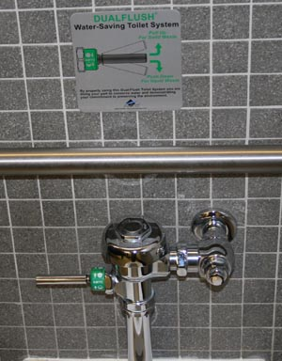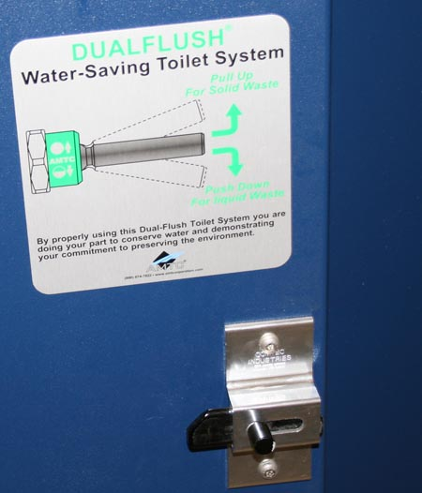

Lavatory Faucets
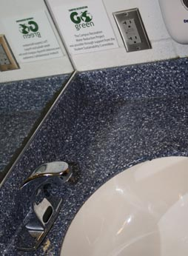

Urinals
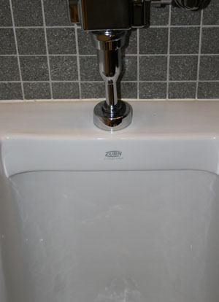

General marketing material used throughout Campus Recreation facilities.

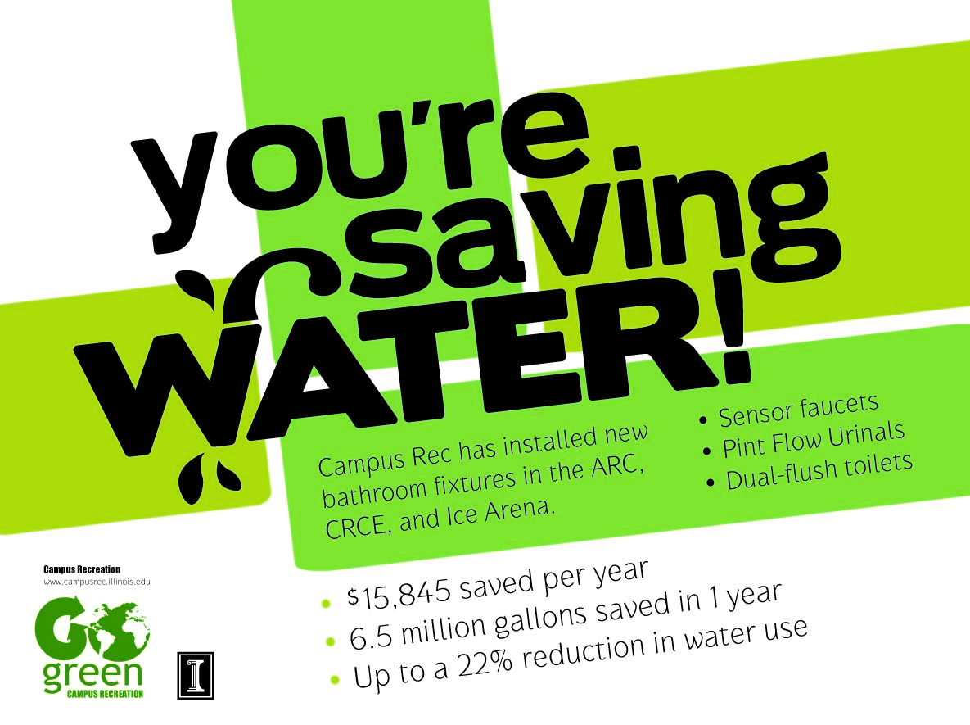

- Conclusions
Campus Recreation would sincerely like to thank the Student Sustainability Committee for their assistance with the funding of this Water Conservation Project. We feel that this project has provided both a positive and educational impact on our patrons by showing our dedication to being more sustainable. Our hope is that this project will make water conservation a much more visible effort that all individuals can partake in at their places of employment and at their personal residences. Campus Recreation looks forward to partnering with both the Student Sustainability Committee and Facilities & Services on future sustainable projects.

