SWATeam Recommendation
Name of SWATeam: Energy Generation, Purchasing, and Distribution

SWATeam Chair: Xinlei Wang Date Submitted to iSEE: April 28th, 2017

Specific Actions/Policy Recommended (a few sentences): Start a project to expand the existing Solar farm, or install a new large scale solar installation in a new location.

Rationale for Recommendation (a few sentences): In order to reach the iCAP objective of 25,000 MWh/year of solar energy by FY25, additional panels will need to be installed. Large scale, ground mounted panels appear to be the least expensive route towards achieving the FY25 objective.

Connection to iCAP Goals (a few sentences): The 2nd objective in the Energy Generation, Purchasing, and Distribution chapter of the iCAP reads, “Expand on-campus solar energy production. By FY20, produce at least 12,500 MWh/year, and by FY25 at least 25,000 MWh, from solar installations on campus property. These targets represent 5% and 10% of our expected 2050 electricity demand, respectively” This recommendation is in line with this objective.

Perceived Challenges (a few sentences): The primarily challenges will include identifying the land where the solar panels can be installed, and identifying a funding source to cover the capital costs of installing the panels.

Suggested unit/department to address implementation: University Administration, Facilities and Services

Anticipated level of budget and/or policy impact (low, medium, high): Medium to high. Capital costs are estimated at $7-26 million dollars, with an estimated simple payback of 37.3 years.

Individual comments are required from each SWATeam member (can be brief, if member fully agrees):

Team Member Name | Team Member’s Comments
Mike Larson | I agree with this recommendation. In order to meet this objective as outlined in the 2015 iCAP, discussions, planning and budgeting needs to start immediately.
Tim Mies | I support this recommendation in order to meet the objectives outlined in the 2015 iCAP.
Jack Morrissey | I agree with this recommendation.
Xinlei Wang | I agree with this recommendation. This is an important step toward the goals set forth by the 2015 iCAP.
Catherine Yee | I agree with this recommendation. It is important that we take this step to meet our goals set in the iCAP.
Yu-Feng Forrest Lin | I support this recommendation and suggest executing in a timely matter.

Comments from Consultation Group (if any; these can be anonymous):

Explanation and Background (can be supplied in an attachment):

Large Scale Solar Panel Fact Sheet

Land Requirements:

The existing Solar Farm is installed on 20.8 acres. The rated peak power (DC) of the PV array is 5.873 MWp. The solar farm has a rated peak power (DC) of 5.873 MWp (a peak AC capacity of 4.68 MW), and will generate approximately 7,860 MWh per year of electricity.

Using this data as the baseline for any permanently ground mounted solar panels in this area, that translates to the following peak and annual electric generation per acre:

5.873 MW / 20.8 acres = .282 MW / acre

7,860 MWh per year / 20.8 acres = 378 MWh per year / acre

The 2015 iCAP has a stated objective to “By FY20, produce at least 12,500 MWh/year, and by FY25 at least 25,000 MWh, from solar installations on campus property.”

In order to achieve the FY20 goal of 12,500 MWh/year, it will require an additional 12.27 acres of installed solar panels.

12,500 MWh per year / 378 MWh per year per acre = 33.07 acres

33.07 acres – 20.8 acres (existing) = 12.27 acres

In order to achieve the FY25 goal of 25,000 MWh/year, it will require an additional 45.34 acres of installed solar panels.

25,000 MWh per year / 378 MWh per year per acre = 66.14 acres

66.14 acres – 20.8 acres (existing) = 45.34 acres

Installation Costs:
Installation costs for solar panels have steadily decreased since 2009. As per the attached chart, utility scale costs of installation (100 MW) are estimated as low as $1.42 per watt.
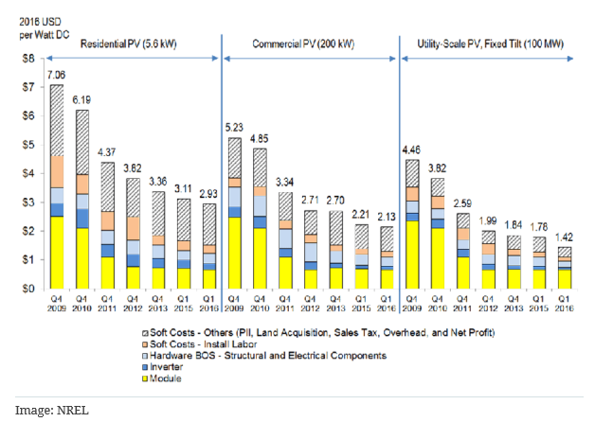

In order to achieve the 2015 iCAP objective of producing 12,500 MWh/year, we would need to install an additional and by FY25 at least 25,000 MWh, from solar installations on campus property.”

In order to achieve the FY20 goal of 12,500 MWh/year, it will require an additional 3.46 MW of installed capacity (dc).

12.27 acres * .282 MW = 3.46 MW
If we assume an installed cost of $2.00 per watt, that translates to an installed cost of $6.92 million.

In order to achieve the FY25 goal of 25,000 MWh/year, it will require an additional 12.79 MW of installed capacity.

45.34 acres * .282 MW per acre = 12.79 MW

If we assume an installed cost of $2.00 per watt, that translates to an installed cost of $25.6 million.

Simple Payback:
The project associated with achieving the FY20 iCAP goal will result in an additional 4,640 MWh/year.
At an average purchase price of $40/MWh that will result in annual savings of $185,600.
With an expected capital cost of $6.92 million, that results in a simple payback of 37.3 years.

The project associated with achieving the FY25 iCAP goal will result in an additional 17,140 MWh/year.
At an average purchase price of $40/MWh, that will result in annual savings of $685,600.
With an expected capital cost of $25.6 million, that results in a simple payback of 37.3years.

