Thank you for your commitment to green initiatives at the University of Illinois. One of the ongoing requirements listed in the terms of the funding agreement for your project is the submission of semesterly reports with key information about your project. In addition to this form, please provide additional financial documentation and/or progress photos if available.

Please be as accurate as possible in describing the project (including possible setbacks or challenges in meeting the initial goals of the project). Not fully meeting your project's goals will not disqualify you from making future funding requests as long as your reports are as complete and accurate as possible. If you have any questions, please contact the Student Sustainability Committee, at sustainability-committee@illinois.edu.
Project Name: Zero Waste Coordination

Date of Report Submission: 1/10/2018

Project Purpose:
This project is to expand the dual bins on the Quad to other areas of campus, increase use of recycling bins, and promote recycling solutions.

Detailed Accounting of Expenditures to Date:
So far we paid $842.80 for Anna Barnes in Customer Relations and Communications at F&S to help develop the content for a PowerPoint presentation to staff about how recycling on campus works – in the context of “Use the Bin!” We transferred $3,560 to iSEE for the student employees. As of 12/13/2017, we have paid $2,618 for Marya Ryan to draft content for the recycling presentation and glove recycling program, map the locations of outdoor waste bins on campus, and assist with research and communications related to glove, glass, battery, and EPS recycling.

Project Progress to Date:
Hired Marya Ryan as an Academic Hourly in Mar. 2017. She has been working about 5 hours per week since then, with occasional weeks off. Marya’s efforts are recorded weekly in the iCAP Portal under the main “Zero Waste” project at https://icap.sustainability.illinois.edu/project/zero-waste. She met with the SWATeam in the spring, and got up to speed on the ins-and-outs of the various special recyclables projects. Battery recycling information has been fully updated online at F&S and on the Portal. She made substantial updates to glove recycling material on the Portal, including instructions for new users. She has met with people asking about recycling on campus, including Jessica Tran at Ashton Woods and some faculty interested in a more detailed analysis of battery recycling impacts. She has updated battery recycling instructions on the Portal. She mapped the existing campus outdoor waste bins for the full University District and turned her maps over to the PWR SWATeam for their recommendations on locations for dual bins. She has worked on the glass recycling issue, which involves a new recycling sign for the small number of locations that will be funding their own glass recycling with their own facility (starting with the Wounded Vets building), and handling the recent issue that arose when CRI was sold to Midwest Fiber and they stopped the service for picking up the glass.

She coordinated with Olivia Harris at iSEE to strategize communication plans about teaching campus how the recycling system works here. She drafted the key message that will go to staff about “Use the Bin.” The Use the Bin messaging will be presented to key campus staff groups this spring by student intern Leah Berti. Berti will work with Morgan White to schedule these meetings and present the key message of “Use the Bin” so campus staff stop mistakenly telling students, visitors, and new employees that they can put recyclables in the trash cans.

Ryan also created an initial draft message to participants in the Styrecycle program, updating them about the current status of the program. She assisted with getting the EPS densifier transferred from Midwest Fiber to campus, when Midwest Fiber notified us that they are not willing to house it as CRI had done prior to the sale of the business. The possibility of installing the densifier at the Waste Transfer Station will be included in the scope statement for the Feasibility Study SSC funded this year for a new baler at that location. Ryan is currently working with the Illini Union Starbucks so that they can distribute used coffee grounds to area farmers.

In June 2017, we added a work order to pay for design work at F&S for Anna Barnes to help out. Using content Ryan developed about how the campus recycling system currently works, she created a PowerPoint presentation for staff. She is currently working on creating materials to promote the glove recycling program, using content from Ryan, White, and Kimberly Clark representatives.

In June 2017, we transferred the funding for the student interns to iSEE, so they could do the hiring and oversight of the students hired to help with the special recyclables. They hired two students for the Styrecycle program this summer, reporting to Micah Kenfield. The other special recyclables are: nitrile gloves, alkaline batteries, and glass. There is a SEE Minor student doing a capstone project on battery recycling, for no cost. The glass recycling is on hold while we address the lack of vendor issue. As soon as the glove marketing material is ready, we will talk to Micah about funding a student to increase participation rates with the various labs and food areas around campus.

We have not begun the building-specific solution efforts at this time. A student named Becky Jonas is volunteering with Morgan and the PWR SWATeam this spring to impact indoor recycling bins. She will start with Hydrosystems Lab, and then work with the buildings from the waste characterization studies. At each building, Jonas will be mapping the existing and proposed bins, working with facility and building service worker contacts, and modifying the indoor collection areas to increase recycling rates at the point of disposal.

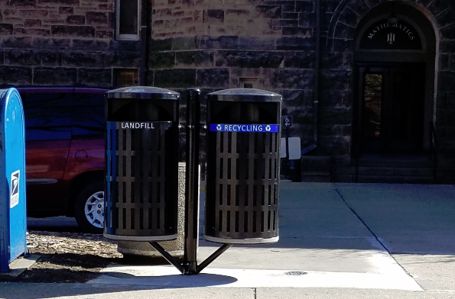
The outdoor bins have been completely mapped by Ryan, and an initial draft of the consolidation with dual bins outside has been written by Purchasing, Waste, and Recycling SWATeam student member Fangxing Liu. See image below with screen shot of one page of the map. Additionally, one sample dual bin was installed (with other funding) at Altgeld Hall near Wright Street, to test their durability. A photo of these bins is shown to the left.

The next steps for the outdoor dual bin expansion is to confirm the proposed location changes with the Grounds department, calculate estimated costs, and confirm the proposed style of bin is final. 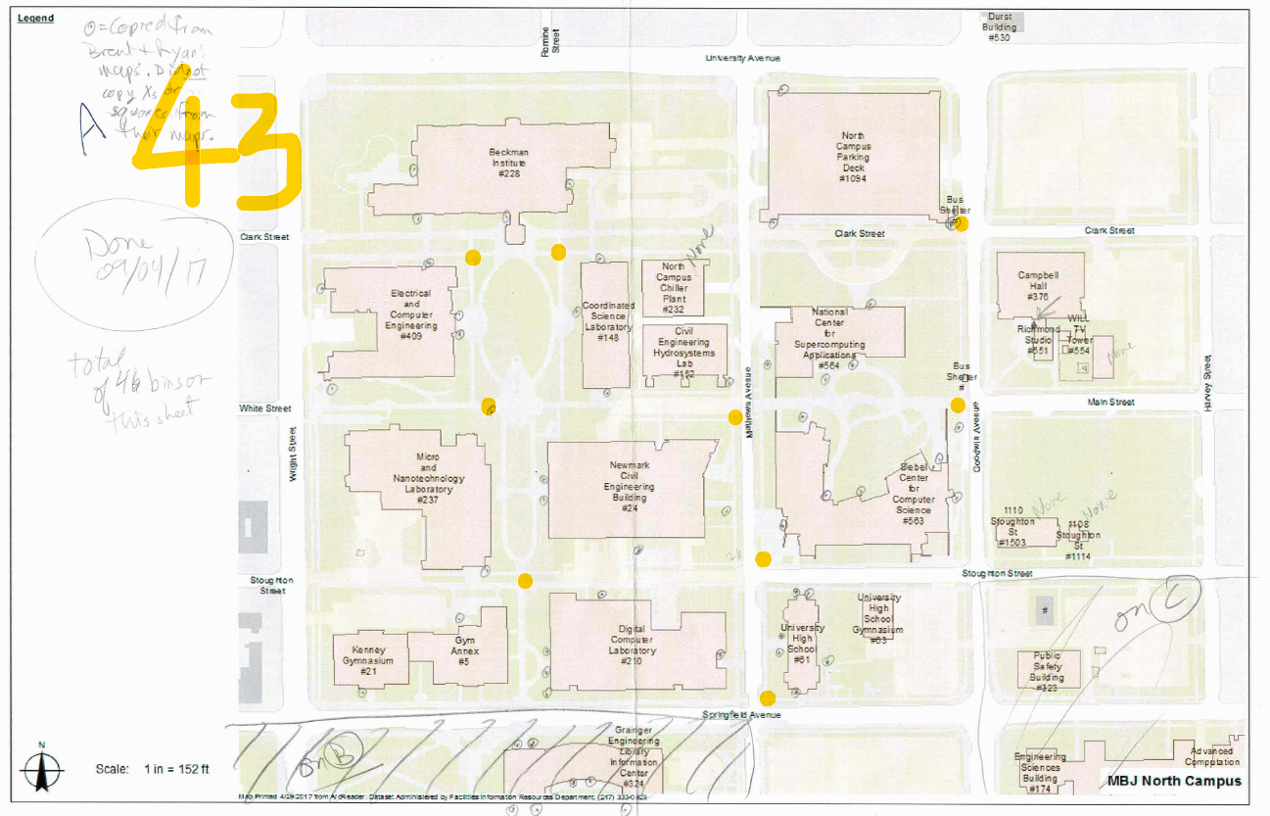

Student Involvement and Outreach to Date:
Over the summer, two students were hired for Styrecycle, with three interns working with them for course credit. Marcus Smith is doing a sustainability minor capstone project on battery recycling analysis. Leah Berti is working with Morgan for course credit to promote Use the Bin to staff. Becky Jonas is working with the SWATeam and Morgan to improve indoor recycling bin placement. Fangxing Liu provided the initial recommendations for changes to the outdoor bin locations.

Marketing and Promotion Efforts to Date:
So far the materials have not been promoted. The project is being tracked and updated on the iCAP Portal.

Additional Comments:
Any additional comments/relevant information for the semesterly report

