From time to time unforeseen challenges or opportunities can affect the planned budget, timeline, or overall goals of a project funded by the Student Sustainability Committee. Past examples of these situations include projects coming in under budget but having additional opportunities available, or inclement weather delaying the planting of agriculture projects.

Below please include a brief project summary and your requested changes. Attach additional documents as needed. If you have any questions, please contact the Student Sustainability Committee at sustainability-committee@illinois.edu.

General Information
Project Name: Illini Bikes – Campus Bike Share

Total Amount Requested from SSC: $86,795

Contact Information
Applicant Name: Lily Wilcock, Active Transportation Coordinator
Unit/Department: Facilities & Services – Sustainability
Email Address: lwilco2@illinois.edu
Phone Number: 217-244-6865

Project Information
Please provide a brief background of the project, the goals, and the desired outcomes:

SSC funding history for this specific funding award:
- The initial grant from FY15 was given for a proposed two year pilot bike share program (see https://icap.sustainability.illinois.edu/project-update/award-letter-bike-share). The iBike pilot was to include a fleet of 50 bikes with the use of smart locks. In fall 2015, iSEE purchased 12 bikes from Neutral Cycle and 12 locks from Bitlock to test the system. Bitlock used smart locks for a dockless bike share system, but in spring 2016 many hardware and software complications arose. In summer 2016, we ended our collaboration with Bitlock.
  - In fall 2016, a revised plan was submitted to SSC with the intention of partnering with Zipcar / Zipbike, under Lily Wilcock’s direction at F&S, to provide an externally managed system supported in part by seed funding from SSC. This scope change was approved in November 2016.
  - Due to corporate issues, Zipcar/Zipbike withdrew from negotiations with campus in spring 2017. Campus began pursuing alternative partners for the bike share program to ensure continuity. During these discussions, bike sharing companies from around the world started contacting both campus and city staff, to inquire about bringing their bikes to our area.
Current status of public bike sharing:
- Now, soon, any minute, bike share is coming to the University and community at no upfront cost. The current plan is that interested bike share companies will be required to obtain a city permit to operate, and the permitting process will address management concerns about the programs.
- These dockless bike share bikes will eventually be in the thousands rather than 50 bikes planned from this original funding request.
- The indirect cost to creating a successful bike share is improving bike parking’s density on campus. The main core of campus has very little “development ready” space. Most buildings and grounds around the Main Quad present challenges to increasing traditional bike storage spaces.
- Transitioning to vertical bike parking will allow the Main Quad area to increase bike capacity and improve students’ access to covered bike parking, thus reducing the stress of several hundred additional bike share bikes on campus.

Please provide a brief summary of how students will be involved in the project’s changes:
Students currently have many options for parking bikes near Altgeld Hall or the Main Library. Unfortunately, there is not enough capacity in those areas for the amount of bikes currently on campus, let alone when you add the bike share bikes to the mix.

Two vertical bike parking shelters will add 90+ bike parking spaces in one structure (Main Library) and add 25+ bike parking spots in a smaller (Altgeld) structure and help reduce the congestion at the existing bike racks.

Additionally, the public bike share systems will meet a persistent demand from students all across campus.

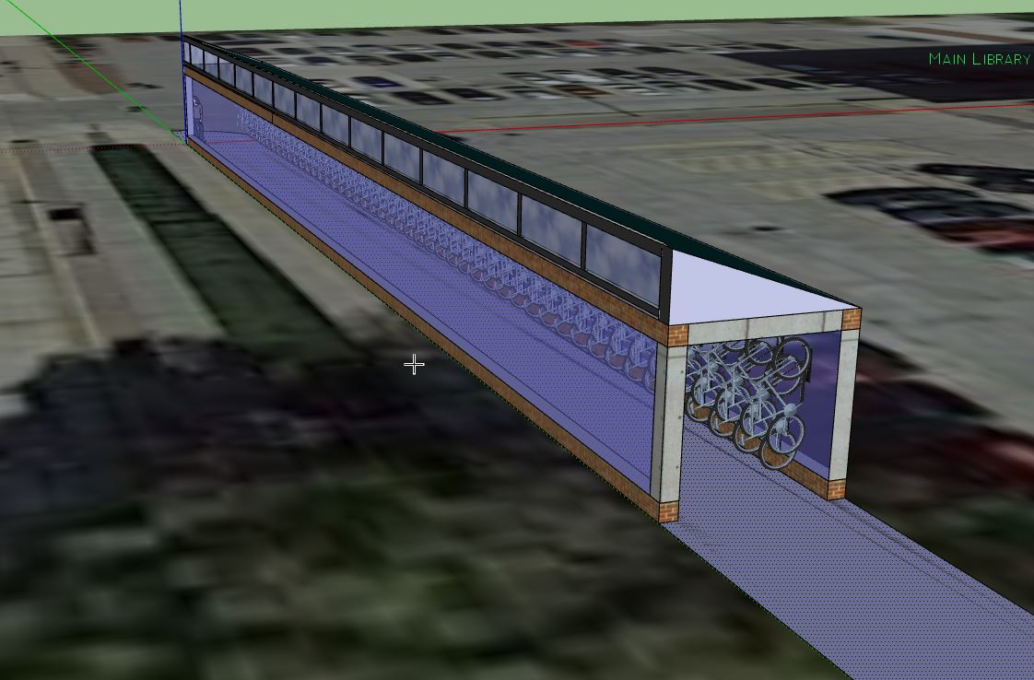
Main Library Proposed Shelter (West of Parking Lot E3)

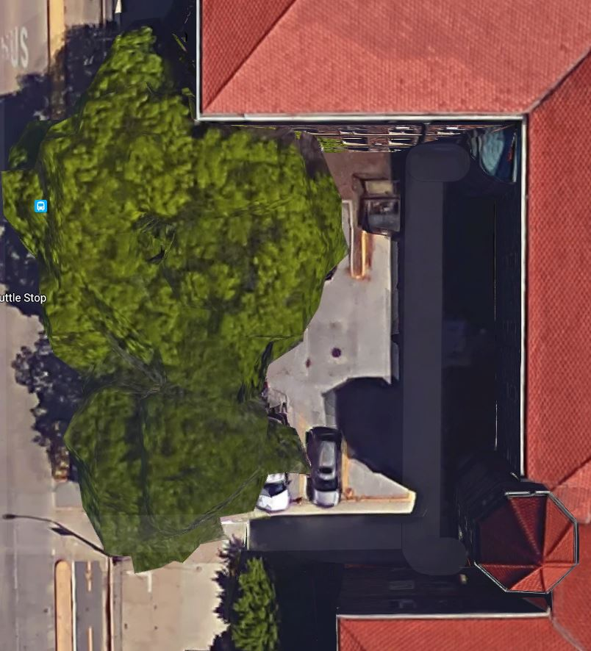
Altgeld Proposed Shelter Location (West side of building)
Please provide a brief summary of your requested scope change. How is your request different from your original plan?

The original grant was to buy bikes and Bluetooth-enabled locks for a campus-wide bike share. Now the bike shares are coming but in numbers that are unpreceded. Meanwhile, places like Altgeld and the Main Library need more bike parking and we could create a dense parking structure. Many cities with space problems transition to vertical bike parking structures or “double-decker” bike parking.

There is $78,631 left from the original funding award to iBike, and this should allow for purchase and installation of the two suggested vertical bike parking shelters. Please approve the use of these remaining funds for vertical bike parking shelters at Altgeld Hall and the Main Library, in support of additional parking spaces for public bike share bikes (as well as existing bikes on campus).

Current conditions (without bike share)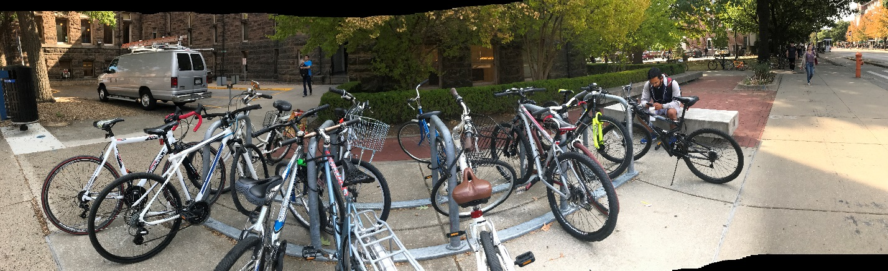
There are 13 bikes parking on these 5 u-loop bike rack. In the background there are an additional 15 bikes. 28 bikes total are in this picture. The Altgeld parking area is in this picture were the van is. The future bike parking structure should go here.
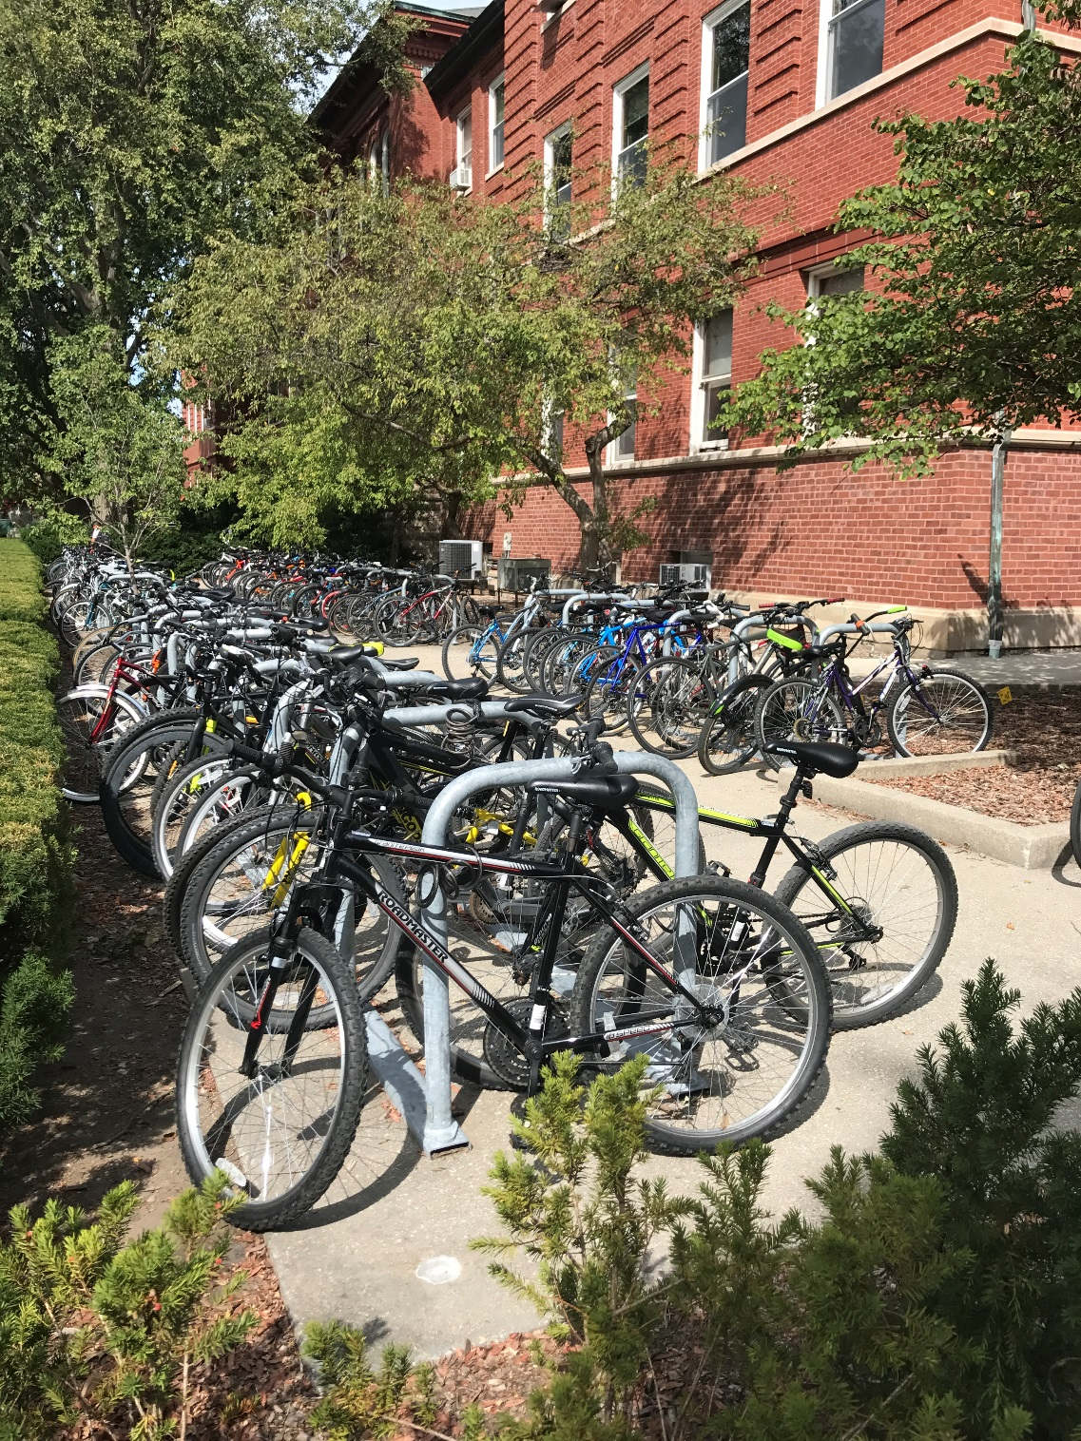
Brand new bike racks on the quad are always full. This is Noyes Lab. Turn the corner to Natural History Building and the scene looks the same.

Additional comments
Bike share is coming to campus! Let’s get serious about bike parking spaces before the existing problems get worse. This would be a great opportunity to show what a bike friendly campus we actually are!

