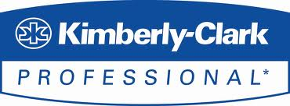
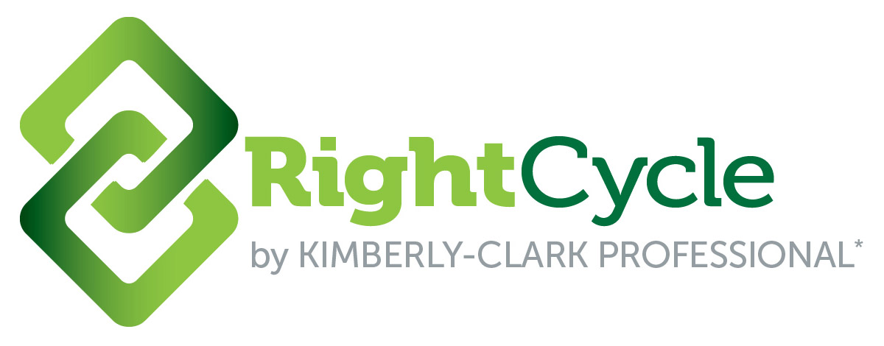

EDITOR CONTACTS:
Ginny Dunn, Kimberly-Clark Corporation
972-281-1481, media.relations@kcc.com

Iris Raylesberg, I.J. Ray Communications
215-518-0275, iris@ijray.com

Innovative Recycling Program Helps Two Midwestern Universities Turn
Used Gloves into Eco-Responsible Durable Goods

ROSWELL, Ga., November 14, 2016 – The Illinois Sustainable Technology Center (ISTC) at the University of Illinois Urbana-Champaign and Purdue University have diverted almost six tons of waste from landfills through an innovative recycling program that turns used lab gloves and garments into shelving, flowerpots and lawn and garden furniture.

Both institutions were looking for ways to reduce their solid waste streams and enhance their sustainability efforts. They found it in a program called RightCycle by Kimberly-Clark Professional, the first large-scale recycling program for non-hazardous lab and industrial waste.

Since its inception in 2011, RightCycle has diverted more than 350 metric tons of waste from landfills. In its first year, it diverted two tons of waste. The number of customers participating in the program has significantly increased, from just a handful at the start to almost 200 as of July 2016. Kimberly-Clark Professional is continuing to expand the program – bringing it to Western Europe and exploring expansion into other regions.

“We pioneered this program because we recognized that the sustainability goals of our university and pharmaceutical customers included reducing landfill waste, and single-use gloves accounted for a large percentage of that waste,” said Randy Kates, director of the Kimberly-Clark Professional Global Scientific Business. “We needed to find a recycling solution that helped them achieve their goals and enabled their people to be positively engaged in the process.”

RightCycle removes gloves, masks, garments, shoe covers and other apparel accessories from the waste stream and turns them into plastic pellets. These are then used to create eco-responsible consumer products and durable goods, such as lawn furniture, flowerpots and planters, shelving, totes and storage bins.

Illinois Success Story
The Illinois Sustainable Technology Center (ISTC) is a division of the Prairie Research Institute at the University of Illinois Urbana-Champaign. Its mission is to drive statewide economic growth through sustainability. To fulfill that mission, ISTC conducts scientific research and, in the process, uses a lot of gloves.
“We conducted a waste audit to see how we could go to zero waste in our own building and realized that gloves were about 10 percent of our total waste by weight,” said Shantanu Pai, ISTC assistant sustainability researcher. “We were already effectively recycling other items – glass, aluminum, paper and cardboard.”

With RightCycle, ISTC was able to reach 89 percent compliance for gloves in its labs – even higher than the rate for paper and cardboard recycling. It then decided to take the program a step further, piloting it in the University’s main dining hall and achieving an estimated diversion rate of 90 percent. It is in the process of expanding the effort to all dining facilities and campus labs. In fact, the university has purchased a storage container to house the gloves, so that shipments can be made just once a year.

Since implementing the RightCycle program in 2013, the Center and the University have diverted 4,945 pounds, or approximately 320,480 gloves, from landfills. “RightCycle has had a huge impact on our activities and our sustainability metrics,” said Kevin O’Brien, Ph.D., director of the Illinois Sustainable Technology Center. “If you ever used gloves as part of your laboratory work, you quickly appreciate the value this program brings from a sustainability perspective.”

Purdue University

Across its campus in the course of a year, Purdue University uses approximately 360,000 disposable gloves. That’s a lot of trash – 3.5 tons to be exact, all of which would normally wind up in a landfill.

The university, based in West Lafayette, Ind., has won numerous awards for sustainability. Its efforts extend to many different areas – recycling, planning management, landscaping and green construction. With a diversion rate goal of 85 percent, the university is always seeking new and different ways to reduce its solid waste stream.

In 2014, Purdue University added glove recycling to its list of sustainability accomplishments, when it adopted the RightCycle program. Since November 2014, the chemistry department at Purdue University has diverted 6,862 pounds of lab gloves from landfills, or approximately 444,718 gloves. Michael Gulich, director of campus master planning and sustainability, is looking to expand the program to other campus labs as well as food preparation areas.

“Once you address cans, bottles, paper and cardboard recycling, you get into smaller niche streams,” he said. “We have some addressed very well, such as electronics waste and landscape debris. Previously, gloves didn’t have a solution. Anything that increases our diversion rate is good.”

To learn more about the RightCycle program, visit www.kimtech.com/rightcycle.

Sustainability Leadership
Kimberly-Clark Professional has a long history of innovation and environmental leadership and has been recognized by leading environmental non-governmental organizations for its efforts. In 2015, it became the first major manufacturer in North America to produce bath tissue and towel products incorporating domestically sourced non-wood fiber. It also was the first away-from-home towel and tissue products company in North America to obtain Forest Stewardship Council (FSC) certification for a broad range of towel and tissue products and currently holds the largest portfolio of FSC certified towel and tissue products in North America. Its parent company, Kimberly-Clark Corporation, was recently recognized by the U.S. Environmental Protection Agency (EPA) Center for Corporate Climate Leadership with one of only 17 Climate Leadership Awards given nationwide for reducing greenhouse gas emissions. Kimberly-Clark Corporation also is
committed to achieving a goal of zero manufacturing and office waste to landfill. All K-C Global Nonwovens manufacturing facilities, which develop and manufacture fabrics and materials used to create products such as protective apparel and face masks, have consistently diverted more than 95 percent of their waste from landfills for the past 10 years. In 2015, Kimberly-Clark diverted more than 95 percent of its own manufacturing waste from landfills. For more information, visit www.kcprofessional.com or www.kimberly-clark.com

[KMB-B]

