Energy Performance Contracting

What is an ESCO?
An ESCO is an accredited Energy Service Company that provides all of the services required to design and implement a comprehensive project at the customer facility, from the initial energy audit through long-term guarantee of project savings through an Energy Performance Contract (EPC). The EPC provides customers with a comprehensive set of energy efficiency, renewable energy and distributed generation measures and is accompanied with guarantees that the energy and operational savings produced by the project will be sufficient to finance the full cost of the project.

Process
The process begins with the Preliminary Technical Audit (PTA) where multiple ESCOs provide high level analyses of a facility. The report provides a list of potential Energy Conservation Measures (ECMs) detailing what that particular measure will cost, what the expected annual savings will be, and payback time. The PTA is the primary basis for selection of an ESCO for a particular project. Once the PTA is complete and an ESCO is awarded the project, an Energy Audit Agreement is signed and the Investment Grade Audit (IGA) begins. The IGA is the last, and necessary, step before the full Energy Services Agreement (ESA) is signed and sealed. Essentially, the IGA affirms for the owner that the technical and economic bases for the project are sound. It will also serve as the critical reference in the event of savings/payback disputes if they occur. The IGA report will provide a final list and design of all potential Energy Conservation Measures (ECMs), related costs, and related guaranteed annual savings. If the University decides to proceed with a contract, the cost of the IGA will be rolled into the total project cost. The ESA is signed upon completion of the IGA, and construction can begin.

Vet Med ESCO Project (U11026)
The first EPC on any of the University of Illinois campuses is being executed at the Veterinary Medicine complex on South Lincoln in Urbana. The Vet Med ESCO project will provide innovative energy efficiency and technology, demonstrable energy savings, and long-term financing solutions for modernization of our facilities and energy infrastructure. By implementing this project, energy consumption at the Vet Med Complex will be reduced by nearly 40%. Notable ECMs included in the project are:
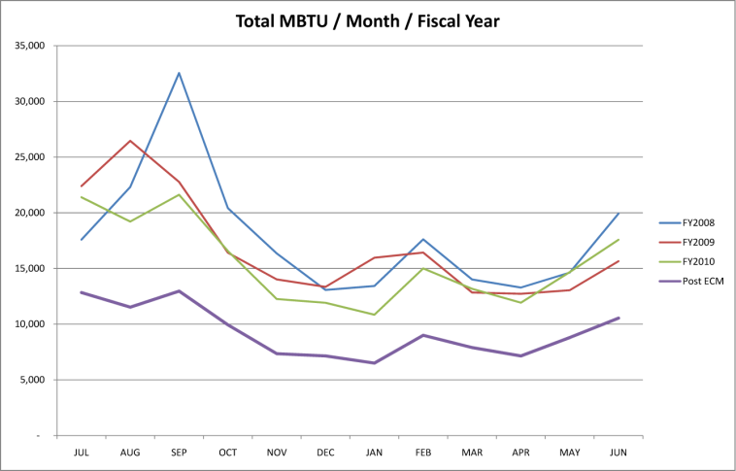
- Lighting Retrofits
- Occupancy Sensors
- Daylight Harvesting
- Water Conservation: DX Compressors/Sterilizers
- Steam Trap Replacement
- Coil Cleaning
- Duct Cleaning
- AHU Upgrades/Replacements
- Motor Upgrades
- Doors/Weather-Stripping
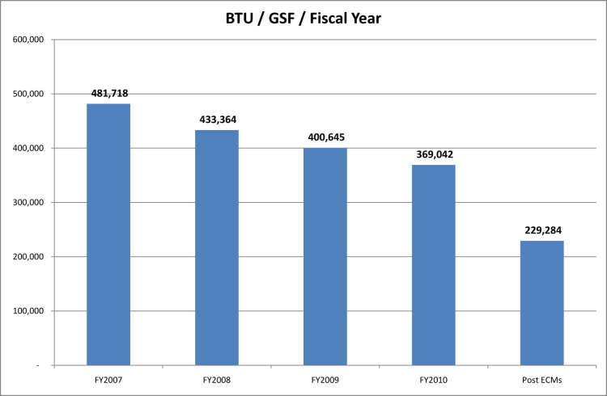
- Chilled Water Variable Flow Reset
- Cooling Tower Modifications
- Fume Hood Conversions
- Demand Control Ventilation
- Loading Dock Stat Relocation
- VAV Retrofit
- Roofing
- Ward Displacement Ventilation Control
- Insulation
- SAC South Wing Improvements

Along with the reduction of energy consumption, a significant amount of deferred maintenance is being reduced at the various Vet Med buildings. Approximately $20 million is expected to be eliminated from the deferred maintenance backlog. Additional benefits associated with this project include indoor air quality improvement, better quality of lighting, more reliable mechanical equipment, automated mechanical systems, and increased occupant comfort.

The total contract value, which is a guaranteed maximum price, is $21,262,345. There will be no change orders unless additional scope is added to the project. Multiple funding sources are being utilized to execute this project:
- Financed @ 3.24% $18,355,000
- AFMFA Funds $2,019,807
- Utilities $750,000
- Vet Med $239,253
- ICECF Grant $207,955
*Additional funds from DCEO are expected to be awarded and utilized as well. This will offset how much we use in the Financed category and used to increase scope.

Energy Systems Group (ESG) guarantees an annual savings of $891,734 which will result in an 18 year payback.

