2020 Illinois Bee Campus USA
A Plan for the Pollinators at the University of Illinois at Urbana-Champaign
September 14, 2020
Contents
Illinois Bee Campus Plan 2
Step 1a. Establish a Committee 2
Bee Campus Advisory Committee 2
2020 Committee Members 3
Sara Mason, Co-Chair/Queen Bee, saraem2@illinois.edu 3
Joseph Kreiling, Co-Chair, jwk5@illinois.edu 3
Teylor Hunter, Secretarbee, teylorh2@illinois.edu 3
Lauren Paddock, Bee Genius, lep4@illinois.edu 3
Blake Cedergren, Punmblebee, blakerc2@illinois.edu 3
Lily Reynolds, DesignerBee 3
Nicole Gamble, Beeliever, ngamble2@illinois.edu 3
Emily Guske, Beeliever, eguske2@illinois.edu 3
Morgan White, Staff, Associate Director for Sustainability at Facilities & Services 3
Brent Lewis, Staff, University Landscape Architect at Facilities & Services 3
Lesley Deem, Staff, Program Coordinator at the Pollinatarium, UI Extension 3
Adam Dolezal, Faculty Member, School of Integrative Biology 3
John Marlin, Staff, Prairie Research Institute 4
Meredith Moore, Staff, Institute for Sustainability, Energy, and Environment 4
May Berenbaum, Faculty Member, Department of Entomology 4
2020 Meeting Schedule 4
Step 1b: Develop a Habitat Plan 4
Integrative Pest Management Plan 4
Introduction 5
Integrated Pest Management Program 5
Acceptable Pest Levels 5
Preventive Cultural Practices 6
Monitoring 6
Mechanical Controls 7
Biological Controls 7
Pesticide Restrictions 7
Campus Native Plants List 8
Step 2. Bee Campus Awareness Event 9
Arbor Day Event 9
Step 3. Student Service-Learning Projects 9
Beekeeping Club at the University of Illinois 9
Red Bison Ecological Restoration Club 9
Step 4. Pollinator-Focused Courses 10
Step 5. Bee Campus Educational Signage 10
Illinois Pollinatarium 10
Temporary Signage 11
Permanent Signage 11
Step 6. Illinois Bee Campus Online 11
Bee Campus Website 11
Facebook Page 12
iCAP Portal Project Page 12
F&S Website 12
Step 7. Annually Apply for Renewal 12
Conclusion 12

Illinois Bee Campus Plan
The mission of the University of Illinois at Urbana-Champaign (U of I) is to enhance the lives of citizens in Illinois, across the nation, and around the world through our leadership in learning, discovery, innovation, engagement, and economic development. The mission of Facilities & Services (F&S) is to provide and maintain “a physical environment that is conducive to supporting learning, discovery, engagement, and economic development at the University of Illinois.” F&S is responsible for oversight of campus landscapes.
Campus is committed to educating the future leaders of the world, especially regarding grand societal challenges like environmental sustainability. The Institute for Sustainability, Energy, and Environment (iSEE) oversees the development of the strategic plan for campus sustainability, called the Illinois Climate Action Plan (iCAP). One objective is to “design and maintain campus landscapes in a more sustainable manner.” One component of implementing this objective is this Illinois Bee Campus Plan, including a formal integrated pest management program.
Bee Campus USA is an initiative coordinated by the Xerces Society for Invertebrate Conservation, an international nonprofit organization that protects wildlife through the conservation of invertebrates and their habitats. To be recognized as a Bee Campus, the U of I must commit to seven steps:
1. Establish a committee and develop a Habitat Plan
2. Host awareness event(s)
3. Sponsor and track student service-learning projects to enhance pollinator habitats​
4. Offer pollinator focused courses and/or workshops​
5. Post signage to educate campus ​and broader community
6. Maintain a web presence to share your Bee Campus USA news and activities
7. Annually apply for renewal
At the U of I we recognize that pollinators are an important asset for our campus and the community, and we are happy to commit to the above steps. They facilitate diversity in plant species and provide us with a variety of fruits and vegetables. Each year, we celebrate pollinators on campus with a variety of awareness and hands-on events. The U of I is dedicated to the conservation of pollinator species, and we plan to continue expanding our efforts throughout each year.

Step 1a. Establish a Committee

Bee Campus Advisory Committee
The Bee Campus Advisory Committee was created in 2018 by student chairperson, Rachel Daughtridge, in order to seek Bee Campus USA designation. This committee is an advisory body to the Campus Landscape Architect and the Superintendent of Grounds at F&S on matters relating to campus pollinators. Responsibilities for 2020 include:
- Lead the efforts of attaining the Bee Campus USA designation, and submittal of annual application when standards are met.
- Write and submit an Integrative Pest Management Plan for campus.
- Provide input regarding efforts to diversify the campus landscapes, including the formation of a native plant list.
- Plan a pollinator-awareness event for the student body on Arbor Day, April 27.
- Identify student service learning project(s) for 2020.
- Identify annual academic courses, including a unit about on pollinators.
- Design and post educational signage pertaining to pollinators on campus.
- Create a university web page describing the Bee Campus USA efforts on campus.
While responsibility for Bee Campus USA efforts are assigned to specific units, including F&S, the Arboretum, and students, the Advisory Committee assists by providing guidance for future planning, input to a comprehensive habitat plan, education of the campus community about pollinators, and development of a community connection related to our campus and community pollinators.
The Bee Campus Advisory Committee is asked to meet regularly during the spring and fall semesters and as needed during the summer months. Committee members are identified annually in the fall, and there is no term limit for committee membership.

2020 Committee Members
Sara Mason, Co-Chair/Queen Bee, saraem2@illinois.edu
Joseph Kreiling, Co-Chair, jwk5@illinois.edu
Teylor Hunter, Secretarbee, teylorh2@illinois.edu
Lauren Paddock, Bee Genius, lep4@illinois.edu
Blake Cedergren, Punmblebee, blakerc2@illinois.edu
Lily Reynolds, DesignerBee
Nicole Gamble, Beeliever, ngamble2@illinois.edu
Emily Guske, Beeliever, eguske2@illinois.edu
Morgan White, Staff, Associate Director for Sustainability at Facilities & Services
Brent Lewis, Staff, University Landscape Architect at Facilities & Services
Lesley Deem, Staff, Program Coordinator at the Pollinatarium, UI Extension
Adam Dolezal, Faculty Member, School of Integrative Biology
John Marlin, Staff, Prairie Research Institute
Meredith Moore, Staff, Institute for Sustainability, Energy, and Environment
May Berenbaum, Faculty Member, Department of Entomology

2020 Meeting Schedule
The committee was formed at the beginning of the spring 2018 semester. After the initial meeting, the advisory committee met in sub-committee groups to focus on specific tasks. Some items were completed via email.
- Bee Spotter Events - 9/14/19, 10/5/19, 4/28/19
- Environmental Ballroom Day - 9/3/19
- Environmental Quad Day - 4/22/19, 10/4/19
- Climate March - 9/20/19
- Bee Identification Workshop - 10/8/19
- Campus Sustainability Celebration - 10/23/19
- Red Oak Rain Garden Opening Ceremony - 10/24/19
- Native Plant Species List Collaboration - 11/6/19, 11/13/19
- Making Pollinator Habitat Work on the Modern Landscape - 3/18/19
- Wildflowers Workshop - 5/16/19
- Champaign Prairie Areas - 7/15/19
- Buzz on Native Bees - 7/22/19
- Illinois Monarch Project - 8/19/19
- Native Plants in the Landscape - 1/27/20
- Honey Bee Class - 1/16/19

Step 1b: Develop a Habitat Plan
The purpose of the Habitat Plan is to document and clarify the campus commitment to maintaining habitat for pollinators. The programs and policies previously in place have been updated to reflect the current industry standards and procedures for environmentally-conscious pest management. With the goal of becoming a recognized Bee Campus, this document describes the existing practices and identifies areas for improvement.
Planning and oversight of improvements on external landscapes for campus are under the responsibility of the Campus Landscape Architect in the Capital Programs division at F&S. This Habitat Plan is the responsibility of F&S Capital Programs. The Integrated Pest Management Plan has been adopted by F&S Grounds, which manages 962 acres on campus—the majority of landscaped areas.

Integrative Pest Management Plan
For several years, F&S Grounds has operated using an informal integrated pest management (IPM) protocol. In conjunction with this Bee Campus effort, the IPM program has been formally documented and adopted. It is published on the F&S website and reprinted below:

Introduction
The mission of the University of Illinois at Urbana-Champaign (U of I) is to enhance the lives of citizens in Illinois, across the nation, and around the world through our leadership in learning, discovery, innovation, engagement, and economic development. The mission of Facilities & Services (F&S) is to provide and maintain “a physical environment that is conducive to supporting learning, discovery, engagement, and economic development at the University of Illinois.” F&S is responsible for oversight and maintenance of the U of I Grounds.
The U of I formally committed to environmental sustainability in 2008 by signing the Climate Leadership Commitments with Second Nature. The 2015 Illinois Climate Action Plan (iCAP) is the campus strategic plan for meeting these commitments, and as part of this plan F&S has implemented a thorough Integrated Pest Management (IPM) program to reduce the use of pesticides on the exterior of the main campus. This IPM program also fulfills the final portion of objective #7.2 in the iCAP.

Integrated Pest Management Program
This document outlines the fundamental aspects of U of I’s IPM strategy, including:
- Acceptable pest levels
- Preventive cultural practices
- Monitoring
- Mechanical controls
- Biological controls
- Pesticide restrictions
All employees who apply pesticides go through rigorous training and education to become State Licensed Public Pesticide Operators or Applicators. This high level of training, along with monthly meetings, ensures that F&S employees understand and follow the IPM strategy.

Acceptable Pest Levels
Transforming university campuses into “living laboratories” is part of the iCAP sustainability effort, and F&S supports this effort by providing opportunities to interact with the campus landscape and expose students to a variety of situations in the landscape in which to learn and observe. Thus the emphasis is on control of pests on campus, not eradication. IPM also holds that wiping out an entire pest population is often impossible, and the attempt can be expensive and environmentally unsafe.
F&S typically only uses pesticide treatment for targeted turf maintenance. Insecticide usage is very limited and is generally utilized on small plantings of roses that are struggling with Japanese beetles. F&S does not spray any insecticides or fungicides on campus trees, and it is used on landscape plants (shrubs, perennials, annuals, grass, etc.) only if the pest has affected the plant to the point it is causing significant harm. Of note, F&S has not sprayed campus trees for any reason in approximately 15 years. In addition, F&S has eliminated all insecticide/herbicide use at the President’s House grounds (+/-7 acres) in May 2015. The goal is to keep the pests in check using a combination of methods, with pesticides being the last resort.

Preventive Cultural Practices
Selecting varieties best for local growing conditions and maintaining healthy crops is the first line of defense for optimum cultural practices. F&S Grounds is working to replace the outdated Kentucky Bluegrass / Ryegrass mix in favor of a more durable Turf Type Tall Fescue mix in all lawn panels. This shift will allow for more sustainable irrigation practices and lawns that are more resistant against high levels of foot traffic. During summers, the fescue lawn will help to out-compete weeds better than the bluegrass mix, thus allowing a further reduction in the use of herbicides on campus.
In addition to choosing diverse and local crops to implement on the main campus, F&S uses techniques such as plant quarantine and crop sanitation. This includes practices such as the removal of diseased plants and regularly cleaning pruning shears to prevent the spread of infections. F&S Grounds Workers remove leaves and herbaceous plant material that have died and transport them to the maintenance facility. The material is placed in windrows where it gets turned a few times each year until it has broken down into compost. F&S also removes any infected plants/trees and/or limbs identified on campus.

Monitoring
Regular observation is the cornerstone of IPM. Observation is broken into two steps: inspection and identification. The Grounds department consistently inspects the different areas of campus; all of the staff are trained and knowledgeable on what to look for and how to identify the presence of pests. There are three main indicators that pests have reached a level of economic and ecological threat:
- When the plant is dying (e.g., turf grass that is infected with grubs to the extent of large brown patches)
- When the plant is defoliating prematurely due to an insect infestation (defoliation from fungal reasons are treated with sanitation methods only)
- When a plant’s foliage is being eaten to a point where aesthetics are being negatively affected (i.e., off color, not blooming, appears defoliated, etc.).
If the plant or grass is in the historic core of campus and has aesthetic/marketing/intrinsic value, F&S would consider applying pesticides when any of the above is present.
In order to use pesticides/herbicides on campus, F&S Grounds Workers are licensed by the Illinois Department of Agriculture every three years. The license is valid from January 1 through December 31. Licenses must be renewed every year and a retest is required every third year. Employees attend what is called a “general standards training” before taking a thorough exam. Grounds Workers must have, at minimum, the general standards pesticide operator license, and supervisors must obtain a pesticide applicator license by passing the general standards plus a category exam (turf, right of way, ornamental, and/or aquatics). This serves U of I well, as any Grounds Worker can help to identify and address pests and outbreaks on the campus.

Mechanical Controls
Mechanical controls are another important line of defense in pest management. Should a pest reach an unacceptable level, mechanical methods are the first option, including using string trimmers to reduce the level of weed growth.
Additionally, F&S utilizes large amounts of green waste wood chips in the planter bed areas of campus to suppress weeds. Application of the wood chips helps to reduce the amount of germination from weed seeds in the soil while also moderating moisture levels. For difficult sites to maintain, a layer of crushed granite may be used in lieu of mulch to suppress weed growth. The previously mentioned sanitation, in addition to the mulch regiment greatly assist the overall pest management.
The university is also able to leverage public assistance with mechanical controls of weeds as part of a social and educational forum. F&S is one of the sponsors of the Boneyard Creek Community Day. The purpose of the event is “to engage the community in awareness and responsibility of naturalizing and sustaining our waterways through organized litter clean up, education and removal of invasive species to restore natural habitat and showcase the amenity value of a healthy ecosystem.”

Biological Controls
Natural biological processes and materials can provide control with minimal environmental impact, and often at lower cost. The focus here is to promote beneficial insects that eat or parasitize target pests. The U of I planting designs incorporate specific types of flowering plants that attract predator insects, in order to naturally encourage an acceptable predator/pest balance. The planned Turf Type Tall Fescue mix is one example of this type of control.

Pesticide Restrictions
When required, F&S Grounds uses only the safest, lowest toxicity products possible for effective control of pests. The university is committed to encouraging and protecting pollinators, and therefore Grounds limits the use of herbicides that contain neonicotinoids. Primarily these products are used in the Main Quad’s lawn panels during high stress seasons. As they are used exclusively in a limited lawn panel area and in a granular form, impact to the local pollinator community is minimized. However, F&S will be trialing alternatives in FY19 to find effective non-neonicotinoids. At all locations of treatment areas, F&S will continue to post highly visible signs informing the public of what is being applied, where it is being applied, and when it is being applied.
Synthetic pesticides are used only as required and often only at specific times in a pest’s life cycle. Many of the newer pesticide groups are derived from plants or naturally occurring substances (e.g., pyrethrum and insect juvenile hormone analogues), but the toxophore or active component may be altered to provide increased biological activity or stability.
Applications of pesticides must reach their intended targets. Matching the application technique to the crop, the pest, and the pesticide is critical. The use of low-volume spray equipment reduces overall pesticide use as well as labor costs. Pesticide-use at the U of I complies with all local, state, and federal regulations. No “restricted use” pesticides will be used.

Campus Native Plants List
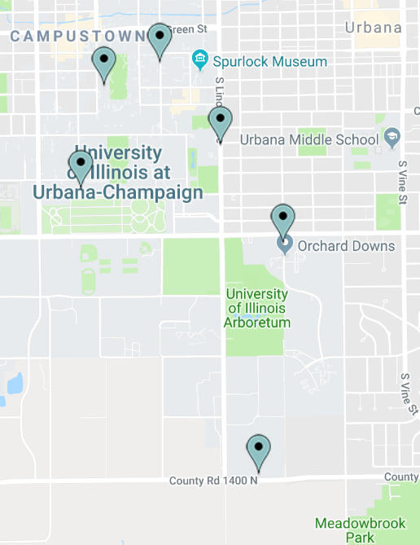
A detailed list of native plants located at key places on campus is published online at the Bee Campus web page. Scientific and common name of each plant species are included in this Native Plants List, in addition to their location(s) on campus.
The key locations for native plant installations are listed below and shown on the map to the right.
- Lincoln Avenue Residence Hall (LAR)
- Florida Orchard Prairie
- South Arboretum Woods (SAW)
- Burrill Hall Walkway
- Natural Resource Building
- Chi Omega Plaza
Specifications on which of these plant species supports pollinators will be added upon submitting our next Bee Campus USA application. Additionally, the Campus Landscape Architect will continue integrating Illinois native plants into the main campus landscape, referencing the approved plant list from the campus Facility Standards.
Recommended locally native plant species list
https://iiseagrant.org/publications/illinois-native-plants-for-the-home-landscape https://iiseagrant.org/publications/pollinator-garden-native-plants-for-attracting-pollinators/ https://iiseagrant.org/publications/rain-garden-a-native-planting-guide-for-rain-garden-beds

Step 2. Bee Campus Awareness Event

Arbor Day Event
The first annual Bee Campus awareness event was held on Arbor Day, April 27, 2018, from 7:30-9:30 p.m., hosted by the Advisory Committee. The purpose of this event was to educate undergraduate students about factors threatening bee populations, while also promoting the Bee Campus USA mission. Main activities included presentations of educational posters, and pollinator-related trivia. The program also included an official screening of ‘Bee Movie’ with refreshments. This event was funded by the Sustainability Living-Learning Community in University Housing.
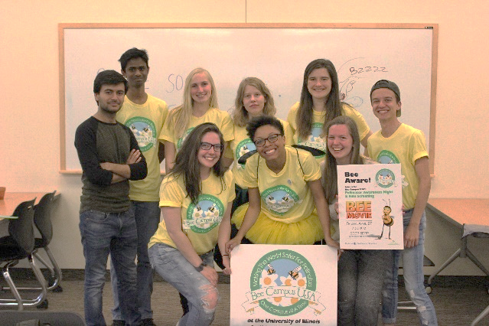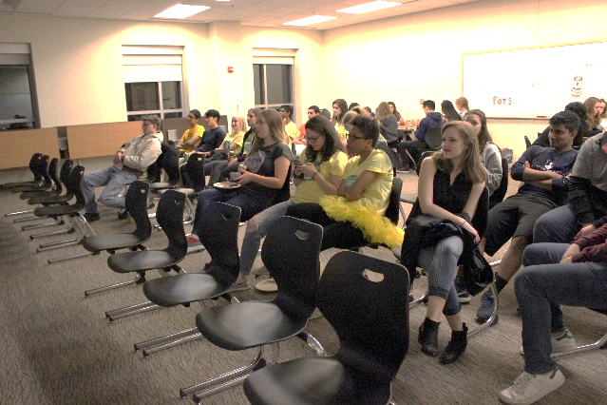

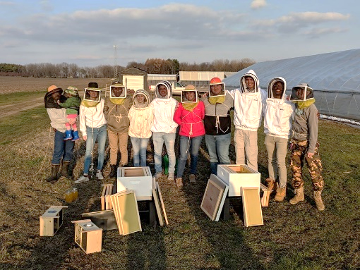
Step 3. Student Service-Learning Projects

Beekeeping Club at the University of Illinois
Beekeeping Club at the University of Illinois is a registered student organization on campus. Their primary focus is maintaining bee hives at the Student Sustainable Farms. The club meets weekly for hive maintenance and offers various educational seminars to the public pertaining to bees.

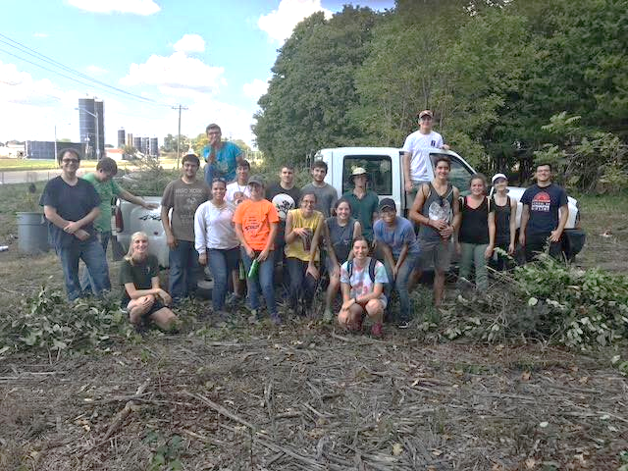
Red Bison Ecological Restoration Club
Red Bison is a registered student organization at the University of Illinois Urbana-Champaign and is a program of the University YMCA. Their primary focus is on restoring natural areas on and near campus, and they also appreciate local flora and fauna throughout Illinois. The club meets on a weekly basis to restore Illinois' prairies and woodlands by planting native plants, removing invasive species, and creating landscapes to maintain biological diversity around campus.

Step 4. Pollinator-Focused Courses
The Department of Entomology has a wide variety of courses, many with units surrounding pollinators:
IB 105: Environmental Biology
IB 335: Systematics of Plants
IB 329: Animal Behavior
IB 444: Insect ecology
IB 451: Conservation Biology
IB 526: Seminar in Entomology

Additionally, there are courses in other departments that help students understand the importance of supporting pollinators, reducing harmful chemical usage, and increasing the use of native plants.

Step 5. Bee Campus Educational Signage

Illinois Pollinatarium
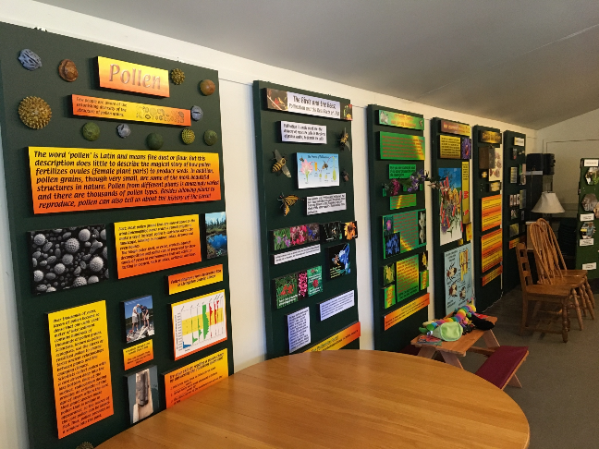
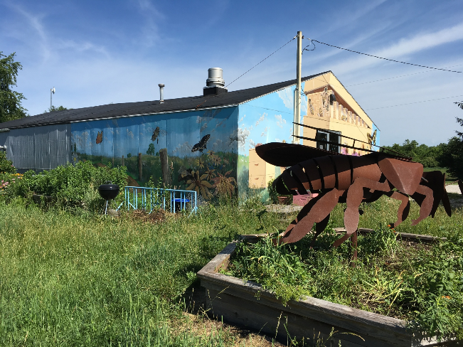
The University of Illinois Pollinatarium (https://pollinatarium.illinois.edu/welcome/) is a Discovery Science Center dedicated to promoting awareness of pollinators. Their facility displays a wide variety of educational signage, ranging from facts about habitat to pollinator-identifying trivia.

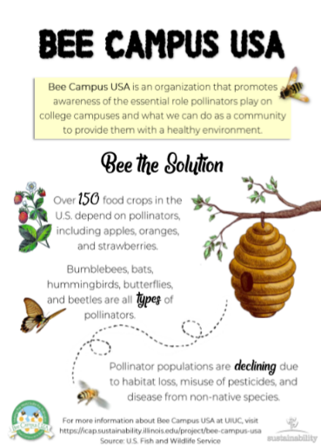
Temporary Signage
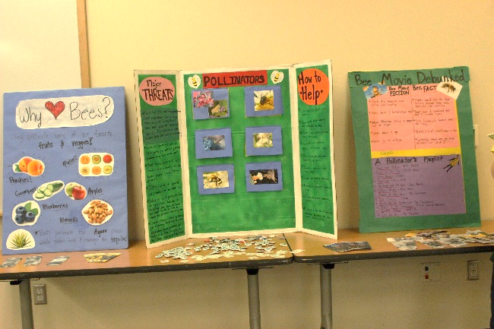
Posters designed by the advisory committee were displayed throughout the main campus on building bulletin boards. This simple design allowed the advisory committee to spread awareness to students and faculty during the Spring 2018 semester.

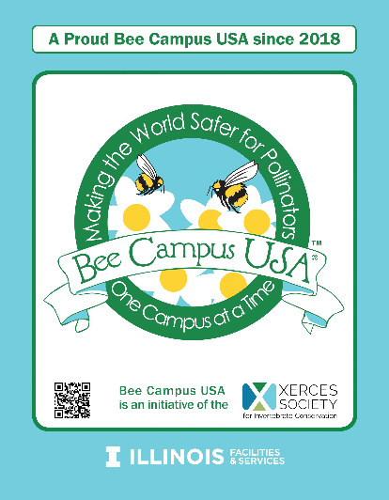
Permanent Signage
During March 2018, the advisory committee was awarded a $3,000 grant from the Student Sustainability Committee. Through this grant, we are able to install permanent, metal signage that (1) announces the university’s Bee Campus USA designation, (2) declares an area on campus as pollinator-friendly, and (3) explains the significance of a pollinator-friendly campus. These signs were created after our university received the Bee Campus USA designation, so that we could include the logo and designation in the designs.
In spring 2020, four of these signs were installed on campus at pollinator supportive locations at Lincoln Avenue Residence Hall, Wassaja Residence Hall, the Natural Resources Building, and Burrill Hall.

Step 6. Illinois Bee Campus Online

Bee Campus Website
The Bee Campus USA website for the U of I is http://beecampususa.web.illinois.edu/index.html. This student-run website connects the public to all activities in which the Advisory Committee is involved. In addition, it provides links to several other organizations actively supporting pollinators and other native wildlife. The “Events” tab of the site includes all past and upcoming events hosted by the advisory committee. The “Habitat Plan” tab of the site displays our campus’ Integrative Pest Management Plan, native plant list, and a map of where to find pollinator-friendly plants on campus (currently in progress). The “Facts and Tips” tab lists several ways to support local pollinators through gardening.

Facebook Page
The Bee Campus USA Advisory Committee also maintains a Facebook page to interact with the public, at https://www.facebook.com/Bee-Campus-USA-at-UIUC-228849297661692/.

iCAP Portal Project Page
The iCAP Portal is a repository of campus sustainability efforts, noting key dates, contacts, and project history. The Bee Campus USA efforts are documented on the iCAP Portal, at https://icap.sustainability.illinois.edu/project/bee-campus-usa.

F&S Website
The official U of I website for this effort will be published through the F&S website, under the Grounds department page. Currently, the Integrated Pest Management program is on this site at http://fs.illinois.edu/services/more-services/grounds/integrated-pest-management. When Bee Campus USA designation is approved, a new page in this section will be added, called “Bee Campus USA,” similar to the Tree Campus USA page.

Step 7. Annually Apply for Renewal
The U of I is very happy that students have initiated and led this application for the Bee Campus USA designation. F&S herein confirms accepting responsibility to oversee the reapplication process for annual renewal of the Bee Campus USA designation.

Conclusion
Pollinators are fundamental to wildlife and human well-being around the globe. Their vitality to biodiversity and food production is highly valued on our campus, and we believe solutions begin with awareness. The University of Illinois at Urbana-Champaign is pleased to present this 2020 Bee Campus USA application and celebrate the benefits of our campus pollinators.

https://xerces.org/pollinator-conservation/
http://fs.illinois.edu/services/more-services/grounds/integrated-pest-management
http://beecampususa.web.illinois.edu/HabitatPlan.html
Download excel file from http://beecampususa.web.illinois.edu/plantList.xlsx
http://fs.illinois.edu/docs/default-source/facility-standards/exhibits/exhibit-32-93-00-01-approved-plant-list.pdf?sfvrsn=bf22feea_4

