Thank you for your commitment to green initiatives at the University of Illinois. One of the final steps in completing the terms of the funding agreement for your project is the submission of a Final Report with key information about your project. You will also need to submit a detailed report of expenses (if you don't list it within this document) as well as supporting photos to showcase your project.

Please be as accurate as possible in describing the project (including possible setbacks or challenges in meeting the initial goals of the project). Not fully meeting your project's goals will not disqualify you from making future funding requests as long as your reports are as complete and accurate as possible. If you have any questions, please contact the Student Sustainability Committee, at sustainability-committee@illinois.edu.
Project Name: Speech and Hearing Building Solar

Date of Report Submission: 1/28/2019

Project Purpose:
Design and install rooftop solar PVs on the Speech and Hearing Sciences Building, in the amount possible with $40,000.00.

Project Summary:
This project was originally proposed by Mechanical Engineering students for Abbott Power Plant in spring 2016. At that time, the SSC members did not want to support solar on the co-generation power plant because it uses fossil fuels. They asked if we could use it on a different campus roof, and we considered all the large or medium campus roofs.

The SSC asked us to identify a building that could have solar added, so I reached out to Applied Health Sciences in 2016 for approval to use the Speech and Hearing Sciences Building. Since that time, Kristine Chalifoux confirmed that the roof is strong enough for solar panels, due to a previous change in the insulation materials. Brian Finet completed design drawings for installing solar on the full available roof, and the Architecture Review Committee confirmed the building is allowed to have solar added.

After the engineering design work, the remaining funds were about $35K. This fall, we received a construction estimate from Jeff Holt for upgrading the electrical system to handle a 70 kW solar PV array. It would cost about $42K if done in conjunction with your capital project, just to get the wiring up to the roof and ready to punch through and install panels later. Rather than ask the SSC for additional funding and an extension, I am returning the remaining dollars and putting this project on indefinite hold.

The overall campus goals for on-campus solar generation are listed in the 2015 Illinois Climate Action Plan (iCAP), which will be updated for 2020. The current objective is to generate 25,000 MWh/year of on-campus solar, and we are currently at about 7,000 MWh/year. Per the direction received from Chancellor Jones, we are working on a second large-scale solar farm to meet the goal, rather than several smaller-scale projects.

The second solar farm is planned to be about 12,000 kW in name-plate capacity, significantly more than the 70 kW rooftop array for Speech and Hearing. Rooftop solar is still an option, and several departments continue to install them at the building scale. The design drawings are posted online through the iCAP Portal, at https://icap.sustainability.illinois.edu/project/speech-and-hearing-rooftop-solar-pvs, for future use.

Summary of Project Expenditures:
We paid a total of $5,132.54 for Engineering Design work by Brian Finet and Kristine Chalifoux at F&S. That leaves $34,867.46 to be returned to the SSC.

The total rooftop array could be 206 340-Watt panels, for a maximum system size of 70.04 kW DC. Based on a typical installation cost of $3.00/Watt, the total install for the full roof array would be well over $200K.

Problems/Challenges Encountered
The first challenge was resolving a location for the rooftop solar. The request was for installing a 19 kW ballasted solar array on Abbott Power Plant, but the SSC voting members did not support installing it at Abbott. Students Corey Weil and Niharika Kishore helped identify a new location, and we got permission from the Architectural Review Committee.

The second challenge was that the original funding request of about $65,000 was not available in spring 2016. The funding provided by SSC was $40,000, and it was understood this would likely support an array of 11 kW instead of the original plan for 19 kW. There was the also a discussion at that time about potentially covering the entire roof with solar. The SSC asked that we develop a design for covering the full roof, rather than just the small 11 kW that current funding allowed.

The next challenge was about the installation coordination. Because the location was selected by students and at the request of SSC, I reached out to the building occupants. I contacted the dean and department head to confirm they would accept responsibility for the (minimal) maintenance of the solar panels, once installed. In May 2016, the College of Applied Health Sciences agreed the project could proceed, provided the installation occurred during the planned capital project. Construction on that project (U10043) was originally planned to start in spring 2017, but it was delayed to summer 2018. That construction will be completed in summer 2019, over a year after the deadline for this SSC funding award.

The final challenge was related to installation costs. The total rooftop array could be 206 panels with 340 watts each, for a maximum system size of 70.04 kW DC. Based on a typical installation cost of $3.00/Watt, the total install for the full roof array would likely be over $200K. After the engineering design costs, there is just under $35,000 for installation. A notable portion of the installation costs is a required upgrade to the electrical panels inside the building, as well as connections from the solar panels on the roof to the electrical panel in the basement.

A preliminary estimate for doing the required electrical upgrades is $41,733.89. This is based on 2018 data, and it does not even provide the punch through to the roof. It is also based on doing the electrical work in conjunction with the ongoing capital construction project, which reduced the work needed to access the electrical wires above drop ceilings. To complete the electrical upgrade in the future will certainly cost more than $42K, and then the solar array costs would be in addition to that.

Student Involvement and Outreach to Date:
This project has involved students through discussions and ideation. The initial proposal came from a student class group, but the materials they selected are no longer available to purchase. One of the key student advocates for rooftop solar, Corey Weil, helped identify the Speech and Hearing Sciences Building as a good option for this effort. Niharika Kishore completed a proposal for a full scale rooftop solar PV retrofit for several campus buildings to reach the iCAP objective of 12,500 MWh/year of on campus solar generation by 2020. Niharika and Corey both participated in the F&S discussions through May 2017.

Marketing and Promotion Efforts to Date:
This solar array effort is on the iCAP Portal at https://icap.sustainability.illinois.edu/project/speech-and-hearing-rooftop-solar-pvs.

The image below is a view for the location of the proposed solar array, as seen from the parking deck at Fifth and Daniels.
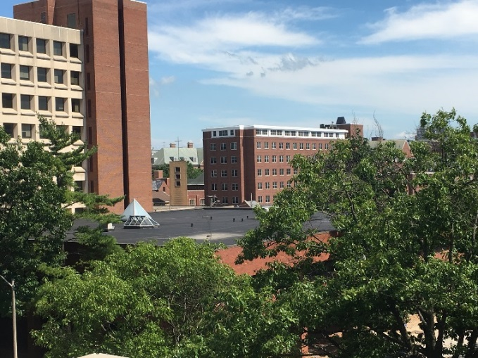
Additional Comments:
Kristine Chalifoux reviewed the roof structure and she found that the original structure was designed for a heavy roof structure which was subsequently upgraded to a lighter insulation material. Thus, the roof has plenty of capacity for the solar PVs and will not require a formal engineering review by a licensed structural engineering consultant.

