Illinois College Assistance Program (I-CAP) for Recycling
2020 Waste Reduction Plan

Submittal Information
Please provide an electronic version of the waste reduction plan to the email address listed below by 4 pm on April 1, 2020.

Jessica Miller
Illinois Environmental Protection Agency
1021 North Grand Avenue East
P.O. Box 19276
Springfield, IL 62794-9276
Email: Jessica.H.Miller@illinois.gov
Phone: 217-524-7948
__________________________________________________________________________________

Date: 12/31/2020
Institution Name:
Mailing Address:
Authorized Contact:
Contact Title:
Contact Phone:
Contact Email:

Section 1– Background

1.1) Institution Identification

Since its founding in 1867, the University of Illinois at Urbana-Champaign has earned a reputation as a world-class leader in research, teaching, and public engagement. A talented and highly respected faculty is the university’s most significant resource. Many are recognized for exceptional scholarship with memberships in such organizations as the American Academy of Arts and Sciences, the National Academy of Sciences, and the National Academy of Engineering, and with awards such as Nobel Prizes, Pulitzer Prizes, and the Fields Medal in Mathematics.

The campus has a fundamental commitment to undergraduate education. More than 33,000 undergraduate students are enrolled in the university’s colleges, which together offer some 5,000 courses in more than 150 fields of study. The campus enrolls more than 12,000 graduate and professional students in more than 100 disciplines. It is among the top five universities in number of earned doctorates awarded nationally each year.

Also integral to our mission is a commitment to public engagement. Each year about 65,000 Illinois residents participate in scores of conferences, institutes, courses, and workshops presented statewide. Research and class projects take students and professors off campus to share expertise and technical support with Illinois farmers, manufacturing firms, and businesses. In a typical year, student volunteers log more than 60,000 volunteer hours.

Facilities & Services (F&S) provides all physical plant, operational, and essential services for sustaining an environment that fosters the research, teaching, and public engagement activities of the university. The organization employs more than 1,000 dedicated men and women serving in both Civil Service and Academic Professional positions. The F&S goal is to support the university's education, research, and outreach missions by improving the physical condition of the facilities and grounds, reducing energy consumption through education and use of alternative fuel sources, and increasing customer satisfaction by providing quality services in a responsive, reliable, and customer-focused manner.

1.2) Contacts

Plan Coordinator
Name: Morgan White
Title: Facilities & Services Associate Director for Sustainability
Address: 1501 S. Oak Street Champaign IL 61820
Phone Number: 217-333-2668
Email: mbwhite@illinois.edu

Recycling/Sustainability Coordinator
Name: Shantanu Pai
Title: Interim Zero Waste Coordinator, Assistant Sustainability Researcher
Address: 1501 S. Oak Street Champaign IL 61820
Phone Number: 217-300-2046
Email: recycling@illinois.edu
1.3) Student/Staff Population

For the 2020 Fall semester the University had an enrollment of 49,214 FTE students. For the 2018 Fall semester the University had a total of 8,550 students residing on campus. Note, the data for 2020 residents are atypical due to COVID-19. In 2019-2020 14,501.77 total FTE faculty and staff on all funds. The University does not directly report on part-time staff directly, as each job classification has different criteria for full-time eligibility. The University’s detailed breakdown on headcount can be found at the Division of Management Information’s website.

1.4) Buildings/Grounds

The University occupies a total of 949 buildings. 305 of the buildings are considered off-campus, i.e. are located outside the core campus. The waste reduction plan applies to all 644 remaining buildings. Table 1 represents a breakdown of building footprint by use and total occupied sq. ft.

Table 1 Buildings on campus by primary use
Primary building use | Number of Active Buildings | Total Occupied Area (sq. ft.)
Academic | 265 | 8,164,905
South Farms | 170 | 702,272
Housing | 123 | 2,442,062
Other | 79 | 1,435,598
Parking Deck | 4 | 933,962
Research Park | 3 | 100,741
Grand Total | 644 | 13,779,544

The University does have many off-site facilities across the State of Illinois that perform a wide array of functions. With the exception of the Arboretum (waste and recycling) and the Willard Airport (recycling only) the University does not provide recycling or waste services for off-campus locations. As waste management and recycling practices are geographically and functionally bound the ability to administer a meaningful program that addresses the needs of off-site facilities is not currently feasible.

1.4) Waste and material processing facilities

Regular municipal solid waste: The University owns and operates a waste transfer station. The waste transfer station currently accepts non-hazardous municipal solid waste and sorted recyclables.

Incinerator: Type 4 waste, animal carcasses, and type 7 waste, laboratory/medical waste, are incinerated. The University has a type 4/7 incinerator at the Veterinary Medicine Basic Sciences Building and a type 4 incinerator at the Edward R. Madigan Laboratory.

Maximum capacity of each: The type 4/7 incinerator can accommodate 400 pounds per hour and the type 4 incinerator can accommodate 500 pounds per hour.

Average daily throughput: In 2014, the type 4/7 facility incinerated 74,212 pounds of material over 708 hours for a throughput of 105 pounds per hour. The type 4 facility incinerated 19,091 pounds over 181 hours for a throughput of 105 pounds per hour.

Section 2 – Current Waste Reduction Activities

Staff Capacity

The University does utilize a full-time recycling coordinator. Beyond the recycling coordinator the University benefits from having a full-time Associate Director of Sustainability and a full-time Sustainability Projects Coordinator that provide waste reduction and recycling support.

2.1 Waste Reduction Program

The University’s overall Waste Reduction program comprises of three components:
- Increase diversion: The University has owned and operated one of the first recycling centers in the State of Illinois. This facility is key to the success of the waste reduction program at the University. The recycling operation at the waste transfer station actively collects, separates, and provides commodities back into the manufacturing cycle.
- Prevent waste: Source reduction has been prioritized since the inception of the waste reduction program. Taking guidance from the Solid Waste Planning and Recycling Act and the State Procurement Code’s provisions for environmental preferred purchasing, the University has promoted, created, and sustained various projects that have led to tremendous source reduction on campus.
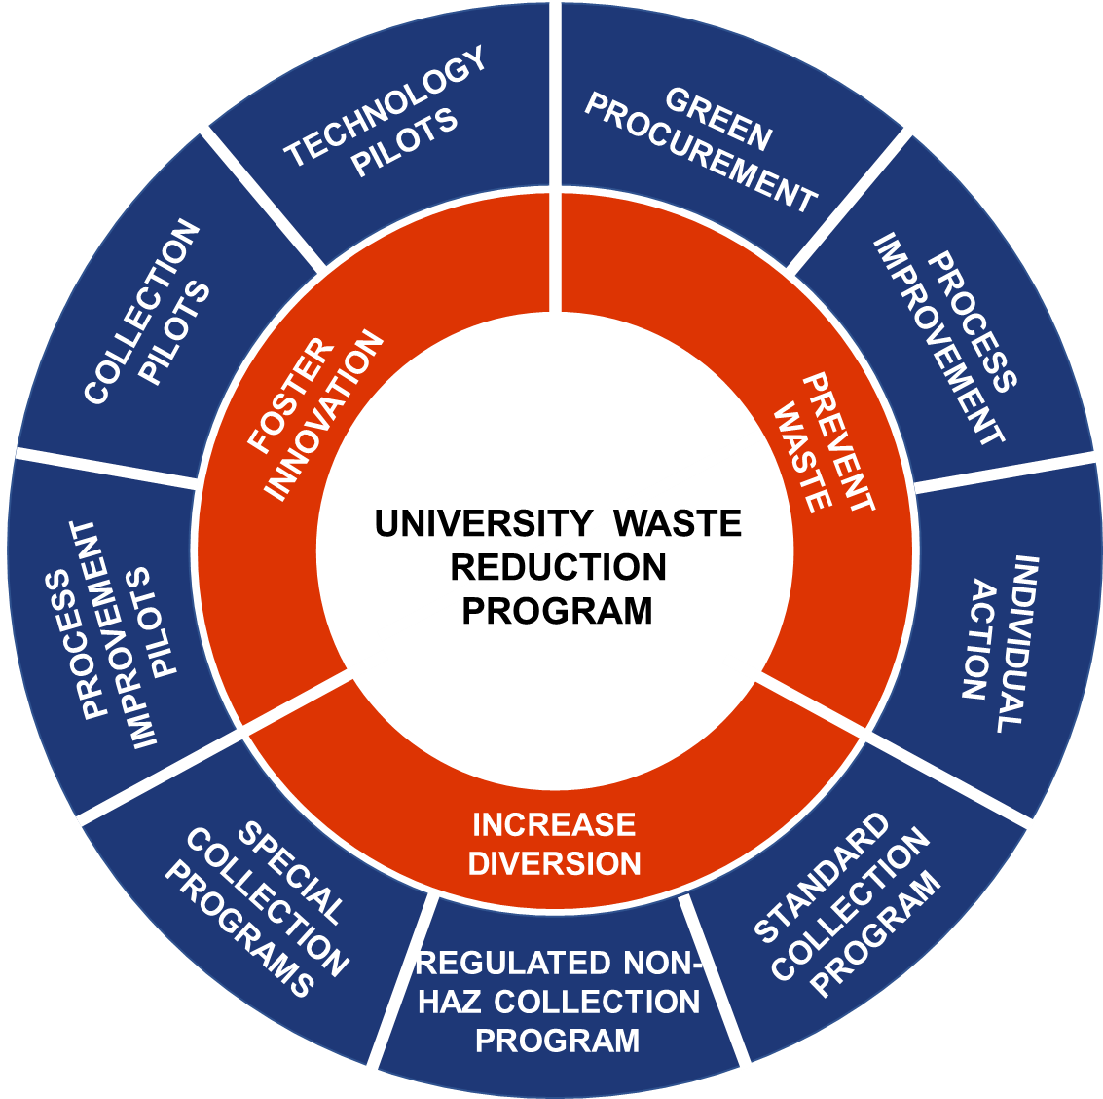
- Foster innovation: The University is home to several leading innovators, thinkers, and implementors in waste management. A significant component of the waste reduction program is to ensure that our assets, experiences, and systems be transparent and accessible to students, staff, and faculty to identify new solutions.
Figure 1 University Waste Reduction Program

The following section provides a detailed overview of the increase diversion program. Information about fostering innovation and preventing waste is covered in Section 5 of this report.

INCREASE DIVERSION

The University’s programs related to increasing diversion can be understood as a combination of four distinct processes; 1) municipal solid waste (MSW) and standard recyclables collection, 2) regulated non-hazardous MSW and recycling, 3) special collections, and 4) operation specific collections.

Table 2 Materials Managed on Campus
 | Standard Collection | Regulated Nonhazardous | Special collections | Operation specific collections
Managed by | Facilities & Services (F&S) | University Surplus, F&S, and Division of Research Safety | F&S or individual departments | Individual departments
Materials recovered | Paper, Cardboard, Plastic Bottles, and Aluminum Cans | Surplus electronics, Lamps and ballasts | Gloves, expanded polystyrene, pallets | Books, scrap metal, green waste, mattresses, tires
Scope | Entire campus | Equipment purchased across campus that qualifies as regulated materials | Material specific collections at participating departments or units | Material specific collections organized by a specific department or unit.

STANDARD COLLECTION

The University collects and processes the material on campus at the University’s Waste Transfer Station. Although the collection and processing of materials evolve based on market conditions and University’s programmatic goals, the materials identified in this section are the standard materials collected.

- Landfill: Unsorted municipal solid waste
- Bottles and Cans: #1 PETE and #2 HDPE bottle-shaped plastic, or “bottles” or “plastic”
- Paper: All clean mixed paper, including white paper, newspaper and newsprint, colored paper, sticky notes, envelopes, magazines, softbound books and journals, file folders, hanging file folders, box board, tablet backs, card stock, and small pieces of flattened cardboard.
- Mixed metal: brass, copper, iron, stainless steel, steel
- Cardboard: Corrugated cardboard boxes, flattened.
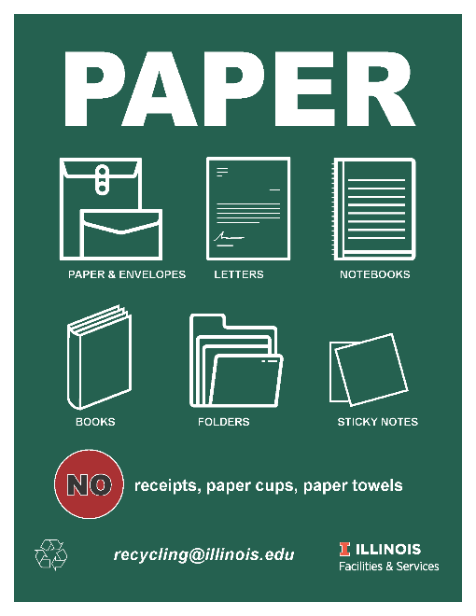
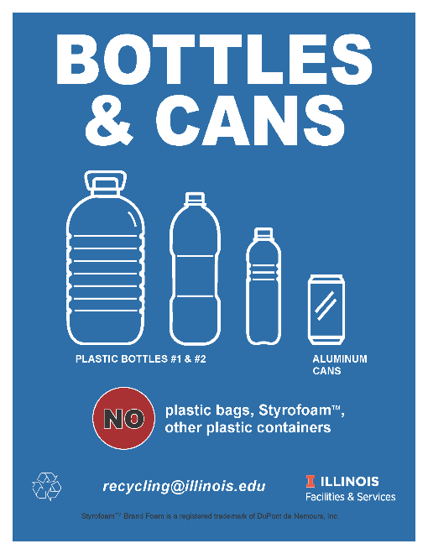
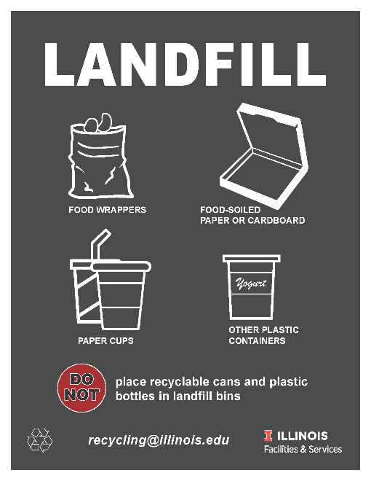
- Construction & Demolition Debris (C&D): Wood waste including lumber, plywood, Medium Density Fiberboard, sticks, pallets, painted wood; scrap metal including rebar, steel, wire, brass, copper, aluminum; concrete and asphalt, including bricks, asphalt, porcelain, rocks, and sand; models and artwork, including models made of wood, cardboard, metal, and combined materials; and broken furniture, including wood, metal, plastic, fabric, and combined materials.
Figure 2 Waste and Recycling Signage

COLLECTION PROCESS
The initial collection and sorting of the common recyclables (paper, cardboard, plastic bottles, and aluminum cans) begins with individuals at campus buildings. Faculty, staff, and students have garbage and/or recycling bins in their personal office or residence hall room to collect paper, bottle and can streams. Individual occupants are responsible for emptying their personal recycling bin into a common recycling bin in the building and place cardboard near the bin. Although each space on campus warrants an individualized response, the figure below provides general information of where collection bins are placed for optimum recovery of materials.

Figure 3 Materials collection infrastructure
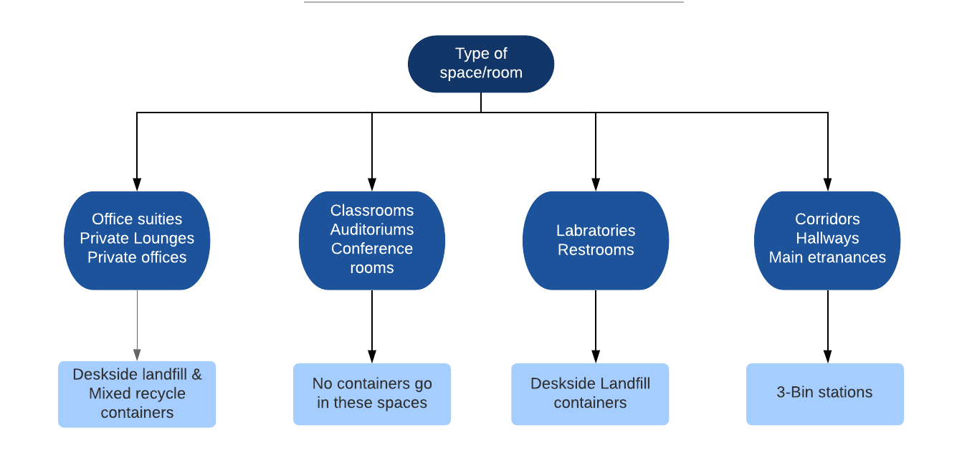

The University utilizes a dual stream system, and dedicated collection systems for special materials. The University is transitioning towards a single unit hallway recycling bin with three dedicated recycling bins (Table 3). Prior to this transition the University had a dedicated hallway paper bins and bottle and can bins across campus. Table 2 shows the current count of bins across campus. Note that this count does not include deskside recycling containers that are placed under or at each workstation.

Table 3 Bin placement
Type of bin | Count
Paper bin | 2,113
Bottle and can bin | 788
3-bin | 135
Total | 3,036

Contamination rates: The University has operated its Waste Transfer Station as a mixed recycling center (often called a dirty MRF in the industry). This configuration allows the sort line to process both materials destined for trash as well as recycling. Thus, the University is not able to track contamination rates.

2.2 SPECIAL COLLECTION

Outside of the traditional recycling program individual departments or operations collect additional materials for recycling. Provided below are summaries of a few programs, for a complete list visit: https://icap.sustainability.illinois.edu/themes/zero-waste.

Waste vegetable oil: The UIUC Biodiesel Initiative (or Illinois Biodiesel Initiative) is a project that evolved from Engineers Without Borders and has collected Waste Vegetable Oil (WVO) from dining halls on campus in order to convert it to biodiesel fuel. When available, this fuel has been used by campus vehicles at the Facilities & Services (F&S) Garage and Car Pool since spring of 2006.

Crop residue: Fresh press is a student-run sustainable paper studio at the University. In a partnership with the Student Sustainable Farm, Fresh Press turns crop residues from corn, rye, tomato, peppers, and Illinois native prairie grasses into paper. On a rotational basis they also use coffee grounds and beer to make paper. To make the papers lighter and more flexible, they use recycled cotton from textile industry trimmings in their paper. Since the start of the initiative, 2,353 pounds of greenhouse gas emissions and 60 gallons of water have been saved. To learn more, visit: https://freshpress.studio/.

Pipette Tip Boxes: Pipette tip box recycling is a lab-based initiative that allows for the recycling of clean, uncontaminated pipette tip boxes, lids and refillable trays in laboratory spaces at UIUC.

Disposable Mask Recycling: Starting September 2020, the University of Illinois Facilities and Services began disposable mask recycling in response to the COVID-19 pandemic. Collection bins have been placed around campus in approximately 35 campus buildings. People may bring their disposable surgical or N95 masks to these locations for recycling where they will be shipped to TerraCycle and processed to eventually become materials such as recycled composite lumber.

Glove Recycling: Select departments at the University participate in a nitrile glove recycling program. Through this program disposable gloves can be kept out of the landfill and recycled into useful plastic products. Previous glove recycling took place in various university research labs, but this is limited due to safety concerns.

Battery Recycling: Select departments at the University participate in battery recycling program through the Call2Recycle program.

2.3) Electronics Recycling

University-owned electronics go to the university surplus redistribution warehouse when they are no longer required by the original user. Surplus items are stored in the warehouse, which is accessible for any university-affiliated entity who would like to search for needed equipment for use on campus. Surplus operations are handled by Property Accounting and Reporting, and appropriate property accounting forms must be filled out to either add or remove items from the surplus area or to exchange items between departments. The university surplus redistribution warehouse uses a web-based software application to tag and track all electronic equipment.

Electronic equipment is processed through the surplus warehouse, and items that are likely to be reused on campus are kept in stock and available for free to campus units. Typically, this includes equipment that is three to five years old and that is likely to be wanted by another campus department. The refresh rate (frequency of replacement) for electronic devices is set by individual departments. Electronic devices which are not redistributed on campus follow the protocols established by the Illinois Department of Central Management Services (CMS) in Springfield. If an item is nonfunctional or is not redistributed, it is sent for recycling to one of the State’s approved e-waste recyclers.

2.4) Composting

Leaves have been composted at the University for over 50 years. Every fall the leaves are collected and hauled to the F&S Nursery where they are placed in windrows and periodically turned to produce compost. Eventually, the compost is reapplied on campus in various landscape projects.

Since the 1990 ban on land-filling landscape waste, the campus chips most of the landscape waste other than leaves and uses it as mulch. When trees are removed by F&S tree surgeons, most of the smaller branches are chipped on site and applied directly to various campus areas immediately. The larger branches are cut into smaller logs that are quickly removed by people needing firewood.

Landscape waste is composted at a central site on campus, including but not limited to leaves, woody plant brush, limbs, and stumps.

Food scrap composting

The University does not have a food scraps composting program. Dining locations at FAR, ISR, LAR, PAR, and Ikenberry are utilizing Grind2Energy technology to tackle food waste. This technology grinds food down to a slurry so that it can be anaerobically digested with ease. In the digesting process, methane is created that can be used as a fuel source. Although direct data is not available, the University estimates 7 tons of food scraps are sent weekly to the off-campus sanitary district. Since composting is not currently a feasible opportunity for dining locations, this technology diverts food waste from landfills while creating energy as a byproduct.

Section 3 - Materials Not Recycled/Composted

Not applicable. The University diverts all the materials enumerated in the Act.

Section 4 - Waste Audit/Assessment

Waste Audits
The most recent in-depth physical waste characterization was conducted in November 2015, for four specific buildings on campus, by the Illinois Sustainable Technology Center.
The report can be found at https://icap.sustainability.illinois.edu/files/project/2704/UI_FINAL%283%29.pdf. Broadly the report identifies 12 strategies to increase recycling, most of which have been implemented or are in various stages of implementation.

Waste Assessments
Since FY18 the University has undertaken a comprehensive data collection and tracking project that allows for real-time assessment of the campus waste streams. Data is collected both at a route level as well as a building level. For the route level data, the University created a custom web-based tracking system. For the building level data the University invested in truck scales that measure real-time waste and recycling tonnage data.
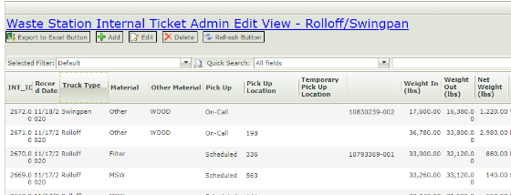
Figure 5 Real-time on-truck scale system
Figure 4 Waste and Recycling collection system

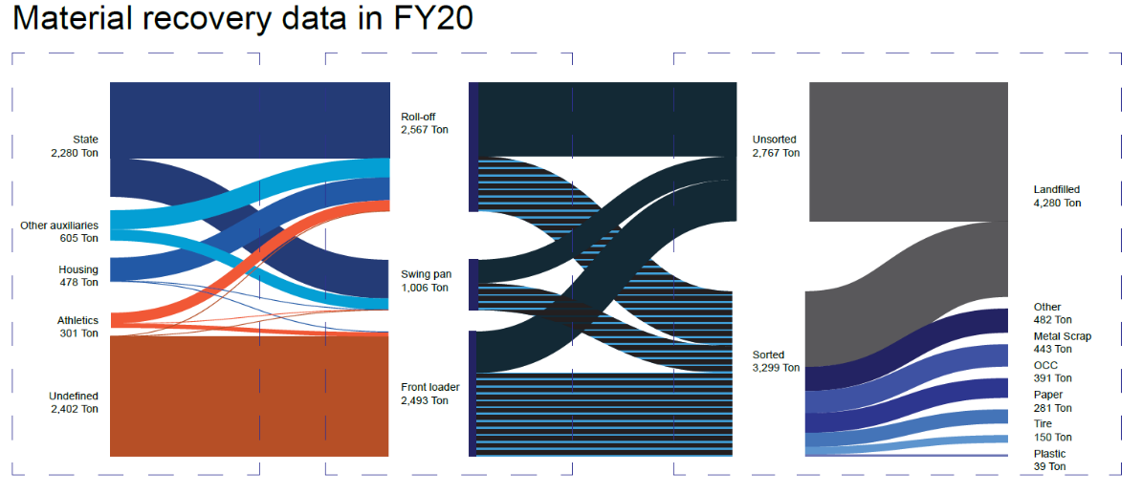
Using these newly created datasets, the University is able to ascertain waste flows, evaluate program efficacy, identify opportunities to increase the efficiency of current operations, as well as pilot new programs. As of FY20 material generated for individual buildings that had roll off and swing pan are analyzed. By FY21 all data will be associated by building.
Figure 6 FY 20 waste assessment

Section 5 – Other Source/Waste Reduction Activities

Outside of the increasing diversion the University’s waste reduction program focuses on waste prevention through direct material/operation specific programing. Included below are a few of the programs, for a complete list of activities please visit the iCAP Portal:

Books: In partnership with the non-profit Better World Books, the University Library is working to keep books out of the landfill. The partnership allows the University to donate or sell duplicated or withdrawn books. Additionally, Better World Books accepts books for recycling that are unable to be sold or donated. Since the start of the program, 138,732 books have been reused or recycled.

Trayless Operations: All residential dining locations are trayless. Trayless dining means less wasted food, less wasted energy from washing trays, and substantial water savings.

Clothes: The Career Closet within the University of Illinois Career Center, provides gently used professional clothing to students for free. This clothing-swap style program is open to all students, and helps students save money and resources.

Sustainability Living Learning Community Re-Use-It station: The Sustainability Living Learning Community, based at Lincoln Avenue Residence Hall is a great place for students to meet other sustainability-minded folks. In addition to the many other sustainability activities the community holds, in the basement of the building there is a Re-Use-It station for members to leave and take items as they please. To learn more, visit https://housing.illinois.edu/Living-Options/Living-Learning-Communities/Sustainability.

Filify: Filify is a recycling initiative that specializes in 3D printed plastic. Collecting from multiple locations on campus, they recycle old 3D printed items into new printer filaments. So far, 650 pounds of plastic has been diverted from landfills.

Project4Less: Project 4 Less is a student-led Food Recovery Program at the University. This organization strives to support local food retailers in redistributing unconsumed meals to those facing food insecurity. Visit https://www.facebook.com/Project4Less to learn more.

Section 6 - Procurement

As the iCAP 2020 states, “procurement is one of the earliest life cycle stages over which we have direct control, and the sources we select for campus purchasing are some of
our most powerful sustainability ‘votes.’” Thus, the University has continued to expand green procurement on campus. The Campus Administrative Manual includes the following policy statement: “University departments and units should purchase products with recycled material content whenever cost, specifications, standards, and availability are comparable to products without recycled content.” Also, the purchase of polystyrene products is prohibited. The policies can be found online at http://cam.illinois.edu/vii/VII-b-9.htm and http://cam.illinois.edu/vii/VII-b-11.htm.

Section 7 – Education and Outreach

Since the start of the recycling program in the 1970’s, F&S has led the communication efforts for promoting recycling to the campus community. This tradition continues today, with tours of the Waste Transfer Station, regular participation in campus sustainability promotional events, and the addition of social media messaging for special events.

In 2010, this campus completed the first Illinois Climate Action Plan (iCAP) setting a strategic plan for making this campus carbon neutral as soon as possible and no later than 2050. With the signing of the 2010 iCAP, the campus moved toward developing a holistic approach to sustainability education and initiatives, including waste minimization. The iCAP 2020 builds on the successes of the prior iCAP and continues to have waste reduction and minimization as one of its key themes. The iCAP Portal hosts an online database recording existing and planned sustainability-related projects and programs, with a listing of waste minimization initiatives at https://icap.sustainability.illinois.edu/themes/zero-waste.

Recycling is one of the key topics in all campus sustainability education and promotion efforts, including Quad Day, Sustainability Month, Earth Week, and social media messaging. While there have been numerous events and reminders each year throughout campus, there are two notable recent improvements: Zero Waste events and the Greener Campus programs. The most recent campus-wide Zero Waste event, coordinated by the Illinois Sustainable Technology Center, was the Homecoming Football game in October 2014. With interdepartmental cooperation and over 150 student volunteers, 60 percent of the waste from inside the stadium was diverted from a landfill, including 9,787 pounds composted and 8,790 pounds recycled.

The campus is spreading awareness of recycling and waste minimization through Greener Campus programs such as the Certified Green Office program as well as the Individual Waste Challenge. These programs managed by iSEE(. Institute for Sustainability, Energy, and Environment) increase engagement across campus. One of the required actions for participating offices is to “Identify, label and communicate the location of recycling stations (paper, bottles and cans) around the office/building and if needed request new bins by contacting Facilities & Services. Also, label bins with a printout of the acceptable materials list to ensure all recyclables make it into the appropriate containers.” Additionally, each of the participating offices assigns a staff person as their “sustainability ambassador” to help share information about sustainability programs on campus, including recycling programs.

Outside of the operational units responsible for managing the waste and recycling programs the following groups assist in education and outreach. This allows the waste reduction program to expand the reach of our education efforts as well as foster innovation through the collective knowledge of the greater campus community.

Zero Waste @ Illinois Facebook Group: This online group is for the Illinois community to share tips, tricks, and questions in the journey to be a waste-conscious consumer.

Zero Waste SWATeam: The Zero Waste Sustainability Working Advisory Team (SWAT) is one of the seven SWATeams created to recommend concrete steps the campus and community should take to meet its iCAP targets, as well as developing suggested revisions and updates to the iCAP every five years. The Zero Waste team focuses on examines sustainable purchasing, waste disposal, recycling, and campus dining — with the goal of achieving zero waste on campus as outlined by the Illinois Climate Action Plan (iCAP). To learn more about the team or become involved, visit https://sustainability.illinois.edu/campus-sustainability/icap/swateams/zero-waste-swateam/.

Institute for Sustainability, Energy, and the Environment (iSEE): iSEE “was created to lead an interdisciplinary approach to researching solutions for the world’s pressing sustainability, energy and environmental needs today and tomorrow. [They] call this “actionable research” — scientific progress with the emphasis on finding real-world, immediately usable answers to these problems.” In addition to coordinating the writing of our Illinois Climate Action Plans, iSEE is involved in many sustainability and waste-related efforts on campus. Learn more at https://sustainability.illinois.edu.

Students for Environmental Concerns: “Students for Environmental ConcernS (SECS) is the University’s oldest and largest environmental group. [They] work with all things green on campus and around the community.” To learn more visit: https://www.facebook.com/SECSUIUC/.

Illinois Student Government’s Sustainability Committee: The Committee on Environmental Sustainability deals with issues related to environmental sustainability, conservation, climate change, and the present and future environmental problems of our planet. The committee works on solutions to climate change, methods to switch to renewable and sustainable energy resources/systems, and ways to preserve our environment.

Section 8 - Future Activities

The University has outlined its ambitious commitment for waste reduction as part of the 2020 iCAP. As part of the iCAP the University identified time bound and measurable goals to guide the campus to achieving zero waste. Each goal addresses a portion of the University Waste Reduction Program and looks to move campus towards zero waste.
Zero waste objectives:
- Create sustainable procurement reporting guidelines and increase compliance to 100% of business managers through training and outreach by FY24.
- Reduce the total campus waste going to landfills from 5,049 tons in FY19 to 4,544 tons or less in FY24, which is a decrease of at least 10%.
- Install appropriate waste collection infrastructure throughout the University District, with new indoor bins placed in at least 150 buildings by FY24.
- Establish a culture of reuse, with two major campus wide zero-waste events using durable goods and composting in FY22, four in FY23, six in FY24, and eight in FY25
- Develop a comprehensive Zero Waste messaging campaign by FY21 and achieve a cumulative total of 10,000 “Use the Bin” pledges by FY24.
- Promote food scraps reduction on campus through a behavior change campaign, and tracking and recovery of surplus food for donation, with at least five new areas tracking and reporting their food waste by FY22.
- Develop a detailed comprehensive plan including implementation and operational costs/benefits to sustainably dispose of all food scraps and other organics by FY24, and fully implement the plan by FY33.
- Increase the use of local food to 35% by FY30.
- Establish a green cleaning program that meets LEED v.4 requirements by FY24.

A detailed description of each objective and related action items can be found at https://sustainability.illinois.edu/campus-sustainability/icap/.

Funding needs
The University’s waste reduction program is integral to the overall sustainability efforts. In an average year the University spends close to $2 million on waste and recycling services. In the last 12 months alone, the following investments have been made to the program, both to expand recycling infrastructure and collection programs as well as to allow the University’s operation to foster innovation:
- New front load truck with onboard scale
- State of the art on-truck scale
- New fuel-efficient roll-off truck
- 25 new recycling totes
- 180 new outdoor recycling stations
- 135 new indoor recycling stations
- Provided over 30 tours to students and community members about waste management and local circular economy
- Optimized processes and systems across all operations to increase efficiency and reduce injury.

To allow F&S to continue providing the level of service to the campus community that would continue to reduce waste in the region as well as a serve as a enable an environment for active innovation in the waste and recycling industry, the University would utilize all available funds for infrastructure modernization. Specifically, the operation could benefit from short term funding to ensure no loss of service, and long-term funding to transform the operation to enable greater research and experimentation for the waste and recycling industry.

Short term funding: The existing baler, that is central to the University’s ability to process and sell materials effectively, was installed in 1996. The equipment is in dire need of replacement, in FY 20/21 repair costs have been over $100,000. A third-party engineering study in 2019 found the cost to replace the baler at $1.2M with additional costs to modernize the facility to be able accommodate the new baler to ranging from $300k to $1.2M. This equipment purchase would allow the University to continue to expand collection programs through additional throughput and redeploy staff capacity to new programs.

Long term funding: The University continues to engage researchers, businesses, and innovators to identify waste reduction opportunities. The Waste Transfer Station, given its colocation with a premier research institution could be transformed to be a center for material management innovation. This center would expand on the long tradition of the University as a Living Laboratory by providing a space to imagine, create, test, and validate new innovative technologies that reduce waste, increase recycling, and create jobs in Illinois.

Section 8 – Target Reduction

The university has continuously exceeded the 40% reduction goal since 2014, the University has included the data for FY 18, 19, and 20 to showcase the continued effects of the programs mentioned above have had on our targets. As described in the future activities section, the University has set additional reduction targets to be achieved in the next five years.

Figure 7 Waste Reduction Progress
Waste Generated (Excluding Construction and Demolition Waste) | Year  1987 | Year  2014 | Year  2018 | Year  2019 | Year  2020
Weight sent to landfill (tons) | 12,000 | 5,426 | 5,508 | 5,050 | 4,280
FTE student enrollment | 36,340 | 42,720 | 49,339 | 51,196 | 52,331
Landfill tons/student population | 0.33 | 0.13 | 0.11 | 0.10 | 0.08
% of 1987 baseline | 100% | 38% | 34% | 30% | 25%
% reduced since 1987 baseline | N/A | 62% | 66% | 70% | 75%

Conclusion

Waste management and recycling has a direct economic impact on our local operations, and regional economy. This supports the mission of campus and help move the state towards a circular economy. The University has appreciated the support the Illinois Environmental Protection Agency in our journey and look forward to greater collaboration in the future.

What is the total number of full-time equivalent student enrollment?
What is the total number of occupants in on-campus student housing?
What is the number of full-time institution employees including faculty and staff? Please exclude student employment.
What is the number of part-time institution employees including faculty and staff? Please exclude student employment.
Identify the approximate total number of institution-occupied buildings and any off-site facilities and/or satellite campuses accounted for in the waste reduction plan.
Identify any off-site facilities and/or satellite campuses operated by the institution not accounted for in the plan and provide an explanation for exclusion.
If the institution currently incinerates any of its solid waste, report the number of incineration facilities, the materials incinerated (e.g., medical waste, hazardous waste, etc.), the maximum capacity of each, the average daily throughput, and whether energy is recovered through the incineration process. Please include the name and address of the incineration facilities used, if any.
Does the institution employ a full-time or part-time recycling/sustainability coordinator? If the institution does not employ an individual in this type of capacity, please explain who manages waste reduction activities at the institution.
What general materials are collected for recycling at the institution (e.g., fiber, plastics, metals, glass)?
How are general recyclables captured, collected, and processed?
Does the institution utilize a single stream system or dual stream system for recycling?
Describe the areas where recycling receptacles are located
Approximately how many recycling receptacles are at the institution and how are the receptacles distributed)
Discuss recycling contamination rates at the institution, if known, and describe any steps taken to reduce contamination.
Describe any special materials that are recycled at the institution.
How are special recyclables captured, collected, and processed?
How are obsolete, unwanted, or nonfunctional covered electronic devices managed at the institution?
List the materials collected for composting at the institution and explain how these materials are captured and processed. If a third party is involved in collection and processing, please identify who performs what services.
If the institution accepts food scraps for composting, how many receptacles are located at the institution and where are the receptacles located?
What materials are not collected for recycling or composting at your institution?
When was the most recent waste audit conducted at your institution?
Who conducted the audit?
Describe other existing source/waste reduction activities employed by the institution that are not covered in Section 2 (e.g., converting from paper to electronic processes, establishing water bottle refilling stations, tray-less dining halls, compostable food containers, eliminating plastic utensils, etc.).
Explain, in detail, how students, faculty and staff are informed of recycling opportunities. Please describe any educational and/or promotional activities used to promote recycling or other waste reduction activities at the institution.
Please describe any future plans to enhance on-campus sustainability/recycling efforts or to improve educational outreach. This could be through the implementation of new programs or the expansion of existing programs. If there are no future plans at this time, please discuss why this is the case or what limitations the institution faces in expanding or implementing new programs.
If grant funding became available in the future, discuss how this funding might best be used at the institution (e.g., improving recycling infrastructure, expanding current programs, creating new programs, developing educational materials, etc.).
Has the institution met the 40% reduction goal?

