11-14-22 Fighting Illini, Fighting Waste – Game Day Guide
- Zero Waste Materials (placed in the Orange Krush Club at 4:00pm)
  - 50 green volunteer shirts
  - 200 orange giveaway shirts (split evenly among S, M, L, XL)
  - 100 orange shirts to be used in a t-shirt cannon (given to Marty earlier in the day)
  - 100 orange shirts to be given away by student volunteers to game attendees
  - 50 giveaway totes (each filled with a t-shirt, hat, 4 reusable straws, and a thank-you card on recycled paper) to be given away by student volunteers to game attendees
  - 1 box of blue bags (~200+ bags)
- Recycling Infrastructure
  - 14 Coca-Cola Don’t Waste It temporary (placed in the upper concourse at 4:00pm)
  - Facilities & Services blue recycling bags to be used in the recycling bins + held by student volunteers
  - Check if the silver recycling bins on Floor 1 also have blue bags in them
  - Check with State Farm Center the day of to confirm where hand-held blue bags will be stored during the game once full
  - Attach 14 posters to the wall above the Coca-Cola recycling bins on Floor 2 at 4:00pm
  - Attach 13 posters to the 13 bathrooms on Floor 2 at 4:00pm
- Overarching Goals of the Event
  - Open with Illinois Climate Action Plan Zero Waste Goal 5.2: “Reduce the total campus waste going to landfills from 5,049 tons in FY19 to 4,544 tons or less in FY24, which is a decrease of at least 10%.”
  - 3 primary goals for this event + how we achieve them:
    - (1) Reduce the quantity of waste going to the landfill. Achieved through the separation of landfill and recycling waste up front at the bin.
    - (2) Increase public awareness for recycling. Achieved through:
- Volunteers wearing bright green t-shirts.
- Greeting attendees at the front door and reminding them at half-time that we are recycling bottles and cans in the blue bags.
- Having student volunteers available for questions.
- Pursuing active bottle and can collection near existing trash bins.
    - (3) Encourage behavior change among basketball game attendees when they are presented with the opportunity to recycle. Achieved through :
- Bin guarding (educating passers-by on what is recyclable on campus and at this game).
- Actively collecting bottles and cans near existing trash bins.
- Catching attendees recycling and providing them with a reward (tote bag, orange shirt).

Volunteer Training (6:15pm – 7:00pm)
Team Leads: Daphne Hulse, Meredith Moore, Dominika Szal, Shreya Mahajan
Orange Krush Club area will be roped off during the game (we can leave it unattended)
*Volunteers arrive at 6:15pm.
*Doors open at 7:00pm.
*Tip-off starts at 8:00pm.
- Check-in
  - Dominika and Shreya posted at the West Entrance, letting students know how to get to Orange Krush Club area.
  - Students check name off sign-up list.
  - Students receive a green volunteer t-shirt.
  - Students can leave belongings in this area.
- Full Group Orientation
  - All ~50 volunteers.
- Thank the students for volunteering!
- Just the fact that we are having this event, and that we have volunteers, is a huge success. Let’s be proud of ourselves!
- Discuss 3 overarching goals of this event: recycling, awareness, impacting the iCAP objective for landfill waste.
- Remind students that many attendees may have no experience with recycling; we want to be inclusive and welcoming.
- Emphasize we are collecting plastic bottles and aluminum cans at this event. Campus only recycles plastic 1 and 2 (determined by the # on the bottom). No concession food containers are recyclable (greasy, contaminated).
- Remind students to take care of themselves! If they are feeling tired, or their voice is tired from speaking loudly, feel free to take a break and get some water.
- Any waste diverted is a success. We may see some cans and bottles end up in the trash, and that is okay. We are starting with baby steps here. What we can collect here tonight is wonderful and something to celebrate!
- Briefly outline the 4 volunteer roles and allow students to group up under the role of their interest. All roles at a minimum will be paired up. No student will be left alone.
- Once students are broken up into their teams, ask for one student from each group to be the Student Lead.
- Snap a group photo!
- Student Volunteer Roles (choose 1 student from each role to function as the Student Lead. Create a group chat with the 4 Team Leads + 4 Student Leads. Student Leads should check in on their volunteers throughout the event)
  - ~8-14 students: Bin Guard Volunteers (Floor 2)
    - Pair students to stand nearby the 14 Coca-Cola recycling bins to draw attention to the bins, educate, and engage attendees as they recycle (explain that we are collecting bottles and cans).
    - Goal: cover a quarter to half of the bins (4-7 bins) with pairs of students (8-14 students)
Bin guards will stand near the Don’t Waste Coca-Cola recycling bins.
  - ~24 students: Blue Bags Volunteers: active bottle and can collection (Floor 2)
    - Pair students to stand nearby the trash bins that are located near the vomitory doors on floor 2.
    - Encourage attendees to recycle bottles and cans instead of landfilling them.
    - Goal: cover all 12 vomitory doors with pairs of students (24 students)
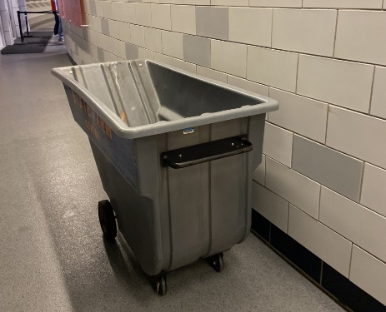
Blue bags are placed into these bins located on the upper concourse.
  - ~6-8 students: Greeter Volunteers (Floor 1 and 2)
    - 8 public entrances when fully staffed for events. 50% of attendees enter through the West Entrance, so focus on this side.
      - 5 public entrances open during the 11-11 game.
    - Greet attendees as they arrive for the game and let them know that we are recycling our aluminum cans and plastic bottles at this game via signage. Hold blue bags as an example for what attendees should look for to recycle.
    - Once tip-off has begun, have the greeters move up to floor 2 to stand near the Blue Bag volunteers and serve as an additional form of education.
    - At half-time, greeters will enter the arena and walk through the stands to remind attendees to recycle their bottles and cans in the blue bags.
    - Goal: 4 students staffed at the West Entrance, 2-4 students at two other entrances. (4-8 students)
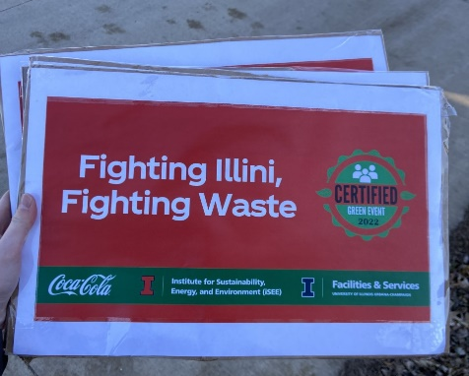
Greeters will hold these signs.
  - ~6-10 students: Giveaway Volunteers (Floor 2)
    - Pair volunteers.
    - “Caught Green Handed”: watch for attendees to recycle, and then reward them with a tote bag or a t-shirt.
    - Will have to travel back to the Orange Krush Club as supplies dwindle.
    - Circulate between the 14 Coca-Cola recycling bins and the vomitory trash bins.
    - Goal: At least 6 students moving between vomitories and bins.
