3-2-23 – Final Report: 2.0

On March 2, 2023 the University of Illinois at Urbana-Champaign held its second Fighting Illini, Fighting Waste event at State Farm Center – a game day recycling event to capture bottles and cans at the Illini vs Michigan Men’s Basketball game. Fighting Illini, Fighting Waste is an ongoing partnership between the Division of Intercollegiate Athletics; the Institute for Sustainability, Energy, and Environment; Facilities & Services; and Coca-Cola.

Additionally, in partnership with Coca-Cola, the University of Illinois is pursuing a “Don’t Waste” campaign to holistically advance the effort to increase recycling and decrease waste across campus. The Fighting Illini, Fighting Waste is the first high-visibility zero waste event that was formed at the weekly “Don’t Waste” meetings with Coca-Cola.

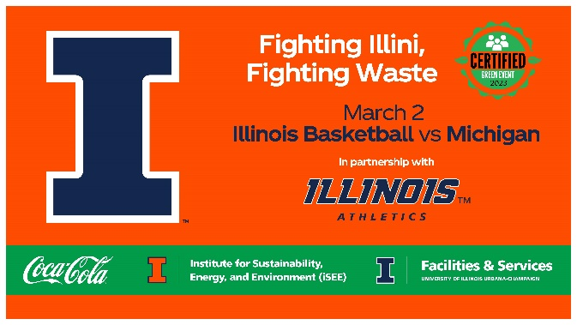

90 student volunteers with the help of 2 staff volunteer leads came together to achieve three priority objectives:
- Directly impact Illinois Climate Action Plan (iCAP) objective 5.2, “reduce the total campus waste going to landfills.”
- Increase public awareness for campus recycling and the iCAP.
- Encourage behavior change among basketball game attendees when they are presented with the opportunity to recycle.

To achieve these objectives, a four-fold approach was executed:
- Established recycling infrastructure within the upper concourse of the facility via the temporary placement of Coca-Cola recycling bins. Student volunteers were stationed near the vomitories on the upper concourse near these temporary recycling bins to help fans recycle the proper materials.
- Instigated public education and engagement initiatives during the game via volunteer-attendee interaction. Student volunteers, sporting bright green shirts, were available for questions regarding what was and was not recyclable. Student volunteers also gave away orange Block I t-shirts to attendees “caught” recycling. Recycling signage was posted near the bins and in the bathrooms to passively educate attendees where student volunteers could not be present.
- Integrated student involvement into the core event operations: students executed the event and directly engaged with attendees.
- Pursued community outreach and publicity ahead of the event, and sent out a news release to local news media in the Champaign-Urbana area.

During this event, student volunteers helped divert 1,280 pounds of recyclable material away from the landfill (cardboard, paper, bottles, and cans). In total, the event achieved a 28% diversion rate. (Note: Municipal Solid Waste (MSW) Diversion rate is defined as “Total Recyclables Solid” divided by the sum “Total Recyclables Solid” and “Total Landfilled.”).
Further breakdown of the diversion rate:
- Arena:
  - 220 lbs aluminum
  - 300 lbs plastic
  - TOTAL: 520 lbs from the arena
- Recycling bins around the concourse:
  - 120 lbs aluminum
  - 200 lbs plastic
  - TOTAL: 320 lbs from the recycling bins
- Pulled from the waste stream (came from the compactor below the facility):
  - 440 lbs of mixed materials (paper, cardboard, aluminum, plastic) that the sort workers pulled at the Waste Transfer Station

TOTAL: 1,280 pounds of recyclables
340 pounds of aluminum
500 pounds of plastic
440 pounds of mixed material (paper, cardboard, aluminum, plastic)

- Diversion rate
  - 4,540 total waste collected that night (trash + recycling)
  - 1,280 of this total waste was recycled that night
  - 1280/4540 = 28% diverted

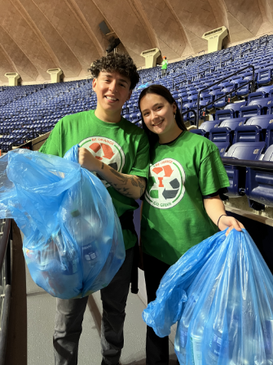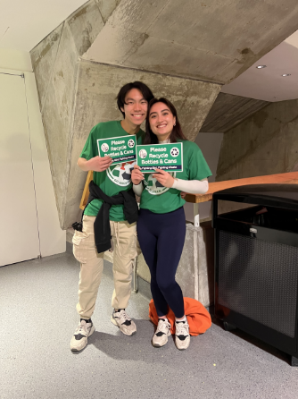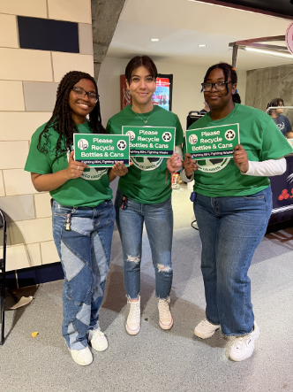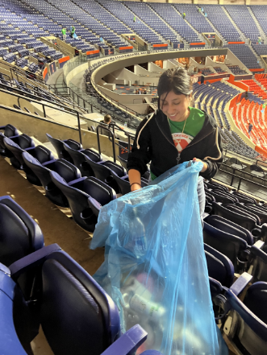
Volunteers in action.

Student Volunteer Feedback
- Blue bags supplied by F&S were too thin for handling; it was common for liquid to leak from the beverage cans into the bags and onto the floor while the volunteers were picking up from the arena after the event.
  - Wearing gloves helps keep hands clean.
- Attendees loved the t-shirt giveaways! Volunteers ran out of giveaway materials quickly, as they did during the November 14th game.
- When attendees are presented with the infrastructure to recycle, they do it and do it well.
- Signage posted above the recycling bins (which indicated what was and was not recyclable) seemed to help with contamination.
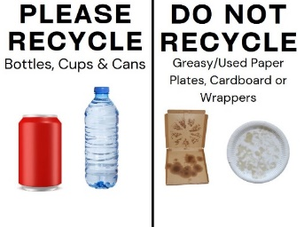
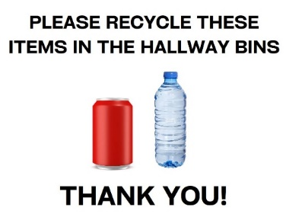
- Provide signage to volunteers that simply and effectively communicates to attendees what is going on was helpful. A new design was created for this event:
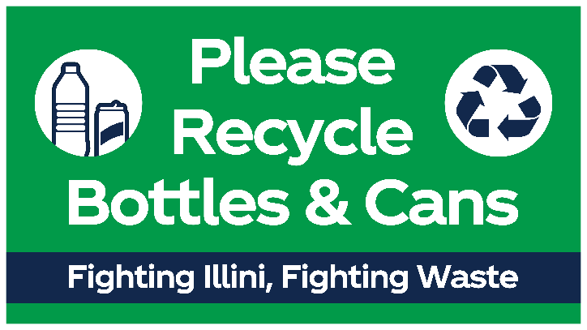

- In an anonymous, voluntary survey sent out to all volunteers after the event, we received the following feedback:
  - 1 = very negative, very unlikely, very unsatisfied
  - 5 = very positive, very likely, very satisfied
    - How would you rate your overall experience at this event?
      - 2 responded with “3”
      - 6 responded with “5”
    - How satisfied did you feel after volunteering?
      - 2 responded with “4”
      - 5 responded with “5”
    - How likely are you to recommend this volunteer opportunity to peers?
      - 3 responded with “4”
      - 5 responded with “5”
    - How likely are you to volunteer with us again?
      - 1 responded with “4”
      - 7 responded with “5”
    - Please use this space to provide any additional feedback, thoughts, concerns, or suggestions.
      - I thought the other people working the event kept making us relocate unnecessarily.
      - There weren’t enough shirts to hand out, but I think it would be fun to give out other items, like shirts, keychains, stickers, lanyards, etc if the cost of giving away free t-shirts is a bit expensive
      - One of the greatest experiences I've had as a volunteer. It gave a new perspective on the quantity of waste a person contributes to, and the quality of a person it takes to bring about that change. Thank you for giving me this opportunity. All the best on this project.
      - Amazing event! If you could give more clear instructions to the volunteers as far as what to put in the recycling bags that would be helpful. I saw a couple of volunteers mixing food waste and napkins with cans because they weren't clear on what to do beforehand.
Successes
- Volunteers were split into three shifts: before the game (4:30 – 6:00, 6:30 – 8:00, 8:00 – 9:30). The split in shifts made the expected labor much easier to manage (as opposed to the previous event, which lasted about 4 hours total for each volunteer).
- Dedicated student volunteers: made the event a success, executed a great diversion rate for the first event, easy to work with, nearly all that signed up showed up.
  - Several volunteers stayed well after the official end of the event to assist with pick up.
- T-shirt designs: attendees positively commented on both the green and orange shirts and were interested in receiving both as giveaway items.
- Anecdotally, there was only positive feedback from attendees that night: positive comments, positive engagement with the “caught green handed” initiative.
- Blue recycling bags were placed in grey bins on the upper concourse when full, which worked very well.
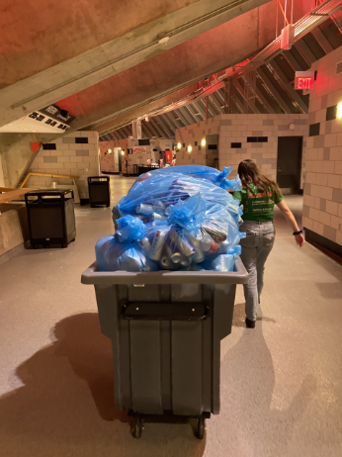
Grey elephants allowed staff and student volunteers to easily move bagged recyclables from inside the facility to the open pans (outdoor waste containers) outside the arena.

Areas for Improvement
- Bin placement
  - Establish permanent recycling bins and blue bag use on the upper and lower concourses ZW011 Recommendation
- Compactor
  - Everything in the facility is currently placed below the facility into the compactor (including blue bags). During these events volunteers brought the blue bags from the upper concourse and the items collected from the arena to three outdoor open top pans. DIA staff could implement similar protocol, to ensure recycling is kept separate from landfill bags.
ZW011 Recommendation
- Student volunteers
  - For shift-based programs, create small placards for each shift outline the important information (what is and is not recyclable at the event) and what the objective of the shift is (e.g. collect recyclables from the stands using blue bags, placing into grey elephants). Shift-based volunteers are hard to bring together into one central location to provide a comprehensive training to. Having overlap between shifts, so volunteers can learn from each other, is also helpful.
- Plan for a longer final shift
  - It took longer than expected to collect from the arena (perhaps more volunteers needed? Or a longer shift period to collect? Aim for earlier start games (like 6pm) for this reason.

Community Response
- WCIA covered this event:
  - Initial news release
  - Article
  - Video

