
This meeting is being facilitated through Microsoft Teams |  | Date: 10/09/2026
Intro | Attendance:  - Names, Why You’re Here  - (Someone start the recording!! Bea isn’t here )
Intro | Icebreaker & Homework  - What’s the last thing you wasted? (recycled, threw away, composted, or *gasp* littered)  - Homework: Read the iCAP 2026  - Action Items:  - Anyone found a new battery partner? N/A  - Becca, reached out to Bevier to present? N/A  - Serenity, updates on My Green Lab? N/A
Updates | - Share-Out: Tailgate! (Betsy + Zach)  - Oct 3 – HOMECOMING! 23 volunteers, 860 lbs of presorted recyclables  - Volunteer for the 24th on SignUp  - Other project highlights  - Thurman Presentation (in Teams folder)  - UCSD Tour on 10/19, 27, or 30- Thanks, Ro!  - (Bea: ensure all attendees have filled out)  - Chris Brown – Welcome & Share-out  - Also interested in Green Greek Tailgate – suggests we attend an interfraternity council meeting  All Team Members:  - What are you working on?  - Are there any tasks that you need help with?
Homework | What should you have ready by next meeting  - Serenity, OK to talk labs on Nov 9th?  - Sara and Betsy really will meet
Other Updates?
Bold Reuse: Reuse for events and festivals. Looking for a champion! Check out their recent Summer or Reuse webinar.
Meeting Dates & Notes:
- September: overview)
- Oct: Tailgate, G2E
- Nov: Labs – Serenity, Dylan (?) to speak, include Engagement team
- Dec: Sara / Engagement Team) – invite to speak
Action Items
- Answer here.

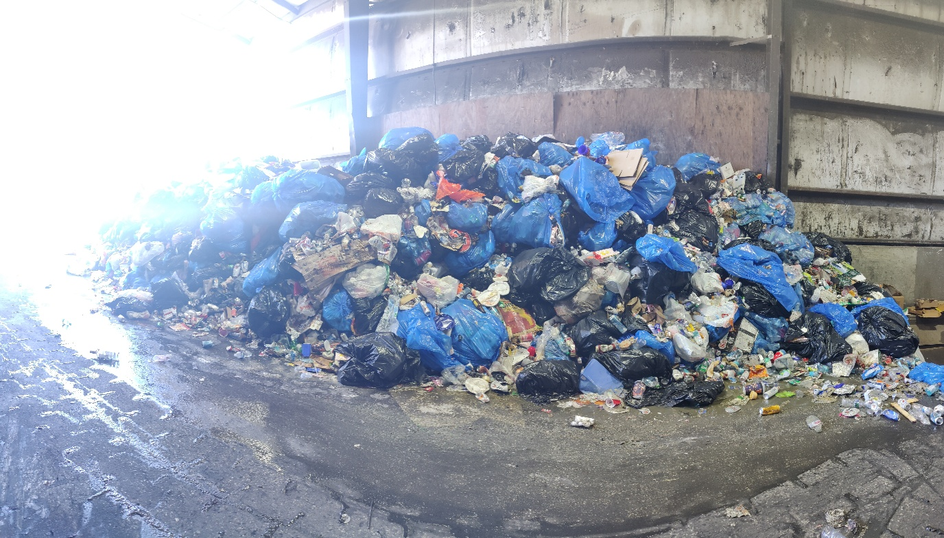
Post-Tailgate Photo

