PERCEPTION-BASED SURVEY QUESTIONS
FOR BICYCLE NETWORK AUDIT 2026

Surveyor Information
- Survey Taken :
- Surveyor Number :
- Block Number :
- How are you collecting the information? (Select only one)
  - Walking
  - Using a mobility aid
  - Using a bicycle
  - Other

Survey Typology
- What type of land uses are present in this block? (Select all that apply)
- UIUC campus institutional buildings
- Residential buildings
- Commercial or retail (shopping centers, restaurants, cafés)
- Industrial buildings (warehouses, factories)
- Parking lots or garages
- Designated green spaces/parks
- Underdeveloped land
- Vacant land
- Other

- What type of residential uses are present in this block? (Select all that apply)
- Single-family housing
- Multi-family housing
- Apartments or condominiums
- Apartments above street retail
- Retirement/senior living facility
- Dormitory
- Fraternity/sorority
- Other
- None

Safety

Bicycle Network
- Select all types of bicycle network infrastructure present in this block
- Bicycle lane
- Off-street bicycle path
- Shared-use path with sidewalks more than 10 ft wide
- Neighborhood greenway
- Sharrow or shared lanes
- Sidewalk 8-10 ft wide
- Sidewalk less than 8 ft wide
- Bicycle route with no 25 mph or lower marking
- No bicycle facility
- Other
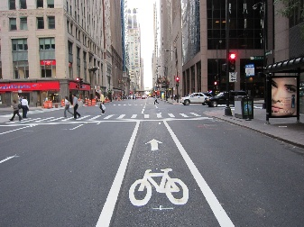  Bicycle lane | 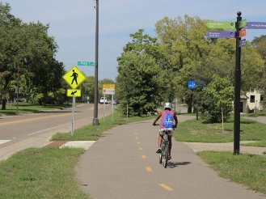  Off-street bicycle path | 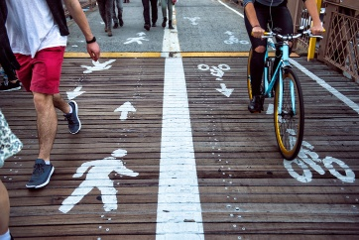  Shared-Use Path | 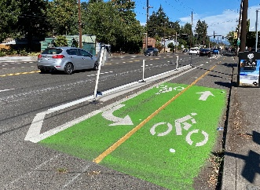  Neighborhood greenway
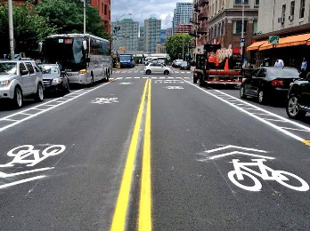  Sharrow or shared lanes | 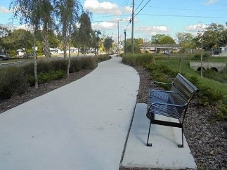  Sidewalk 8-10 ft wide | 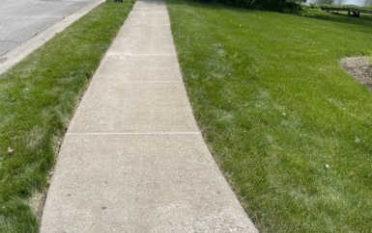  Sidewalk less than 8 ft wide | 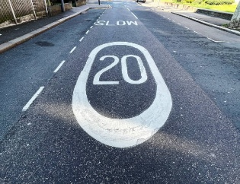  Bicycle route with no 25 mph or lower marking

- How is the continuity of bicycle network from this block to the adjacent block(s)?
- Transition is seamless because the bicycle network type remains the same in all directions
- Transition is mostly seamless because the bicycle network type remains the same in most direction, but changes in one or two blocks (E.g. transition from bike lane to shared-use path or vice versa)
- Transition is somewhat disrupted because bicyclists must change their direction or the bicycle network type in most adjacent blocks
- Transition is disrupted because bicyclists must change either their direction or the bicycle network type in all adjacent blocks
- Transition is highly disrupted because the bicycle network changes from a designated bicycle network to no bicycle facility (or vice versa) in most blocks
- No bicycle facility from all directions

- If no bicycle lanes are present, is there any other place to bike that is safe from traffic? (Select all that apply)
- No
- Yes – Bicycle lanes/path on the other side of the road
- Yes – Street Shoulder
- Yes – Buffer
- Yes – Sidewalks
- Other
- N/A – Bicycle lanes present on both sides of the street or off-street bike path continues in the zone
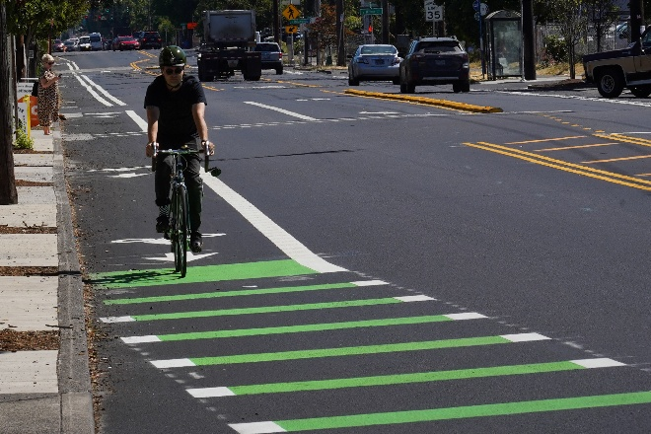  Bicycle lanes/path on the other side of the road | 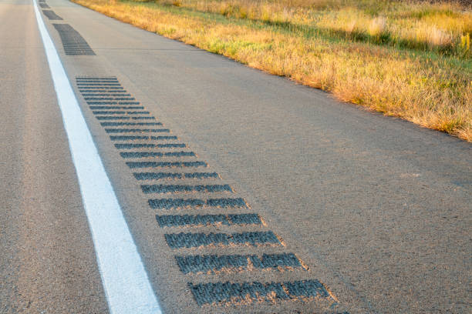  Street shoulder
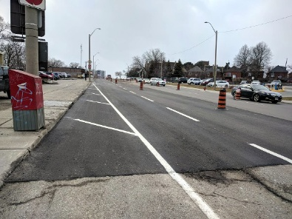  Buffer | 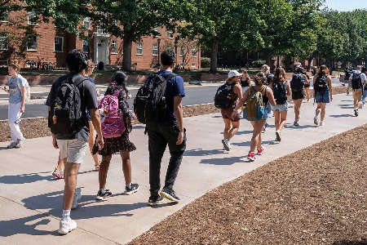  Sidewalks

Bicycle Markings
- Are bicycle markings present on the street?
- Yes, markings are clearly visible
- Yes, markings are somewhat visible
- Yes, markings have faded
- No, markings are not present

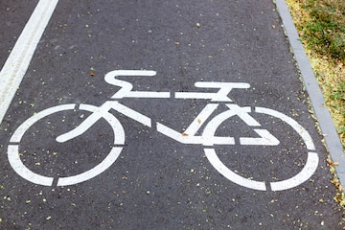  Visible markings | 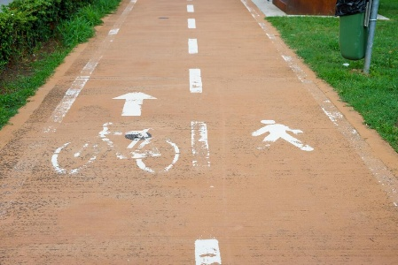  Fading markings

Bicycle Crosswalks
- Are there bicycle crosswalks present on the street?
- Yes
- No
- Not applicable

- Are bicycle crosswalk markings present on the street?
- Yes, markings are clearly visible
- Yes, markings are somewhat visible
- Yes, markings have faded
- No designated bicycle network

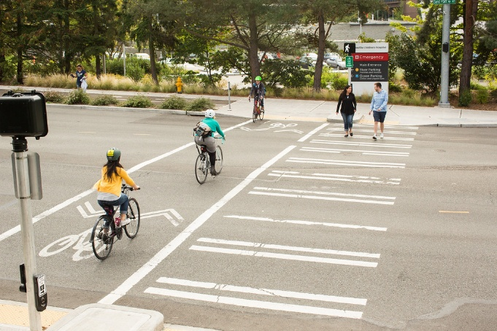  Visible bicycle crosswalk | 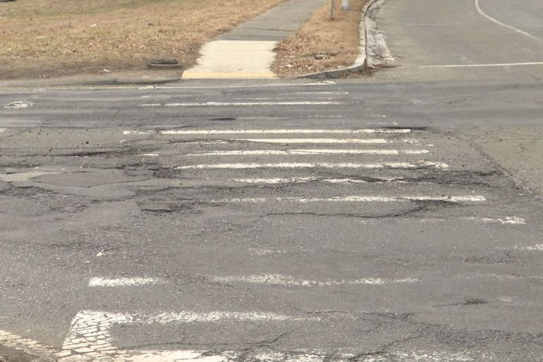  Fading bicycle crosswalk

Nighttime Safety Features
- To what extent are the bicycle network lit in this block?
- Well-lit with ample lighting (regularly spaced pedestrian lampposts)
- Somewhat lit with overhead streetlights on utility poles with wide spacing
- Not well lit
- No lighting

Traffic Calming Measures
- What type of traffic calming measures are generally present in this block? (Select all that apply)
- Speed bumps
- Curb extension
- Raised intersections and crosswalks
- Mid-block crosswalks without RRFB (rapid rectangular flashing beacons)
- Mid-block crosswalks with RRFB (rapid rectangular flashing beacons)
- Traffic diverters
- No traffic calming measures
- Other

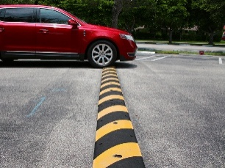  Speed bumps | 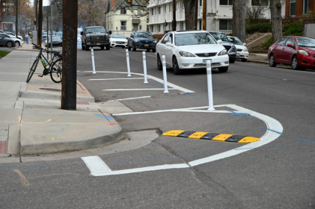  Curb extension | 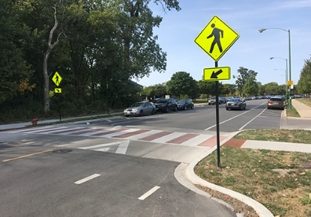  Raised intersections and crosswalks
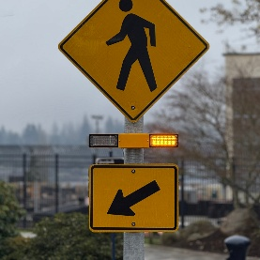  RRFB (Rapid Rectangular Flashing Beacons) | 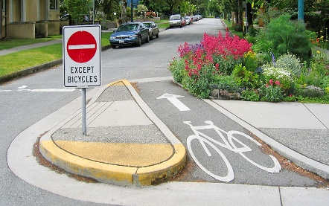  Traffic diverters

Bicycle Visibility
- Are bicyclists on bicycle networks easily visible and identifiable to pedestrians and/or other bicyclists?
- Yes, easily identifiable
- Low visibility
- Not visible

- Are the bicyclists along the bike paths easily visible to vehicular traffic?
- Yes, easily identifiable
- Low visibility
- Not visible

- Are the bicyclists entering/exiting a crosswalk or intersection easily visible to vehicular traffic?
- Yes, easily identifiable
- Low visibility
- Not visible

Bicycle Racks
- What is the general condition of bike racks in this block?
  - Very good
  - Good
  - Need some improvement
  - Need a lot of improvement
  - No bike racks in this block

- Are bicycle racks visible or noticeable while riding?
- Always
- Most of the time
- Sometimes
- Rarely
- None of the time

- How would you rate the level of bike racks usage?
  - 5 – Very high usage
  - 4 – High usage
  - 3 – Moderate usage
  - 2 – Low usage
  - 1 – No usage

Path Quality

Path Size
- Experts recommend that a one-way bike lane/path be at least 4 feet wide. Considering this recommendation, how would you rate the existing one-way bike path/lane width in this block, accounting for barriers that may reduce the width or make passing difficult? (Examples of barriers: Stationary -signal poles, fire hydrants, trees, utility poles; Moveable –planters, street signs, trees, furniture, mailboxes).
- Very adequate width
- Adequate width
- Slightly narrow width
- Narrow width
- Very narrow width
- No designated lane/path in this block

Shared-use with Pedestrians
- Traditional bicycles are allowed to operate on campus sidewalks. If a designated bicycle infrastructure is not present, could sidewalks accommodate occasional bicyclists during peak hour pedestrian traffic?
- Yes
- Needs to be wider
- Not observed during peak hour

- In general, what is the overall condition of bicycle network infrastructure in this block?
- 5 – Excellent (Continuous bicycle network, well maintained and of sufficient width to accommodate bike traffic)
- 4 – Good (Bicycle network on both sides of the street)
- 3 – Need some improvements (Bicycle network on both sides of the street, minor discontinuities and maintenance problems but does not present major obstacles for bicycle)
- 2 – Need a lot of improvements (Bicycle network on one side of the road, several deficiencies)
- 1 – Poor (No permanent bicycle lane surfaces, discontinuous bicycle lane, or major maintenance problems)

Shade
- To what extent are the bicycle lanes/paths shaded by trees in this block?
- Well-shaded with regular intervals of trees
- Mostly shaded by trees
- Somewhat shaded by trees
- No trees present

Path Maintenance
- Are there any obstructions in the bicycle network infrastructure in this block (Select all that apply)
- Drain gates
- Utility covers
- Metal plates
- Rumble strips
- Temporary construction signage, equipment, or vehicles
- Vegetation growth obstructing the path
- Other
- No dangerous obstructions
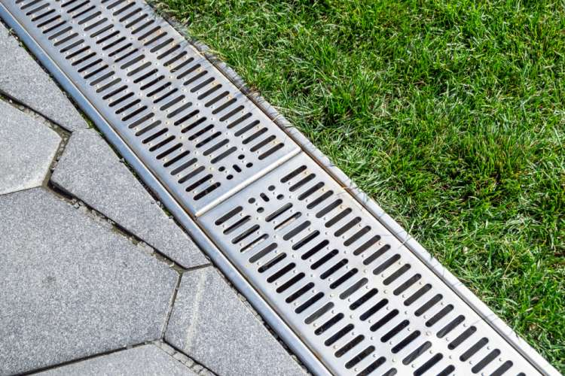  Drain gates | 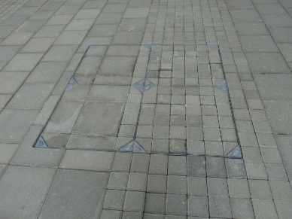  Utility covers | 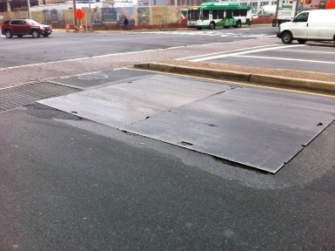  Metal plates
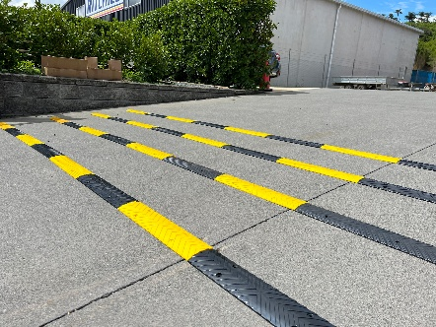  Rumble strips | 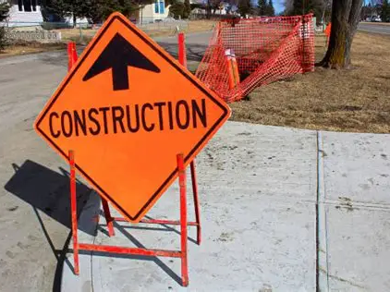  Temporary construction signage, equipment, or vehicles | 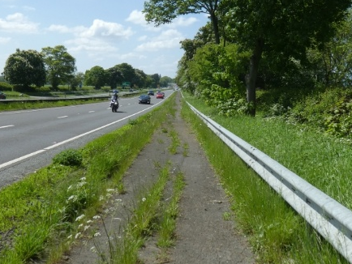  Vegetation growth obstructing the path

- Are there any faults with the bicycle network infrastructure in this block? (Select all that apply)
- Potholes
- Uneven surfaces
- Too narrow
- Major cracks
- Discontinuous path
- Vegetation growth obstructing the path
- No faults
- Other
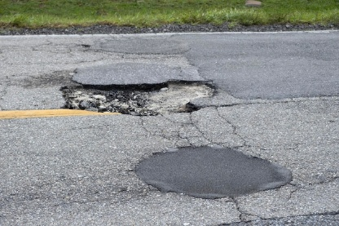  Potholes | 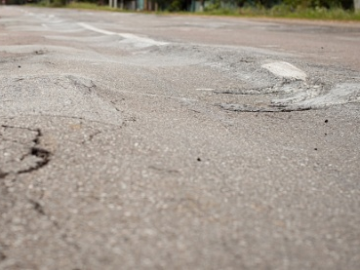  Uneven surfaces | 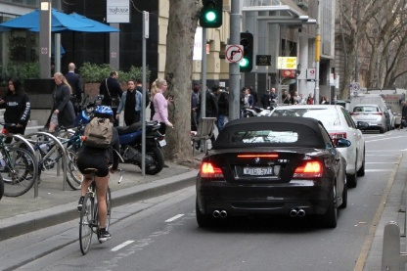  Narrow lanes
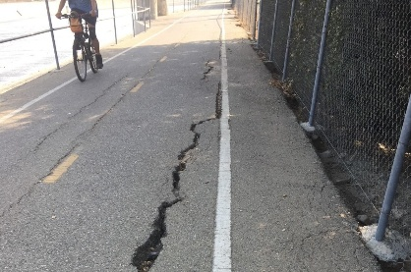  Major cracks | 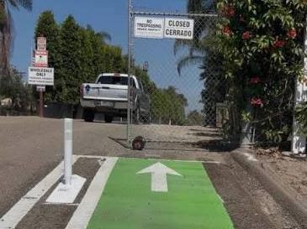Discontinuous path | 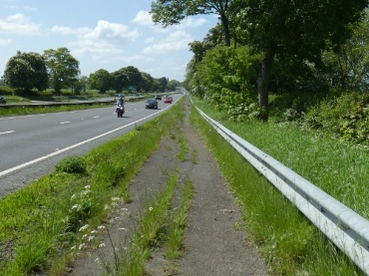  Vegetation growth obstructing the path

- What do you think of the overall quality of the bicycle network maintenance? Consider things such as cracking, buckling, or standing water on or near bicycle lanes.
- 5 –Bicycle networks are in excellent condition with no visible deficiencies)
- 4 –Bicycle networks are mostly in good condition with a few deficiencies)
- 3 –Bicycle networks are mostly in good condition with several deficiencies)
- 2 –Bicycle networks are poorly maintained with many visible deficiencies but are generally bikeable)
- 1 –Bicycle networks are poorly maintained with frequent or severe deficiencies, and are not bikeable)

Buffer
- Please choose the average amount of space separating one-way bicycle lanes/paths from adjacent roadways. Choose the option that most closely matches your overall assessment of the buffers in this block.
- Buffer is > 5 feet wide
- Buffer is 3-5 feet wide
- Buffer is < 3 feet wide
- No buffer from roadway
- Not applicable because the bicycle network type is sharrow

- Please choose the average amount of space separating one-way bicycle lanes/paths from street parking. Choose the option that most closely matches your overall assessment of the buffers in this block
- Excellent – Buffer is > 5 feet from roadway
- Good – Buffer is 3-5 feet wide
- Satisfactory – Buffer is < 3 feet wide
- Poor – No buffer from street parking

Aesthetics
- Which of the following amenities are available along the streets and bicycle network? Only select the ones easily identifiable by bicyclists
- Trees
- Green space
- Transit stops
- Bicycle racks
- Bicycle repair station
- Air pump
- E-bike charging station
- Covered bike racks
- None of the above
- Other

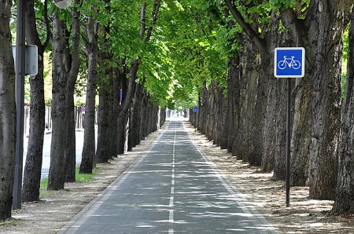  Trees | 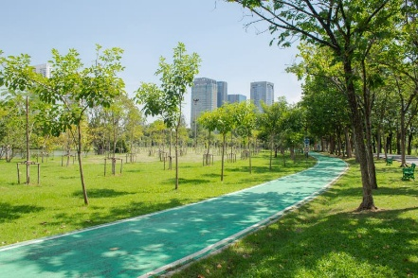  Green space | 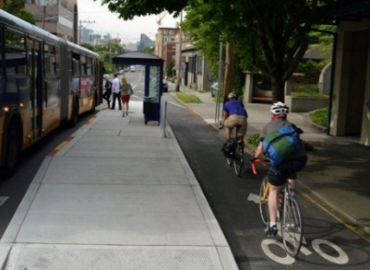  Transit stops
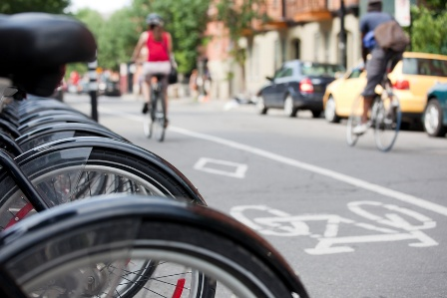  Bicycle racks | 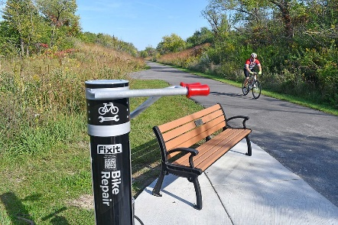  Bicycle repair station | 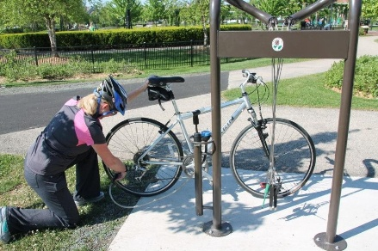  Air pump
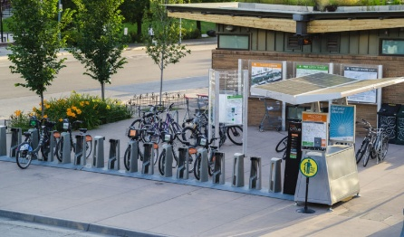  E-bike charging station | 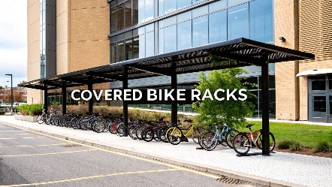  Covered bike racks

- What do you think of the quality of aesthetics along this block? Consider things such as quality of landscaping, proximity to construction zones, fences, buildings, noise pollution, and bicycle-oriented features. Choose number that most closely matches your overall assessment of the aesthetics in this block.
- 5 – Very Pleasant (Visually inviting, quiet, landscaping, tree cover and architecture)
- 4 – Pleasant (Has minor deficiencies but a good block to bike)
- 3 – Average
- 2 – Unpleasant (A good block to bike but has immense scope for improvement)
- 1 – Uninviting (I will not bike in this block again!)

Bicyclist Behavior
- What kind of bicycles did you observe in this block? (Select all that apply)
- Traditional bicycles
- E-bikes
- E-scooters/E-skateboards
- Veo Bikes
- Other micromobility devices
- No bicycles are present
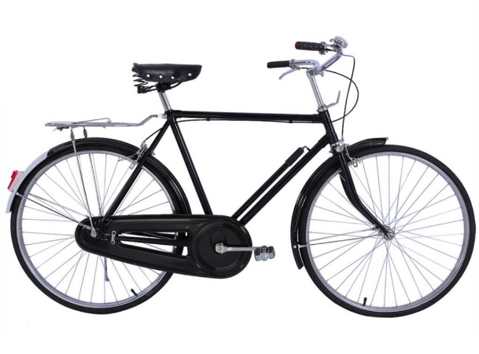  Traditional bicycles | 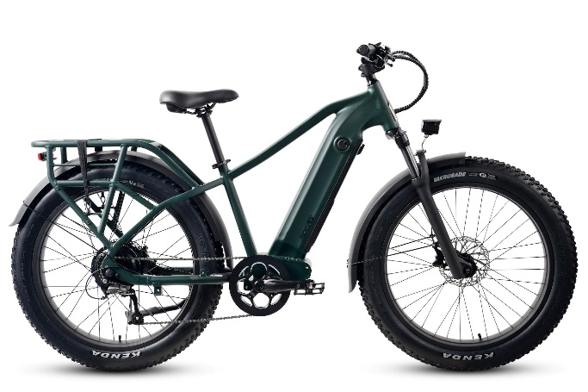  E-bikes
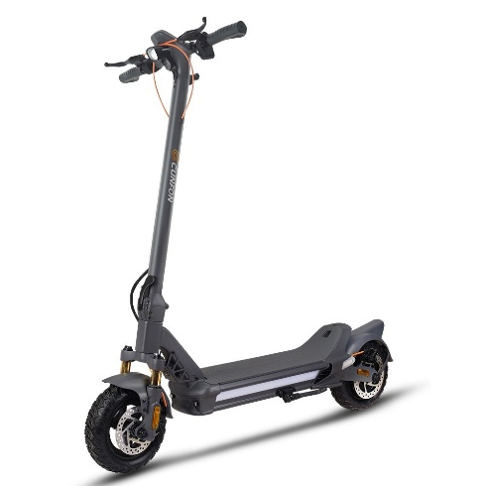  E-scooter/E-skateboards | 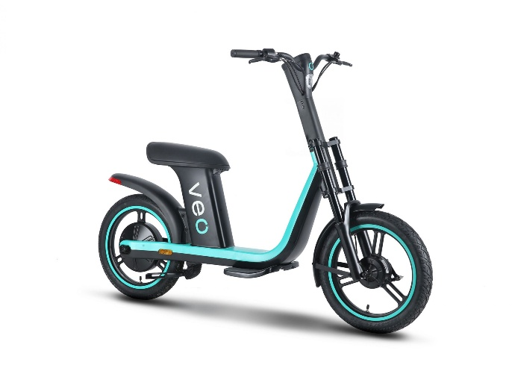  Veo Bikes

- Are bicyclists riding with helmets?
- All bicyclists
- Most bicyclists
- Some bicyclists
- Few bicyclists
- No bicyclist
- I don’t know

- Where are they mostly bicycling?
- Riding on the sidewalk
- Riding on a bike lane or path
- Riding on the shared use path
- Riding in the same direction as traffic
- Riding in the opposite direction as traffic

- How often do bicyclists:
 | 5 - Always | 4 – Most of the time | 3 - Sometimes | 2 - Rarely | 1 – None of the time | Not applicable
Obeying stop lights
Obeying stop signs
Yielding to pedestrians on sidewalks and shared-use paths

Safety Perception
- In general, how pleasant was your bike experience on this block?
- 5 – Excellent
- 4 – Mostly satisfied
- 3 – Somewhat satisfied
- 2 – Needs considerable improvement
- 1 – I will not bike in this block again

- How safe do you feel:
 | 5 – Very safe | 4 – Safe | 3 – Somewhat safe | 2 – Unsafe | 1 - Stressed | Not observed during this time
When biking in this block during the day
When biking in this block at night
When biking in this block from crime, harassment, road rage, and other threats
When crossing the road in this block with bicycle

- Consider the speed, traffic volume, and visibility, how safe do you feel:
 | 5 – Very safe | 4 – Safe | 3 – Somewhat safe | 2 – Unsafe | 1 - Stressed
When sharing the road with motorized vehicle
When using the shared-use path with pedestrians
When sharing the bicycle network with other bicyclist/E-scooter/other micromobility device users

Overall Quality
- What is your overall perception of the bicycle infrastructure on campus?

- What improvements would you like to see to enhance the campus bicycling experience?

