Workplace Charging Challenge Partnership Communications

As part of the Workplace Charging Challenge Pledge, Partners commit to 1) publicly announce a plan for the installation of workplace charging and 2) publicly highlight new and existing workplace charging installations. Partners and Ambassadors may choose for such announcements to coincide with their signing of the Challenge Pledge which raises awareness of charging infrastructure deployment in America and highlights the employers’ leadership.

This document provides recommendations for communicating about your organizations’ participation, commitment, and resulting accomplishments in the Challenge. Accurately and consistently presenting the benefits of the Challenge maintains and builds its value.

Opportunities for Promotion by the Department of Energy (DOE)

DOE will provide recognition to Challenge Partners and Ambassadors through the collection and dissemination of:
- Profiles and Map on DOE website
- Photos and videos to use on DOE social media
- Best practices and testimonials to use in DOE blogs, presentations, and informational resources

Opportunities for Promotion by the Partner/Ambassador

We encourage Partners and Ambassadors to highlight their participation in the Challenge in their communications and public relations efforts. Partners and Ambassadors may send public announcement material to DOE for a courtesy review prior to release. Communication efforts may include describing the Challenge and providing a link to the Workplace Charging Challenge website through:

- Press releases related to sustainability
- Social media related to sustainability
- Corporate sustainability website
- Corporate sustainability report
- Internal and external newsletters
- Presentations at relevant stakeholder events

Writing About Participation in the Workplace Charging Challenge

PREFERRED | NOT PREFERRED
DOE EV Everywhere Grand Challenge | EVs Everywhere or EV Everywhere Challenge
Workplace Charging Challenge Partner/Ambassador | A Workplace Charging Challenge company
A Partner/Ambassador in the Workplace Charging Challenge | Company X, a company endorsed by DOE
A Partner/Ambassador in DOE’s Workplace Charging Challenge | A DOE approved seller of plug in electric vehicles (PEVs) or electric vehicle supply equipment (EVSE) or related services
A Workplace Charging Challenge Partner/Ambassador | Endorsed by DOE
The Challenge | WPCC, WPC, or WCC

Social Media Amplification

After release of press announcements, blog posts, etc., Partners and Ambassadors are encouraged to link to DOE social media accounts to amplify their Challenge-related news.
- Facebook: DOE’s Office of Energy Efficiency and Renewable Energy’s page is www.facebook.com/eeregov. These can be highlighted on Facebook by using the @energygov or @eeregov construction.
- Twitter: DOE’s Twitter handle is @ENERGY and suggested hashtags are #EVs, #ElectricVehicles, or #WorkplaceCharging
- Instagram: DOE’s Instagram account is http://instagram.com/energy

Graphics and Images

Partners and Ambassadors may choose to accompany their Challenge-related public announcements with images. The sources below provide a variety of original graphics for electric vehicles and charging infrastructure. All graphics are available for public use as long as the appropriate photo credit is given.

IMAGE SOURCE | LOCATION | CITATION
EV Everywhere Infographics | http://energy.gov/articles/ev-everywhere-charges-workplace | Infographic courtesy of Sarah Gerrity, Energy Department, www.energy.gov
EVs in Argonne National Laboratory Flickr Photostream | http://www.flickr.com/search/?w=35734278@N05&q=electric%20vehicle | Photo courtesy of Argonne National Laboratory (or ANL)
Vehicles in National Renewable Energy Laboratory Image Gallery | http://images.nrel.gov/albums.php?albumId=207412 | See image for citation

Photo Tips: Following a few simple photo tips will result in higher quality images that receive greater reach on DOE’s social media, resulting in greater recognition for your organization.
- Include people in your photos, where possible.
- Choose “action” photos over “posed” photos.
- Photos should be high-resolution (448 x 236, 72 dpi).
- Ensure that images are well-lit, and not blurry.
- Avoid photos that include license plate numbers, where possible.
- Photos with employer logos are encouraged, but not the logo alone.

Branding and Logos
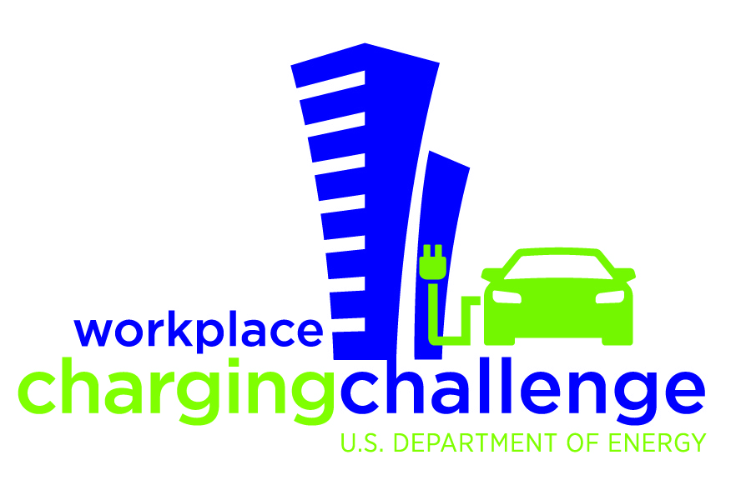

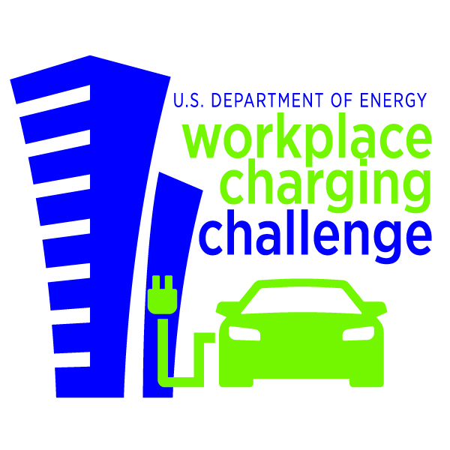
Partners and Ambassadors can use the Workplace Charging Challenge name and partnership logo—both owned by the U.S. government—to publicize your participation and achievements in the Challenge and distinguish your organization as a national leader in workplace charging. Correct and consistent use of this logo helps your organization to align its efforts with the DOE and builds the value of the Workplace Charging Challenge brand for all involved. You can find the logo in a variety of sizes and resolutions to fit your needs on the DOE Office of Energy Efficiency & Renewable Energy (EERE) Communications Standards website.

Recommended Logo Use: Recommended uses of the Challenge logo may include, but are not limited to:
- Corporate web pages
- Corporate sustainability reports
- Employee charging stations
- Presentations
- Print communications materials such as posters, flyers, brochures, etc.

Note: The DOE and EERE logos may not be used. If you have a specific request, contact WorkplaceCharging@ee.doe.gov.

Logo Guidelines: When using the logo, organizations should abide by the following guidelines:
- The Workplace Charging Challenge name and logo may never be used in any manner that would imply DOE or Federal government endorsement of a company, its products, or its services. Neither the logo nor the Workplace Charging Challenge name may be used in any other company name, product name, service name, domain name or website title.
- The logo may not be altered, separated, or otherwise distorted in perspective or appearance.
- The logo may never be used in a manner that would disparage DOE, or any other government body.
- Partners, Ambassadors and other authorized organizations are responsible for their own use of the Workplace Charging Challenge logo, as well as use by their representatives, such as ad agencies and implementation contractors.

Sample Talking Points

- On March 7, 2012, President Obama announced the EV Everywhere Grand Challenge, a “Clean Energy Grand Challenge” with the goal of enabling the United States to be the first in the world to produce plug-in electric vehicles (PEVs) that are as affordable and convenient for the average American family as today’s gasoline-powered vehicles within the next 10 years.
- PEVs can offer consumers significant advantages over gasoline-powered vehicles, including savings on fuel costs, added convenience from home refueling, and reduced maintenance costs. Electricity is cheaper than gasoline to power a vehicle – generally equivalent to about $1 per gallon. More background information on PEVs is available on the Alternative Fuels Data Center website.
- As part of the EV Everywhere Grand Challenge, DOE launched the Workplace Charging Challenge in January 2013, with the goal of increasing the number of American employers offering workplace charging by tenfold in the next five years.
- Employer-provided PEV charging serves as an attractive employee benefit, enhances corporate sustainability efforts, and signals corporate leadership in adopting advanced technology. It also fills an important gap in America’s PEV charging infrastructure, increasing consumer exposure and access to PEV charging opportunities. The ability to charge at work can potentially double the all-electric daily commuting range for a PEV driver.
- The Workplace Charging Challenge calls upon America’s employers to act as Partners and make a bold commitment to provide PEV charging access to their workforce. Partners are employers that commit to assessing employee demand for PEV workplace charging, and developing and executing a plan to provide PEV charging access. See website for list of current Partners.
- The Workplace Charging Challenge also enlists stakeholder organizations as Ambassadors to promote and facilitate workplace charging. Ambassadors are stakeholder organizations that commit to developing and executing a plan to support and promote deployment of workplace charging infrastructure. See website for list of current Ambassadors.
- In support of those who join the Challenge, DOE will provide resources and establish an information-sharing forum. DOE will also recognize successes made by Challenge participants and identify best practices.
- Find more information about the Workplace Charging Challenge and the EV Everywhere Grand Challenge at www.electricvehicles.energy.gov.

Additional Questions

If you have questions, please contact WorkplaceCharging@ee.doe.gov.

