SSLC Meeting Minutes
3/14/14
Group Presentations
Three student groups presented information about their group, including mission statements, group function on campus, and future plans. If you would like to present at the next SSLC meeting, please contact Nishant Makhijani, nishant.makhijani19@gmail.com
- SSC – Student Sustainability Committee
- Green Observer
- SECS – Students for Environmental Concerns
SSC:
- Structure
  - 10 students, 6 faculty, 6 staff
  - $1.1 million to distribute among student and faculty projects
    - Cleaner Energy Technologies fee
    - Sustainable Campus Environment fee
  - 4 Subcommittees
    - Executive
    - Bylaws
    - Fines
    - Marketing
  - 6 topics – include more community input
    - Land
    - Energy
    - Food and waste
    - Education
    - Water
    - Transportation
- Strategic Impact
  - ICAP concerns - fund projects that help UIUC reach ICAP goals
  - Projects that have no other method of funding.
- Process
  - Step 1: ideas get turned into specific requests and goals, submitted to SSC in application with project abstract and approximate funding needed.
  - Applications are reviewed and selected based on strategic impact goals, get invited to step 2…
  - Step 2: Specific logistics figured out, feasibility reports made
  - Step 3: Entire SSC votes
- SSC allocations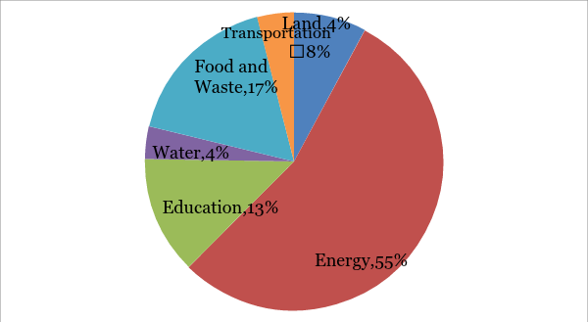

- Future goals
  - More student engagement
  - Expand outreach efforts
  - Get more student-driven project applications
- Some projects/organizations SSC has funded…
  - Green Observer
  - Bike Shop
  - Solar decathlon house
Green Observer:
- RSO and YMCA program
- Publish 4x/year
  - Next issue comes out Monday, 3/17
  - In print at YMCA, Greg Hall, ACES library, Union, LAR (maybe)
- Mission
  - Inform students about environmental news
  - Provide students with platform to practice journalism and practice journalistic advocacy
    - Journalistic advocacy – choosing specific topics to write about, inherently advocating for those issues.
- Mutual Benefit
  - Goals to collaborate with other environmental organizations
    - Send press release about upcoming events (email Olivia Harris, oharris2@illinois.edu)
    - Co-sponsor events
    - Calendar function – google calendar with environmental events/talks/presentations
SECS:
- 6 Project Groups
  - Earth Week Committee
    - Organize events for Earth week
    - Includes speakers, panels, movies, benefit concert
  - Education Project Group
    - Develop environmental curriculum to teach 4th and 5th graders
  - Florida Orchard Prairie (SSC funded)
    - Sustainable landscaping
  - Sustainable Food
    - Introduce ideas about food
    - Work with Student Sustainable Farm
    - Farmer’s Market
    - “group of friends talking about food”
  - Weatherization Committee
    - Design methods to make homes more efficient
    - Distribute packets of information and supplies
  - Beyond Coal Committee
    - Stop UIUC from investing in “the filthy fifteen” coal companies
    - Design campaigns
- Past events
  - Powershift conference – social and educational events
  - Keystone XL rally
  - Sierra Club training
- Meetings
  - SECS – Wednesdays at 6:30p in YMCA
  - Beyond Coal – Thursdays at 8:00p in YMCA basement

SSLC Presentation – iSEE plans (presented by Ben McCall)
Recall: ICAP requires that campus is carbon neutral by 2050. We have a lot of work to do, but we have accomplished some so far…
Projections (Business as usual vs. Where we are now):
Business as usual…
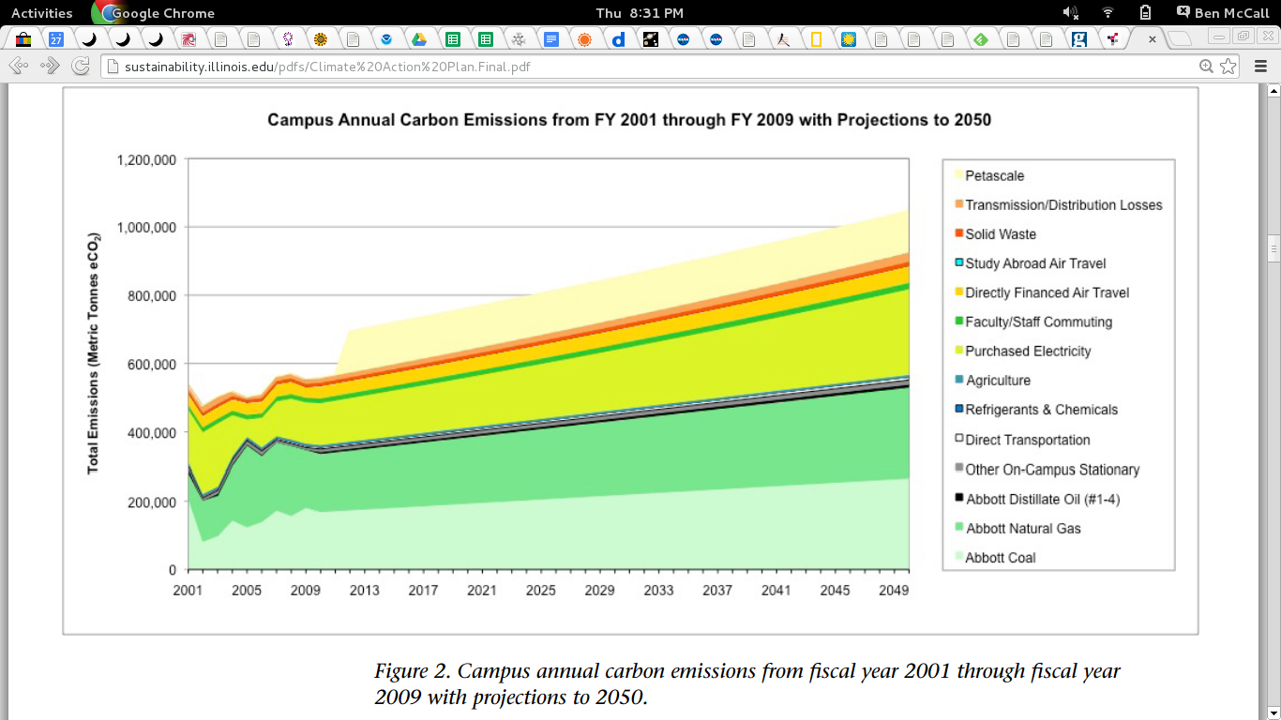
Where we are now…
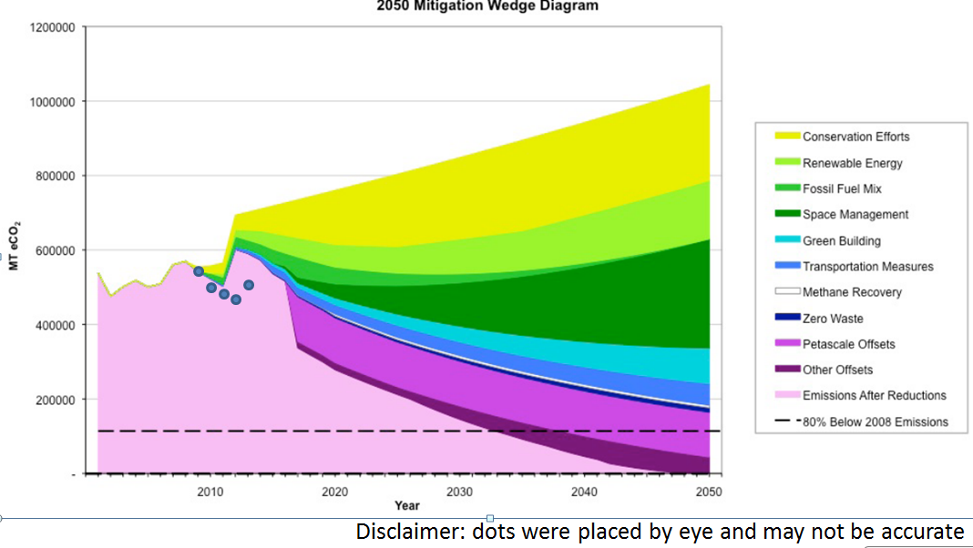
NOTE: Projections start at 2009. Dots denote where we actually fell during those years. Moral: we’re doing better than expected.

SWATeams
- 6 topics
  - Energy Generation, Purchasing, & Distribution
  - Energy Conservation & Building Standards
  - Purchasing, Waste, & Recycling
  - Agriculture, Land Use, Food, & Sequestration
  - Transportation
  - Water
- Core group
  - 2 students
  - 2 faculty
  - 2 staff
- Core group surrounded by consultation group
  - Consultation group members will be figured out soon (look out for an email about it!)
SWATeam Goals
- Evaluate campus progress towards iCAP goals (has been initiated)
  - Hopefully done by Earth Week!
- For the future…
  - Formulate recommendations and give them to iCAP working group
  - iCAP working group will filter out based on size
    - small recommendations → just do it
    - large recommendations → need feasibility studies
    - Very large recommendations → send up to sustainability committee
SWATeams so far:
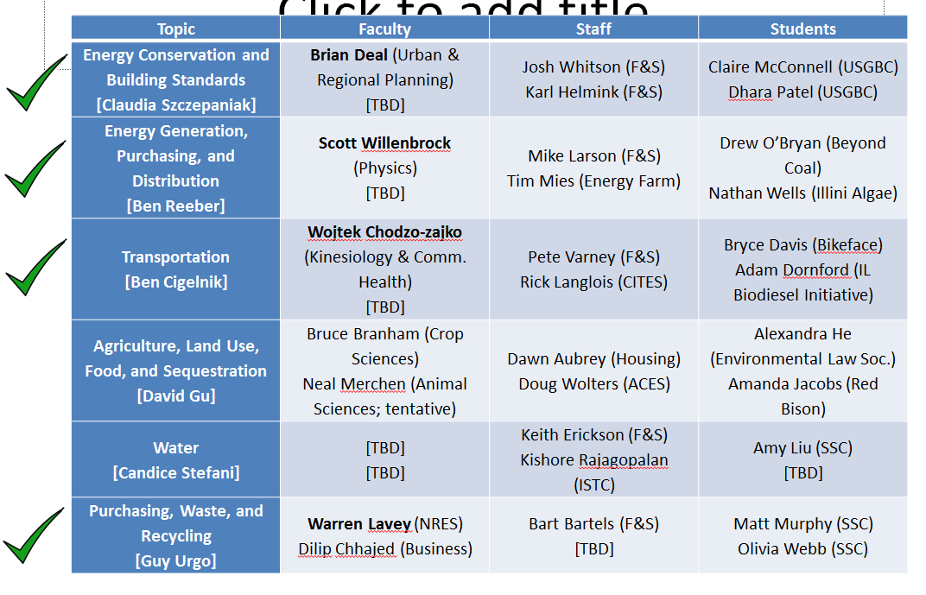
Email Ben McCall if you would like to join one of the remaining student spots!

8 iCAP goals by 2015
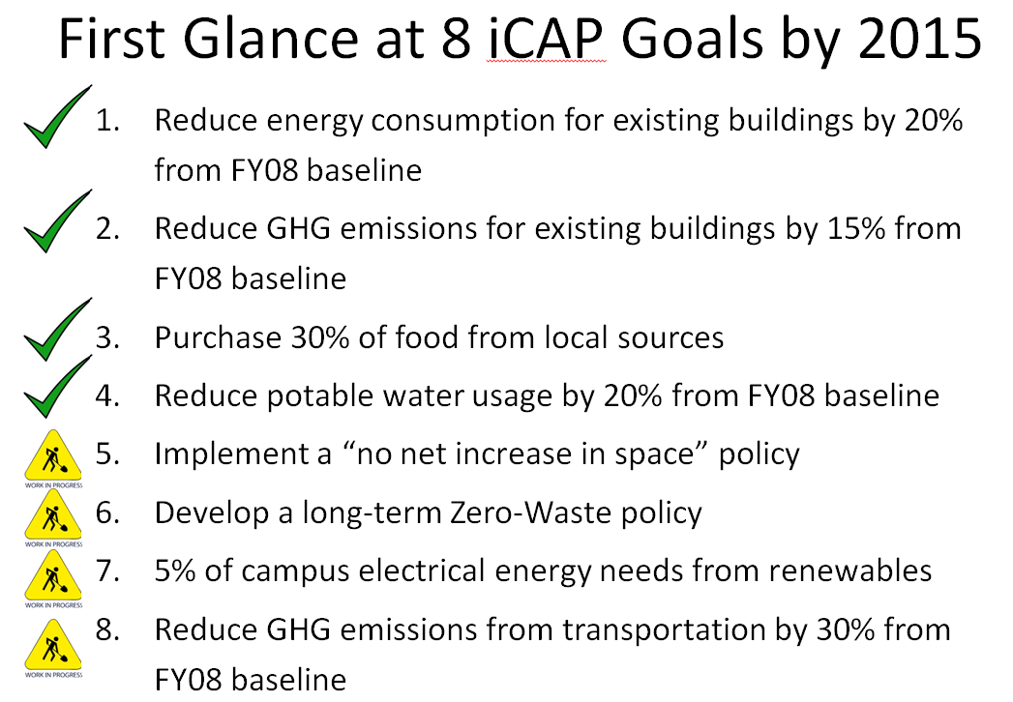
NOTE: Green check denotes that the goal was met. Yellow sign denotes that the goal is a work in progress.

