EcoOlympics Closing comments
Overview
The competition reached students and showed a measurable amount of behavior change across campus. This being the main goal of the campus conservation nationals means the competition was a success. The amount of energy saved ranged from -14.7% * to +12.2%. These numbers are in line with other Big10 schools that participated in the Big10 Unplugged, Ohio’s largest savings 5% and Nebraska was 21.8%. There is definitely room for growth in all areas of the competition and reaching the students to create behavior change. Being the inaugural campus event and first ever participation in the campus competition nationals (CCN) there were beginning logistics and marketing hurdles that have been overcome and remain in place for the years to come. The sustainability movement continues to grow and flourish across the nation and locally here at the university across all disciplines. With the roadmap in place I look forward to great gains and a wonderful local competition and competitive level of participation again in next year’s Big10 competition.
Reflection Notes
The competition development was quite involved and took a good amount of effort to identify meter ID numbers, residence Hall eligibility, usage tracking methods and reporting capability. The final method was a daily report from the utilities system that included all but two of the halls, these two halls were screen captured by utilities personnel daily and emailed to me. This proved to be very effective and easy to do with limited time requirement.
Marketing and recruiting students proved to be very challenging as the student body have structured schedules and interests, the RSO’s the students have joined already have agendas and events that keep them occupied throughout the semester. Recruiting the organization team and creating the campus competition” ECOOLYMPICS” from start to finish was an awesome learning experience for all of the team members.
Registering and establishing the university as a member of the national Campus Conservation Nationals took a fair amount of time with online introductory meetings and trainings.
Getting the support of campus organizations and funding turned out to be a key element of marketing and getting the word out. Obstacles and difference of understanding on how to communicate throughout the residence halls proved to be a fun journey in learning. There are often more than one way to reach your goals.
Ideas for next year is to treat the event more like a political campaign in recruiting and getting the word out to create a competitive spirit across campus. Possibly registering the event as an RSO in order to aid in recruiting, planning, events and fund raising.

*Designates building that had increases in electric usage due to window air conditioner units.
EcoOlympics 2014 Final screen captures:
Note: The dots over the yellow bar graph indicate the baseline recorded usage.
Overall standings
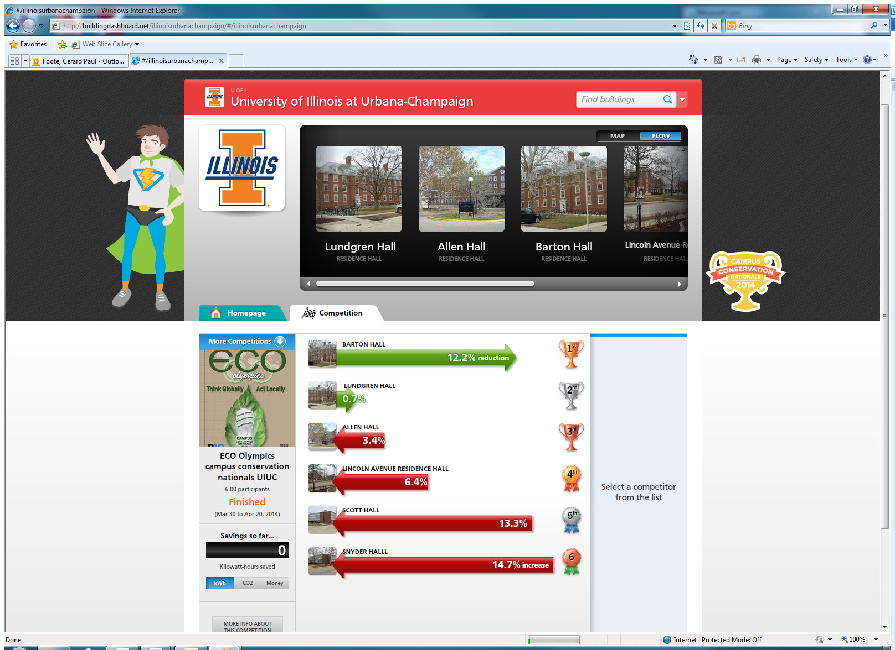

LUNDGREN
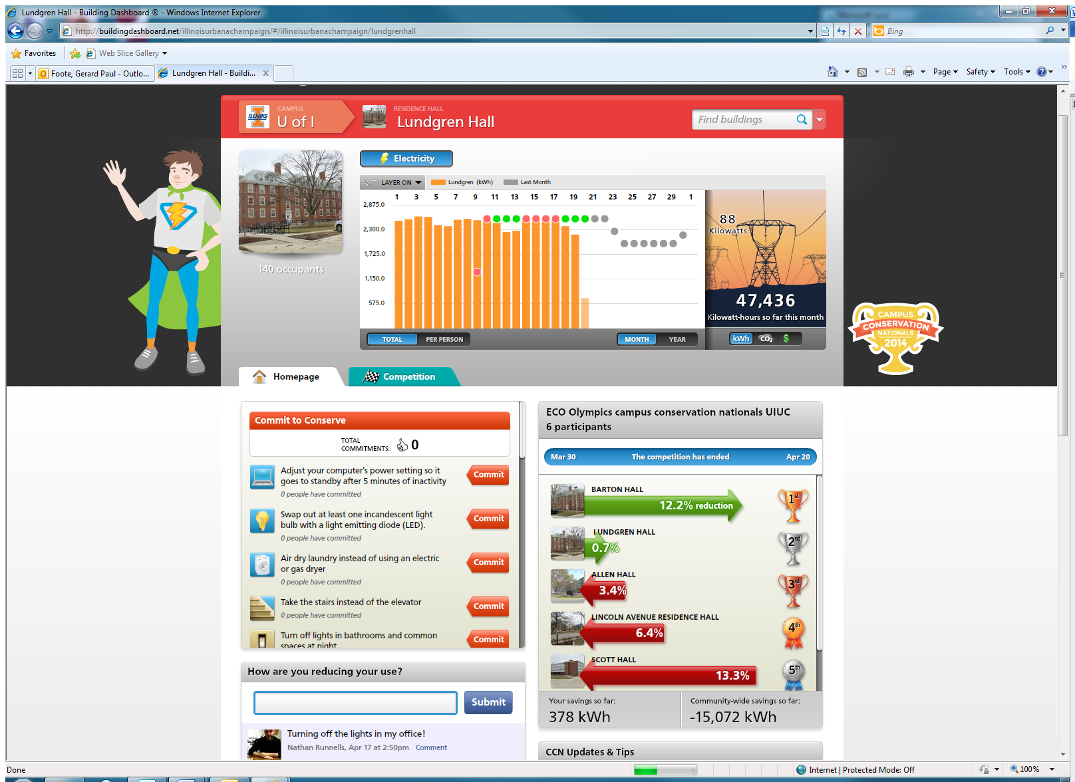

Allen Hall
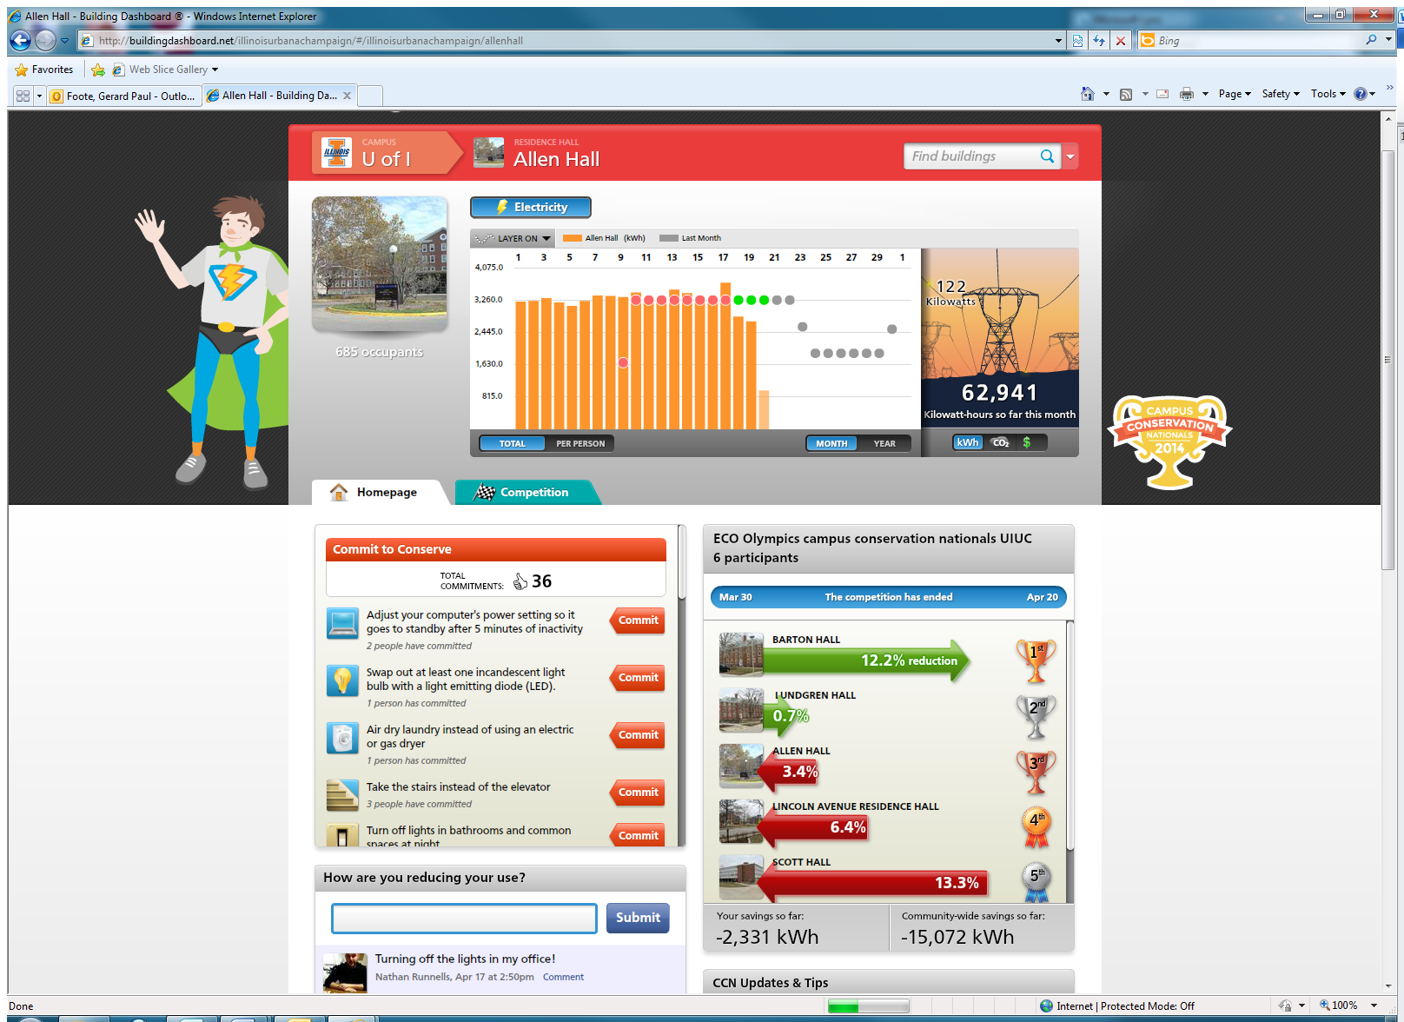

Barton Hall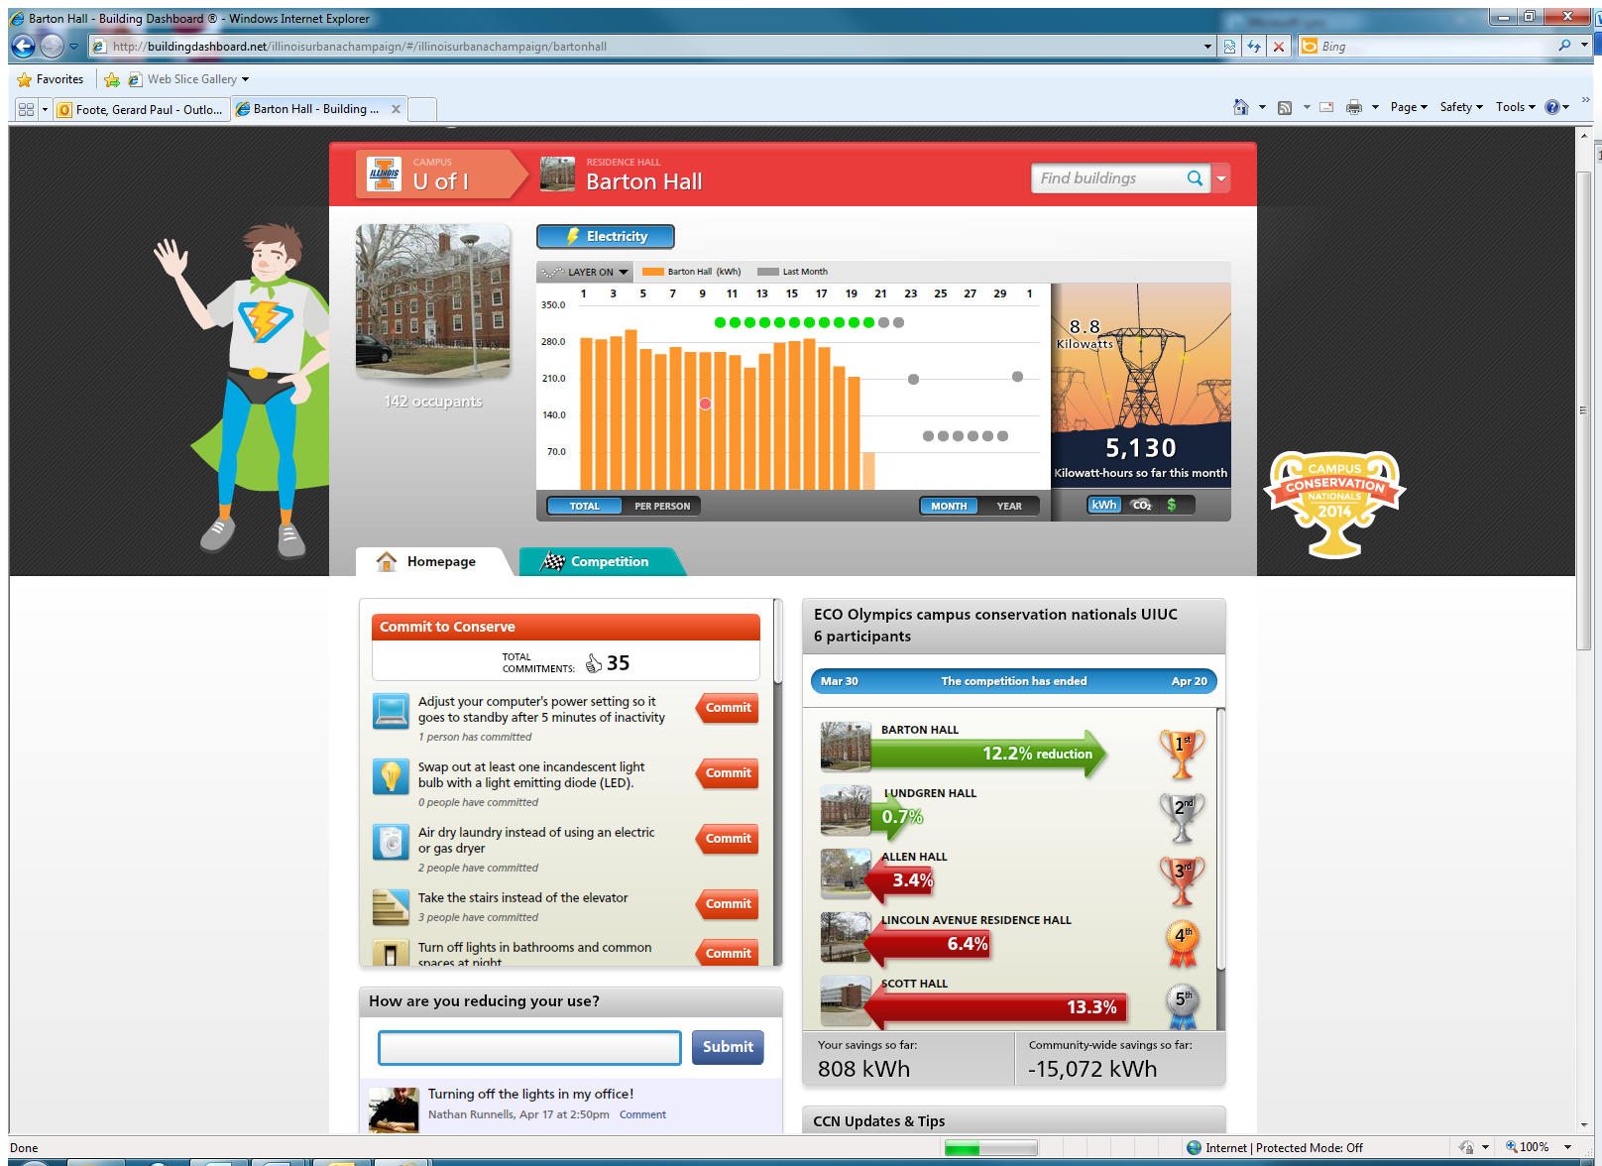
Lincoln Avenue Residence Hall
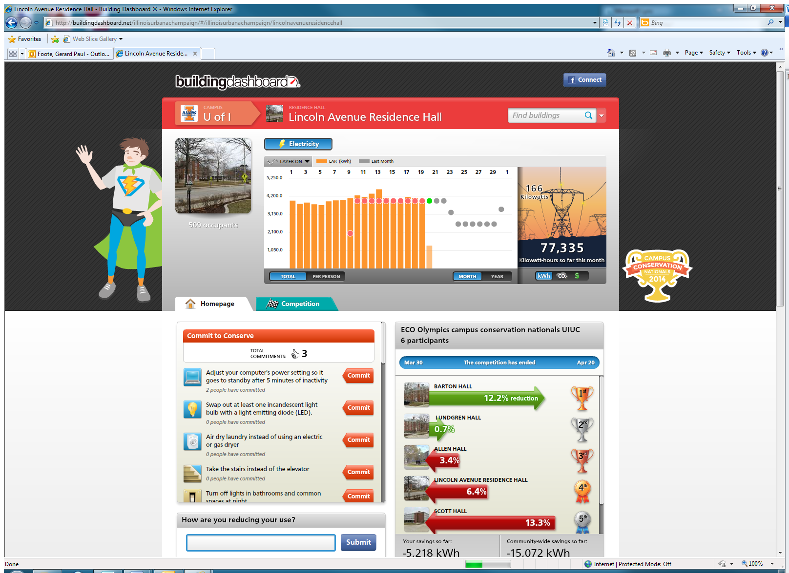

Scott Hall
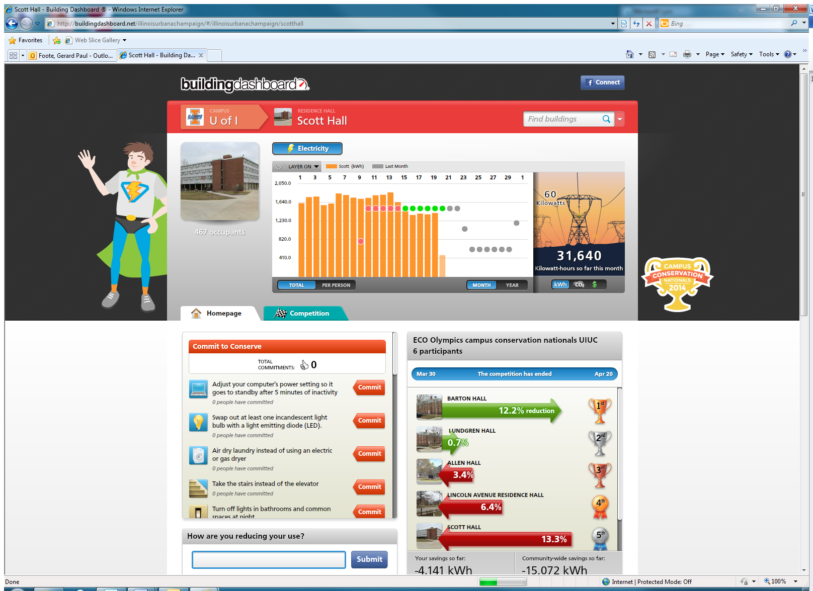
Snyder Hall
