Sustainability Assessment of small-scale Outdoor Wood Burning Appliances
Eric Dyer

- Introduction
Since the beginning of the Industrial Revolution, scientists have reported drastic increases in greenhouse gases caused by anthropogenic emissions. In recent decades, research and policy-making has been focused on lowering emissions through the energy sector. Biomass is a developing renewable fuel that is considered carbon neutral, or in certain cases, a sequestration sink.
In this case study, an Outdoor Wood Burning appliance was installed in central Illinois as a biomass substitute for existing natural gas heating. The location is owned by the University of Illinois at Urbana-Champaign and is operated under the name Allerton Park. Allerton Park is a 1,500 acre estate with numerous woodland, riparian, and prairie areas. This location was selected by the University’s Student Sustainability Committee which disperses student fees allocated for sustainability improvements. The visitor center and several workshops at Allerton Park used a 1960 boiler/heating unit that was expensive to run and produced excessive CO₂ emissions.
The solution in this case was to purchase and install a Central Boiler ECL2300, to supplement their existing heating units. The installation cost a total of $33,167.40 and uses 200 cords per year of on-site Osage Orange wood. Analysis for this project is based on emissions and costs.

- Data and Information
Site specific data for this research was gathered through the application submitted by Allerton Park to the University of Illinois iCAP Portal [3] and through an interview with Derek Peterson, Director, at Allerton Park [4]. All other research was completed based on outside sources and application of standard scientific procedure.

- Goals and Definitions
This wood fueled boiler project was submitted and selected for Allerton Park to achieve the goals of Green Allerton, their sustainability initiative. Green Allerton was an initiative developed at Allerton Park to achieve 3 outcomes: 1) Develop programs for research and education with a focus on understanding of nature, landscape and sustainability. 2) Employ balanced management techniques for preservation of Alerton’s reserves. 3) Be good stewards of a natural setting where visitors gain an understanding of their relationship to nature.
In terms of definitions, this initiative does not specifically define sustainability, however, based on their projects it can be seen to have a focus on recycling, energy conservation, fossil fuel use, water conservation and purchasing. For this specific project they also listed a goal of reducing heating bills by 45% so there is a clear influence of cost as well.

- Analysis
  - Emissions
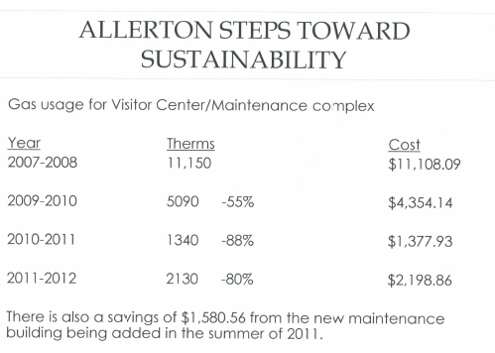
When looking at the emissions of this project we must consider that the wood fired boiler uses a carbon neutral source in Osage Orange wood since Allerton Park is replanting in areas where trees are cut. However, that does not mean that the Central Boiler model ECL 2300 is emission free. It produces Fine Particulate Matter which is a different form of air pollution that can have dangerous side-effects such as visibility impairment, Environmental Damage (acidification) and aesthetic damage [5]. This Fine Particulate Matter (FPM) can be estimated using the flow chart indicated in Figure 1. The input for cords of Osage Orange comes from an estimate on the SSC proposal, BTU’s per cord is gathered from the University of Illinois’ extension office, and FPM per BTU can be found in the Vermont EPA’s report on the ECL2300. These calculations led us to find that the ECL2300 at Allerton Park was producing an estimated 40.6 pounds of FPM per year. [3,7,10]
Figure 1
For complete emissions testing we must also look at the previously installed system of exclusive natural gas heating. From Figure 2 [3], we can see the natural gas use in the year 2007-2008 which is used as our baseline in analysis. The system was using 11,150 therms of natural gas per year which produces an estimated 59.12 metric tons of Carbon Dioxide per year based on EPA emission factors [9].
Figure 2

  - Costs
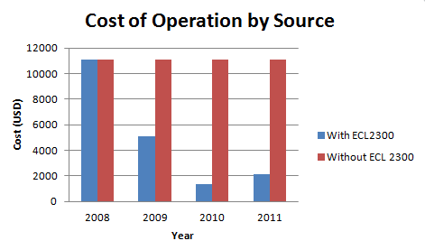
When analyzing the costs of the project, we must consider first the operating cost and integrate that with capital costs to estimate a return on investment. In this analysis the year 2008 will be used as a baseline for cost, and natural gas prices will be fixed at $1.004 per Therm which was the price according to figure 2.
Scenario 1 is an analysis that relies on the data from Figure 2 and shows that out of pocket operation costs drop significantly after the successful implementation of the ECL2300. From the baseline of $11,108.09, natural gas cost drops to near $2,000. See figure 3.
Figure 3
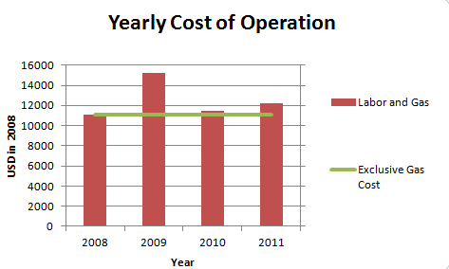
Scenario 2 considers the additional cost of labor for felling trees, splitting wood, stacking wood, and fueling, the results are not as positive, see Figure 4. Labor is primarily provided through volunteer efforts and the cost of labor was estimated at $20.25 in 2008 [11]. The number of volunteer hours used per year is 500 and was given as an estimate from Derek Peterson [4].
Figure 4
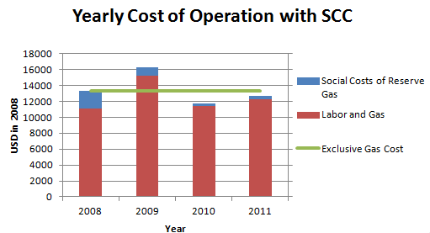
The final scenario 3 used in cost analysis includes the social cost of carbon. This social cost was set at a valuation of $37 per ton which was the conservative estimate given by the EPA in 2014. This value would ideally be standardized to 2008 with proper discount rates however that data is not currently available so a conservative estimate was selected. When we include this additional cost of carbon, we can see how it would theoretically be less expensive to operate the wood fueled boiler as opposed to exclusive natural gas. See Figure 5
Figure 5
To determine the return on investment we must look at the projected operation costs and age of the product. Unfortunately we cannot determine how long the implemented ECL 2300 will last because it has not been tested to failure. In the first scenario we would hit the break even point in 3.54 years, the second scenario there would be financial loss, and in the third the break even would occur at 30.47 years

- Discussion
The emissions analysis performed shows that the ECL2300 unit produces 40.6lb of FPM per year however the Carbon Dioxide emissions drop by nearly 50 tons per year. Unfortunately it is difficult to determine whether the increase in FPM is worth the drop in CO2. In Fann’s 2008 article [6], it is shown that Fine Particulate Matter pollution can have major or minor affects based on location, type and source. It is likely that the single boiler will not produce significant haze or health effects; however they cannot be fully rejected.
We must also acknowledge that the source for natural gas is more stable than the wood fueled boiler. The supply of Osage Orange is estimated at 30 years and there are no planned, sustainable sources after 30 years. The trees are deemed invasive by Allerton Park and so they can be freely removed, but the replanted trees are native species that will likely not be harvestable.
The cost analysis also brings into account variables that are not directly tied to operating cost. For example, the volunteer hours would not necessarily be used on other projects so they may not have the realized value of $20.25 per hour. This estimate is primarily used to gauge the hidden costs of switching from natural gas to a small-scale wood fueled boiler. It is not necessarily realized in their annual budget which was one of Allerton’s original goals, lowering the direct heating costs.
The social cost of carbon is also a variable that would be unlikely to affect direct expenses. At this point in time the federal government will not reimburse Allerton Park for saving 50 tons of CO2 emissions per year. It is possible that there will eventually be a subsidy or related program for wood fueled boilers in the future however this is not included in our analysis today.
This analysis did not look at alternative fuel sources however it is possible that a more efficient heating system exists, from the emissions and cost perspective. This is dependent on technologies and would require further research.

- Conclusions
In terms of emissions analysis, it is unclear whether or not the wood fueled boiler is superior to the previously installed natural gas system. The Fine Particulate matter produced by the ECL2300 cannot be definitively shown to be less dangerous than the Carbon Dioxide emissions from the natural gas boilers. If modeling was done on the area, it is possible that risks could be weighed to determine which technology is superior in terms of emissions.
The cost analysis in the research shows that the wood fueled boiler did significantly reduce the natural gas expenditures; however it was not clear that the operational cost was significantly reduced. The introduction of labor costs of fueling the wood boiler confounded the issue because of the value of volunteer hours versus the zero labor costs of natural gas. If we look at the goal of 45% reduction of heating costs, we can see a success with the first method of analysis, but a failure after including labor and social cost of carbon.
Although this research may not have proven the sustainability of the wood fueled boiler, the project did accomplish the goals of Green Allerton. The project involved students from the University of Illinois’ Architecture and Natural Resources and Environmental Science departments fulfilling the first Green Allerton goal. It also diversifies the fuel supply of Allerton Park which leads to a more balanced management of resources on Allerton. Finally, it is reasonable to assume that Allerton is being a good steward by switching to a zero net carbon source and visitors are gaining an understanding of their relationship to nature by touring the wood fueled boiler. Allerton Park hosts nearly 100,000 visitors per year and the wood fueled boiler is commonly shown on tours. There are many aspects of this project that cannot be quantified but advance Allerton towards their goals. For this reason the project can be considered a success despite the unclear findings in data.

Sources:
- Bernat, E. Environmental assessment of small-scale production of wood chips as a fuel for residential heating boilers. Renewable Energy. Feb 2013. 62. 106-115
- Central Boiler. http://www.centralboiler.com/
- Green Allerton Wood-fired Boiler. iCAP Portal, University of Illinois. http://icap.sustainability. illinois.edu/project/green-allerton-wood-fired-boiler
- Interview: Derek Peterson. April 11th 2014.
- Kaivosoja, T. Comparison of emissions and toxicological properties of fine particles from wood and oil boilers in small (20–25 kW) and medium (5–10 MW) scale. Atmospheric Environment. Oct 2013. 77, 193-201
- N. Fann. 2009. The influence of location, source, and emission type in estimates of the human health benefits of reducing a ton of air pollution. Air Quality and Atmospheric Health. 2(3)169-176
- University of Illinois Extension: Firewood in Illinois.
- US Forest Service Website
- U.S. EPA Website. Social Cost of Carbon 2014.
- Vermont Certifies E-Classic 2300 Outdoor Wood Furnace. Industrial Environment. May 2008. 19,5,(6-7)
- Independent Sector. Value of Volunteer Time

