Stephanie Kim
GreenLink Project Assessment
The University of Illinois is an educational institution that strives for excellence in sustainability. Under this new goal, many projects have been funded such as the green roof over the Link Gallery. The Link Gallery is a space used to exhibit student work and is wedged between the Art and Design Building and the Krannert Art Museum. The project, titled GreenLink, was proposed by Nan Goggins, the Director of the School of Art and Design, and David Akins, the Director of Art and Design Facilities in 2008. The goal of this project was to make visible the concerns and interests of Fine and Applied Arts students and faculty in working collaboratively on “greening the art campus”. They also had the goals of lowering the heating and cooling costs for the Link space, as well as collecting and storing rainwater to water the gardens on either side of the Link Gallery.
Before going into detail about the project, I think it is necessary to give a brief overview of green roofs since they are a relatively new concept. There are many components to a green roof. At the bottoms, there is often a waterproofing root barrier layer. Above that is the drainage and water storage layer that is lightweight. A filter layer is necessary for filtering out silt from the planting medium to prevent drainage problems. Then there is the planting medium, which is specially made to be lightweight and allow for the percolation of water like pumice. Vegetation is then put on top and while species chosen are highly dependent on the climate or green roof type, they are usually dry-resistant succulent types.
In the original GreenLink budget proposal, they included the cost of replacing the existing Link Gallery roof surface that would be carried out by Facilities and Services. According to David Akins, one of the projects leads, the original roof was already at the end of its lifespan and was in need of repair. In their original proposal and budget, Weston Solutions was the vendor of choice. Their plan was to install 360 2ft x 2ft GreenGrid panels with an estimated cost of $17,160. In order to follow through with their goal of collecting and storing rainwater, they proposed to remove the defunct water softener and AC unit in the Link basement and install a 535-gallon water tank that would tie into the existing roof drainpipe. In addition to this, they hoped to replace the second floor window of the Art and Design Building that overlooks the Link Gallery roof to make the space accessible. The total estimated cost in the budget proposal was $91,911.
The Student Sustainability Committee provided $63,900 to partially fund this project with the requirements that the rest of the funding be obtained from Facilities and Services and outreach or publicity indicates the support of the Committee. The funding source was noted to be through the Sustainable Campus Environment Fee. In September 2009, James R. French, a structural engineer, performed a structural analysis of the roof to see the weight loading of the Link roof. The rainwater collection system was installed by East Central Construction in May and June of 2009. In April 2010, the roofing was replaced by Facilities and Services and cost $54,900. At this point, the project requested more funding from the Student Sustainability Committee to account for the additional roof area and in response, the Committee added $3,400 more to the project’s account. In August 2010, the final green roof was installed through Ingram Nursery and Urban Enviroscapes at a cost of approximately $25,940. Urban Enviroscapes was a startup company created by Andy Camp, a University of Illinois graduate. Some changes to the original plan included the exclusion of replacing the second floor window due to safety issues regarding the lack of railings on the roof. Also instead of 360 modules installed, there was enough room for 432 modules. Compared to the original proposal budget of $91,911, the final cost of the project ended up being $103,600.
In attempting to assess this project is should be noted that there has been no maintenance or monitoring since the installation of the green roof in 2010. Ideally, green roofs should be low maintenance but some weeding may be necessary as well as watering during long dry periods. One way in which I am able to assess this project is through LEED certification points of green roofs. There are certain categories in which green roofs can help buildings earn credit towards LEED accreditation. Green roofs can earn credit under 5 of the 6 major categories of LEED accreditation: sustainable site, water efficiency, materials and resources, energy and atmosphere, and innovation and design process. In total, these points can contribute almost 20% of the total points needed to certify. While many of these require specific details in order to receive credit for them, I will instead be using them as a general guideline to compare the GreenLink project to.
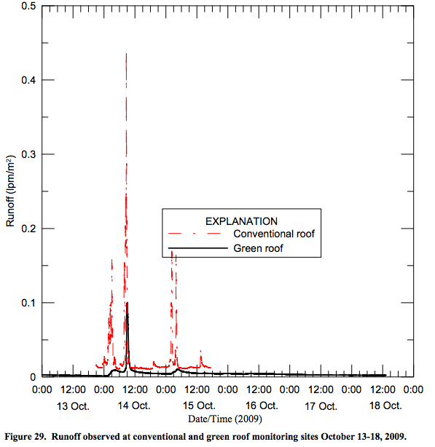
Under sustainable site, one can receive up to two points for protecting or restoring habitat and maximizing open space. This includes native or adapted planting, promoting biodiversity, etc. The green roof vegetation was a sedum variety of plant species. These are succulents, have water-storing leaves, and are found throughout the northern hemisphere. I would award the GreenLink project one point under this since it did restore a certain amount of landscape to an otherwise developed surface. Two points can also be awarded for storm water quantity and quality control. Green roofs can reduce runoff and have the ability to remove suspended solids and other pollutants by being filtered through vegetation. To earn points for stormwater quantity control, the US Green Building Council requires sites to implement a plan that results in a 25% decrease in stormwater runoff. To fully assess the stormwater runoff reduction qualities, monitoring must be implemented. In addition, a point is rewarded for management that removes 80% of total suspended solids and 40% of total phosphorus. The BIF green roof is currently being monitored with rain gauges and automated water samplers. In a preliminary report, it was shown that on October 2009, there was a 40% retention in rainwater and a peakflow reduction of 78% (Figure 1). While it is possible that the green roof over Link Gallery reduces runoff rates and total suspended solids due to vegetation and a filtering rainwater storage system, it is hard to estimate with the lack of proper monitoring. Finally under the sustainable site criteria, it is possible to earn one point for reducing the heat island effect, or the thermal fluctuations that comes with the over mounting impervious rooftop surfaces in cities. The US Green Building Council states that a green roof that covers more than half of the roof surface can meet this objective. In this case, the green roof only covers 30% of the entire Link Gallery roof surface.
Figure 1 BIF stormwater runoff for October 2009
Under the category of Water Efficiency, it is possible to earn several points for water efficient landscaping. This includes reducing potable water consumption for irrigation by 50% or for more points, using only captured rain or recycled site water to eliminate all potable water use for site irrigation. There are two gardens on either side of the Link Gallery space. The plan was for rainwater to be collected in a tank that could then be used to water these gardens. After speaking with David Akins, the pipe system only allowed for the collected rainwater to be used on one of the gardens. Considering how no watering is needed on the green roof, I would say that this is a form of water efficient landscaping and merits a point for reducing potable water by at least 50% for irrigation.
LEED offers points for the materials and resources used for building projects. The greater percentage of recycled content in the materials rewarded different points. There are also points awarded for the percentage of regional materials, or products manufactured within a 500 mile radius. The recycled content of the modules from Urban Enviroscapes was unable to be found. However GreenLink’s original green roof vendor, Weston Solutions, advertise that their GreenGrid modules and growth compost are from both pre-consumer and post-consumer materials. As for regional materials, all the companies that GreenLink consulted with were regional businesses. Ingram Nursery is based in St. Joseph, Illinois which is approximately 13 miles from campus. The recycled content and locality of materials used for this specific project are incalculable but are important factors in a life cycle analysis of a green roof which will be touched on further below.
The energy and atmosphere category under the LEED certification is where points are given on the optimizing energy performance of a building. A green roof can reduce the energy demand of a building since the vegetation can act as a thermal barrier. Vegetated roof surfaces as compared to conventional roofs are cooler due to latent heat loss and increased solar reflectivity. The Chicago City Hall green roof on average year-round is 7 degrees cooler than its surrounding roofs and as much as 30 degrees cooler in the summer. Lee et al. estimated a green roof savings of anywhere between 0.17 kWh/ft² to 0.63 kWh/ft² in cooling energy and a savings of 0.02 therms/ft² in heating energy. The approximate coverage area of the Link green roof is 1,728 ft². These numbers are highly dependent on a variety of factors such as growing medium type and depth, plant coverage, building characteristics, and weather conditions. However using Lee et al.’s averages, we get an approximate energy savings from the Link green roof of 691.2 kWh in cooling energy and 34.6 therms of natural gas heating energy. I was unable to extend this analysis for cooling savings since data for building chilled water usage started towards the end of the 2013 fiscal year. In terms of heating, the Art and Design building steam consumption data is in kilopounds (KBL), thus 34.6 therms to steam pounds would be 3326.9 steam lbs or 3.33 klbs. Steam consumption data for the Art and Design building date back to the 2009 fiscal year and averages around 9,652.31 klbs/year. Since the green roofs installation in August 2010, there is noticeable downward trend from the fiscal years 2010 to 2012 (Figure 2). However confounding factors such as HVAC retrofits or just the replacement of the roof itself could have contributed to this. Based on these calculations it is unclear whether the addition of this green roof has significantly contributed to reduced heating and cooling needs due to a lack of baseline usage data as well as other confounding improvements on the buildings. The data is also split between the Art and Design building and the Krannert Art Museum so it is unclear where the Link space falls under.
Figure 2. Art and Design building steam consumption data by fiscal year
Finally, LEED awards points for innovation and the design process. Projects can receive up to four points for improving workplace environment, creating an educational laboratory, or a recreational space. Green roofs have the ability to serve all of these functions. Intensive green roofs can be accessible by people and can act as a recreational green space as well as improving workplace environments. Green roofs are also a great opportunity for research. A great example of this is the monitoring and modeling of the green roof on the Business Instructional Facility. In relation to the GreenLink project, an educational impact was the integration of sustainability in two Art and Design courses, ARTD 299 and ARTD 499, in 2009. It is also arguable that the green roof improves the educational environment since it is a highly visible space from the second and third floors of the Art and Design Building. Due to this, I believe that this is where GreenLink derives most of its strengths from as a project.
Conclusion and Further Considerations
After speaking extensively with my contact, I got the impression that there were many obstacles to the success of this project. When the structural engineer first performed a roof analysis, it was then apparent that there were several safety issues involved with the lack of railings or ridges along the edges. This would complicate the process since it meant that maintenance of the green roof would have to be overseen by third party landscapers rather than Facilities and Services which would come at an additional cost to the university. The safety issues of the roof also meant that the second floor window overlooking the Link Gallery roof could not be constructed. The design of the hinged window was, as I was told, a collaborative effort between Architecture and Art and Design students.
I also had an issue trying to contact Andy Camp from Urban Enviroscapes, the startup company used for the green roof modules. I would have loved to speak with him further about the green grid module design and construction in order to do a full life cycle analysis of the project. The decision to choose Urban Enviroscapes over their original vendor, Weston Solutions, was likely made because they wished to support a University of Illinois graduate’s startup that showed much potential. It is unfortunate that this company did not pan out because they were also a part of another proposal for a green roof over the Krannert Center for the Performing Arts. As noted in this other green roof proposal, the company began when the founders won a sustainability case competition in Seoul, South Korea.
While Weston Solutions may have come at a higher cost, they also have more experience behind them. Their operations are transparent which gives consumers confidence in their products. In addition to this, they have a commitment to meeting the demands for sustainable building and roofing solutions today, in order to meet tomorrow’s environmental challenges. They partner with a variety of universities to conduct research and evaluate the efficacy of green roof systems through measurable scientific means. This is also in their best interest since through this research they are able to constantly adapt and optimize their green roofs for the most impact.
While this project may have not been successful in some aspects, I want to emphasize that this shouldn’t deter the University of Illinois from investing in further green roof operations. A green roof may come at a higher initial cost but it is guaranteed that if executed right, there will be a return on investment in the long run. A 2006 University of Michigan study found that over a green roof’s lifespan there would be a return 64.5% greater than the initial cost. These savings include reduced heating and cooling costs as well as the extended lifespan of green roofs versus conventional roofs. Conventional roofs have a lifespan of 10 to 15 years while an extensive green roof can have a life span of up to 50 years. There are also a variety of other benefits of green roofs that have been studied such as lowered air pollution to storm runoff reduction. In a full lifecycle impact analysis of a conventional roof versus extensive and intensive green roofs, Kosareo found that an extensive roof would have about half the impact of a conventional roof. The intensive green roof had the least impact in its life cycle analysis and only amounted to one-tenth of the impact of the conventional roof (Figure 3). These life cycle analyses include the resources extracted in production, impacts on human health, and ecosystem quality.
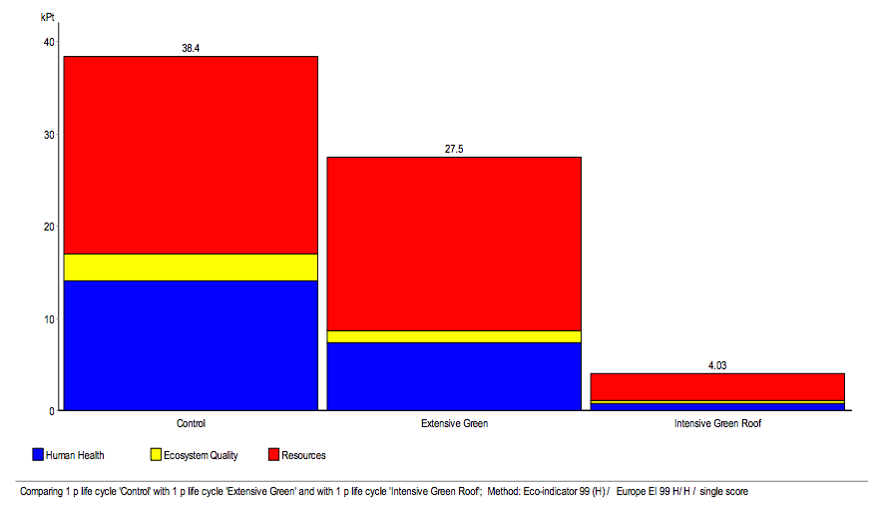
Figure 3. Kosareo 2007, Eco-indicator 99 life cycle impact single score results for roof alternatives.
In order for future successes with green roofs, below are some considerations. A green roof is a commitment despite being touted as low-maintenance. Occasional weeding may be required and thus should be expected. Consulting reputable companies may add to the success of future green roof projects. From the LEED certification system, it’s clear that green roofs that cover more than half of a building’s roof surface will have the most impact. In initiating future green roof projects, goals should be set for continuous management and monitoring. Being an educational institution that leads by example, the University of Illinois has great potential in building a body of literature and filling in the gaps of knowledge about green roofs. This can be achieved by using green roofs as an opportunity for long-term collaborative learning. Horticulture could provide insight into the species composition that would be best for green roofs. Natural Resources & Environmental Sciences could study soil composition and drainage, or ways in which green roofs can provide habitat for species. The College of Architecture and Landscape Architecture could be valuable in piecing together design and functionality of green roofs.
Monitoring is also crucial for future green roofs because if we cannot measure the effects of these projects we cannot calculate the benefits. If we cannot put the benefits in metrics, there is no way we can learn from these projects and incorporate how they impacted the University of Illinois goal of carbon neutrality by 2050. Green roofs have much potential in addressing a multitude of issues the University is working to solve due to their multiplicative benefits. They have the ability to reduce a building’s energy demand. Less steam and cooled water means less coal and natural gas needed and thus less GHG emissions. The benefit of stormwater runoff reductions and filtering out pollutants means less water is being supplied to the sewage system and reduces the demand of treating the water. One takeaway from GreenLink that I think could be utilized elsewhere on campus is the collection of rainwater and utilizing it for non-potable uses. This is cost efficient and sustainable since this collected water could replace tap water where it is allowable. In this instance, they use it to water the gardens. This can be expanded to replacing toilet water and even using greywater for heating and cooling needs. From this analysis, I hope the University of Illinois will continue to see green roofs as a viable option and consider investing in future green roof projects.

The original GreenLink Proposal can be found via the iCAP portal.
"How GreenGrid Contributes to LEED Certification." GreenGrid Roofs. Weston Solutions, Inc., n.d. Web. 3 May 2014. <http://www.westonsolutions.com/pdf_docs/B-GG-3-LEED.pdf>.
Bolton, Brad, Nathaniel Hanna-Holloway, and Arthur R. Schmidt. Monitering and Modeling of Green Roof on Business Instructional Facility. Illinois Floods. Illinois Association for Floodplain and Stormwater Management, n.d. Web. 08 Apr. 2014. <http://www.illinoisfloods.org/documents/Grant_Program/UIUC_IAFSM_Report_April-2010.pdf>.
"Chicago City Hall." Roofmeadow – Green roofs. For good. Roofmeadow, n.d. Web. 3 May 2014. <http://www.roofmeadow.com/case-studies/selected-case-studies/chicago-city-hall/>.
Lee A, Sailor D, Larson T, Ogle R. Developing a web-based tool for assessing green roofs; 2007. Greening Rooftops for Sustainable Communitites, Minneapolis, April 29-May 1. Green Roofs for Healthy Cities.
Data on the cooled water and steam usage of the Art & Design building and Krannert Art Museum was provided by Morgan B. Johnston, Associate Director of Sustainability.
Kosareo, Lisa M. The thermal performance and life cycle assessment of a green roof in Pittsburgh, Pennsylvania. Diss. University of Pittsburgh, 2007.

