Alex Blankley
NRES 285
8 May 2014

Examining the Solar Thermal Panels at the Activities and Recreation Center

For the Spring 2014 semester, I am enrolled in NRES 285 – a field course entitled Performance Metrics and Assessment Techniques for Sustainability Projects. This course utilizes experiential learning in order to gain hands-on experience with sustainability projects on the UIUC campus. In order to assess these initiatives it is necessary to evaluate effectiveness of the project, means of improvement, methods of communicating results, and suggestions for the future. In particular, a project I found particularly appealing is the solar thermal system at the Activities and Recreation Center (ARC) used to heat the indoor and outdoor pools.
Before delving into performance metrics of this site-specific project, it is pertinent to gain a greater understanding of what solar thermal energy is exactly. When many hear the phrase “solar panels,” most immediately think of solar photovoltaic (PV) panels. Photovoltaic cells get their name due to “the process of converting light (photons) to electricity (voltage)” typically with silicon being the material to create an electric charge after being exposed to sunlight. Although both are concentrating solar power technologies, solar thermal panels operate in a significantly different manner.
Rather than convert sunlight directly to electricity, solar thermal panels take heat from the sun’s rays to heat water. When sunlight hits the solar collector, it heats the fluid (often water) within the panels and heat from the liquid is transferred into hot water via a solar pump and controller; this heated water is then distributed as necessary within the system. This is a very elementary look at the difference between the two primary types of solar energy, but it is necessary to establish this difference before developing metrics to evaluate success of the system.
Upon starting this project, my available resources were restricted to the information through the Illinois Climate Action Plan (iCap) Portal and the website for the Student Sustainability Committee. This was limited namely to the Student Sustainability Committee - Funding Application: Step 2, headed up by Gary Miller – Associate Director of Special Projects at Campus Recreation. Unfortunately, this application dates back to November 2012, so the proposed plan is significantly different than what is in operation today. Initially, the general purpose of the project was to “pre-heat domestic cold water prior to its introduction into the steam heat exchanger for the domestic hot water (showers and sinks).” Since then, however, the project has evolved significantly and the solar thermal panels are currently used to heat the indoor and outdoor pools. Regardless of the intended use, the goals generally remain the same: 1. Reduce energy consumption and therefore lower the greenhouse gas impact and 2. Show beginning of efforts to use renewable energy on campus. The second goal is especially relevant, considering the high visibility of the ARC on campus coupled with the fact that majority of the users are students. This makes the ARC an ideal location for a sustainability initiative in order to raise awareness among the student and faculty bodies.
In order to advance my research, I met with Krissy Pettigrew, the Facilities Coordinator at Campus Recreation, on April 13th, 2014 and interviewed her to find out more information on the project. Ms. Pettigrew informed me that the panels are, in fact, in operation. However, the system was completely revamped from the initial purpose of domestic hot water usage as listed on the SSC funding application. The steam system at the ARC was located on the opposite end of the pool, making the initial plan too expensive and impractical.
After this, Campus Recreation determined that the best usage of the project was to employ the solar thermal panels to heat the outdoor and two indoor Olympic-sized swimming pools. Construction of the panels was completed September 9th, 2013, but failed an initial test run with a system malfunction that resulted in water in excess of 250°F being pumped into the pool. After this failure, a balancing valve with a flow meter and safety release steam valve were installed with their collaborative purpose was to avoid this aforementioned issue. Upon installation of the necessary components, the solar thermal system was re-launched on January 31st, 2014. Due to the short duration of operation, Ms. Pettigrew informed me that Campus Recreation wants a full season of operation with the new options installed before providing any means of trending data. Ms. Pettigrew gave me several documents from the project, which greatly expanded relevant, timely information for determining updated goals and developing metrics to analyze the success of the project.
After catching up with the current status of the project, it is important to define the various stakeholders. Clearly, Campus Recreation is the primary stakeholder, but by association, the student and faculty of the University are also primary stakeholders. The manufacturer of the solar thermal system is Caleffi Solar, installation by Engineering Concepts and Solutions, Inc., and Facilities & Services is responsible for research, development, and maintenance of the panels. The project was primarily funded by the Student Affairs Repair & Replacement Fund ($327,746) and the Student Sustainability Committee ($74,601) for a total of $402,347.
Caleffi Solar designed the 24 glazed, flat-plate solar thermal panels (product number: NAS10410) for the system, which are set on a 4’ x 10’ frame, leading to a surface area of 37.4 sq. feet; the total gross surface area of the 24 panels is 955.84 sq. feet. In order to gauge the ability of the solar thermal system, an independent third-party organization named the Solar Rating & Certification Corporation developed a framework by which to certify and rate solar collectors. For this particular panel, the SRCC rating is a Category C given that the output of the panel is 40,000 Btu per panel per day (11.7 kWh per panel per day). The pool is heated by a combination of the solar thermal panels and an 85% gas-fired boiler. The installation site is located on the roof of the indoor pool, due southwest of the outdoor pool and meets the ideal conditions prescribed by Caleffi solar: 1. Mounted at 40° due south 2. No cover and 3. No windbreak.
Regardless of the recommended installation site locations, Champaign itself is not necessarily the most ideal location for a solar thermal project. On average, Champaign experiences roughly 3.73 kWh/m² per day of solar radiation. To put this into perspective, the most solar-intense areas of the United States are in the southwest and receive in excess of 6.5 kWh/m² per day of solar radiation, although Champaign is still considered a feasible solar site.
Despite the lack of trending data, the information provided by Ms. Pettigrew includes the following results of an annual simulation carried out by T*SQL Pro 5.0 – a simulation program for solar thermal heating systems:
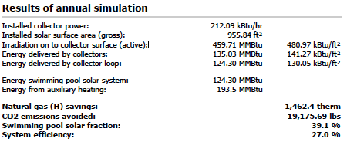
To break down this simulation, the swimming pool solar fraction (39.1%) refers to the percentage of the pool’s total heated water input, which is derived from the solar thermal system and the boiler provides the remaining 60.9% of the heat to the pools. On the other hand, the system efficiency is measured by the ratio of input to output. High efficiency is desirable, because “not only will [high efficiency] reduce your annual operating costs, but may also require fewer square feet of collector area to heat the pool.” Efficiency can be affected by several variables, and the following figure shows the energy balance schematic for this particular system at the ARC:
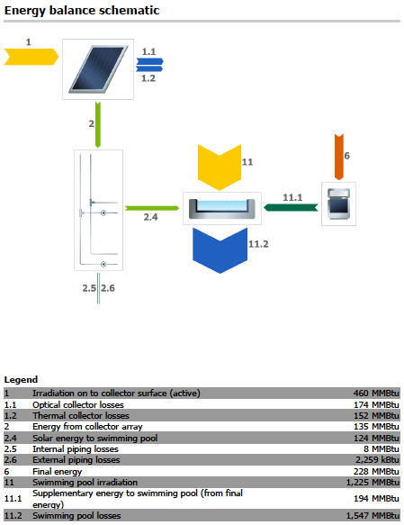
To break down this legend further, here is a glossary of explanations in plain English:
1 – Solar energy irradiated onto tilted collector area (active surface area)
1.1 – Reflection and other losses
1.2 – Heat Conduction and other losses
2 – Energy output at collector array outlet (i.e. before piping)
2.4 – Energy from collector loop to swimming pool (minus piping losses)
2.5 – Internal piping losses
2.6 – External piping losses
6 – Final energy supply to the system. This can be from natural gas, oil or electricity (not including solar energy) and takes efficiency into account
11 – Energy irradiated onto swimming pool
11.1 – Supplementary energy to swimming pool, e.g. from boiler or auxiliary heating
11.2 – Swimming pool losses, i.e. evaporation, radiation and heat conduction

Clearly there are plenty of opportunities for efficiency loss during the solar thermal system. The R&D conducted by the engineers at Facilities and Services aims to minimize losses by the system design, but in a real world system, efficiency losses are unavoidable.
Given all of this information, the questions are raised: So, what does this all mean? What are the actual savings?
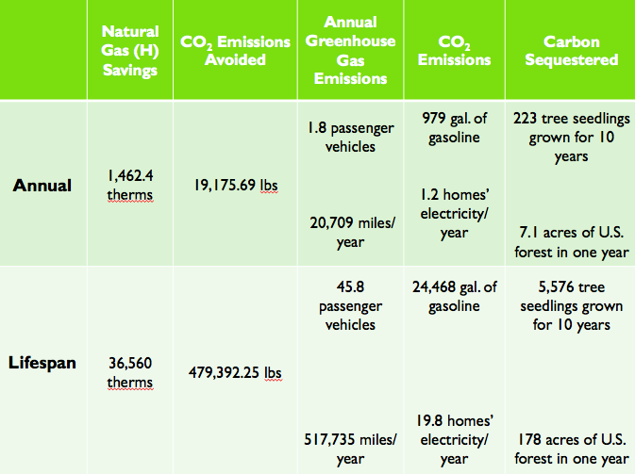

This chart takes the projected annual natural gas savings and CO₂ emissions avoided from the simulation, and with the aid of the EPA’s Greenhouse Gas Equivalencies Calculator, shows the annual and lifespan savings based off of a predicted 25-year lifespan. Information regarding the specific Life-Cycle Analysis of the Caleffi NAS10410 is unavailable, however, this information would be very helpful to fully assess the impact of the production, shipping, and maintenance of the solar thermal system. Again, once trending data is made available, then there will be confirmation of the projected savings.
In order to continue success in the future, I offer a few key suggestions for the solar thermal project at the ARC. First, monitoring the data is absolutely crucial. Although the current stance on data is that Campus Recreation wants a full season of data before making any conclusions, I feel that this is waiting too long. In order to actively benchmark the success of the system, there should be monthly reports showing exactly how much money is saved. Clearly there will be a lot of variability between months and also between years, but if the short-term data is available, I suggest that it be read cautiously to provide a glimpse of what the immediate savings are. Once trending data is collected, the annual energy savings can be determined which can lead to finding the pay-back-period for the project as a whole. I do not have specific data for this exact system, so I do not want to erroneously provide a pay-back-period, but rest assured, this system should go beyond paying itself off within its lifespan.
Besides monitoring data, physically reevaluating the system is also a necessary component to ensuring long-term success of this project. Clearly, the system has its faults; the initial failure in September 2013 proves that one cannot expect 100% success out of the box. Once trending data is collected, the system should be tinkered with in order to maximize efficiency of the system. This may involve physically adding more components to the system and/or utilizing the iSolar WMZ-G1 Energy Meter, which provides a clean interface to calculate measured values, reports, balance values, and more. With effective monitoring, any potential technical issues can be addressed at their source and altered to ensure the system is running to its full potential for this site.
Finally, all of this data is essentially meaningless unless it reaches the intended audience. Communicating results is necessary on this campus – not only for the continued success of this project, but to ensure the viability for other similar projects. By providing sustainable metrics, it shows the various stakeholders involved exactly what the purpose of the project is and gives concrete quantitative and qualitative data as to why related projects should be pursued. As the University of Illinois aims to be a leader among sustainable college campuses, the metric of public outreach must also be heavily considered in a holistic assessment of the project. In order to further this goal, I suggest that signage be displayed throughout Campus Recreation facilities advertising the solar thermal system and provide digestible data to exhibit its importance. At the Business Instructional Facility (BIF), real-time savings data from their PV panels is displayed throughout the facility via monitors. This shows student and faculty real, relatable data and this sense of close relation to the project is necessary to garner further support. Additionally, I feel that a green campaign at the ARC would be very beneficial for raising awareness of the system – student employees could be issued new, green shirts as part of their uniforms to pique interest of patrons at the ARC. Regardless of the marketing path taken, it is absolutely necessary to communicate results of this project, otherwise all the funding and hard work that went into it will only be known by a select few individuals.
Finally, my last suggestion is more radical than the previously mentioned approaches. The purpose of the solar thermal panels was primarily to reduce energy usage at the ARC itself – but why stop there? Campus Recreation should look at all of its facilities in order to determine the most cost-effective ways of reducing greenhouse gas emissions throughout their facilities. Freer Hall contains a lap pool, which is under the jurisdiction of Campus Recreation; the pool is open year round (minus breaks) M-F 5-7 PM and closed on weekends. As a former employee of Campus Recreation, I had a weekly shift at Freer Hall where, on average, only 10-15 patrons used the pool per hour. Freer Hall was built in 1931 and I can only assume it does not have the most efficient, state of the art water-heating system necessary to maintain a water temperature of 82°F. Unfortunately, energy data for Freer Hall is unavailable through the Illini Energy Dashboard. With the right source, however, a cost-benefit analysis should be undergone to determine if it really still makes sense to keep the Freer Hall pool open. Not only is energy and water required for the pool, but there are also male and female locker rooms, which exacerbate resources. Also considering that CRCE is literally right behind Freer, the issue of a pool in that part of campus is not a factor. However, given that the building is on the National Register of Historic Places, there may be some issues regarding remodeling/closing of the facilities.
In conclusion, this project requires a full season of data before true trends can be established. However, the simulated models do predict significant natural gas savings and CO₂ emissions avoided, thus satisfying the first goal of the project. As I mentioned previously, however, these results must be directly measured and communicated to the campus. Communication and awareness will be the tipping point of this project, and other similar proposed projects in the future. Solar thermal panels are proven to save energy – now, it is time that everyone should know that.

"Solar Photovoltaic Technology Basics." Learning About Renewable Energy. National Renewable Energy Laboratory, 18 May 2012. Web. <www.nrel.gov/learning/re_photovoltaics.html>.
"Solar Hot Water Systems." Consumer Energy Center. California Energy Commission, n.d. Web. <www.consumerenergycenter.org/renewables/solarthermal/hotwater.html>.
Miller, Gary. Student Sustainability Committee - Funding Application: Step 2.
Miller, Gary. Student Sustainability Committee - Funding Application: Step 2.
"ARC Solar Thermal Panels." Personal interview - Krissy Pettigrew. 13 Apr. 2014
"ARC Solar Thermal Panels." Personal interview - Krissy Pettigrew. 13 Apr. 2014
"ARC Solar Thermal Panels." Personal interview - Krissy Pettigrew. 13 Apr. 2014
"ARC Solar Thermal Panels." Personal interview - Krissy Pettigrew. 13 Apr. 2014
Miller, Gary. Student Sustainability Committee - Funding Application: Step 2.
Caleffi Solar. (2013). Flat Plate Solar Thermal Collectors. Milwaukee, WI.
"Solar Facts - Collector Ratings." Solar Rating & Certification Committee, n.d. Web. <www.solar-rating.org/facts/collector_ratings>.
Caleffi Solar. (2013). Flat Plate Solar Thermal Collectors. Milwaukee, WI.
Caleffi Solar. (2013). Project Report: Pool Comfort. Milwaukee, WI.
“FAQs.” Caleffi Solar. n.d. Web. <www.caleffisolar.us/solar/en_US/Solar/Site/Resources/FAQ/index>.
Caleffi Solar. (2013). Project Report: Pool Comfort. Milwaukee, WI.
Roberts, Billy. "Photovoltaic Solar Resource of the United States." National Renewable Energy Laboratory. N.p., n.d. Web. <www.nrel.gov/gis/images/map_pv_national_lo-res.jpg>.
Caleffi Solar. (2013). Project Report: Pool Comfort. Milwaukee, WI.
Caleffi Solar. (2013). Project Report: Pool Comfort. Milwaukee, WI.
"Solar Swimming Pool Heaters." U.S. Department of Energy, 29 May 2012. Web. 07 May 2014. <www.energy.gov/energysaver/articles/solar-swimming-pool-heaters>.
Caleffi Solar. (2013). Project Report: Pool Comfort. Milwaukee, WI.
Caleffi Solar. (2013). Project Report: Pool Comfort. Milwaukee, WI.
“Greenhouse Gas Equivalencies Calculator.” Environmental Protection Agency, 16 April 2014. Web. <www.epa.gov/cleanenergy/energy-resources/calculator>.
"Large Commercial Solar Thermal Projects." NC Public Power. Southern Energy Management, n.d. Web. <www.ncpublicpower.com/Libraries/Solar_Energy_Studies/Large_Commercial_Case_Study.sflb.ashx>.
Caleffi Solar. (2013). Flat Plate Solar Thermal Collectors. Milwaukee, WI.
"Pools." Campus Recreation, n.d. Web. 08 May 2014. <www.campusrec.illinois.edu/aquatics/pools.html>.
"Illini Energy Dashboard." UIUC, n.d. Web. 08 May 2014. <www.illinienergy.illinois.edu>.

