Evaluation of Current Website

Expectations Before Seeing Website
Simple Layout
Bold letters
Nice graphics
Bar graph for each building
Building profiles
Monetary values for money spent
Compare utilities to university budget, historical data, and other schools
Relevant news stories
Not a lot of numbers
Dropdown for finding buildings
"What you Can Do" on side column
Video would be nice

Feedback From Website

Intro
Intro is helpful in explaining things
Video for intro (1 minute long, maybe with someone important like the chancellor)
Video may be an option, but text is better for getting info quickly
Home Page
Main graph is confusing. What are they used for? (Gas, electric, steam)
Graphs should be beautiful
Scroll bars suck
Explain how cost of energy works
Is steam efficient? More information on the different sources of energy
Sponsors mean nothing to user (explain significance)
Featured Building is nice (add why energy usage might be up or down)
Building selection on the side is nice
Featured building is cool
Layout is not too cluttered
A "Top 10" efficient buildings would be nice on the home page with grading
The time of day is nice
User likes personal tips
Not a fan of a potential map for buildings
Exploring buildings was one user's first action
Graphs/Data for Individual Buildings
Units don't make sense on the graphs. What is the time/frame and context for the data usage?
Graphs are incorrectly scaled, with no baseline or reference point
What is "good" for energy use?
Area Square Footage is useful, but should be applied for units. (Energy/Square Footage)
Electricity is inexplicably not available for some buildings, some buildings inexplicably not available for some stats but are for historical utilization
User assumed some newer buildings are more efficient, but couldn't tell because there was no comparison
User has no idea what graphs mean, and has no frame of reference
Hourly graph is cool and useful
A lot of information is good
Hover over units for an explanation (analogy)
Explanation of units for Historical Utilization?
CO2 is important to users, but they are given no context
Why are there 2014 statistics?
It would be nice to have explanations for outlier years in historical energy usage
The building stats are a big draw, very interesting
Some buildings have no data (probably shouldn't be included)
Error in stats for Lincoln Ave. Residence Hall
Up to date info is important (include a "last updated" stat for all graphs/numbers)
Building Comparison
Building comparison did not work, and was the last thing the user discovered on the site
What is the purpose of building types in the "Building Comparison" page? Unclear to user
Took a long time to find building comparison, but it is useful. Except user did not know how it works.
Other Content/General
Loading times are toooooo slow
Link to measure your own carbon footprint
Include some engaging stats on the money saved on utilities
Navigation sucks
Back button takes you out of site (not good)
Color change on hover and use different mouse on hover
Spelling errors
Why is there a button to replay the intro?

Conclusions
User is not impacted in decision making, actions, or behaviors
User is more aware of energy usage, may or may not discuss with friends
User didn't learn that much
"What do I do about it?" is user mentality
"If I knew what was going on, I might talk about it with others"
Would never check it out twice

Screens in Buildings
Today's usage
Stock ticker (up or down arrow)
YTD usage
Unlikely to follow action items
Some users like tips for how students can help

New Website Design

(First mock-up)
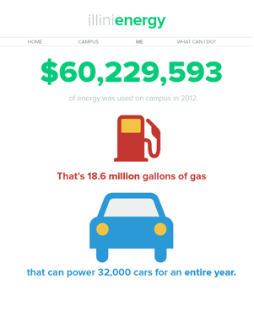

See College of Business website or Student Sustainability Committee website for inspiration

Home Page
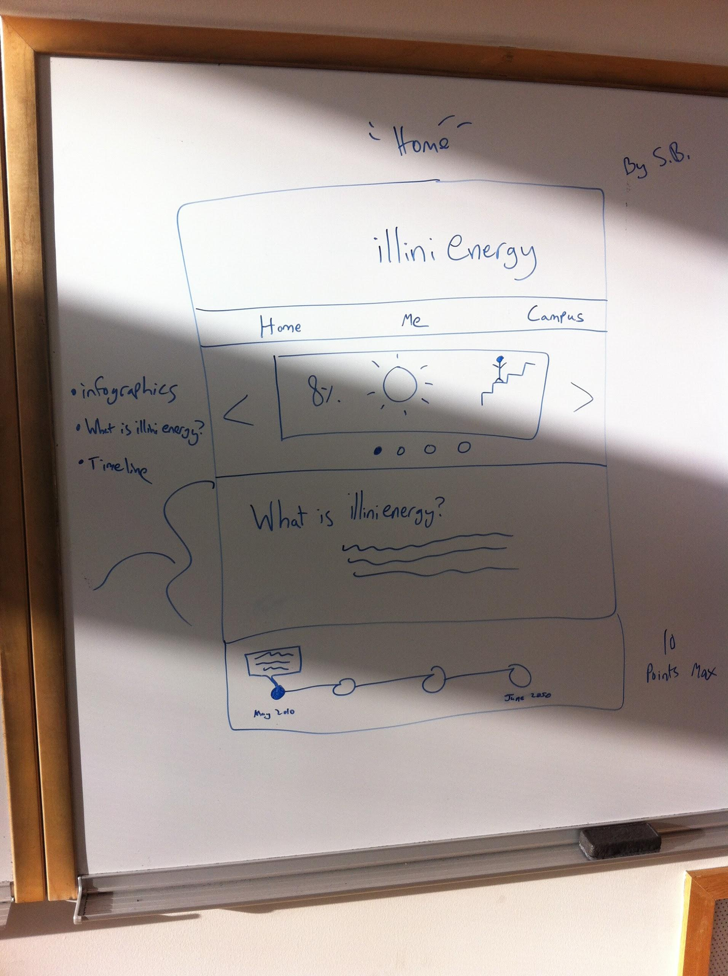
Infographics about campus energy usage:

“What is illinienergy?” description:
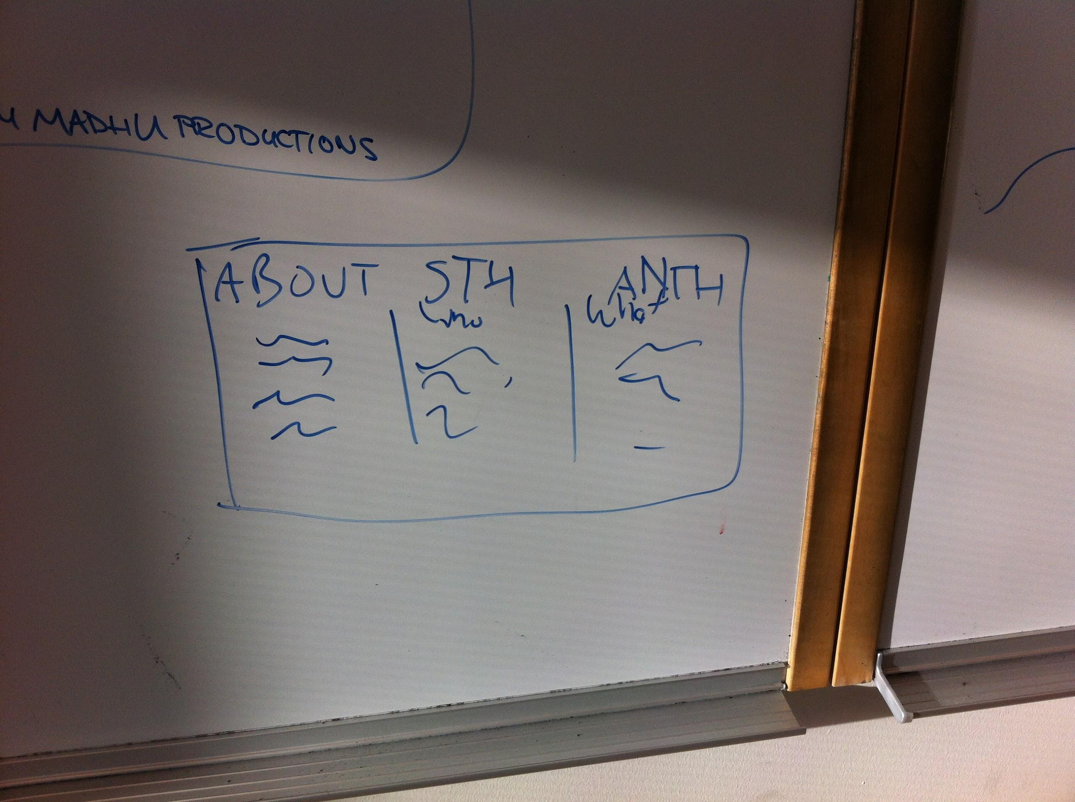

Timeline:
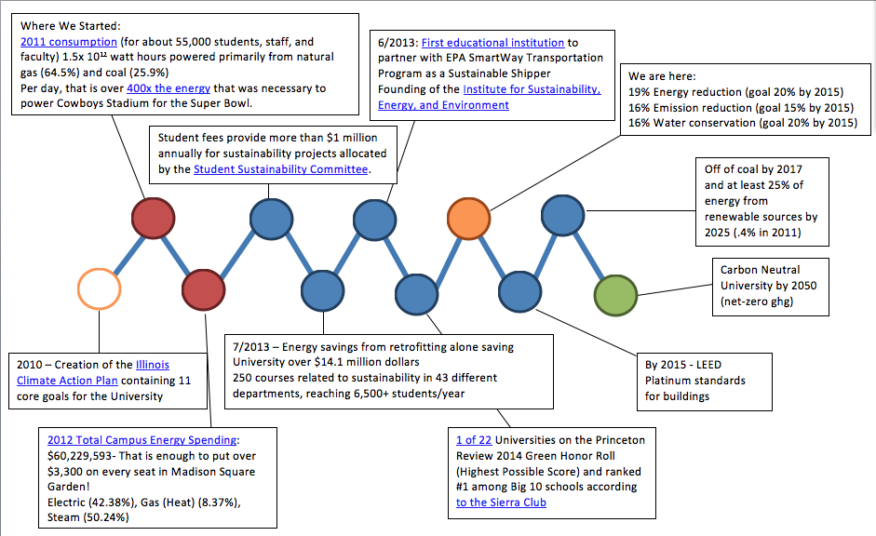
- Link to file: https://drive.google.com/file/d/0B9IAyA5IdBRVU3M1YWNPdnZGNG8/edit?usp=sharing

Me
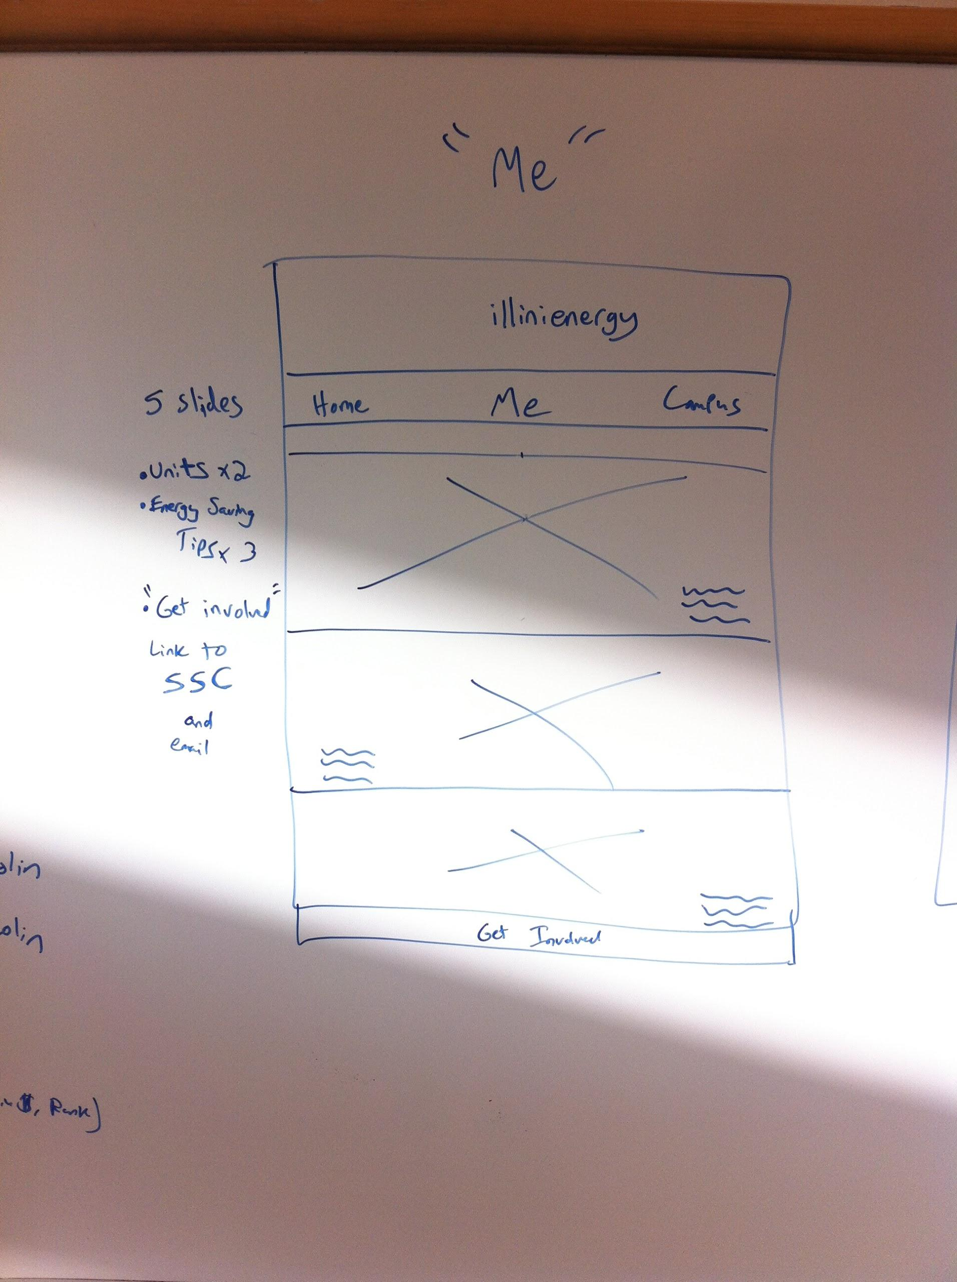
3 Infographics about the best personal energy saving tips:
1. Turning your computers off at night
- There would be a laptop placed on top of a desk inside a dorm room. The laptop would have open a Word document and on the document it could read " Turn off your computer if you won't be using it for at least 2 hours. There is a small usage of energy when a computer starts up, but this small amount is still less than the energy used when a computer is running for long periods of time."
2. Consolidate Coffee Makers & Mini-Fridges
- This would be needed to taken in a kitchen, mainly taking a picture of a coffee maker and some mugs in the background. The picture would then read " Sharing your kitchen devices can make happy colleagues, roommates and friends. Consolidate coffee makers and enjoy a cup of coffee with someone else in the morning"
3. Always Turn off the Lights
- This picture can be taken in any room that has a light switch. Preferably, a person putting their hand out to turn off the switch as they walk out the door. The picture could have text saying "When leaving an empty room for more than 5 minutes, make sure to turn off the lights. This allows for more energy conscientiousness and allows for higher energy savings."

2 Infographics about energy units:
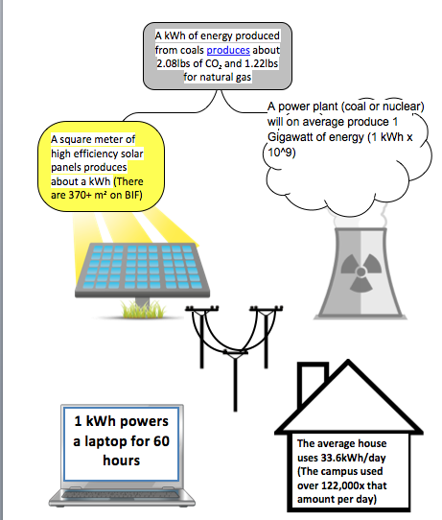
- Link to file: https://drive.google.com/file/d/0B9IAyA5IdBRVU3M1YWNPdnZGNG8/edit?usp=sharing

Average consumption per students in a year:

Get involved link on “me”:

Campus
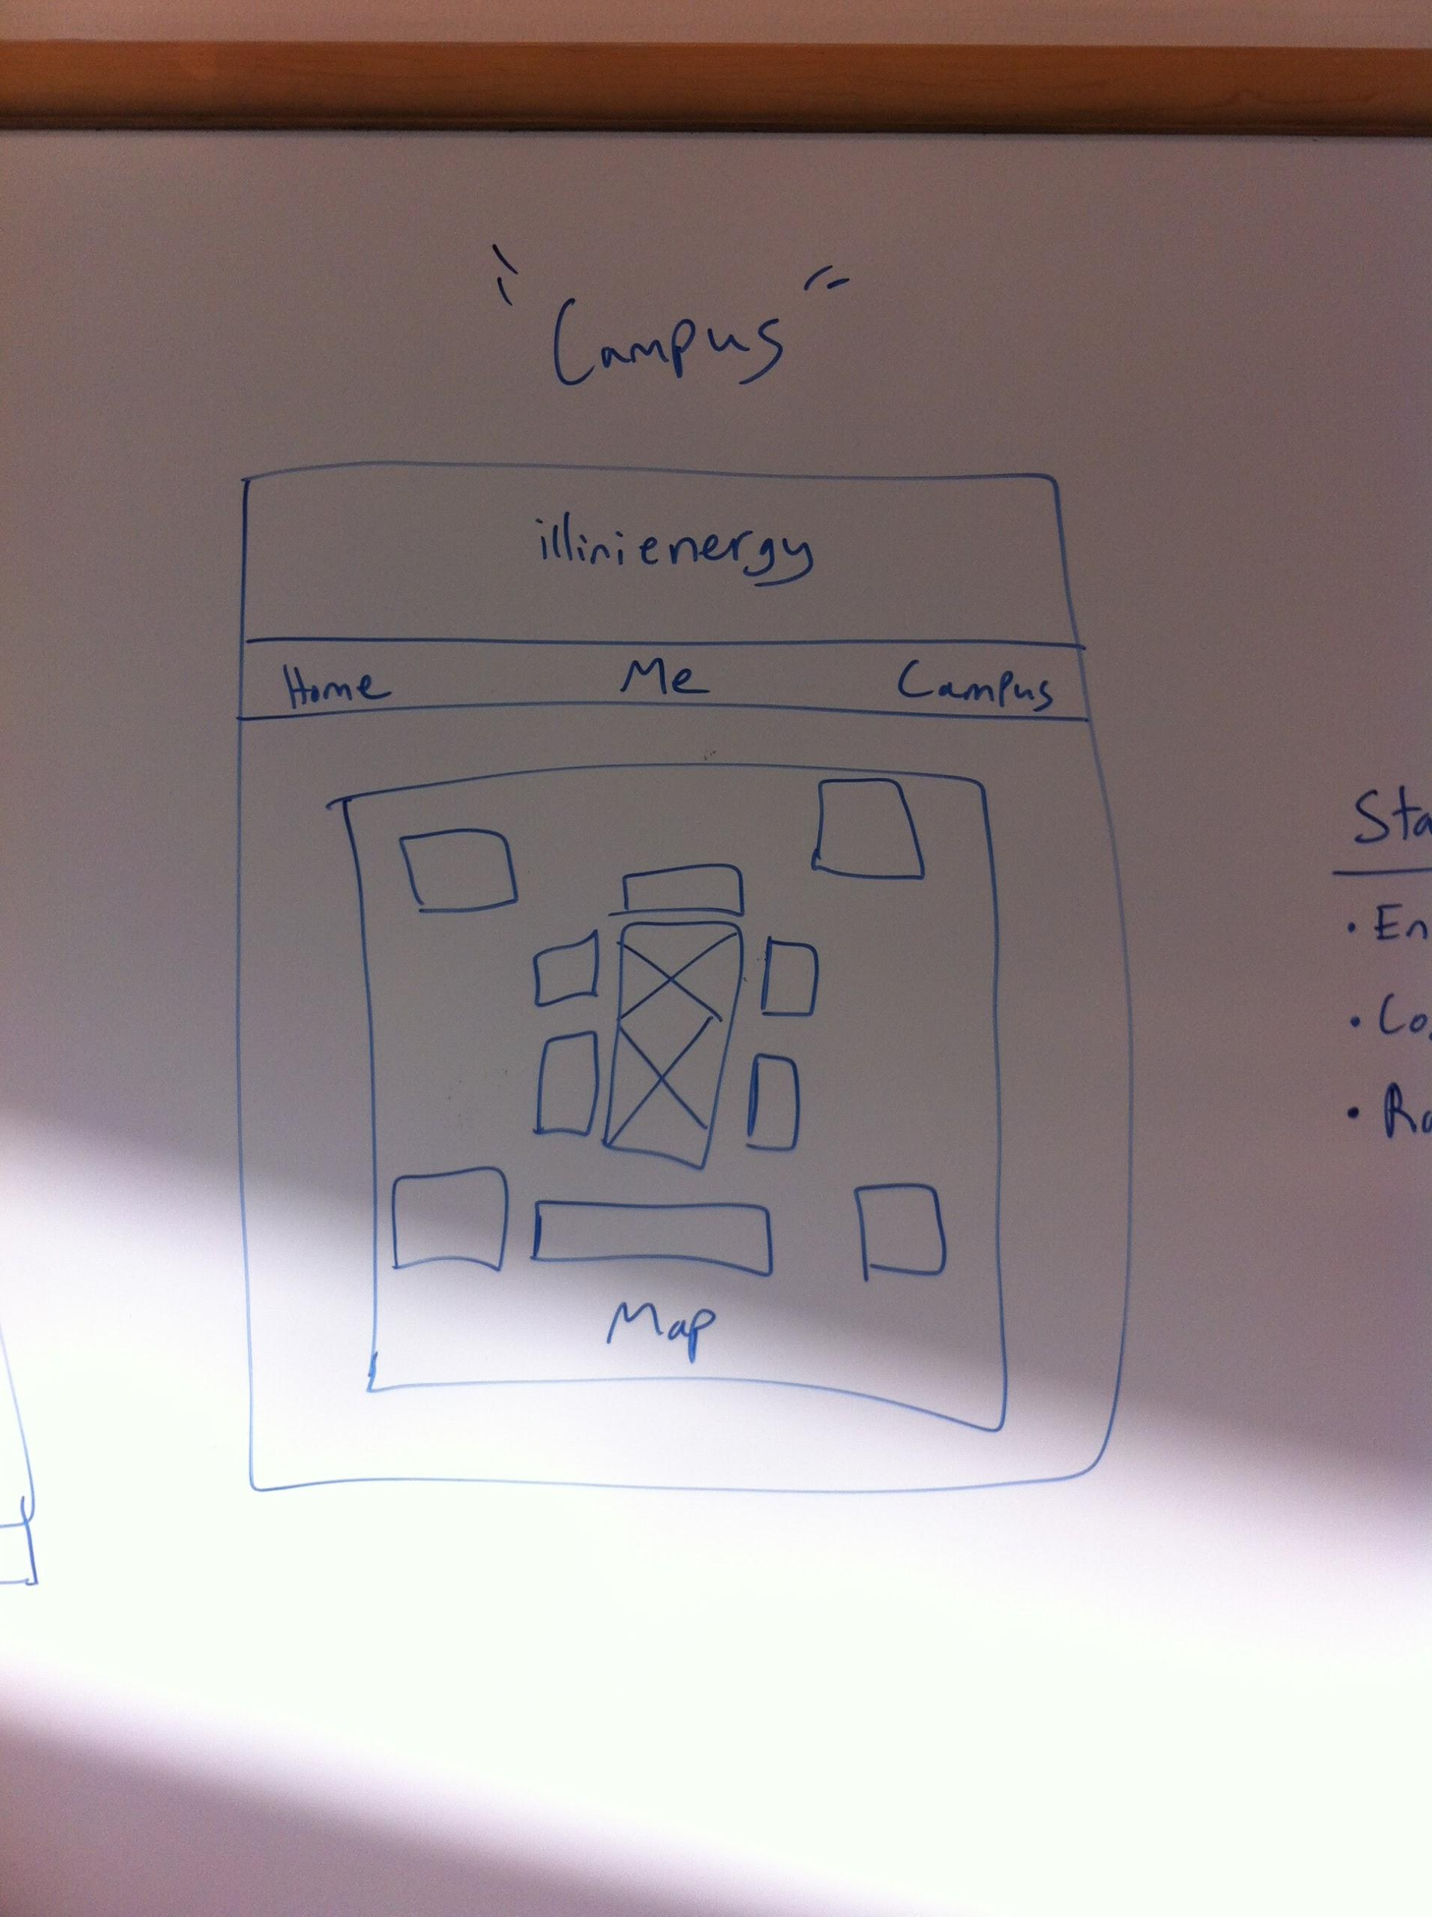
Map of campus that can be navigated

List of buildings to include, stats for those buildings (kwh/sqft, cost in $, rank in category [residence, academic, non-academic])

Miscellaneous Website Content Information
1. What is Illini Energy?
- The Illini Energy project fosters individual sustainability habits among students and staff using up to the minute energy tracking statistics. See how your practices and behaviors are driving energy demand and what you can do to help Illinois become a leading “.green” university.

2. Our Current Environmental Footprint
- 2011 consumption: 5 million MMBTU of energy.
  - 64.5% - natural gas, 25.9% - coal, 0.04% - renewable energy (solar panels on the Business Instructional Facility)
- Average consumption per-student (44,520 students) = 112 MMBTU

3. Vision for the Future
- Carbon Neutral by 2050 (net-zero ghg).
- Off of coal by 2017 and at least 25% of energy from renewable sources by 2025
- Integrate sustainability into the University’s curriculum such that each graduating student obtains their own understanding of sustainability.
- Find out more about the University’s 11 core goals here!
  - (hyperlink “here!” to iCap: http://icap.sustainability.illinois.edu/)

4. What’s Being Done and How We Will Get There

  - Presently, the campus has one Platinum building, one Gold, and two Silver.
- The two student fees ($17 per student per semester) provide more than $1 million annually for sustainability projects.
  - Projects are reviewed and money allocated by the Student Sustainability Committee.

5. Achievements So Far
- Meeting, Exceeding Goals
  - We are well on our way to meeting all our goals. At the end of last year,
    - 19% Energy reduction (goal 20% by 2015)
    - 16% Emission reduction (goal 15% by 2015)
    - 16% Water conservation (goal 20% by 2015)
- Retrocommissioning - As of July 2013 almost 6.1 million gross square feet, 105 football fields, or 48% of the campus academic space have been improved.
  - Reducing energy use by 1.6MMBTU and saving the University over $14.1 million dollars!
- Sustainability Education
  - 250 courses related to sustainability in 43 different departments.
  - The Office of Sustainability organizes an annual curriculum workshop reaching 35 professors who reach 6,500 students per year.
- Lighting
  - Over $1.2 million allocated to sustainable lighting

6. Sustainability Recognition
- First Big Ten school to sign the American College and University Presidents’ Climate Commitment.
- First educational institution registered as a EPA SmartWay Transportation Program Shipper
- Rank second in Big Ten behind Ohio State (Princeton Review)
- Bronze Level Bicycle University
- Award winning retrocommission

7. I Don’t Speak Energy
- Killa-What?
- B-T-who?
- Lbs! I recognize that unit...but what does it have to do with energy?

kWh: Killa-What?
- What is a kWh really?
  - Kilowatt Hour
  - One kWh is equivalent to a 100-watt light bulb running continuously for 1,000 hours (5 weeks)
  - You’ll often see kWh on your energy bill!
- So are we using a lot?
  - The number you are seeing is the rolling 60 minute consumption. By comparison, In 2011, the average household (there is a lot of variability here, this is just based on total consumption nationwide) was 33.6kWh/day
- What does it take to produce a kWh?
  - Types of energy are different. For example
    - A square meter of high efficiency solar panels produces about a kWh
    - A power plant (coal or nuclear) will on average produce 1 Gigawatt of energy (1 kWh x 10^9)!!
- What is the environmental impact?
  - Based on 2009 EPA data, 1kWh translates to about 1.307 lbs CO₂ hour of delivered electricity.
BTU: B-T-Who?
- What is a BTU?
  - British Thermal Unit
  - A BTU is the amount of heat required to increase the temperature of a pound of water by one degree Fahrenheit.
- Okay, but this says KBTU and MBTU,what are those?
  - KBTU = 1 BTU x 1,000 =
  - MBTU = 1 BTU x 1,000,000 (1 million)
- And what is that GSF thing on the Energy Utilization Tab
  - That stands for Gross Square Footage or the sum of all floor areas on all floors of the building.
- I just learned kWh what happened to those.
  - You can convert them!
  - 1 kWh = about .34 MBTUs
OR
- 1 KBTU = .293 kWh and 1 MBTU = 293 kWh
- Soo...what can a BTU do?
  - A wooden kitchen match produce approximately 1 BTU, and air conditioners for household use typically produce between 5,000 and 15,000 BTU.
- What does it take to make a BTU?
  - One cubic foot of natural gas produces approximately 1 KBTU
KLBS - LBS? Like pounds? I know that!
- Yes! This is a measure of pounds.
- What do pounds have to do with heat?
  - This is a measure of the amount of steam the university uses to provide heating
- What can pounds of steam do?
  - It takes about 6.25 pounds of steam to heat the water for a 10 minute shower.
  - The volume of steam is 1,600 times greater than an equal mass of water.
  - It takes 1BTU to raise one pound of water 1 degree.Farenheit, remember, liquid water turns to steam at 212 degrees farenheit

7. Sponsors and How You Can Get Involved(separate page, correct?)
- Student Sustainability Committee: http://ssc.union.illinois.edu/
- Office of Sustainability: http://sustainability.illinois.edu/
  - Environmental Change Institute : http://sustainability.illinois.edu/ECI.html
- Facilities & Services: http://www.fs.illinois.edu/
- Sustainability fellows (link to website)

Student Sustainability Committee -The Student Sustainability Committee receives fees from students and allocates these resources to fund campus sustainability projects and initiatives.
Environmental Change Institute - The Environmental Change Institute helps focus the unique educational, outreach, and research capabilities of the University of Illinois to advance our understanding of global environmental change and support solutions that enable society to mitigate or adapt to its effects.
Office of Sustainability - The Office of Sustainability provides operational leadership and some funding for numerous initiatives under way on campus and works with campus units, student groups, and community partners to develop and promote engagement activities and enhance communication about sustainability initiatives.
Facilities & Services - Facilities & Services supports the academic enterprise at Illinois by planning, constructing and maintaining the campus physical environment with a commitment to sustainability as well as regulatory compliance.

BIF In-building Displays

The following observational testing was done on the “BIF Display 1” file in the BIF atrium:

Observer | Date and Time Range | # Observed looking for 5+ Seconds (passing period only) | General Observations/Notes
Doug | Monday (12/2) 330-5 | 0 | People coming down stairs definitely looked, though it is hard to estimate just how much they were reading the material. Saw several people pause/glance at the screen, so definitely drawing attention!
 | Wednesday (12/4) 3:30-5 | 2 | 1- The "bring a cup" slide does not specify Espresso Royale 2- I really thought there would be more people coming in and out of the Gregory St. entrance (especially around passing periods), but very little traffic 3- I feel like more movement will draw their attention
Colin | Monday (12/2) 12:30-2 | 6 | Saw two people stand and watch a few slides play through. For those who do see, I think it does serve an informative purpose.
 | Wednesday (12/4) 10-12 | 10 | Less people looked at it during passing periods than during classes. A good amount of people looked but not sure if they were able to retain the info
Julie | Tuesday (12/3) 2:30-4:00 | 9 | People walking down the stairs noticed the display more but don't know if the material registered to them.
Tim | Monday (12/2) 5-6 | 4 | More of the people who briefly looked at the panel was from the monitor coming down from the stairs. Did see a couple smiles/smirks from the observers
 | Wednesday (12/4) 2-3 | 0
Johnny | Wednesday (12/4) 5-6 | 0
Ofelia | Tuesday (12/3) 5-6 | 0 | Looked but more as they passed by, students didn't appear captivated by the images. Actually talked to someone and they told me it looked "boring," didn't understand what Illini Energy was, would like to see more moving images, more interactive would actually be interesting.
Dan | Monday (12/2) 10-12 | 1 | No animations / 60 million in energy in 2012?
 | Wednesday (12/4) 12:30-2 | 2

- BIF display 2 was also developed but captured even less attention
- BIF display 3 has been developed using GIFs but was not tested in the BIF

Personal Energy Saving Tips
- Cooling
  - Switch your ceiling fan to turn in a counter-clockwise direction In the summer; in the winter, run it at low speed, but clockwise.
  - Close your exterior doors and windows tightly when the AC is on. Save even more by turning off kitchen and bath exhaust fans.
  - Change or clean your AC's air filters at least once a month to keep your system running at peak performance.
  - Make sure your AC has a rating – or Seasonal Energy Efficiency Ratio (SEER) – of 15. Not only will your AC be more efficient, you could also be eligible for a rebate up to $300.
  - Make saving automatic: Set your thermostat fan switch to "auto" to save energy. Leaving it in the "on" position keeps air running constantly.
  - Block the sun from overheating your home! Inside, use shades, blinds and drapes. Outside, use awnings, trees and shrubs.
  - Insulate your walls with injected foam insulation to help you save energy by keeping hot outside air from seeping through porous block walls – check with your local building supply company for details.
  - Give your AC tune-up. Running an inefficient AC system can result in high monthly bills. Plus, you could qualify for a rebate.
  - Open interior doors so that cooled air flows freely throughout your home.
  - Repair leaky ducts to reduce heating and cooling costs and qualify for a rebate up to $120 toward repairs.
  - Install attic insulation rated R-30 and sealing any attic leaks to reduce high home cooling costs. You’ll save money each month and qualify for a rebate of $75 or more.
  - Check for household leaks to make sure air isn't escaping through openings such as fireplace dampers, doors and windows.
  - Decorate for a cooler home by hanging light-colored curtains that allow light to enter a room while blocking some of the sun’s rays, and light-colored paint to reflect heat.
  - Close unused air vents. If you have central AC you can close air vent in rooms you're not using so you're not paying to cool them.
  - Plant trees to provide shade on the sunny side of your home.
  - Use ceiling fans to cool off for less. Ceiling fans use no more electricity than a standard light bulb. However, be sure to turn fans off when you leave — they only cool people, not rooms.
  - Install more ceiling fans. Because the breeze of a fan can make you feel three to four degrees cooler, you can raise that thermostat and still stay comfortable.
  - Raise the temperature on your thermostat by a few degrees to save on your cooling costs.
  - Install a programmable thermostat to adjust your temperature during the day.
- Heating
  - Cover all bare floors. Carpeting or rugs add to comfort and heat retention, especially if there is little or no floor insulation.
  - Raise the temperature slowly to keep your bill lower. Quickly raising your heat pump's temperature activates the heat strip, which uses tons of energy.
  - Set your thermostat to 68-70 degrees during the day in the winter, and 65-68 degrees at night to keep your home comfortable and save on heating costs.
  - Close the flue in your fireplace and install glass doors to keep in the warm air.
  - Limit your use of portable heaters. They’re great for "spot" heating, but running a 1,500-watt heater 24/7 can be expensive.
  - Keep your thermostat close to the outside temperature – it’s cheaper to keep your home at 70°F when it’s 50°F outside than when it’s 30°F.
  - Don’t block air vents with drapes and furniture.
  - Get an energy-efficient heat pump and you could cut your heating costs in half. Duke Energy Progress offersrebates up to $300 to help you upgrade.
  - Change the filters in your heating system every month for optimum efficiency.
  - Give your air compressor space to work efficiently. Never stack anything against your HVAC or drape anything over it.
  - Set your thermostat to 60 degrees if going on vacation during the winter months, but don’t turn it off.
  - Heat your home with the sun's help. Leave window shades or blinds open during the daytime. And consider using solar heat to supplement your normal heating source.
  - Lower your thermostat every time you leave the house.
- Lighting
  - Buy bulbs for less. Check out the Duke Energy Progress Residential Lighting Program to find local retailers who offer energy-efficient compact fluorescent (CFL) bulbs at discounted prices.
  - Replace standard bulbs with CFLs. Compact fluorescent light bulbs are more energy-efficient than regular bulbs, while giving off the same amount of light.
  - Use the right bulb. Make sure you’re using the appropriate CFL bulb for your light fixture – they come in various sizes and types for different lighting needs.
  - Replace halogen light bulbs, which can get hot enough to be a fire hazard, with CFLs – they use less energy and don’t get as hot.
  - Use motion-detector lights for all your outdoor lighting – they’re convenient and efficient.
  - Recycle your CFL bulbs. Check the CFL recycling page to find out how, where and why.
  - Replace your five most-used light fixtures and/or bulbs with ENERGY STAR® products. If every American did so, we would save about $8 billion per year in energy costs.
  - Consider using timers to turn lights on in the morning and off during the day.
  - Choose outdoor CFLs for outdoor lighting – they last up to 10 times longer than standard bulbs.
  - Select light-colored or opaque lamp shades. Place lamps in corners so they reflect light from two walls.
  - Install fluorescent tubes as an efficient way to light your workshop or playroom.
- Appliances
  - Use microwaves and toaster ovens to cook or warm leftovers. You’ll use less energy than cooking with a conventional oven.
  - Pull the plug on that second fridge located in the hot garage or utility room. Duke Energy Progress will pick it up and pay $50 to recycle it.
  - Set your refrigerator temperature between 30 and 42°F. Use the power-save switch if you have one.
  - Repair refrigerator door seals if you feel cold air around the closed door or if moisture is collecting.
  - Replace a refrigerator bought in 1990 with an ENERGY STAR®-qualified model – energy-efficient models cost less to operate than older refrigerators.
  - Dust your fridge the next time you dust your house. Check the coils behind the refrigerator — and use coil vacuums or dusters to clean it off and keep costs down.
  - Keep your freezer full – it uses less energy than an empty one. For maximum savings, consider filling your freezer with gallon containers of water.
  - Choose energy-efficient appliances. They don’t just save you money, but they’re good for the environment because they use less energy.
  - Replace your refrigerator. Look for the yellow EnergyGuide® label to compare features. Choose models with improved insulation and power-saving switches.
  - Wash and dry several loads at once, so that your dryer isn't completely cooled down when it heats up for the next load.
  - Avoid over-drying your clothes. It wastes energy, plus causes static and wrinkling.
  - Separate wash loads into light and heavy fabrics for the shortest drying times. Or better yet – air-dry your lightest fabrics.
  - Vent your dryer to the outside to reduce the workload on your air conditioner.
  - Wash full loads of clothes when possible. When smaller loads are necessary, use less water.
  - Hang dress clothing to air dry on portable laundry racks; they will also look better.
  - Clean the dryer lint filter before every load to keep your dryer running efficiently.
  - Set your dishwashers on economy mode, to use less water and electricity.
  - Turn off your dishwasher after the wash cycle — and let your dishes air-dry. You'll save energy and keep your dishwasher from heating up your kitchen.
  - Keep the oven door closed while cooking – the temperature can drop by as many as 25 degrees each time you open the oven door.
  - Grill out more often during the summer. Using the oven in the heat of summer forces your AC to work harder, which raises your energy bill.
  - Use copper-bottomed pots and pans that use heat more efficiently when cooking on the stove.
  - Keep stove reflector pans clean to reflect more heat upward while cooking.
  - Turn off your oven or burners when food is almost ready and let existing heat finish the cooking for you.
  - Use tight-fitting covers on pots and pans when cooking on the stove to shorten your cooking time and save energy.
  - Match your pot size to the burner on your stove. Heat is lost when small pots are used on large burners.
  - Turn off kitchen and bath fans immediately after use.
- Water heating
  - Always wash with cold water, laundry detergent works just as well, and you’ll save 40 cents per load.
  - Check your hot water pipes for leaks, which can drain your energy savings.
  - Install aerating, low-flow faucets and showerheads – available at home improvement stores – to reduce your hot water use.
  - Turn off your water heater until if you plan on leaving home for a few days. And you get back. Most models will reheat the water to the set temperature in about an hour.
  - Shorten those showers to cut hot water costs.
  - Insulate the first six feet of the hot and cold water pipes connected to the water heater. It’ll keep your comfort high and your energy bills low.
  - Install a solar water heater to save energy and money by using solar power.
  - Get an insulation wrap to help your old water heater heat in more effectively.
  - Reduce your water heater temperature setting from 140 degrees to 120 degrees — it will save you money while keeping water hot enough for showers and cleaning dishes.
  - Look for the EnergyGuide label when purchasing a new water heater — if a more efficient heater is more expensive, you'll save money over time.
  - Make sure you are washing a full load if you like using hot water for your laundry.
  - Stop that dripping hot water faucet. Leaky faucets not only increase water bills but also increase gas or electricity use for heating the wasted water.
  - Install a timer for your water heater that will turn it off when you are not at home.
  - Choose the right water heater for your needs. While they may promise savings, tankless models are pricey to install – and on-demand water heaters may actually increase your electric bill.
- Electronics
  - Plug electronics into a power strip, then turn the strip off when not in use to save in energy costs.
  - Avoid energy vampires. Even when they’re turned off, home electronics in “standby” mode use energy to power features like clock displays.
  - Look for ENERGY STAR-qualified TVs – they’re up to 30 percent more efficient than noncertified models.
  - Consider a laptop next time you're looking to buy a computer – they use less energy than desktop computers.
  - Set your computer to sleep or hibernate mode instead of using a screen saver so it uses less electricity during periods of inactivity.
  - Unplug battery chargers when the batteries are fully charged or the chargers are not in use. Many chargers draw power continuously, even when the device is not plugged into the charger.
- Windows
  - Install high-performance windows, screens and films to protect upholstery, wood and artwork from UV rays while saving energy.
  - Eliminate "hot spots" in your home by using High-performance windows, solar window screens and qualified window films.
  - Consider high-performance windows before you replace your AC system. They’re so efficient that they may help reduce the size and cost needed for a AC system.
  - Install high-performance windows with double-glazing and spectrally selective coatings that reduce heat gain and avoid cranking up your AC.
  - Look for the National Fenestration Rating Council label when shopping for new windows: It means the window's performance is certified.

