Targets (iCAP Section 9.4.1):
- Reduce Building Energy Consumption By:
  - 20% by FY2015
  - 30% by FY2020
  - 40% by FY2025

The University has exceeded the goal set for FY15. The goal set forth in the iCAP report assumed total energy with no growth, however campus growth has occurred and the committee agreed the industry standard Energy Use Intensity (EUI) is the most appropriate method to measure campus reduction. The attached chart indicates a significant EUI reduction. The data used to create this chart excludes the following: Airport, Allerton, Leased Space, Chicago Space, Dixon Springs, and Petascale.

The university has been very successful at managing its energy expenses. It is below many of its peers in the amount spent on electric and heating costs per sq. ft. When inflated to FY13 values, energy unit costs have held steady since FY11.

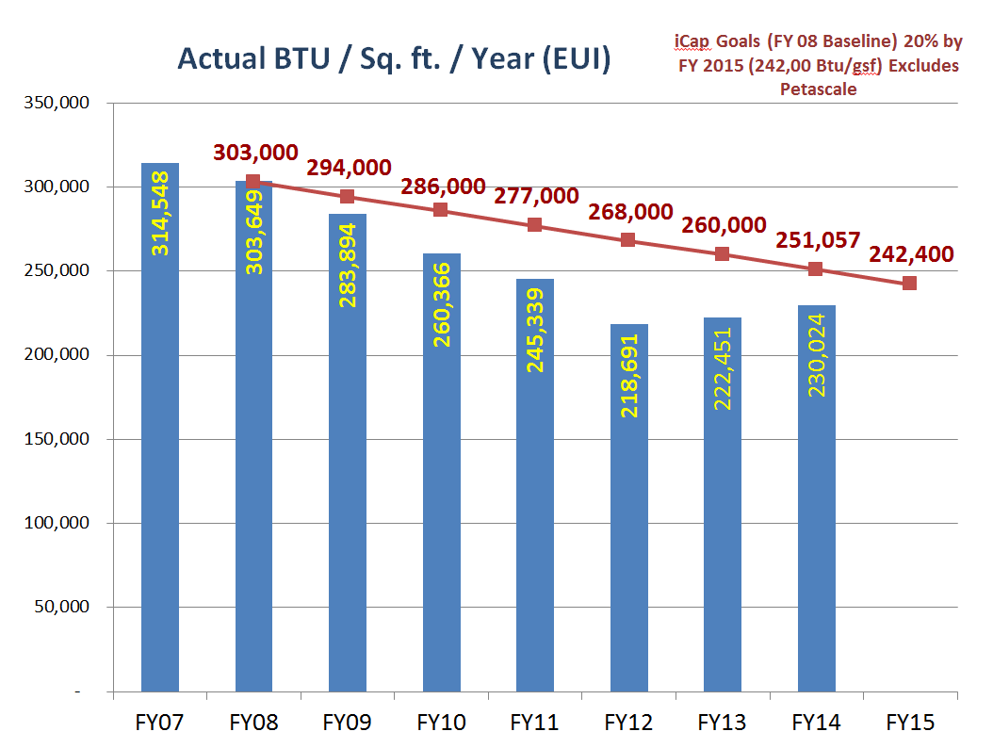

- Reduce Building Related GHG Emissions By:
  - 15% by FY2015
  - 30% by FY2020
  - 40% by FY2025

- Not Calculated
- Need standard GHG calculating procedure for individual processes to track progress

- Complete all SAIC-prescribed energy conservation measures by 2022.

The success of the conservation work is largely due to the initiatives started and managed by Facilities & Services (F&S). The SAIC report recommended multiple conservation programs which F&S has initiated, many of which were underway at the time of the SAIC report. Some of these programs include the following:

Energy Performance Contracting (EPC):
An ESCO is an accredited Energy Service Company that provides all of the services required to design and implement a comprehensive project at the customer facility, from the initial energy audit through the long-term guarantee of project savings with an Energy Performance Contract (EPC). The EPC provides customers with a comprehensive set of energy efficiency, renewable energy, and distributed generation measures and is accompanied with guarantees that the energy savings produced by the project will be sufficient to cover the full cost of the project.

To date, two EPC projects (Vet Med and the Oak Street Chiller) have been completed with expected energy cost avoidance totaling $2M annually which will be utilized to pay down the debt service. In addition to the energy cost avoidance, a substantial amount of deferred maintenance has been reduced from the backlog. A long-term plan has been developed for 18 buildings with a series of EPCs. These efforts are focused primarily on research facilities which have both large energy and deferred maintenance demands. The first contract associated with the plan is expected to address five buildings including Loomis, ESB, MRL, Superconductivity, and Micro-electronics ,with an ESCO under contract by early FY15. The design work is underway on this item.

Retrocommissioning (RCx):
The process of retrocommissioning campus buildings is focused on reviewing and improving the operation and maintenance of building systems. Facilities & Services utilizes composite teams of engineers, technicians, and craftspeople to complete an in-depth analysis and corrective work for the building’s systems, update operations, and maintenance programs. The goal of the team is to establish optimal operating conditions and control strategies for greater energy conservation, sustainability, and occupant comfort.

Many campus buildings have extensive deferred maintenance issues which waste energy and affect building systems. The RCx effort is successfully addressing this campus-wide backlog. Since August 2007, RCx teams have performed work in more than 50 campus buildings totaling more than 6.5 million gross square feet. The average energy reduction in buildings that have been updated through the RCx process is greater than 27% with a cost avoidance of more than $23M.

Lighting Retrofits:
The Campus Lighting Retrofit Project has resulted in improved interior lighting, substantial cost avoidance, reductions in maintenance, and the elimination of obsolete lamps and ballasts. As of FY13, 82% of fixtures around campus were upgraded. By the end of FY14, 93% of campus fixtures will be outfitted. Utilities & Energy Services and Operations, Maintenance, & Alterations (OMA) allocated $254K and $200K respectively toward the remaining lighting retrofits.

LED Campus:
Chancellor Wise committed us to being an LED Campus on the 50th anniversary of Prof. Holonyak’s demonstration of the first visible LED. She said “This will make us the first LED university campus in the United States, with interior and exterior wayfinding fixtures to be replaced by 2025 and with the majority of all lighting to be LED by 2050.” F&S is working with the Parking Department to upgrade various parking lots to be LED, with the consideration of energy efficient bi-level lights.

Adaptive Bi-Level Lighting:
A University of Illinois at Urbana-Champaign parking lot is one of the first test locations in the State of Illinois to feature energy-efficient, motion-activated Light Emitting Diodes (LED). Campus Parking upgraded the lighting fixtures in Lot E15, at the corner of Fourth Street and Pennsylvania Avenue in Champaign, after receiving $50K in funding from the Student Sustainability Committee. The motion sensors used in E15 double the light intensity when movement is detected in the parking lot. This allows the lights to consume less power, while still maintaining a minimal level of lighting at all times. The many benefits of adaptive lighting include:
- Reducing energy consumption
- Producing brighter lighting when required
- Increasing visibility of surroundings for occupants and police
- Activating automatically

The 15 LED fixtures are estimated to last up to 100,000 hours, reducing operation and maintenance expenditures. Cost avoidance is expected to provide a payback for the initial investment within three to seven years.

Grants:
Since 2005 we have received over $15 million in grants mostly for our energy conservation work on campus. The energy conservation work that we have completed includes lighting upgrade projects, retro-commissioning projects, energy performance contract work, insulation upgrades, steam trap upgrade work, and new construction projects (to a limited degree). The majority of our grants are provided by two granting agencies which are the Illinois Department of Commerce and Economic Opportunity (DCEO) and the Illinois Clean Energy Community Foundation (ICECF). We have built strong relationships with both of these groups. This amount of funding is significant and allows us to continue to do more necessary energy conservation work on campus.

FY 14 Summer update per iSEE press release: Funding provided by Chevrolet and matched by campus leadership contributed over $1 million for continuing efforts towards carbon neutrality in 2050. The grant was awarded for energy efficiency activities on campus including retrocommissioning and energy performance contracting of campus buildings.

- Implement decentralized energy billing at the college level. Immediately establish a dedicated, centralized funding pool for energy conservation projects. This “clean energy” fund will allow for both internal (student fees, faculty contributions, staff contributions, energy savings reinvestment, capital programs), and external (programs, rebates, donations, outside investors) participation in the fund. It will be established as a capital infusion and coordination mechanism aimed at physical energy and energy cost reductions that also allows for the sustained maintenance of these investments.

Energy Conservation Incentive Program (ECIP):
With approval from the Provost’s Office, the Energy Conservation Incentive Program (ECIP) was initiated in FY14 to incentivize energy conservation in campus buildings. The ECIP awards building upgrades in facilities which have produced energy conservation results through the behavioral and structural changes of academic units and cooperation of building occupants. Approximately $350K was awarded for FY13 usage. FY 14 winners will be announced shortly.

Each year eight campus buildings will receive ECIP awards in two separate categories. One category is for buildings whose energy reduction is the result of central funding from a significant energy conservation project (Energy Advancement Category). A second category is for buildings which have not benefited from substantial energy conservation projects in the last fiscal year (Occupant Action Category). The ECIP measures energy conservation in buildings as the percentage difference of energy usage during the most recent fiscal year compared to the previous fiscal year. Building energy consumption is tracked online in the Energy Billing System (EBS). New users may request EBS authentication from Facilities & Services Utilities & Energy Services (UES) Division.

Revolving Loan Fund (RLF):
The Revolving Loan Fund (RLF) was set up as a funding source for utility conservation projects with less than ten-year payback periods. These can include steam, electricity, chilled water, or water reduction projects, and the savings from utility costs are paid back annually to replenish the fund. Project suggestions will be solicited from facility managers when the RLF has over $1M to allocate. This fund was originally called for in the 2010 iCAP, as the “clean energy fund.” It was established in Fiscal Year 2012, with funding from the Student Sustainability Committee (SSC) and the Office of the Chancellor. Within the first year, the Office of the President committed additional funds. There is over $2 million in this fund presently and this is scheduled to be allocated to proposed projects during the fall of 2014.

- Allocate proper maintenance funds to ensure that the energy reductions are sustained, and reorganize building maintenance procedures to support long-term energy savings.

Long-term plans have been created to keep the initiatives mentioned in this report moving forward and continue avoiding potentially growing energy costs. The preventative maintenance team was established to follow-up behind Retro Commissioning and the Energy Performance Contracting (EPC) projects. The preventative maintenance keeps the equipment well maintained to extend the life, avoid future repair cost by eliminating equipment failures, or keep such failures within limits. This work over time will reduce the maintenance backlog and drive down maintenance expenses while limiting degradation of energy savings achieved by Retro Commissioning and EPC projects. Per our Summer 2014 discussions, more manpower will be allocated to this effort over the next couple of years.

- Offset the GHG impacts of the National Petascale Computing Facility when the next contract is negotiated.
- Impose charges for the purchase of renewable energy at the National Petascale Computing Facility
- Offset GHG Emissions at Blue Waters
- No plans or progress

- Incorporate a "no net increase in space" policy for the entire campus by 2012, including auxiliary units and rental space
  - Implement a space marketplace to enable rewards for space reduction and swaps. Ben McCall has started some campus conversations in this area.

- Any new buildings or major renovations should be net energy neutral or a net energy provider by 2025.
- Move LEED certification requirements from Silver to Gold for new buildings and major renovations by 2011, and LEED Platinum by 2015.
- Apply LEED Gold construction standards without certification for all other construction projects.
- Currently planned projects should demonstrate at least a 30 percent improvement in building

Looking forward
- Investments are being made for future EPC projects.
- Lighting/Occupancy sensor work continues.
- Existing building envelope problems need attention.
- RCx is working to advance its efforts with auxiliary units. (Funding is needed.)
- Fume Hoods/ Lab ventilation schemes will continue to be addressed through EPC projects. More campus involvement is needed with this item in order to limit or reduce the campus fume hood inventory. Means of chemical storage should be revised in some locations.
- Paths to reductions
  - Conservation
  - Broader Participation
  - Tracking and Monitoring

