Feasibility Study of LEED Lab at the
University of Illinois Urbana-Champaign

John Eul
Shangyang Fang

University of Illinois Urbana-Champaign
December 8th, 2014

Executive Summary
This study analyzes the feasibility of introducing LEED Lab at the University of Illinois. LEED Lab is a project-based learning course that promotes green building and best sustainability practices. An integral part of the LEED Lab, is the course project where students implement more energy-efficient infrastructure at an existing campus in hopes of the building achieving LEED for Building Operations and Maintenance Standards. While actual LEED certification is a secondary goal to the students gaining real work experience and having the ability to interact with professionals in the field, the project can be both time consuming and costly. At this time, the University of Illinois Facilities & Service Staff does not believe the university has the budget to introduce LEED Lab.
Introducing an alternative LEED course that teaches the same LEED principles and sustainability goals as LEED Lab would be a much easier task. These LEED courses are only one semester long and do not have a course project. Without the course project, however, these classes lack the same hands-on experience LEED Lab offers students. This interactive quality is what makes LEED Lab such a unique course.
There are certain ways a university can reduce the costs of the course project. USGBC Director, Jamie Van Mourik, suggests selecting an already LEED-certified building to save the university a significant amount of money. Selecting a LEED-certified building, reduces the costs to: monitoring/ testing the energy performance of the building and LEED project fees. However, LEED project fees depending on the building selected from the University of Illinois can range from $3,590 - $10,780.
While further research needs to be done to determine the allotted budget for LEED Lab and the actual quantitative feasibility, a modified one-semester long LEED Lab with the course project having students showing the implementations they would make to a campus building to achieve LEED EB: O+M certification through a model, could be feasible. The model, rather than an actual renovation of a campus building, eliminates the cost of LEED project fees and still allows students to display their knowledge tangibly.

Contents

Introduction & Background……………………………………………………………………… 1
Project Objective…………………………………………………………………………………. 3
Methodology……………………………………………………………………………………... 3
Alternative Strategies…………………………………………………………………………….. 4
Preliminary Results & Discussion……………………………………………………………….. 5
Conclusion……………………………………………………………………………………… 15
Reflection……………………………………………………………………………………….. 15
Miscellaneous…………………………………………………………………………………... 16
Acknowledgements……………………………………………………………………………... 18
References………………………………………………………………………………………. 18

Introduction & Background
Sustainability Practices on U.S. College Campuses
According to the U.S. Energy Information Administration, fossil fuels meet nearly 82 percent of the U.S. energy demand (“Fossil Fuels-IER”). Fossil fuels, a nonrenewable resource, have been a hot topic among environmentalists as they explore new ways to more efficiently use the limited supply of fossil fuels. One way to go about this is building “greener infrastructure”, i.e. buildings that use energy more efficiently. The U.S. Green Building Council (USGBC) has made it their goal to make “greener” infrastructure a priority at college campuses nationwide (Green Campus). The USGBC created the Green Campus Campaign which promotes the construction of green buildings on college campuses, and the “greening” of operations and maintenance of existing campus buildings. The Green Campus Campaign aims to help create “greener” universities nationwide in an effort to make a positive impact on overall student health, school operational costs, and the environment (Hincha-Ownby, 2010).
LEED
“LEED, Leadership in Energy & Environmental Design, is a green-building certification program that recognizes best-in-class building strategies. Building projects must satisfy prerequisites and earn points to achieve certain levels of LEED certification… The number of points a project earns determines the level of LEED certification.” (LEED). The typical certification levels are certified (40-49 points), silver (50-59 points), gold (60-79) points, and platinum (80+ points). How these points are earned is dependent upon that building project’s required prerequisites which are derived from the LEED rating system in which it belongs. The LEED rating systems are categorized by the type of building, as well as, the type of construction being done. Based upon this, LEED has formed five categories: Building Design & Construction, Interior Design & Construction, Building Operations & Maintenance, Neighborhood Development, and Homes (LEED).
LEED EB: O+M Rating System
The focus of this project will be on the LEED for Building Operations and Maintenance (O+M) rating system. The focus of this rating system is the implementation of more energy-efficient infrastructure to an existing building to allow it to achieve LEED certification (Getting to Know LEED, 2014).
LEED Lab
“In 2012, the Architecture Record noted that 56 percent of firms surveyed reported difficulty finding employees with adequate skills in sustainability.” (Students Gain 2013). As a result, Catholic University of America’s School of Architecture and Planning partnered with the USGBC and the Green Building Certification Institute (GBCI) to create LEED Lab. LEED Lab is a multidisciplinary course that prepares students to become leaders in the green building industry and sustainability-focused citizens through a hands-on learning approach. During the course, students assess the energy performance of a campus buildings, select a campus building to implement more energy-efficient infrastructure in, and take the LEED EB: O+M professional credential exam (LEED Lab).
Catholic University’s School of Architecture designed LEED Lab to give their students an advantage in the job market (Students Gain, 2013). LEED Lab allows students to collaborate with organizations such as the USGBC or GBCI, where these organizations can give the students feedback on their project, as well as, provide the students with LEED advisors. LEED Lab is also a prerequisite to the LEED Green Associate and LEED AP exams, two exams that help young professionals demonstrate that they possess the knowledge to meet market demand (Andrasik, 2013).
LEED Lab is also unique in combining the goals of the students and the university. Students gain experience by assessing campus buildings’ cost effectiveness, functionality, and feasibility of becoming LEED certified. While gaining professional experience, the students provide a system for the university to keep a check on existing facilities. These tasks also create a student awareness of general energy inefficiencies on campus, and can educate university administrators on building practices that embrace greater sustainability goals (Andrasik, 2013).
LEED EB: O+M Professional Credential Exam
The LEED EB: O+M Professional Credential Exam measures students’ understanding of green building design, construction, and operations, as well as their understanding of the LEED rating system and their ability to facilitate the certification process. The LEED EB: O+M Professional Credential Exam distinguishes students as leaders in the field and active participants in the green building movement (Distinguish Your Expertise). This credential is a big differentiator in the job market for young professionals (Van Mourik, 2014).
LEED Lab at the University of Illinois
USGBC representative, Jamie Van Mourik, expressed interest in introducing LEED Lab at the University of Illinois. Jamie believes the goals of LEED Lab complement the university’s current sustainability goals and existing requirement that all new building projects satisfy at least LEED Gold Standard (Van Mourik, 2014). However, the University of Illinois Facilities and Services staff is concerned the funding priorities will not be able to support the introduction of the course (Johnston, 2014). The introduction of LEED Lab requires determining the usual logistics of introducing a new university technical course: credit hours, qualified and available instructors, number of students, availability of facilities, course syllabus, curriculum adjustment, etc. Additionally, LEED Lab requires the assistance of a LEED advisor provided by the USGBC or GBCI and the implementation of more energy-efficient infrastructure at an existing campus building as part of the class (About LEEDlab, 2013). The implementation of this infrastructure to meet LEED O+M Rating Standards can be very costly depending on pre-existing building performance. This study will analyze both the cost of introducing the actual class portion of LEED Lab and the implementation of more energy efficient infrastructure to meet LEED O+M Rating Standards at an existing campus building.

Project Objective
This study will analyze the feasibility of introducing LEED Lab at the University of Illinois given the limited budget and resources available. Our group will:
- Task 1- Review and summarize LEED Lab materials provided by the USGBC
- Task 2- Interview Jamie Van Mourik about why the University of Illinois is a good choice for LEED Lab and the course introduction process
- Task 3- Interview LEED Lab course directors: Sarah Spencer (Colorado State University-Pueblo) and Michael Ursem (Purdue University) about the course curriculum and project at their respective universities
- Task 4- Use the curriculum of LEED Lab at other universities and seek advice from Professor Liu to create a course structure that would best fit the University of Illinois Urbana Champaign’s unique academic situation
- Task 5- Analyze the cost of the implementations made by other universities during their course project to predict the cost at the University of Illinois Urbana- Champaign
Methodology
Task 1- USGBC LEED Materials
To understand LEED Lab, our group will review and summarize the LEED Lab Introduction Manual and the LEED for Building Operations and Maintenance Rating System. The LEED Lab Introduction Manual provides a basic understanding of the LEED Lab course and what it aims to teach students. Additionally, it shows potential professors how to align their curriculum with the course, which type of building to select for the course project, and how to create a budget. The LEED Lab Introduction Manual also provides links to any other potential resources the course may require. The LEED for Building Operations and Maintenance Rating System shows the level of energy efficiency required to achieve certain level ratings. Using these two texts, our group can begin to determine some logistical aspects of the course, as well as, the preliminary course structure and curriculum timeline.
Task 2- USGBC Representative Interview
Our group will interview USGBC representative, Jamie Van Mourik, who expressed interest in introducing the LEED Lab at the University of Illinois. Jamie will be able to tell our group why the University of Illinois is a good fit for the course. Jamie will also be able to tell us what benefits LEED Lab provides a student taking the course, and put us in contact with LEED Lab course directors of other universities. This interview will be the first step into determining the ease in which this course can be introduced at the University of Illinois, and if the students’ experience from the course will outweigh the extra cost and resources LEED Lab demands.

Task 3- LEED Lab Course Director Interviews
Our group will interview the course directors Sarah Spencer (Colorado State University-Pueblo) and Michael Ursem (Purdue University) to see how LEED Lab was run at their universities, as well, as the course project. From these interviews we will be able to gain actual logistical information about how LEED Lab was run at a university. We can compare the number of credit hours, number of teachers, course curriculum, and timeline of the different universities to predict how LEED lab would be most efficiently operated at the University of Illinois. The course directors will be able to tell us how the LEED Lab was advantageous compared to a normal class, and if their universities will continue to have the LEED Lab course. If other universities continue to have LEED Lab courses, it shows that these universities are willing to spend the extra money and time because they believe LEED Lab is benefitting the students.
Task 4- Determining Course Structure at UIUC
At this point, we will analyze all the information provided by the interviews and actually begin to determine how the class will be operated at the University of Illinois. We will determine the number of students, number of teachers, available facilities, and necessary materials for the class portion of LEED Lab. Then, our group will devise a mock course curriculum to show how the actual class will be operated on a daily basis. This will demonstrate how the class will be split up into different lecture, discussion, or lab sections and just how often these different sections will meet. Finally, our group will seek advice from Professor Liu to learn about the initial introduction process of a class at the University of Illinois and how LEED Lab’s unique multi-semester introduction process could be modified to work at the university.
Task 5- Analyzing the cost of LEED Lab Course Projects
LEED Lab teaches students LEED principles and sustainability practices through the course project. The actual implementation of LEED infrastructure is a very costly process, especially when it comes on top of the cost of introducing the actual class portion. Our group will analyze the previous LEED project at the Edward M. Crough Center (Catholic University of America LEED Lab) and use the cost calculator provided by the USGBC to estimate the cost of implementing more energy efficient innovations at one of the seven LEED-certified UIUC buildings to meet LEED (O+M) Rating Standards. The previous LEED project will provide us with an idea of how to go about finding energy inefficiencies and determining potential implementations of various energy-saving categories that could be a solution. After analyzing those costs, our group will use the cost calculator to determine the LEED fees based on the sq. footage and previous LEED rating of the building to estimate the total cost of the implementation. Our group can now combine this cost with the cost of the class portion and compare it with the allotted budget. This is the final step to determining the financial feasibility of the course at the University of Illinois
Alternative Strategies
LEED Lab is not the only LEED-related course offered at U.S. college campuses. American University offers the course, Sustainable Design & LEED, where students work on LEED project documentation for the university’s sustainability office. At Georgetown University, its real estate program offers a course on green buildings. The Catholic University of America even offers alternative LEED courses, such as LEEDing Green, where students determine the LEED certification level of campus buildings. These alternative LEED courses have the same core goals as LEED Lab, provide contact with organizations such as the USGBC and GBCI, and prepare students for the LEED Professional Credential Exam (Meehan, 2010). The fundamental difference between these classes and LEED Lab is the difference in time and cost. LEED Lab is a project-based course; students are able to actually put the sustainability practices they learn into use and experience a real work-environment. However, LEED Lab is more costly and time consuming. LEED Lab requires a three-step, two-year introduction process and is a multi-semester course, something the University of Illinois does not currently offer. An alternative LEED course could be a better option if the university is looking to save money, but still expose students to sustainability practices and LEED principles. This course could be integrated into the University of Illinois’s curriculum as a sustainability course, something the university already offers, with a stress on LEED principles. The alternative LEED courses are much simpler to introduce and only last one semester, making it a much smoother transition. Yet, these alternative LEED courses lack the hands-on experience of LEED Lab. Without a course project, the students are not able to apply what they learn and really understand how these concepts are used in the projects of professionals in their field.
Another alternative solution would be to complete a mock project. Instead of implementing the energy efficient infrastructure at an existing building, students could run a performance test on a campus building and construct a model to show how they would implement more energy-efficient infrastructure to allow that building to achieve LEED EB: O+M rating standards. Students still learn the same LEED principles and sustainability practices through a specific example at a much lower cost to the university. Students are still able to gain real work experience in their mock energy performance of a campus building, an integral part of LEED Lab. Students are also still able to physically demonstrate the concepts they have learned in a model of a campus building. The mock project eliminates the extra costs of implementing actual energy-efficient infrastructure at a campus building, and cuts down the time needed to introduce and operate the course significantly.
Preliminary Results & Discussion
LEED Lab Class Portion
At the University of Illinois Urbana-Champaign to register a class, a faculty member must sponsor the course and fill out the proper paperwork to apply for the introduction of the new course. This paperwork is then reviewed by the department of that college, where it is ultimately decided whether or not to approve the introduction of the new course (Liu, 2013). The registration of a LEED Lab course, if approved by the university, would then have to be registered online with the LEED Lab organization. Then, the USGBC assigns the university a LEED advisor who works with faculty member in charge of LEED Lab to introduce and organize the course at the University of Illinois. The LEED advisor would walk them through the introduction process, course curriculum timeline, and building selection process. The staff member in charge of LEED Lab would then adapt the curriculum, course timeline, and course project in a way that best fits the University of Illinois’s academic situation (Van Mourik, 2013).
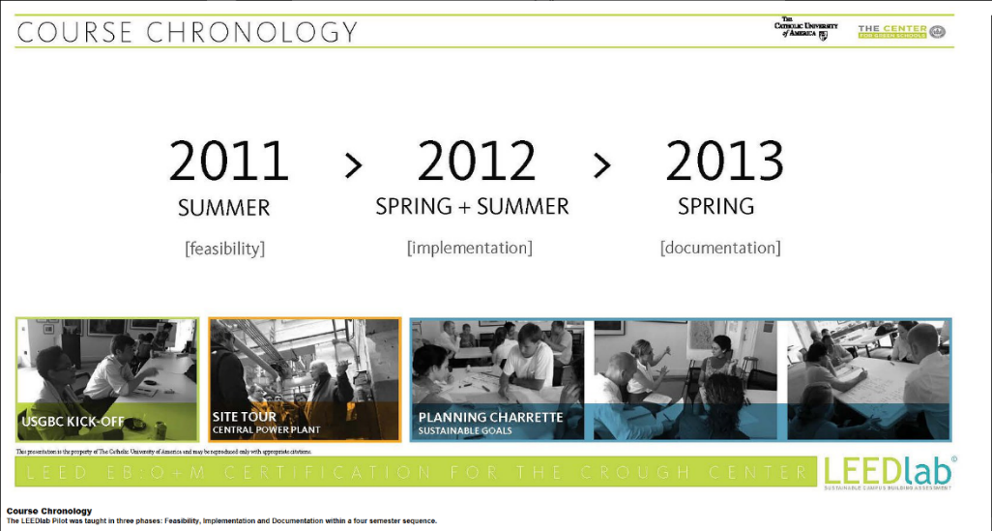
The first LEED Lab course was introduced as a pilot course in the summer of 2011, by the school of Architecture at the Catholic University of America. The full introduction of LEED Lab at the Catholic University of America was a three-step process that took nearly three years. The faculty broke the course into three steps: feasibility (Summer 2011), implementation (Spring+ Summer 2012) and documentation (Spring 2013) (Figure 1).

Figure 1. (Course Structure, 2013)

LEED Lab traditionally, has followed the same three-step process of feasibility, implementation, and documentation at all universities it has been introduced. However, certain universities have taken a more aggressive approach with the introduction timeline, especially those universities where LEED Lab is primarily a graduate student course. At both North Carolina State and Colorado State University-Pueblo the LEED Lab course was introduced in four consecutive semesters (Spencer, 2014). At these two universities LEED Lab is primarily an undergraduate level course. Purdue University was able to offer graduate students a year-long LEED Lab course (Ursem, 2014). These more aggressive timelines have become possible as universities are able to use previous LEED Lab as a guideline in designing the course at their own university (Van Mourik, 2014).
LEED Lab as seen above, is a multi-semester course with the goal of completing one semester-long project. Each semester, students learn the same LEED principles and sustainability practices as the previous semester’s students, however, their role in the project may differ. Depending on the semester the students is enrolled, they could be analyzing the feasibility of the course project or documenting the implementations made at the building to achieve LEED EB: O+M certification. The students build off each other’s work until the project is complete, and then a new campus building would be picked to restart the process (Van Mourik, 2014).
The University of Illinois Urbana-Champaign does not currently offer any multi-semester courses. Professor Liu thought this could be a big obstacle LEED Lab needs to overcome if it is going to be introduced at the university (2014).
Also a part of the introduction process, is what college LEED Lab will introduced in. LEED Lab was part of the school of Architecture at the Catholic University of America (About LEEDlab, 2013). The University of California Santa-Barbara, as well as, Colorado State University-Pueblo introduced the course in the school of Environmental Studies (Spencer, 2014) While Purdue University offered the course in both its Business and Engineering Schools (Ursem, 2014). However, the college in which it is introduced does not matter as it is a multidisciplinary course and is offered to any student interested in the course.
The University of Illinois Urbana-Champaign does offer multidisciplinary courses. The project-based course, CEE 398, is a class in the school of Civil Engineering, however, students of majors other than civil engineering are able to take the class.
An integral part to the introduction process is the determining of the logistics of the class. The LEED Lab course director must determine the type of class, level of class, number of teachers, number of students, credit hours, etc. before the class can officially begin operation.
LEED Lab has been introduced as both a normal-structured class (Lecture/ Discussion Sections) and a lab class. At the North Carolina State University, LEED Lab was entirely lab-based; lab-based LEED Labs put more of a focus on the actual implementation process of the course project. Students still learn the LEED principles and sustainability practices behind the implementations that they make to a campus building, however, the lab classes consist of fewer quizzes and discussions stressing the material (Van Mourik, 2014). The majority of colleges use a more normal class structure when introducing LEED Lab. The pilot course at the Catholic University of America emphasized LEED principles and sustainability goals through a combination of both lecture and discussion sections. The material learned by the students in each of these sections is also supplemented by periodic quizzes and case studies of relevant concepts (About Leedlab, 2013) (Figure 2).

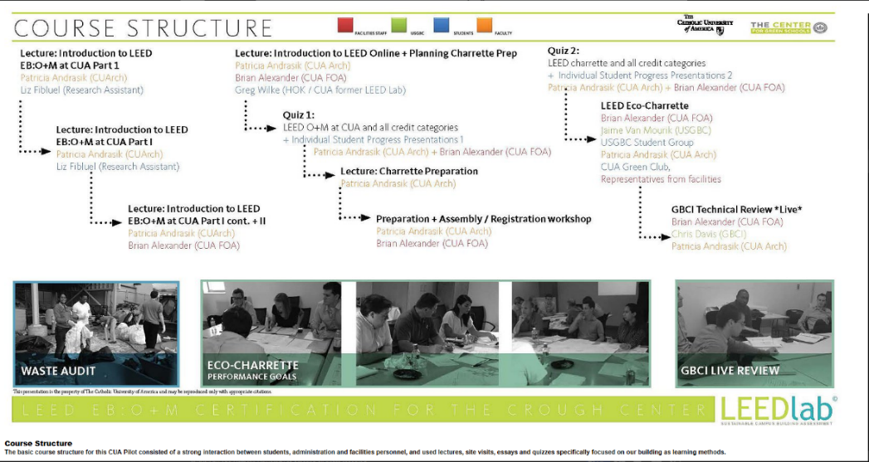
Figure 2. (Course Chronology, 2013)
This set-up of LEED Lab usually requires a professor, as well as, several teacher assistants. At Purdue University, undergraduate students in LEED Lab are hosted by one professor and three teaching assistants throughout the course (Ursem, 2014). At Colorado State University-Pueblo each lecture was taught by a single professor and then two teaching assistants taught discussions sections (Spencer, 2014). Jaime Van Mourik stated that LEED Lab has worked best when one professor is supported by two strong teaching assistants (2014).
Continuing with the comparison to LEED Lab to courses at the University of Illinois. The university offers courses that match the structure of both types of LEED Labs. Neither structure would need a big adjustment to fit into the University of Illinois curriculum.
Finally, course directors must determine what course level LEED Lab will be offered at and the number of credit hours it will be. LEED Lab has been both a graduate and undergraduate course at different universities. Purdue offers LEED Lab as a 2-3 credit hour course for graduate students and a 1-2 credit hours course for undergraduate students (Ursem, 2014). Colorado State University-Pueblo offers LEED Lab as a three credit hour course to second-semester sophomore, juniors, and seniors (Spencer, 2014). LEED Lab is usually a two-three credit hour course offered to non-first year undergraduate students (Van Mourik, 2014).
Currently at the University of Illinois, CEE 398 is a two-credit hour course open to non-first year undergraduate students. However, it will soon transition to be a 200-level course required for every civil engineering student to take. LEED Lab has a very similar course level and credit hours as the pilot CEE 398 course. However, LEED Lab covers a much narrower range of topics; as it pertains almost entirely to LEED principles and sustainability practices, and the goal would not be to transition it to a required 200-level course. LEED Lab would most likely fit into the University of Illinois curriculum as an elective or 300/400-level sustainability course in the college of civil engineering.
Class Analysis
The class portion of LEED Lab has the same costs as a normal class: teachers, facilities, materials, etc. Our group was able to estimate the cost of purchasing the necessary materials for LEED Lab based on our decision for it to have one professor and two teaching assistants. The table below (Table 1) shows how much it would cost the university to buy the USGBC materials for the three faculty members. Students taking the LEED Lab course would also have to purchase: the LEED study guides, LEED v3 Reference Guides, LEED v4 Reference Guides, and access to Education @USGBC subscription, however, these are sold independently to the students.
Table 1 (Van Mourik, 2014)
USGBC Materials: | Cost: | Total:
Publications:
LEED Study Guides | $70/subscription | $210(3)
LEED v3 Reference Guides | $160/subscription | $480(3)
LEED v4 Reference Guides | $199/subscription | $600(3)
Access to LEED v4 web-based reference guide | $99 | $99
Education:
Access to Education @USGBC subscription | $175/ subscription | $525(3)
Additional:
Greenbuild Registration | $600 | $600
 | Total: | $2,514

All college courses require the university to buy the necessary materials for the staff to teach the course. The only extraneous cost LEED Lab has is the Greenbuild Registration. However, $600 is not a very significant amount of money and it does not affect the overall feasibility of the project. In this aspect, introducing LEED Lab is just as feasible as any other college course at the University of Illinois.
Using the advice of Professor Liu and the structures of other LEED Labs our group developed a course curriculum that would best fit the University of Illinois’s academic situation. The first change was to make LEED Lab into a one semester course by modifying the course project (Discussed in course project section). After determining the length, our group decided that LEED Lab would be offered as a three credit hour course offered in the college of Civil Engineering to non-first year undergraduate students. Like other multidisciplinary courses, LEED Lab would be offered to students of all majors. Our group was influenced by the course level and college of CEE 398 because both classes are very similar in their curriculum. These two classes both have a semester long project that is the majority of the workload. However, we added an extra credit hour to the LEED Lab course because it focuses on the LEED principles and sustainability goals behind the project, while CEE 398 just focuses on the semester project.
Additionally, our group decided to use the same curriculum structure as the pilot course at the Catholic University of America. The University of Illinois has many classes with a similar structure, where class sessions are split between lecture and discussion sections. The lecture sessions are taught by one professor and focus on the LEED principles and sustainability goals of the course. Then, the lecture is split into two discussion sections each taught by a teaching assistant. These discussion sections are where students discuss how to connect what they learn in lecture to the course project. Periodically, these discussion sessions will also consist of quizzes or case studies about the class material.
Course Project
The LEED Lab project requires students to select one campus building to implement more energy-efficient infrastructure in to meet LEED for Building Operations and Maintenance Standards. These implementations cost the university a significant sum of money depending on the pre-existing condition of the building selected (Van Mourik, 2014)
The pilot LEED Lab at the Catholic University of America chose the Edward M. Crough Center for their course project. The Edward M. Crough Center had no previous LEED certifications of any type, and the students came up with three areas where the building needed to improve its energy performance. The three areas selected by the students were: maximizing energy, site/water conservation, and pollution reduction (About Leedlab, 2013).
In regards to maximizing energy, the students came up with eight initial strategies for the Edward M. Crough Center (Figure 3). After completing an energy performance assessment of the building, the students decided the very large, inefficient light fixtures were the area that needed the biggest improvement. The Edward M. Crough Center receives a considerable amount of sunlight during the day, and it was decided that installing an automatic shut-off switch was the best way to maximize energy. The automatic shut-off switch turned building lights off when it received a sufficient amount of lighting due to sunlight. The automatic shut-off switch saved the Edward M. Crough Center 20-30% of its annual electricity cost (Maximizing Energy).

Figure 3. (Maximizing Energy, 2013)

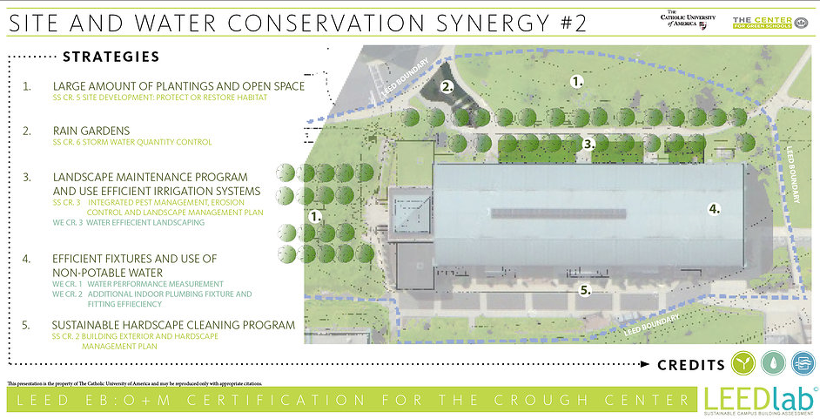
For site/ water conservation the students used the same approach by narrowing down five solutions to one strategy that would benefit the building the most (Figure 4). The biggest problem the Edward M. Crough Center faced in the area of site/ water conservation was increasing municipal storm water fees. The students decided installing rainwater cisterns, to collect rainwater, was the best route. These cisterns were able to decrease the amount rainwater drained from the Edward M. Crough Center, decreasing the cost of the building’s municipal storm water fees (Site and Water Conservation).

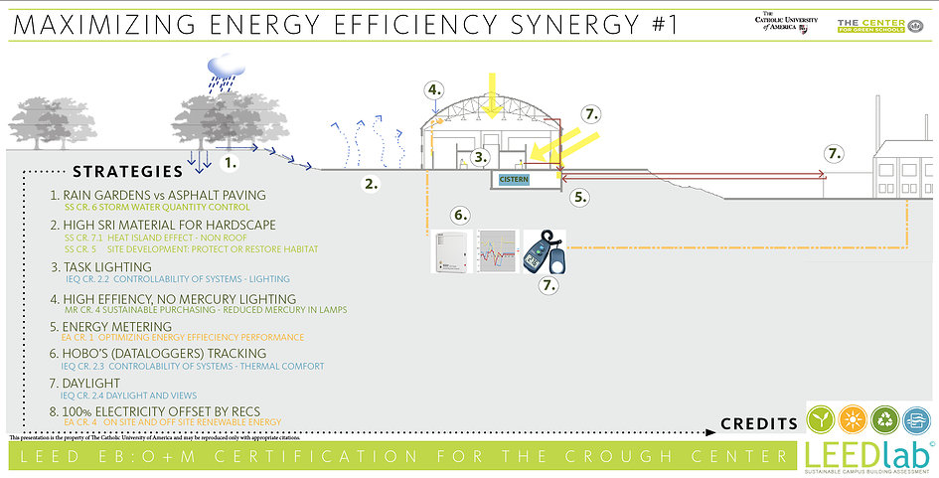
Figure 4. (Site and Water Conservation)

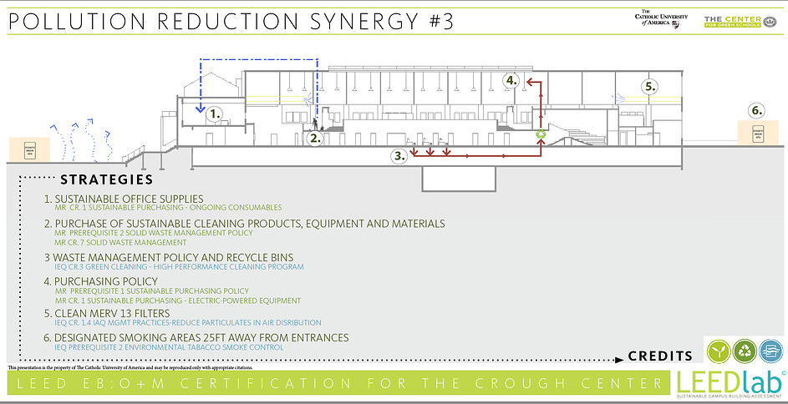
In regards to pollution, six initial strategies were narrowed down to replacing the AHU and cooling units as the most effective solution (Figure 5). Students got consultants to perform an ASHREA test and walkthrough, which shows the pollution production of the building(Pollution Reduction)
Figure 5. (Pollution Reduction)
These implementations of more energy-efficient infrastructure at the Edward M. Crough Center allowed it to achieve LEED EB: O+M certification, and provided several new benefits to the surrounding university and community (Figure 6).

Figure 6. (Sustainable Achievements)

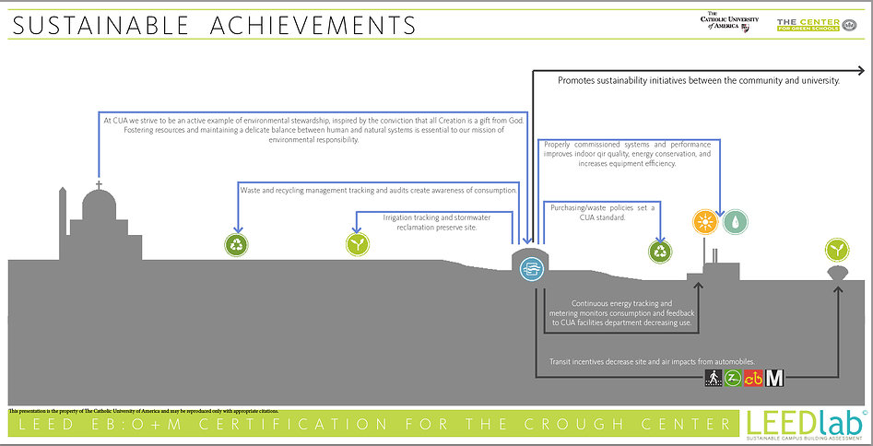
The pilot LEED Lab at the Catholic University of America helped a non-LEED certified building achieve LEED EB: O+M certification, however, most LEED Lab are not as ambitious. Most universities see LEED certification as a secondary goal to providing students with real work experience and promoting best building practices on campus (Ursem, 2014). Purdue University LEED Labs are currently working on two buildings, neither of which have achieved LEED EB: O+M standards (Ursem, 2014). Another approach taken by many universities is to select an already LEED-certified building for the course project, in fact, this is what USGBC recommends in its introduction manual (Van Mourik, 2014). Students of the Colorado State University-Pueblo selected the Library Academic building for its course project, a building that earned LEED Platinum for new construction in 2012 (Spencer, 2014). For buildings that are already LEED-certified, the focus of the course project is to make the sure the buildings have proper monitoring systems and periodic test to keep performing at the same energy performance level (Spencer, 2014). Universities that choose buildings that are already LEED-certified have very minimal implementation costs in regards to the course project. The only significant costs would come from the LEED project fees. The LEED project fees are derived from three processes: LEED Registration, LEED Certification (O+M), and LEED Interpretations. The University of Illinois Urbana-Champaign is an organizational member which makes LEED Registration $1200 and LEED Interpretations $380. The LEED Registration payment allows access to LEED Online and a variety of other tools and resources necessary to start the LEED Certification process. The LEED Interpretations Submission is a review of the project by the USGBC using an online LEED Interpretations Database of rulings that can be applied to both current and future building projects (LEED Interpretations, 2013). The third fee, LEED Certification (O+M) is where LEED reviews the project and using a point system decides which level of rating the building project has earned. This certification fee is based upon the square footage of the building, at the organizational level it costs $0.04/ SF (Van Mourik, 2014).
Based upon the recommendations of Jamie Van Mourik to pick a LEED-certified building at the University of Illinois Urbana-Champaign, the following table (Table 2) displays the cost of achieving LEED EB: O+M certification at each of the seven LEED-certified buildings on campus.

Table 2 (Van Mourik, 2014)
Building | Area (sq. feet) | Cost | Reg. / Inter. | Total
Nugent Hall | 58,000 | $2,320 | $1,580 | $3,900
IKE Dining Hall & Residential Programs Building | 139,000 | $5,560 | $1,580 | $7,140
Blue Waters Petascale Facility | 88,000 | $3,520 | $1,580 | $5,100
YEH Center | 20,500 | $2,000 | $1,580 | $3,580
Electrical & Computer Engineering Building | 230,000 | $9,200 | $1,580 | $10,780
Lincoln Hall | 107,447 | $4,298 | $1,580 | $5,878
BIF | 162,000 | $6,480 | $1,580 | $8,060

Analysis
While selecting an already LEED-certified building saves the University of Illinois the costs of implementing energy-efficient infrastructure at a campus building, the monitoring/ testing and LEED EB: O+M certification can still cost the university $3,580 - $10,780. The project process would also cause the course to take longer than one semester, an option the University of Illinois does not offer.
Our group found time was the biggest factor in eliminating the original course project. Therefore, our group came up with an alternative class project that could fit into a one semester timeframe. Instead of implementing actual energy-efficient infrastructure in a campus building, the students would perform an energy performance test and then build a model to show how they would implement energy-efficient infrastructure in the building to achieve LEED EB: O+M certification. This saves the university any additional costs of LEED certification, while still giving the students a real work experience and the opportunity to work with professionals.

Conclusion
This study analyzed the feasibility of introducing LEED Lab at the University of Illinois Urbana-Champaign as a project-based learning class that stresses LEED principles and sustainability practices. While other LEED-related classes teach the same concepts, these other classes really lack the hands-on work experience and interaction with professionals that LEED Lab offers students. However, for LEED Lab to be effectively integrated into the University of Illinois curriculum, two major changes needed to happen:
- LEED Lab needed to be modified so that it was only a one semester course.
- The LEED Lab course project would consist of students performing a mock energy performance assessment on a campus building and then building a model of the building to show what energy-efficient infrastructure they implemented, rather than actually implementing this infrastructure at a campus building.
This is was seen as the best option as it kept the integrity of the course, while significantly cutting down the cost and time of LEED Lab. Students are still able to learn the same LEED principles and sustainability goals in this one semester timeframe. The new project still gives students a real work experience as they need to perform an energy performance test and seek advice from professionals on what energy-efficient infrastructure to implement in their building model. Further research of the university budget still needs to be performed to determine the actual quantitative feasibility the University of Illinois has for LEED Lab, however, based on information provided to our group a one-semester LEED Lab with a modified project seems to be the most feasible option.
Reflections
Our project’s biggest triumph was that we were able to interact with several professionals in the field related to our topic. The USGBC Director, Jamie Van Mourik, and the two LEED Lab Course Directors Sarah Spencer and Michael Ursem were really able to give us information that internet research could not provide. There is not extensive information about LEED Lab on the internet, and I think our group was able to still get a significant amount of information and make an accurate analysis of the feasibility of introducing LEED Lab at the University of Illinois. The interviews also taught our group that you need to be very efficient with your time when interacting with a professional. We had to contact several professionals numerous times before they would give us time for an interview. Even during the interview, several interviewees had a limited amount of time and we had to really narrow it down to what questions were the most important to get answered.
Our group’s biggest shortcoming was the lack of actual quantitative data. This shortcoming did not end up being a huge problem as our group was able to use our limited data and interviews to show the pros and cons of introducing LEED Lab at the University of Illinois, rather than an actual quantitative feasibility. Our group was able to interpret our data and make any necessary assumptions to completely answer the feasibility of LEED Lab. However, initially going into the project our group thought we would get more quantitative data and actually be able to come up with a number for the necessary budget of LEED Lab.
Miscellaneous
Schedule
Date (Week of…) | Goal
9/17 | - Group should begin to read LEED Lab Introduction Manual and LEED Rating System to possess a basic understanding of LEED and the course
9/24 | - Finish taking notes on LEED Lab Introduction Manual and LEED Rating System  - Start online research of LEED Lab website and schools that have previously participated in LEED Lab  - Complete and submit Milestone 1 Draft
10/1 | - Start to wrap up initial online research period and compile notes into a readable document  - Edit Milestone 1 using critiques of classmates and professors  - Complete and submit Milestone 1 Final
10/15 | - Contact Jaime Van Mourik and Professor Liu  - Review comments and grade of Milestone 1 and begin to edit Milestone 2  - Received two LEED contacts from Jamie Van Mourik
10/22 | - Interview Professor Liu (Thursday) and Jamie Van Mourik (Friday)  - Set up interview with LEED contacts Sarah Spencer and Michael Ursem for next two weeks  - Finish revisions and submit Milestone 2 Draft
10/29 | - Review peer review comments and make revisions before submitting it to Mary Hays  - Interview Sarah Spencer, LEED Lab Course Director of Colorado State University-Pueblo (Saturday)  - Review information provided Michael Ursem, LEED Lab Course Director of Purdue University (Saturday) and e-mail him back with any follow-up questions  - Compile all notes from interviews and research to use for results and discussion section  - Complete and submit Milestone 2 Final
11/12 | - Finish conducting all interviews  - Organize results and begin to organize course curriculum and other important logistical figures of the class
12/3 | - Review comments and peer review of Final Report Draft  - Conduct any necessary research to complete the analysis of the LEED Lab feasibility  - Finalize course curriculum and introduction timeline  - Begin to practice presentation of project
12/10 | - Complete and submit Final Report  - Present project

Project Budget
The basis of our project research is USGBC texts and interviews of experts on sustainability practices and green building, neither of which cost our group money. The project’s main cost will be from buying materials to present our findings. Our presentation will require poster board (≈$12), permanent markers (≈$5), and the cost of printing paper (≈$2). The group projects our budget to be no more than $25.

Acknowledgments
Our group would like to thank Jaime Van Mourik, Sarah Spencer, and Michael Ursem for their in their information and advice about LEED Lab. We would also like to thank Professor Liu and Morgan Johnston for their information about the University of Illinois class introduction process and budget. Finally, we would like to send our gratitude to all the professors in CEE 398 who supported our project.
References
"About LEEDlab." (2013) LEEDlab. http://www.leedlab.com (Oct. 14, 2014).
Andrasik, Patricia. (June 2013) "LEED Lab Sets the Course for Campus EB: O M Certification." U.S. Green Building Council, < http://www.usgbc.org> (Oct. 7, 2014).
"Course Chronology." LEEDlab, http://www.leedlab.com/#!syllabus/zoom/c1u8c/i1loj Web. 18 Oct. 2014.
"Course Structure." LEEDlab, http://www.leedlab.com/#!Course Chronology/zoom/c1u8c/i02go Web. 18 Oct. 2014.
"Distinguish Your Expertise." USGBC, < http://www.usgbc.org> (Oct. 7, 2014.)
"Getting to Know LEED: Building Operations and Maintenance (O M)." U.S. Green Building Council. < http://www.usgbc.org> (Oct. 5, 2014)
“Green Campus.” The Center for Green Schools, http://www.centerforgreenschools.org/green-campus.aspx (Oct. 5, 2014)
Hincha-Ownby, Melissa. (Feb, 2010). "Understanding the USGBC’s Green Campus Campaign." Mother Nature Network, http://www.mnn.com (Oct. 5, 2014)
Johnston, Morgan. (Oct. 5, 2014) “Initial LEED Lab Feasibility.” Interview
"LEED." U.S. Green Building Council, < http://www.usgbc.org> (Oct. 4, 2014)
"LEED Lab." LEED Lab. The Center for Green Schools. http://www.centerforgreenschools.org (Oct. 7, 2014)
Liu, Professor. (Oct. 2014) "UIUC Course Introduction Policy." Interview
"Maximizing Energy Efficiency." LEEDlab, http://www.leedlab.com/#!crough-certification/zoom/c1nt6/image16iw Web. 18 Oct. 2014.
Meehan, Peggy. (Jan. 2010) "Hands-On LEED." USGBC, < http://www.usgbc.org> (Oct. 18, 2014).
"Pollution Reduction." LEEDlab, http://www.leedlab.com/#!crough-certification/zoom/c1nt6/image2pw Web. 18 Oct. 2014
"Site and Water Conservation." LEEDlab., http://www.leedlab.com/#!crough-certification/zoom/c1nt6/imagepbx Web. 18 Oct. 2014.
Spencer, Sarah. (Nov. 21, 2014) “Colorado State University-Pueblo LEED Lab.” Interview
"Students Gain Professional-Level Experience in CUA’s LEED Lab." (Apr. 2013) LEED Lab, http://publicaffairs.cua.edu (Oct. 7, 2014)
"Sustainable Achievements." LEEDlab, http://www.leedlab.com/#!Sustainable Achievements/zoom/c1nt6/image1z8c Web. 18 Oct. 2014.
Ursem, Michael. (Nov. 21, 2014) “Purdue University LEED Lab.” Interview
Van Mourik, Jaime. (Oct. 31, 2014) "LEED Lab Information." Interview

