EVALUATING GREYWATER USAGE AS A REPLACEMENT FOR POTABLE WATER IN TOILETS AT THE BIF

ZACH SIGLER
NAM PHUONG LE
TREVOR VOGLER

University of Illinois at Urbana-Champaign
DECEMBER 10, 2014
Executive Summary
The University of Illinois at Urbana-Champaign is trying to take actions to make the campus more sustainable. Some new buildings are LEED certified; they have light sensors in classrooms, low-flush toilets, green roof garden, and more. One category that the campus has not focused on, however, is reusing the water discharged in a building for other purposes. For example, water that is used for hand washing or from washing machines could possibly be reused again as toilet water. At the beginning of the project, we were told that the Business Instructional Facility (BIF) has pipelines specifically designed for greywater, but they are currently not being used. This gave our team the idea to propose a project to see if we could actually give a purpose to those pipelines. Initially our team decided to find out how much water we could save by reusing the greywater to pipe back into the toilets inside the building or to use the greywater to irrigate the plants that are around the BIF, but we encountered the problem of having to figure out how the pipelines in the building worked. We also had to figure out where to store the greywater when it’s not being used, and how much that system could sustain before it has to be dumped. Due to the time constraint, we changed our goal to figure out if BIF can supply enough greywater to use for its own toilets. Our research would answer the question, “Can this system be self-sustaining?” We had to disregard the fact that the pipes may not be designed to allow all greywater sources to be collected and reused for toilets. We concluded that the BIF is not fitting building to install a greywater system because it might not supply enought greywater source for the toilet water’s demand. An ideal commerical bukding

TABLE OF CONTENTS

Introduction and Background….……………………………………………………………….2
Project Objectives………………………………………….…………………………………….3
Methodology…………………………………………………………………………………...…4
Results and Discussion…………………………………………………………………………...6
Conclusions………………………………………………………………………………….........7
Reflections………………………………………………………………………………………...8
Acknowledgements………………………………………………………………………………8
References……………………………………………………………………………………….10
Appendix and Budget………………………………………………………………………......11

Introduction & Background
Greywater is any type of water that has been slightly used, that means it can have some residues of dirt, food, grease, cleaning product, and so on (Ludwig 2014). It is not as pure as drinking water, but it can be used for other practical purposes. As Sandra Mason, an Extension Educator at the University of Illinois, mentioned how "for a family of 4, about 5,000 gallons of greywater [is used] a month which just about fills a backyard swimming pool," (Mason 2011). Nowadays greywater systems have been an interest for residential household owners, where greywater filters and pump systems have been installed for reusing the greywater (Ludwig 2014). Benefits of installing greywater systems includes using less fresh water, less energy and chemicals used to treat greywater, and encourage a green living habit by using the water for plant growth and to conserve water usage. By reusing greywater this means there is less demand on potable water which also means saving money for the homeowners and the wastewater treatment center (Waskom and Kallenberger 2014).
The trend of sustainable practices nowadays includes greywater systems. Irrigation and flushing toilets are common uses for greywater systems (Ludwig 2014). Residential greywater systems are the most popular for greywater systems since it is easier to monitor. Commercial scale buildings have considered installation of greywater systems as well. For example since Fall of 2010, the University of Georgia has built a new residence hall which “use[s] treated graywater (recycled water from showers, sinks and washing machines) for flushing toilets” (Sargent and Garrison 2009). Based on the Illinois Climate Action Plan (iCAP) portal’s report referenced that the Business Instructional Facility was designed to have pipelines that are specifically used for greywater, however they are not being used at this time (Institute for Sustainability, Energy, and Environment 2008).
Water is a finite resource on Earth, so we would like to implement the use of those greywater pipelines so the BIF can start reusing water, rather than just dumping the water straight to the sewage. By reusing the greywater we can save money and learn to reuse this valuable resource rather than wasting both.
For those reasons, our team was motivated to see if we can actually use the greywater pipelines at the BIF. We lean towards reusing the greywater as toilet water rather than irrigation because of the winter conditions, which would not be beneficial to irrigate. By looking at the data of the water consumption at the BIF given by Morgan Johnston, from Facilities and Services department, we estimated how much water is consume at the BIF every month so we estimated how much greywater we need to supply for the toilet water.

Project Objectives
The main objective project was to determine how much the Business Instructional Facility can satisfy its own toilet water demand by using a greywater pipeline system that we didn’t know for sure existed. When we found out the system did not exist, we sought to find out how feasible it would be to put one in.

Objective #1:
Obtain data that shows how much water BIF has used per month for the past few years its been open and approximate how much of it is used for toilets versus other sources (assuming all other sources become greywater after their usage). Use these values to determine how much the building can supply its toilets with its own greywater.

Objective #2:
Examine the proposed plans for a greywater system in the building; discuss with members of Facilities and Services how it works and see if the plans show whether or not the system was implemented.

Objective #3:
Obtain data on the total amount of water used by the building per month using the graphs we obtained from Morgan Johnston. Use data from objective #2 to determine the exact number of gallons of water that can be saved if the system is put in use, and if the building can be self-sustaining. Interview some Facilities and Services people and ask questions regarding the status of the greywater system plans and

Objective #4:
Find out why the system was or was not implemented and if there could be a feasible way to do so if it was not.

Methodology
These are the specific directions on how we planned to carry out our objectives, followed by elaboration on how they worked out as we did them.

Objective #1.
Task 1: Research data on how much water an average building uses
Subtask 1: Create a modified chart that modifies percentages to adjust to an academic building rather than a household
Task 2: Ask Morgan Johnston to get data on how much water the BIF consumes every month and year since its opening
Task 3: We combined both sets of data and create a graph showing greywater demanded (for toilet water) and greywater supplied (other sources) throughout the fiscal year

Objective #2:
Task 1: Submit data request to the Facilities and Services website to request data regarding the plumbing plans for the building
Subtask 1: Get Morgan Johnston in contact with the Facilities and Services people who are processing the request so the request can be approved

Task 2: Talk to Professor Arthur Schmidt and Morgan Johnston and have them help interpret the plumbing plans; figure out if the system was implemented or not and if so, how it works

Objective #3:
Task 1: Contact Guy Grant, a management engineer in Facilities and Services who is knowledgeable on BIF and can find us some answers that cannot be found elsewhere
Task 2: Calculate exact number of toilets and greywater sources in the building; determine average usage of each one, and use this to figure out exactly how many gallons of water can be saved
Objective #4:
Task 1: Do some research on greywater systems; understand the implications of installing a greywater system and find out why it was not used in BIF

Elaboration on Objectives:
Objective #1:
Facilities and Services directly gave us total water consumption data for the BIF, however we still had to determine how much of the water is reusable as greywater and how much of it is used for flushing toilets (This initial data is shown in Table 2). There are no devices installed within BIF that measure exactly how much water is used by each water-consuming appliance, so we didn’t have accurate data showing the true supply and demand of greywater. In order to make an estimation, we used a chart from the EPA’s website that shows the average water usage in a household with percentages of each water-consuming appliance. We then took this chart and modified it to be more accurate with the BIF’s infrastructure. Our modified chart takes out the Clothes Washer and Leaks parts of the graph and has new percentages based on the other utilities that are already present. Finally, we applied the percentage of water used for toilets to the total water consumed to determine the total amount of water used for flushing toilets (This final graph is shown in the Results and Discussion section). This determined how much of its own greywater the BIF could supply to see if it could at least meet some of the demand for toilet water, and therefore be a more sustainable model for buildings on campus.

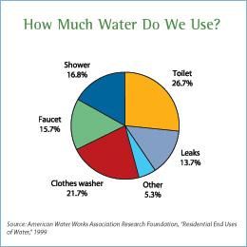
Figure 1. Taken from the EPA’s website, the figure shows the water distribution in a household (Environmental Protection Agency 2008).
Table 1. Shows the recalculated percentage ratio to fit the BIF’s infrastructure.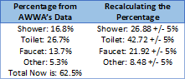
We assumed any water that are not from toilets will be categorized as a greywater source for our calculation. Therefore the percent of water supply with no error margin is 57.28% with 42.72% showing the toilet water demand. We then estimated how much greywater will be need per month by taking the average of water consumption at the BIF from the past four years. This is done by multiplying the percent of the water supply and demand to each month’s water consumption. In the case of January we multiplied .5728 to 83.5 kilogallons to get 47.83 kilogallons and .4272 to 83.5 kilogallons to get 35.67 kilogallons. This means that there’s a demand of 35.67 kilogallons for flushing toilet water and there’s a supply 47.83 kilogallons to supply that demand. In case of any errors we did a -/+ 5% with the supply and demand to show how much kilogallons of water need to supply for the demand. For the ‘Supply with -5% Error Margin’ the percent was 52.28% and ‘Demand with +5% Error Margin’ was 47.72%. For the ‘Supply with +5% Error Margin’ and ‘Demand with +5% Error Margin’ was 62.28% and 37.72%, respectively.

Table 2. Display a graphical look of the supply and demand of water at the BIF
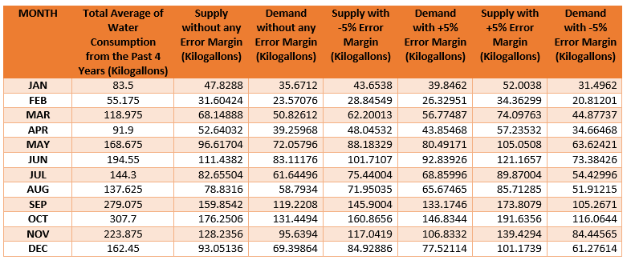

Objective #2:
We were able to get our data request approved, which got us access to the building floor plans that included the plumbing plans. More detail on what these looked like is included in the appendix. After interpreting it, we realized that there were alternate plans for a non-potable cold water system being hooked up to the toilets in the building, which is precisely what we are looking for. However, we had no way of knowing whether or not these alternative plans were the final plans used in construction, so we had to look further by interviewing some other people such as Keith Erickson and Guy Grant.

Objective #3:
We were able to get in contact with the two Facilities and Services people we needed, and Guy Grant explained that there is a separation of water lines to the toilets and urinals within the building, but a greywater system was not implemented. He explained that there were separate lines installed in the event that a system like this is installed in the future. With this knowledge and the time constraint we had, we decided to move forward with our project by doing some research on greywater systems to how one could be installed and if it would be a good decision for the BIF. With no way of calculating exactly how much water was used by each source within the building, we decided to stick with our chart we already made for the data of water supply and demand.

Objective #4:

To properly install a greywater system we need to control the inputs of the greywater source. For example, we cannot use any water from a kitchen because of food residues. For washing machines, anything containing phosphates, bleaches, or ammonia should be avoided (Cabonargi and Hansen 2011). From the diagram shown below there are different components to make a safe and clean greywater system. It is important to have a filter, purification system, storage tank, and pump.
If we had more time to do this project rather than just having a semester to research about it, we would have looked into how to fully install a functional greywater system, shown in Figure 4 below. More information regarding our final thoughts on this is elaborated on in the Results and Discussion section. 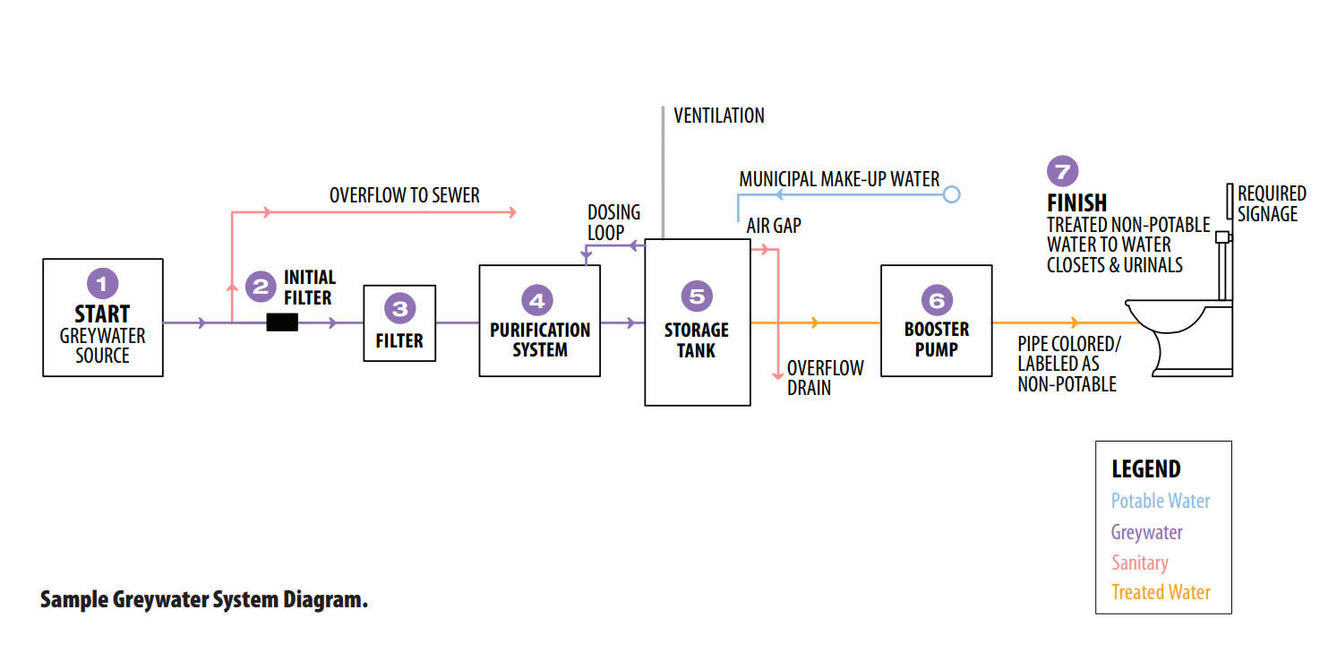
Figure 4. Shows the different components of how a greywater system should be installed (Cabonargi and Hansen 2011).

Alternative Solutions:
Alternative #1: Create a plan to install a greywater system in a residence hall, calculating costs and benefits
Task 1: Determine exact sources of greywater
Task 2: Research exactly what parts a greywater system needs to function
Subtask 1: Figure out where to put these parts and pipelines
Subtask 2: Research costs associated with each part and installation of the whole thing

This option would be our preferred alternative solution because this could actually be a feasible solution. With the amount of water a residence hall produces through washing machines, it may be possible to have a somewhat constant source of greywater flowing into toilets. “Greywater reuse is only beneficial if there is adequate source of water present and available to harvested” (Cabonargi and Hansen 2011). As the University of Illinois is working on many new dorms within the Ikenberry Commons area, this could possibly be carried out in the design of a future dorm if not an existing one. Some issues that arise with this solution are that the total cost of a greywater system adds up to be a lot of money that may not have immediate cost savings, making the decision to spend the extra money an unfavorable one. For example, Brac Systems Inc. is a company that manufactures greywater system parts with the total price of the parts alone being $34,650 (Cabonargi and Hansen 2011). This does not include installation costs or the costs associated with connecting the right pipelines. Furthermore, Brac Systems is not approved in the state of Illinois to do such work (Cabonargi and Hansen 2011). A greywater system is only useful if there is a fast return rate for installing the system and for saving the cost of money purchased

Alternative #2: Use greywater to water the plants and garden areas that surround and are part of the building.
Task 1: Determine where to pump the greywater out of the building; figure out if and what else would need to be installed/changed in the system to make this work
Subtask 1: Calculate relative surface area of plants and how much water they will require (demand)
Subtask 2: Do research on chemical compositions of greywater and various plants; determine if it is actually safe to use greywater on these plants
This alternative solution was not chosen because there were many implications. It is likely that it would cost more to design an irrigation system using greywater to water the plants than to use a potable water source. As stated earlier, we also do not know if greywater will actually be healthy enough for the plants or just kill them off slowly. Extreme weather conditions are also an issue.
Alternative #3: Determine if greywater from BIF can be pumped to another nearby building such as Wohlers Hall so as to provide another building with the resource
Task 1: Contact Facilities and Services; find out if there are any existing pipelines between BIF and Wohlers Hall that could be used to transport greywater and if not, find out how much it would cost to implement them
Task 2: Create data request for Facilities and Services on pipeline system of Wohlers hall; figure out how greywater can be moved around the building

This alternative solution was an idea we had because we had heard from some professors that there were unused raw water pipes beneath some of the streets around the area, and could potentially be used to transport water from one building to another. This was not carried out because this would require a bunch of data that may not exist. Even if it does, any solution produced would probably not be as optimal as a method for using greywater directly in BIF.

Results and Discussion
We interviewed with Keith Erickson, an associate director in Utilities and Energy,
and Guy Grant, a management engineer, from Facilities & Services, and we learned a few key components in our greywater dilemma. We learned that the building was plumbed for dual plumbing, meaning that there is a raw water line and a potable water line. Currently the building is using the potable water line. Raw water could be used as a source of “greywater” potentially because there are pipes around campus that were installed next to potable water lines. However, Erickson told us that in order to connect to those pipelines it would cost $500,000. We also learned that in the basement of the BIF the toilet and urinal lines are separated from the rest of the buildings’ water lines. The hope was to use the untreated (raw) water from the pipes to supply water to the toilets and urinals in the future, assuming that the raw water lines became operational. Due to the $500,000 cost though, this is unattractive.
For the building to produce its own greywater there needs to be a storage tank to hold the water. The BIF has no such tank. Because water is so cheap in Champaign-Urbana, the need to treat water in order to reuse it becomes very unattractive.
Guy Grant also noted that bacteria could pose a health risk to users, and that is also a potential danger to be considered in using a greywater system.
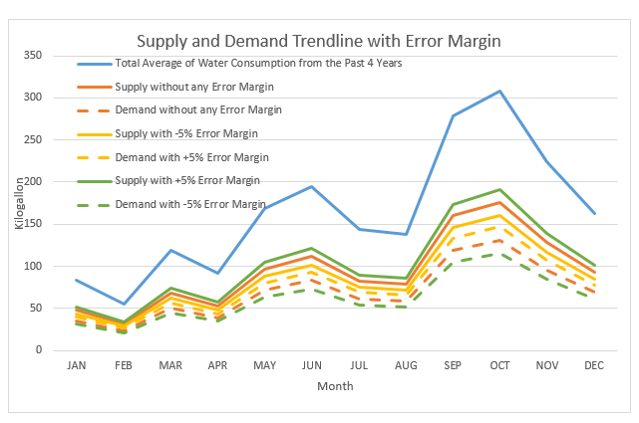
Figure 3. Display a graphical look of the supply and demand of water at the BIF

The figure above shows the graphical version of Table 2. This shows that in a perfect system, the building could supply its own toilet water demand, although it is important to estimate the correct amount of water. With the data and knowledge that we’ve gained, we decided that implementing a greywater system in the BIF would not be cost effective, at least for an unreasonably long time. As stated earlier, this greywater system approach to saving water could only really be effective in a building such as a residence hall where a greywater source is more consistent.

Conclusions
In Illinois it is hard to get approval for greywater systems. “Currently, greywater systems are not expressly allowed as an alternative to traditional plumbing systems in the Illinois Plumbing Code (the State has jurisdiction over plumbing issues in Chicago). Approval from the State must be sought for greywater systems until such an alternative is legislatively allowed” so there are some hoops to jump through (Cabonargi and Hansen 2011).
Based on our calculations it is theoretically possible, with the amount of water given, to reuse the water inside the BIF. The main caveat is there needs to be a reliable greywater source, along with additional greywater system components such as pipes, storage tank, and operating pumps to efficiently do this. The state of the BIF currently this is not possible. It appears that the greywater system might have only been “included” to pander for LEED points in order to reach a certain level of certification. With the high cost of connecting to the raw water lines, lack of key operational greywater system components, and potential code violations it is clear that the greywater system at the BIF is not very attractive.

Reflections
This project really showed us how proposing solutions to real-world problems can be a very lengthy and tedious process, and how a scope that may not seem so large can take a very long time to implement. We had a lot of ideas for our project scope just three months ago, but many of these parts had to be cut out due to how much time we had to get it all done; three months is not nearly enough time to create a feasible solution to a large project that consists of many elements and depends on a lot of data that couldn’t always be found. We definitely experienced some shortcomings on trying to get the data we wanted; we couldn’t get exact data on how much greywater the BIF produces day-to-day and week-to-week, so these numbers had to be based on estimates.
This project was not without successes though; we managed to get hard data on how much water the BIF uses every month of every year its been open, as well as the diagrams for the piping system within the building. We were able to communicate with a lot of professors and F&S people that gave us explanations of our data and helped us figure out exactly why implementing a greywater system is not necessarily cost efficient. Our group was able to meet most weeks of the semester, and each group meeting was productive and efficient.
This whole project experience proved to be useful in many ways, one being an example of what a real-world problem might look like. We had a vision for something that could be changed for the greater good, created a scope for a way to make the project work, found most of the data we needed to assess the scope, and specifically talked to people to help make it possible. Although we did not have a lot of time to carry out this scope, we got a feel for how this kind of work is done.
If we did this project again, we would keep our scope narrower at the start so we could focus more on what hard data we could get and what we could do with the data. We would have looked more at our alternative options such as examining other buildings on campus that use a lot of water, such as the residence halls. We encountered issues finding data early on, especially with such a large scope. If we had kept it narrower from the start we may have had more time to collect data that would actually be useful. We also spent a lot of time deciding which parts of the scope to narrow due to different ideas we had about the project going in; our scope could have had two or three different projects if it was divided up that way.

Acknowledgements
We would like to thank Keith Erickson for explaining to us the current state of the pipelines usage at the BIF, Morgan Johnston for providing us the water consumption data of the BIF and blueprints of the BIF’s layout, Professor Arthur Schmidt for helping interpret the blueprints of the BIF, Guy Grant for giving us information about the greywater system, Professor Jeffery Roesler, Paul Littleton, and Alek Heilstedt for giving us advice on how to improve our project, and finally Professor Mary Hays for teaching us how to fix our proposal to make it more concise and understandable.

References
Cabonargi, E. L. and Hansen, I. (2011). "Water Reuse Handbook." Public Building Commission of Chicago, <http://www.pbcchicago.com/pdf/WaterReuse.pdf> (Oct 20, 2014).
DEQ Graywater Advisory Committee. (2010). "Recommendations on Graywater Treatment, Disposal and Reuse." State of Oregon Department of Environmental Quality. Portland, OR, 10-20
Environmental Protection Agency. (2008). "Indoor Water Use in the United States."<http://www.epa.gov/WaterSense/pubs/indoor.html> (Oct. 20, 2014).

Institute for Sustainability, Energy, and Environment (2008). "BIF Greywater Pipe System." iCAP Portal, <http://icap.sustainability.illinois.edu/project/bif-greywater-pipe-system> (Sept. 28th, 2014).
Ludwig, A. (2014). "About greywater reuse." Greywater Action, <http://greywateraction.org/content/about-greywater-reuse>. (Oct 20, 2014).
Ludwig, A. (2014). "Grey Water Central." Oasis Design, <http://oasisdesign.net/greywater/> (Oct 20, 2014).
Mason, Sandra, (2011). "Going Green May Mean Going Grey - Using greywater in the landscape." The Homeowners Column, <http://web.extension.illinois.edu/cfiv/homeowners/110812.html> (Sept. 20th, 2014).
Sargent, R. and Garrison, J. (2009). "Bulldog Families: A Magazine For the Families of UGA Residence Hall Students." Department of Housing At the University of Georgia, <http://housing.uga.edu/sites/default/files/publications/bulldog-families/2009/bf-summer-2009.pdf> (Oct. 20, 2014).
Waskom R. and Kallenberger J. (2012). "Graywater Reuse and Rainwater Harvesting." Colorado State University Extension, <www.ext.colostate.edu/pubs/natres/06702.html/> (Oct 20, 2014).

Appendix and Budget
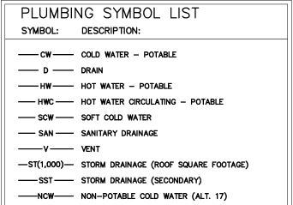
This is part of the key from the plumbing area plan. This was important because it helped us figure out what to look for: the Non-Potable Cold Water lines (NCW). As shown, this points specifically to Alt. 17, which was an alternative plan proposed; however that could not tell us whether the alternative was used or not.
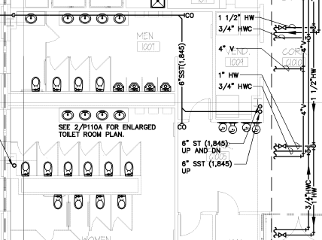
This is a section of the first floor plan area. You can see how there are multiple water lines, including potable hot water (HW) and potable hot water circulating (HWC). The sizes of the lines are also shown.
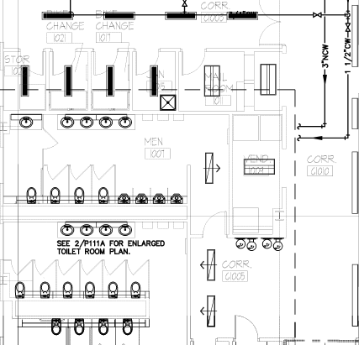
This is the first floor plan area of Alt. 17. You can see that instead of HW and HWC lines, NCW and CW lines are used. It can also be noted that the NCW line has a larger size; there are physically less pipelines running through that area than the first floor plan so it is possible to make it larger.

Budget:
For this project, we had a budget of $100 to spend. When we first scoped the project, we knew we would not need to use any of the budget because our project was mainly research based, and the data we needed could be obtained through contacting people and resources on campus. As expected, we did not need to use any of the budget allocated to us because there was no need for it.

