**Economic and Environmental Benefits** **of Implementing Low-Flow Toilets in UIUC Buildings**

Final Report

December 10, 2014

CEE 398 PBL

Written By: Qingjin (Jill) Fan, Kunal Patel, Jasmine Puthuvelil

**Executive Summary**

We believe that water is an abundantly used resource on campus that can be used more conservatively. We aimed to research how we could use sustainable technologies such as low-flow toilets in university buildings to reduce water consumption and to reap the most economic benefit. Our group researched two different types of low-flow toilets - ultra-low-flow and high-efficiency. As opposed to traditional toilets that use 3.4 gallons of water per flush and are still present in older buildings on campus, these low-flow toilets use less water and we tested our assumption that they provided environmental and economic benefits.

Our group’s objective was to quantify the economic and environmental benefits of low-flow toilets to determine if they could provide significant value to the University of Illinois. If so, we wanted to narrow down our options and decide which of the two toilets low-flow toilets would be most beneficial. We developed a dynamic spreadsheet analysis tool using Microsoft Excel that allowed a user to input the custom costs for different parameters of installing a low-flow toilet such as the cost of the toilet, cost of labor, cost of materials, and cost to dispose of the old toilet. We made our analysis tool specific to the University of Illinois by inputting specific water and labor costs for the university obtained from Facilities and Services. The analysis tool also took into account the amount of water used by toilets at different daily flush frequencies and calculated the payback period of installing a new low-flow toilet, the volumetric savings in water, and the economic savings in water.

Our final conclusion is that the university should immediately replace any traditional toilets with a daily flush frequency of 12 or higher with high-efficiency toilets. High-efficiency toilets result in higher water resource savings compared to ultra-low-flow toilets even though the payback periods are about the same. If traditional toilets were replaced under the condition we previously determined, the maximum payback period would be ten normal years, or 15 school years, and the minimum amount of water saved would be 6000 gallons per toilet per year, which is a minimum annual monetary savings of about $45 per toilet. Toilets with a daily flush frequency greater than 12 can save even more water and money. We can assume that there is a high proportion of traditional toilets on campus that are used much more than 12 times per day and by targeting these toilets for replacement, the university can save thousands, if not millions of gallons of a precious resource in a year, depending on the number of toilets that are replaced. We highly recommend that the University of Illinois invest in high-efficiency toilets because we were able to determine that they can save the university a significant amount of money and water resources, which would also increase the sustainability of the campus.

**Table of Contents**

**Introduction and Background** 4

**Project Objectives** 5

**Methodology** 6

**Task 1 – Categorization of Daily Flush Frequencies** 6

**Task 2 – Formulation of Installation and Operations Cost Functions** 7

**Task 3 – Comparison of Cost Functions** 7

**Task 4 – Development of Analysis Tool to Calculate Economic and Environmental Benefits** 8

**Results and Discussion** 9

**Formulation of Cost Functions for Comparison** 9

**Payback Period and Water Savings Analysis** 12

**Conclusion** 16

**Reflections** 16

**References** 18

**Appendix A: Dynamic Spreadsheet Analysis Tool for High-Efficiency Toilet** 20

**Appendix B: Dynamic Spreadsheet Analysis Tool for Ultra-Low-Flow Toilet** 21

**Budget** 22

# **Introduction and Background**

College campuses are increasing their initiatives to implement more sustainable practices. The University of Illinois is actively working to meet its goal to reduce its carbon footprint and energy consumption by 20 percent by 2015. Furthermore, the university has invested over $100 million in programs to increase sustainability and reduce resource consumption by renovating and retrofitting existing university buildings with sustainable programs and technologies. (Green Honor Roll, 2014)

One sustainability program the university is using is Leadership in Energy and Environmental Design (LEED), which establishes criteria to define how a project can be sustainably designed, constructed, operated, and maintained, and awards a certification status to projects that meet these criteria. The University of Illinois adopted the LEED standard for the construction of new projects and renovations of over $5 million for existing buildings on campus. (Office of Sustainability | Illinois, 2014) The principles of the LEED program involve utilizing sustainable technologies, which use less energy and resources and also reduce maintenance and operations costs, to develop more efficient systems for many different parts of a building.

However, our group believes that it may be more advantageous to analyze specific frequently used systems of a building to replace or retrofit with sustainable technologies in order to reduce the costs of maintenance and operation for the university. In doing so, we could calculate how much money and resources the University of Illinois could save due to the economies of scale that arise from implementing sustainable technologies in frequently-used buildings systems without having to completely replace or retrofit systems that do not have as significant economic impact on increasing sustainability.

The University of Illinois attempted to target reducing water consumption in its buildings, without seeking LEED certification in early to mid-2014. It launched an initiative to reduce the amount of water used in restrooms across campus by installing 2,500 faucet aerators and 120 water-saving urinals, which are sustainable technologies that reduce indoor water consumption. (Install Low Flow Fixtures throughout Campus, 2014)

However, this initiative did not provide specific details about the actions taken to reduce water consumption due to flushing toilets, even though this often account for the greatest indoor water usage on campuses. Studies conducted by Indiana University, Vanderbilt University and UC Berkeley corroborate this fact and more evidence can be found in the sustainability initiatives resources for many other universities in the United States. At Indiana University, researchers conducted a national survey that asked Americans what the best strategies to conserve water were. About 43 percent of respondents answered that taking shorter showers would be the best way to conserve water. However, the researchers conducted another study that found that the water used to flush toilets accounted for the highest daily use of water almost always because of the high frequency of toilet flushes in homes, which can translate to university residence halls and other buildings. (IU Bloomington Newsroom, 2014) In 2007, Vanderbilt University launched an initiative to reduce water consumption in its facilities by retrofitting its bathrooms with low-flow toilets, low-flow faucets, and water-free urinals and were able to save 50 million gallons of the nearly 800 million gallons of water it uses annually. The university stated that flushing traditional 3.4 gallon per flush (gpf) toilets were usually the largest consumer of water in its facilities. (Water Conservation on Campus, 2014) In states that have experienced significant droughts such as California, institutions such as the University of California at Berkeley performed water audits to decide how to reduce water usage on campus. UC Berkeley found that 67 percent of the water used in restrooms on its campus went towards flushing toilets alone, consuming almost 100 million gallons of water during a school year. (Zhang, 2010) One of the actions that the university took to reduce its water consumption was to replace 75 percent of its traditional toilets that were not in residence halls to low-flow toilets, saving about 25 million gallons of water annually. (Zhang, 2010)

The United States Federal Government passed the Energy Policy Act of 1992, which mandated that all residential toilets manufactured after 1994 could only use a maximum of 1.6 gallons per flush (gpf). (10 Years After Low-Flow Toilet Regulations, 2004). Toilets installed in residential buildings prior to 1994 did not have to be replaced to meet Energy Policy Act standards, older university buildings, such as the Illinois Street Residence Hall, still use traditional 3.0 to 3.4 gpf toilets, according to University of Illinois Facilities and Services. (Install Low Flow Fixtures throughout Campus, 2014) It therefore makes sense to research if and how the University of Illinois can reduce the amount of water it uses for flushing toilets in its buildings and facilities.

We think that replacing existing toilets that use about 3.4 gpf in university buildings with low-flow toilets can save the University of Illinois money and water resources. A low-flow toilet is commonly used in LEED projects to obtain credits for the Indoor Water Use Reduction category because of it uses less water than traditional toilets. (Indoor Water Use Reduction, 2014) There are two types of low-flow toilets: high-efficiency toilets and ultra-low-flow toilets. Ultra-low-flow toilets come in both single-flush and dual-flush models. A single-flush high-efficiency toilet uses about 1.28 gallons of water or less per flush. (Toilets, 2014) An ultra-low-flow toilet uses about 1.6 gpf. High-efficiency toilets and ultra-low-flow toilets use about 60 and 50 percent less water per flush than a traditional toilet, respectively, which uses 3.4 gpf. A dual-flush high-efficiency toilet can use 0.8 gpf in one flush for liquid waste or 1.6 gpf in two flushes for solid waste. (Toilets, 2014)

We see a clear opportunity to evaluate the potential reduction in water consumption and cost by analyzing the economic and environmental benefits of implementing low-flow toilets on campus. The use of low-flow toilets has been studied by other universities and has been mandated by the federal government for all new toilet installations. Therefore, this proposal explains how our group will conduct analyses to aid the University of Illinois in developing a policy that will allow it to determine whether it should replace a traditional toilet with a low-flow toilet, the type of low-flow toilet it should use, the amount of water that will be saved when the toilet is replaced, and the payback period for the low-flow toilet.

# **Project Objectives**

The objective of our project was to develop an analysis tool to help the University of Illinois determine when it is environmentally and economically effective to replace a traditional toilet with a low-flow toilet in its buildings and how much money and resources it could save. We aimed to find a relationship between the amount of times a traditional toilet is flushed and the payback period of replacing that toilet with a low-flow toilet. In addition, our group wanted to estimate the amount of water that would be saved if a traditional toilet was replaced with a low-flow toilet. We considered two types of low-flow toilets, the ultra-low-flow and high-efficiency, in our analysis to determine which one is a better investment. Our goal was to quantify the economic and environmental benefits of implementing low-flow toilets in university buildings to enable the university to make policy decisions about increasing sustainability through reduced water consumption. We believe that by targeting to reduce the consumption of water in buildings with a high frequency of toilet usage, rather than just replacing all traditional toilet fixtures on campus, we can help the University of Illinois make intelligent investments in low-flow toilet fixtures that will promote sustainability on campus by reducing resource consumption.

# **Methodology**

We divided our project into four main tasks. These tasks were developed to help us translate daily flush frequencies for different toilets throughout campus into quantitative economic savings and environmental benefits if these toilets were replaced with different kinds of low-flow toilets. Task 1 was used to help our group stratify the range of daily flush frequencies for toilets across campus intro three categories. We used these categories in conjunction with our analysis tool in Task 4 to determine which categories of toilets based on daily flush frequency should be replaced with low-flow toilets based on the economic and environmental benefits we calculated. Tasks 2 and 3 were used to formulate and compare the cost functions for the traditional toilet, ultra-low-flow toilet, and high-efficiency toilet. These tasks helped our group determine the equivalent number of flushes that would equate operation of a traditional toilet to the installation and operations cost of the low-flow toilets. This helped us determine which type of toilet would have the lowest cost for different ranges of total flushes over the toilet’s lifespan.

## **Task 1 – Categorization of Daily Flush Frequencies**

The purpose of Task 1 was to categorize the daily frequencies of toilet usage for traditional toilets into high, medium, and low categories of flush frequencies. By categorizing the daily flush frequencies into three different ranges we accounted for the variance in the usage of different toilets in different buildings throughout campus. We determined high, medium, and low categorical ranges for the frequency of toilet flushes based on reasonable assumptions of how many people occupy a building and could potentially utilize restroom facilities throughout the day. Our low, medium, and high categories, were 0 to 5, 6 to 15, and 16 to 50 flushes per day, respectively. These ranges in each category are arbitrary and were only meant to be used to stratify the data to make analysis easier for our group. We also developed these categories to avoid having to exert a lot of time and effort in measuring flush frequencies in various buildings and so that we would have more time to perform analyses on theoretical data.

We calculated the average flush frequency for each category so that we could input these averages into our analysis tool in Task 4 to calculate the average economic and environmental benefits associated with each category. These averages were only rough estimates of the total benefits derived by the low-flow toilets in each category because we relied on a linear relationship to describe all of our data, but obtained a non-linear function for our payback period. The results of our calculations are provided in the *Results and Discussion* section.

The end result of this task yielded the below Figure 1, where the frequency of daily flushes is on the x-axis and the categories are discriminated by color. The calculated averages for the low, medium, and high flush frequency categories were 2.5, 10.5, and 33, respectively. However, we used whole number averages for our calculations to provide realistic estimates because we were not considering fractions of flushes. Our new adjusted averages are 3, 11, and 33 flushes for the low, medium, and high categories, respectively.

|  |  |  |  |  |  |  |  |  |  |
| --- | --- | --- | --- | --- | --- | --- | --- | --- | --- |
|  | **Figure 1.** Daily Flush Frequency Categorization Model  00  10  20  30  40  50  Frequency of Daily Flushes for One Traditional Toilet  Medium  Low  High |  |  |  |  |  |  |  |  |
| |  | | --- | |  | |  |  |  |  |  |  |  |  |  |
|  |  |  |  |  |  |  |  |  |  |
|  |  |  |  |  |  |  |  |  |  |
|  |  |  |  |  |  |  |  |  |  |
|  |  |  |  |  |  |  |  |  |  |
|  |  |  |  |  |  |  |  |  |  |

## **Task 2 – Formulation of Installation and Operations Cost Functions**

The purpose of this task was to determine the cost functions for different kinds of toilets we were analyzing. The cost function for each type of toilet was broken into two individual cost functions: operations and installation. The operations cost is dependent on the flush frequency because we assumed that a toilet that was not flushed would not incur a cost because there was no water being used. The operations cost would therefore be a linear function because as the number of flushes increases, the cost also increases. The second cost is the installation cost. This is a one-time fixed cost because once a toilet is installed, it no longer incurs the installation cost. We assumed that the entirety of the installation cost is paid off at the beginning of a new toilet’s installation. The cost function for the traditional toilet only consisted of the operations cost of flushing the toilet because it was already in place and we wanted to replace it with a low-flow toilet. The cost function for the two types of low-flow toilets depends on both the installation and operations costs because we are implementing new toilets.

We defined the cost of installation for a new low-flow toilet as the cost of the new low-flow toilet fixture, the cost of materials, equipment, and labor, and the cost of removing the old traditional toilet fixture. The cost of daily operation was the cost of the water that is used to flush the toilet and the cost of treating the flushed water, both of which depended on the frequency of the toilet usage. Our group coordinated with University of Illinois Facilities and Services to obtain information regarding the types of toilets installed in current buildings, the cost of a gallon of water for the university, the cost of a contractor and/or labor rates for plumbing services, and the cost to the university for sending the water used to flush toilets to wastewater treatment facilities. This information allowed us to make realistic estimates of how much the university would have to pay to install low-flow toilets in its buildings.

## **Task 3 – Comparison of Cost Functions**

The purpose of this task was to determine the number of total flushes that will equate the cost function of the two types of low-flow toilet to cost function of a traditional toilet. We believed this was important to calculate because it represented the point at which the cost of both the low-flow toilet and traditional toilet were the same, indicating the number of flushes that must occur for the university to receive an economic benefit for installing a low-flow toilet. We plotted the linear cost functions for each type of toilet in a graph where the x-axis represented the total number of flushes and the y-axis represented the total cost and found where the traditional toilet cost function intersected the ultra-low-flow toilet and high-efficiency toilet cost functions. We expected that our graph would show that the low-flow toilets would cost less money after a large amount of flushes because the cost of water saved would make up for the initial installation costs.

The results of this task are provided in the *Results and Discussion* section. We provided the formula for each cost function, the plot of the cost functions, intersection points for the different kinds of toilets, and the ranges of total flushes where each type of toilet has the lowest absolute cost compared to the other two toilets.

## **Task 4 – Development of Analysis Tool to Calculate Economic and Environmental Benefits**

The purpose of this task was to develop our analysis tool to calculate the economic and environmental benefits of installing low-flow toilets. We developed this tool by performing calculations on a range of daily flush frequencies from 0 to 75 flushes based on cost information obtained in Task 2 and organized it into a dynamic spreadsheet. We determined an equation for payback period by dividing the cost of installation of the two types of low-flow toilets by the difference in cost of flushing a traditional toilet and each type of low-flow toilet at different daily flush frequencies. The equation is as follows.

$$Payback Period=\frac{\text{(cost of installing low-flow toilet})}{\text{(}\text{cost of flushing traditional toilet – cost of flushing low-flow toilet)} \text{×}\text{ flush frequency}}$$

We also quantified the theoretical volume and cost of water that was saved due to the operation of low-flow toilets. From our analysis tool, we obtained functions that relate the frequency of daily flushes to the payback period and to the savings in water resources. We found payback periods for both a normal year with 365 days and a typical school year, which has about 250 days. This additional step made our findings more relevant to the University of Illinois because we accounted for a drastic decrease in the student, faculty, and staff population during winter and summer breaks, which we knew would impact daily toilet usage.

We performed our calculations using Microsoft Excel. We created a dynamic spreadsheet that calculated costs, volumes, payback periods, etc. based on the parameters and frequencies of daily flushes that we input. These parameters can be varied based on the cost of resources to an organization to allow different users to enter custom information that pertains to them. We used the parameters of our dynamic spreadsheet to create graphs that represent the relationships between inputs and different calculated outputs. We included the dynamic spreadsheets for high-efficiency and ultra-low-flow toilets as *Appendices A* and *B*, respectively, and graphs representing the frequency of daily flushes versus the payback periods and savings in water resources. The findings of this task are provided in the *Results and Discussion* section.

# **Results and Discussion**

## **Formulation of Cost Functions for Comparison**

Facilities and Services provided us with the cost of labor to install a new low-flow toilet, which is about $200, and the costs to deliver and provide sanitary treatment for 1000 gallons of water, which are $3.70 and $3.16, respectively, for a total of $6.86 per 1000 gallons for 2014-2015. ("UIUC FY15 Utility Budget and Rate Approval.") The estimated cost of a gallon of water would therefore be $6.86 divided by 1000 gallons, or $0.00686 per gallon. We assumed that the cost of water would remain the same for the next 200 years in our calculations for simplicity and because we do not have any other future expected costs of water. This will provide some inaccuracy in our calculations, but we believe that our analysis tool is still useful and can be manually adjusted for changes in prices and inflation later.

We calculated the total cost of installing each kind of low-flow toilet. The total costs included a $100 adjustment on top of the costs we found for each type of toilet in the case installation complications such as discrepancies in proper piping alignments or additional labor hours were required. We expected the cost of installing a new ultra-low-flow toilet for commercial use to be $550. The breakdown was $200 for the cost of a new ultra-low-flow toilet fixture, $200 for the cost of labor (Facilities and Services’ valuation), $25 for the cost of materials related to installation, and $25 for removal of the existing traditional toilet. We estimated this number by using a cost calculator from a website that provides cost information for various home improvement services and fixtures based on geographical location. ("Cost to Replace a Toilet.") We also expected the cost of installation for a commercial grade high-efficiency toilet to be $650. The breakdown was $300 for the cost of a new ultra-low-flow toilet fixture, $200 for the cost of labor (Facilities and Services’ valuation), $25 for the cost of materials related to installation, and $25 for removal of the existing traditional toilet, which we also estimated by using an online cost calculator. ("Homewyse Calculator: High Efficiency Toilet Prices, Options and Installation Costs.") These costs represented contractor grade low-flow toilet fixtures for commercial use and can be changed if necessary by inputting values specific to different locations.

We developed the cost functions for each type of toilet. For the traditional toilet, the cost function was just the cost of water times the gallons of water used per flush times the number of flushes. For the high-efficiency and ultra-low-flow toilets, the cost functions were the cost of installation plus the cost of water times the gallons of water used per flush times the number of flushes. These are the cost functions and Figure 2 shows the graphical representations of the functions.

$$Traditional Toilet: y=\frac{\$0.00686}{gallon of water}*\frac{3.4 gallons of water}{flush}*x$$

$$High-Effieciency Toilet: y=\$650+\frac{\$0.00686}{gallon of water}*\frac{1.28 gallons of water}{flush}*x$$

$$Ultra-Low-Flow Toilet: y=\$550+\frac{\$0.00686}{gallon of water}*\frac{1.6 gallons of water}{flush}*x$$

$$where x is the total number of flushes and y is the total cost$$

By equating the cost functions of the low-flow toilets and the traditional toilet, we obtained the minimum number of flushes required to receive positive economic return. For the ultra-low-flow and traditional toilets, we equated the cost functions and found that at least 44,542 total flushes were needed to receive economic gain. For the high-efficiency and traditional toilets, we equated the cost functions and found that at least 44,694 total flushes were needed to receive economic gain. The time period in which these minimum number of flushes is reached is considered the payback period of the investment. Toilets that are flushed more frequently in a day will achieve these total flushes counts faster and have shorter payback periods than toilets that are flushed less frequently. The full analysis of payback period is discussed later on. A graphical representation of the cost functions is shown below. The intersection points in the graph determined where the cost of a traditional toilet (water cost) matches the total cost (water and installation costs) for an ultra-low-flow and a high-efficiency toilet.

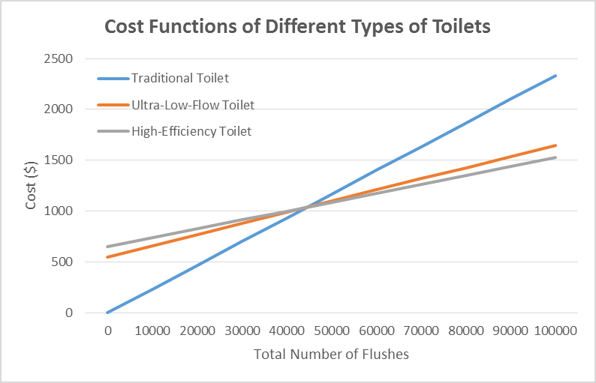

**Figure 2.** The cost function graph for different types of toilets. Traditional toilets have a lower cost for a lower total number of flushes, but low-flow toilets are less costly in the long-run, especially the high-efficiency toilets.

Using our equation for the payback period equation and analysis tool for the daily flush frequency category averages of 3, 11, and 33, we obtained rough estimates for the payback periods, volumetric and economic savings in water resources for ultra-low-flow and high-efficiency toilets. Table 1 shows our findings for these categories. Figures 3 and 4 show the volumetric and economic savings in water, respectively for ultra-low-flow and high-efficiency toilets. Our results show that the high-efficiency toilet saves more money and more water overall compared to the ultra-low-flow toilet. In the low category, there is a small difference in the volumetric and economic water savings. However, as the daily flush frequency categories increase, the difference in savings between the two types of toilets becomes larger, showing that the high-efficiency toilet is more economically and environmentally viable than the ultra-low-flow toilet.

We found the payback periods for our categories in both normal and school years. For an ultra-low-flow toilet, these values were 59.4, 16.2, and 5.4 school years for the low, medium, and high categories, respectively. Likewise, for a high-efficiency toilet, the payback periods were 59.6, 19.9, and 5.1 school years for the low, medium, and high categories, respectively. These were just values that we calculated based on our arbitrary category assignments. Additionally, we calculated payback periods for a large range of daily flush frequencies using our dynamic spreadsheet analysis tool.

**Table 1.** Comparison of low-flow toilet statistics for different categories of daily flush frequency.

|  |  |  |  |  |  |
| --- | --- | --- | --- | --- | --- |
| Type of Low-Flow Toilet | Category of Daily Flush Frequency | Payback Period (Normal Years) | Payback Period (School Years) | Volumetric Savings in Water for School Year (Gallons) | Economic Savings in Water |
| Ultra-Low Flow | Low | 40.677 | 59.389 | 1350 | $9.26 |
| Ultra-Low Flow | Medium | 11.094 | 16.197 | 4950 | $33.96 |
| Ultra-Low Flow | High | 3.698 | 5.399 | 14850 | $101.87 |
| High-Efficiency | Low | 40.789 | 59.593 | 1590 | $10.91 |
| High-Efficiency | Medium | 13.606 | 19.864 | 5830 | $38.99 |
| High-Efficiency | High | 3.499 | 5.108 | 17490 | $119.98 |

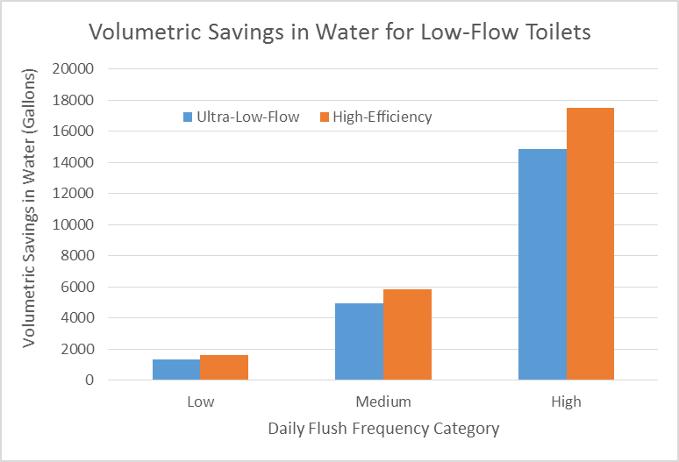

**Figure 3.** The comparison of the volumetric savings in water for the two different types of low-flow toilets. High-efficiency toilets save more water in each category and the difference in volume of water saved increases as the daily flush frequency increases.

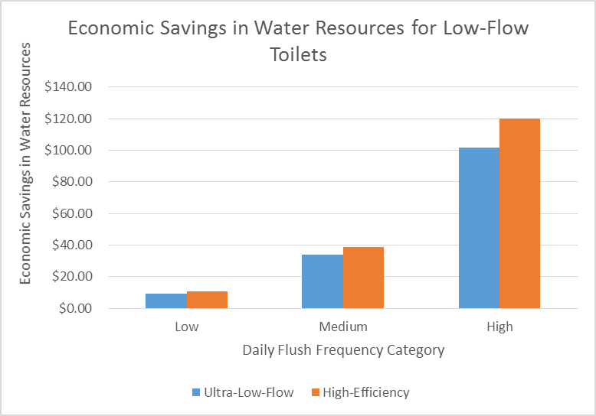

**Figure 4.** The economic savings in water resources for different daily flush frequency categories. High-efficiency toilets save more money in water resources in each category and the difference in volume of water saved increases as the daily flush frequency increases.

## **Payback Period and Water Savings Analysis**

We determined how the daily flush frequency of toilets affected the payback period and water savings of newly-installed low-flow toilets. Our analysis confirmed our expectation that the amount of water saved is linearly proportional to the daily flush frequency. Therefore, as the daily flush frequency increases, the amount of water and money saved also increases. This is displayed as a linear trend in Figure 8.

In addition, we found that the payback period decreased as the daily flush frequency increased, forming an inverse relationship. We expected this inverse trend because we were able to reach the total number of flushes necessary to break even in a shorter period of time with a higher daily flush frequency. We compared the payback periods for both types of low-flow toilets in normal years and in school years. The graphs for each type of low flow toilet are represented in Figures 5 and 6, below. The payback period in normal years is shorter than that in school years because a normal year is longer, allowing the break-even point to be reached faster. We compared the payback periods of ultra-low-flow and high-efficiency toilets and found no significant difference, as shown in Figure 7. The similarity in the payback periods can be accounted for by the fact that high-efficiency toilets use less water than ultra-low-flow toilets, which makes up for their higher installation costs. The functions for the payback periods are shown on the next page.

Therefore, based on our analysis tool, using a toilet with a daily flush frequency of at least 12 flushes would have a payback period of about ten normal years, or 15 school years. Replacing toilets that operate at this daily flush frequency seems reasonable because we can assume that we can commonly find these toilets in highly-occupied campus buildings such as residence halls and multipurpose buildings like the Illini Union. If the University of Illinois went through with replacing traditional toilets that met this criteria with high-efficiency toilets, then this would have the potential to save the university at least $45 in water cost and at least 6000 gallons of water per toilet annually. Considering that there are many toilets on campus, especially in places such as university residence halls, which may have a higher daily flush frequency than 12 flushes, the university could save thousands of dollars in water cost and several thousand to millions of gallons of water per year. The investment of implementing high-efficiency toilets is an intelligent economic and environmental decision because it reaffirms the university’s commitment to become more sustainable by reducing water consumption.

Payback Period Equations

Ultra-Low-Flow Toilet

$$Payback Period in Normal Years= \frac{\$550}{\left(\$0.023324-\$0.010976\right)×daily flush frequency}*\frac{1 year}{365.25 days}=\frac{121.95}{daily flush frequency}$$

$$Payback Period in School Years= \frac{\$550}{\left(\$0.023324-\$0.010976\right)×daily flush frequency}*\frac{1 year}{250 days}=\frac{178.17}{daily flush frequency}$$

High-Efficiency Toilet

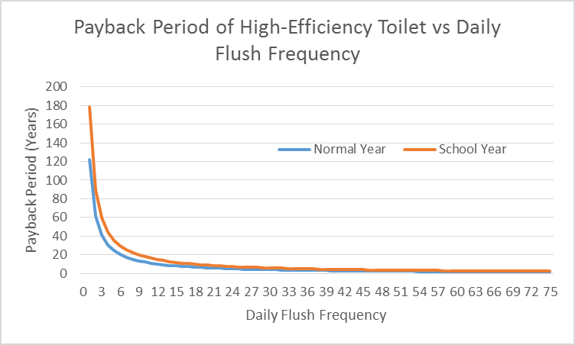

**Figure 6.** The payback period function for high-efficiency toilets based on daily flush frequency. Trend is the same as that of ultra-low-flow toilets.

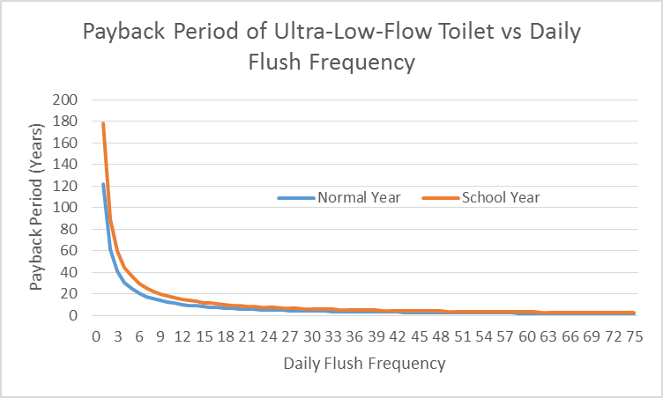

**Figure 5.** The payback period function for ultra-low-flow toilets based on daily flush frequency. There is a significant difference in the payback period in normal years and school years for lower daily flush frequencies, but as it increases, the payback periods become relatively small and the difference decreases.

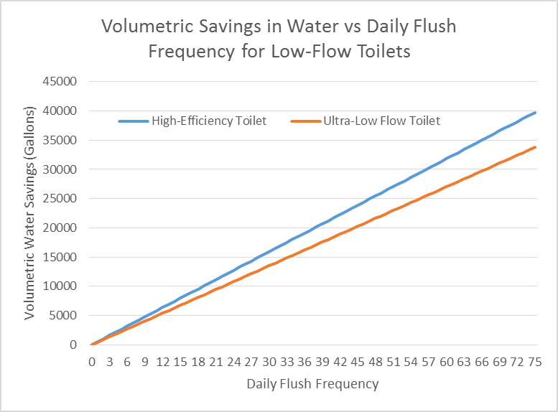

**Figure 8.** The volumetric savings in water functions for low-flow toilets based on daily flush frequency. The daily flush frequency and volumetric water savings are linearly proportional. The high-efficiency toilet saves more water compared the ultra-low-flow toilets because it uses less per flush.

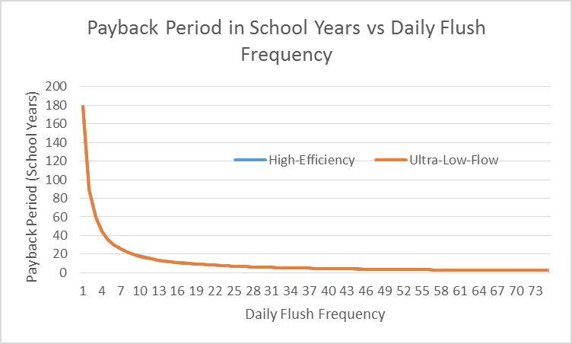

**Figure 7.** The payback period curves for ultra-low-flow toilets and high-efficiency toilets are nearly identical, showing that as daily flush frequency increases, the payback period initially decreases quickly and then more slowly and constantly.

# **Conclusion**

Low-flow toilets have the potential to save the University of Illinois money and water resources in a relatively short period of time. Using our payback period and volumetric and economic analysis, we found that replacing traditional toilets with this kind of sustainable technology should be done among areas with daily flush frequencies greater than 12 to maximize benefits. Potential areas to implement low-flow toilets include residence halls and highly populated zones such as the Illini Union. We also found that high-efficiency toilets, as opposed to ultra-low-flow toilets, are the best option for the university to go with because they have shorter payback periods. Although the initial one time installation cost for high-efficiency toilets are slightly more expensive, the payback period is smaller in populated areas.

This project shows that the University of Illinois can increase sustainability by implementing resources to reduce water consumption on campus. The minimum amount of water and money that can be saved per toilet replaced according to our recommended criteria is about 6000 gallons and $45 per toilet per year, which adds up to a large savings if the university replaces a lot of its older traditional toilets. We recommend that further action be taken based on the results of our analysis. We suggest that Facilities and Services take the initiative to estimate daily flush frequencies based on the current water usage of university buildings that have traditional toilets installed. Based on this initiative, Facilities and Services should determine which buildings that meet the criteria of toilets with a daily flush frequency greater than or equal to 12 so that they can replace the traditional toilets with high-efficiency toilets and calculate the costs and benefits using our analysis tool.

# **Reflections**

Our group has gained a lot of beneficial experience from developing analysis tools to measure the economic and environmental benefits of replacing existing toilets with the low-flow toilets. We researched two different kinds of low-flow toilets, developed customizable analysis tools to compare the two kinds of toilets to each other, and decided which kind of toilet is more economically and environmentally beneficial to be installed at the University of Illinois. This process showed how we were able to rely on skills we learned in mathematics, science, and economics classes to undergo a project that has results that can make an impact on campus. Our project illustrated the potential to save money and water resources by implementing a low-flow toilet for locations that met a certain requirement that we set.

Our project relied on analyzing benefits based on a range of data by making reasonable assumptions instead of collecting physical data about the parameters we were interested in. We were able to structure the parameters into a dynamic spreadsheet analysis tool, which helped us meet our goal of quantifying the economic and environmental benefits associated with implementing low-flow toilets. Our customizable analysis tool could also make it easy for others to obtain results based on their own input parameters. We wanted our analysis tool to be used by other people and organizations to calculate how much water could actually be saved by implementing low-flow toilets because water is a very valuable resource, even though it can be obtained for fractions of a cent. It is important to understand that the demand for water will increase as the global population increases and that we must take measures now to reduce consumption.

If we were to do this project again, in order to enhance the credibility, we would work more closely with Facilities and Services to obtain information about the total number of traditional toilets on campus, so that we could determine how many should be replaced, where they should be replaced, and what the total savings would be. It was difficult for our group to determine how many traditional toilets there were on campus in one semester because this sort of information may not be immediately available from Facilities and Services. However, this motivated us to develop functions that could quickly and accurately be used to measure benefits for a large range of toilets with different daily flush frequencies.

**Acknowledgements**

We would like to thank the instructors of CEE 398 for their help on this project. Specifically, we would like to thank Professor Lance Schideman of the Agricultural and Biological Engineering Department for helping us come to the final conclusion to develop an analysis tool for our project. We would also like to Morgan Johnston for providing us with information and a line of communication with Facilities and Services. We would like to thank Professor Jeffery Roesler and Professor Arthur Schmidt of the Civil and Environmental Engineering Department for providing feedback for our Milestone submissions, which helped us formulate our methods better. We would also like to thank Paul Littleton and Alec Heilstedt of the Civil and Environmental Engineering Department for providing comments and reviewing our draft submissions. We would like to thank Professor Mary Hays of the English Department for providing writing advice.

# **References**

"10 Years After Low-Flow Toilet Regulations Went Into Effect, Plumbing Innovations Make Major Inroads in Efficiency, Flushability." *American Standard*. N.p., 27 Apr. 2004. Web. 15 Oct. 2014.

<http://www.americanstandard-us.com/pressroom/10-years-after-low-flow-toilet-regulations-went-into-effect- plumbing-innovations-make-major-inroads-in-efficiency-flushability/.>

"Champaign, IL Real Estate." *Coldwell Banker*. N.p., n.d. Web. 23 Oct. 2014.

<http://www.coldwellbanker.com/real_estate/home_search/IL/Champaign>.

"Cost to Replace a Toilet." *Homewyse*. N.p., Jan. 2014. Web. 23 Oct. 2014.

<http://www.homewyse.com/services/cost_to_replace_toilet.html>.

"ECE Illinois." *The Building Campaign For ECE Illinois Frequently Asked Questions Comments*. N.p., n.d. Web. 15 Oct. 2014. <http://buildingcampaign.ece.illinois.edu/faqs/>.

"Green Honor Roll." *The Princeton Review*. N.p., n.d. Web. 15 Oct. 2014. <http://www.princetonreview.com/green-honor-roll.aspx>.

"Homewyse Calculator: High Efficiency Toilet Prices, Options and Installation Costs." *Homewyse*. N.p., n.d. Web. 23 Oct. 2014.

<http://www.homewyse.com/costs/cost_of_high_efficiency_toilets.html>.

"Indoor Water Use Reduction." *LEED*. N.p., n.d. Web. 15 Oct. 2014.

<http://www.usgbc.org/credits/data-centers-existing-buildings/v4-draft/wec2>.

"Install Low Flow Fixtures throughout Campus." *Icap portal|University of Illinois*. N.p., n.d. Web. 15 Oct. 2014.

<http://icap.sustainability.illinois.edu/project/install-low-flow-fixtures-throughout-campus>.

"IU Bloomington Newsroom." *Indiana University Research: We Want to save Water, but Do We Know How?: IUB Newsroom: Indiana University*. N.p., n.d. Web. 15 Oct. 2014.

<http://news.indiana.edu/releases/iu/2014/03/water-efficiency-study.shtml>.

"Office of Sustainability | Illinois." *Institute for Sustainability, Energy and Environment.* N.p., n.d. Web. 15 Oct. 2014. <http://sustainability.illinois.edu/greenbuilding.html>.

“Toilets.” *Conserve H2O*. N.p., n.d. Web. 15 Oct. 2014.

<http://www.conserveh2o.org/toilet-water-use>.

"UIUC FY15 Utility Budget and Rate Approval." *Facilities and Services. University of Illinois*, n.d. Web. 4 Nov. 2014.

<http%3A%2F%2Ffs.illinois.edu%2Fdocs%2Fdefault-source%2FUtilities-Energy%2Ffy15-utility-budget-and-rate-approval.pdf%3Fsfvrsn%3D0>.

"Ultrasonic Flow Meters." *Clamp On*. N.p., n.d. Web. 23 Oct. 2014.

< http://www.rshydro.co.uk/ultrasonic-flowmeter.shtml>.

"Urbana, IL Real Estate." *Coldwell Banker*. N.p., n.d. Web. 23 Oct. 2014.

< http://www.coldwellbanker.com/real_estate/home_search/Illinois/Urbana>.

"Water Conservation on Campus." *Vanderbilt University*. N.p., n.d. Web. 15 Oct. 2014.

<http://www.vanderbilt.edu/sustainvu/what-we-do/water/water-conservation-on-campus/>.

Zhang, Joanna. *UC Berkeley Water Usage & Conservation Study Report* (n.d.): n. pag. Web. 15 Oct. 2014. <http://sustainability.berkeley.edu/sites/default/files/UC_BERKELEY_WATER_CONSERVATION_REPORT_CACS_2010.pdf>.

# **Appendix A: Dynamic Spreadsheet Analysis Tool for High-Efficiency Toilet**





# **Appendix B: Dynamic Spreadsheet Analysis Tool for Ultra-Low-Flow Toilet**





# **Budget**

Our group did not use any funds to complete our project. All of our procedure were completed using software and techniques already in our possession. Therefore, the sum of our expenses is $0.