**Arbor Day Celebration Plan**

MBJ 4/6/2015

**Arbor Day Celebration:** In support of achieving the Tree Campus USA designation for the University of Illinois at Urbana-Champaign through the Arbor Day Foundation, the Chancellor is proclaiming Friday April 24, 2015 as a day of celebration. An Arbor Day Celebration will occur on the Main Quad at 11:30, with the planting of a new tree near the Henry Administration Building. Please join Associate Chancellor Mike DeLorenzo for the reading of the proclamation and the tree planting.

**Location of the Event:** The tree location is circled in orange on the aerial image below. The area for the celebration is designated in orange as #8 on the map image below, in front of the Henry Administration Building.

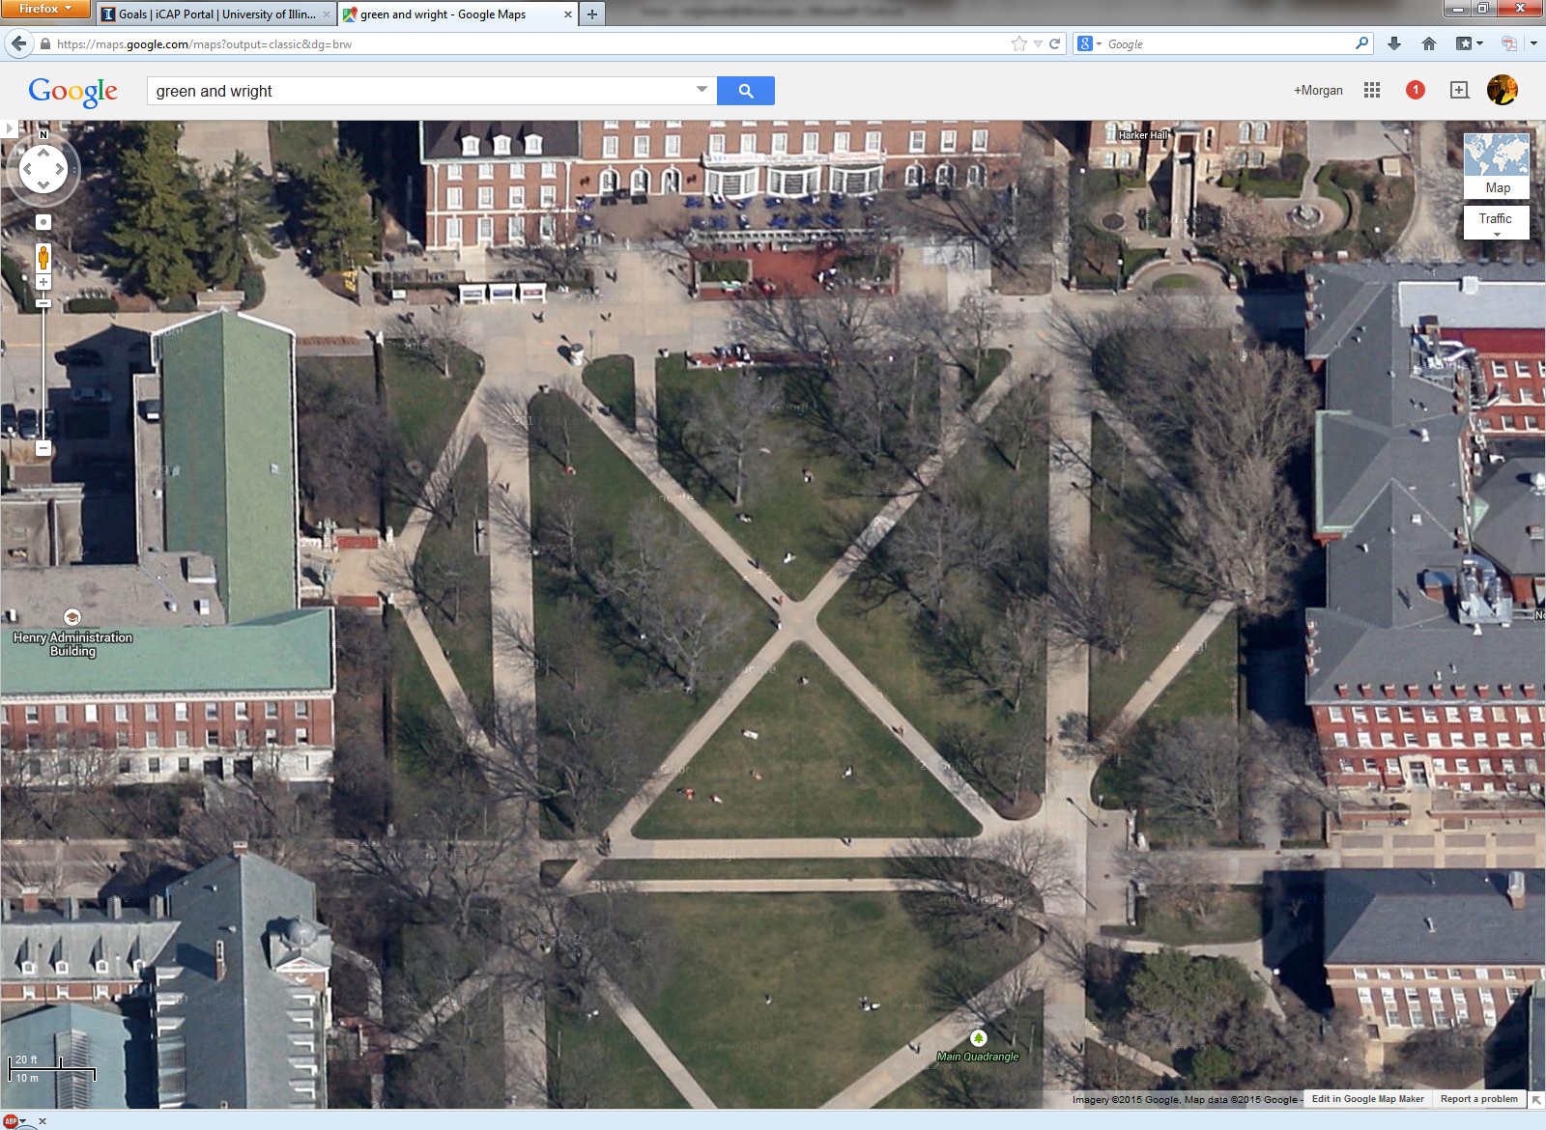 

8

**Schedule of the Celebration:** There will be a hole pre-dug for the tree on Friday morning. The hole will be fenced off to prevent the danger of falling. Everything for placing the tree (equipment, tree, soil) will be placed near the tree location by 11:15. A podium, sound system, and table for the trivia game will be in place and arranged by 11:15. The official event agenda will occur from 11:30-12:30. Take down of the event items will occur early afternoon.

**Agenda for the Celebration:** The agenda includes a welcome, proclamation, speech, tree planting, and trivia game.

* Welcome by Carl Wegel 5-10 minutes
* Proclamation by Mike DeLorenzo 5-10 minutes
* Speech about trees by Brent Lewis/Ryan Welch 10 minutes
* Placing of the tree into the hole by Grounds crew 15-30 minutes
* trivia game facilitated by volunteers with prizes (hopefully seedlings) during the tree placement and through remainder of the hour

**Publicity for the Celebration:** The event will be listed on the Earth Week calendar of events from SECS and iSEE. F&S will send out a press release and an e-week. F&S will ask Public Affairs to include the event on the Illinois homepage. Invitations will be sent to sustainability groups and appropriate academic departments. Al Stratman will invite people to the event, during the Earth Day master plan presentation.