**Zero Waste Game Day Project Final Report**

By Morgan Johnston – March 5, 2016

**Project purpose**

In working toward Zero Waste, behavior change is a key component and zero waste events are a very visible way to raise awareness about the goal. "Zero Waste" is a common term that refers to the desired outcome rather than any expectation. For this specific project the goal is to change to habits of fans, starting with a single basketball game. The game will be the university's first zero waste event and first participation in a national competition called RecycleMania. The desired outcome is for the State Farm Center to move from a single bin system to dual bin system, thereby changing the status quo. The new system will be accompanied with new signage for clarification. Volunteers will assist at the first event.

**Project summary**

On February 26th 2014 the University of Illinois at Urbana-Champaign participated in its first RecycleMania competition—a game day recycling event at the Illini/Nebraska basketball game. Over 100 volunteers came together to change the waste bin system at the State Farm Center into duel bin stations that included clear signage for landfill and recycling. Each station was staffed by at least one volunteer to educate the fans about proper disposal. In an effort to increase diversion levels, a student also collected all #5 plastic cups, material that is normally not recycled on campus. The game was a collaborative effort involving the Division of Intercollegiate Athletics, Institute for Sustainable Energy and Environment, the State Farm Center, and Facilities & Services.

After the game the volunteers captured all recyclable material from the seating area. Landfill and recycling was then each weighed to calculate a diversion rate. For this game the diversion rate was 31.5%. Data was entered into the RecycleMania database for comparison to other institutions, and the University of Illinois at Urbana-Champaign was ranked 19th of all the schools participating in the 2014 RecycleMania Game Day Challenge.

**Problems encountered**

One problem during the event day was that after the game the custodial staff was not available to collect the recycling bags. This was resolved through the dedication of the student volunteers. They stayed past their appointed time and completed the collections themselves.

Post-game feedback was collected from the volunteers. Thoughts included the following:

* Place pictures on the signs to more easily identify what goes in each bin
* Work more with the vendors to change the products they serve with food
* Change to process to include all plastics
* Composting would enable much better diversion numbers

The volunteers were happy to help out but wanted to do more. They were frustrated that more items couldn’t be recycled.

**Pictures of finished project**

Students were trained on how to manage the event:

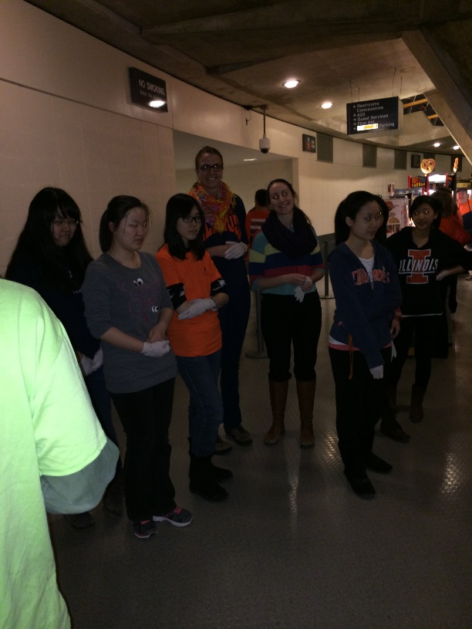 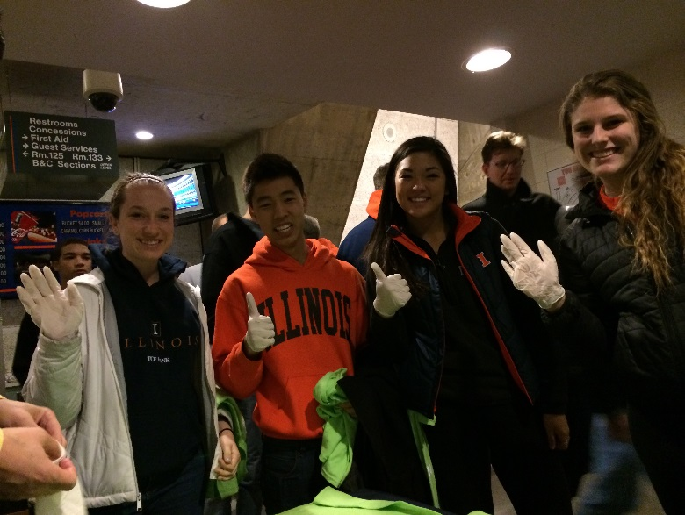

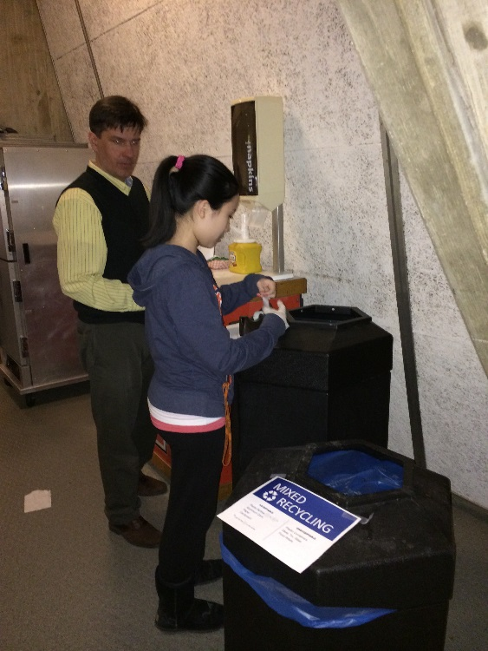 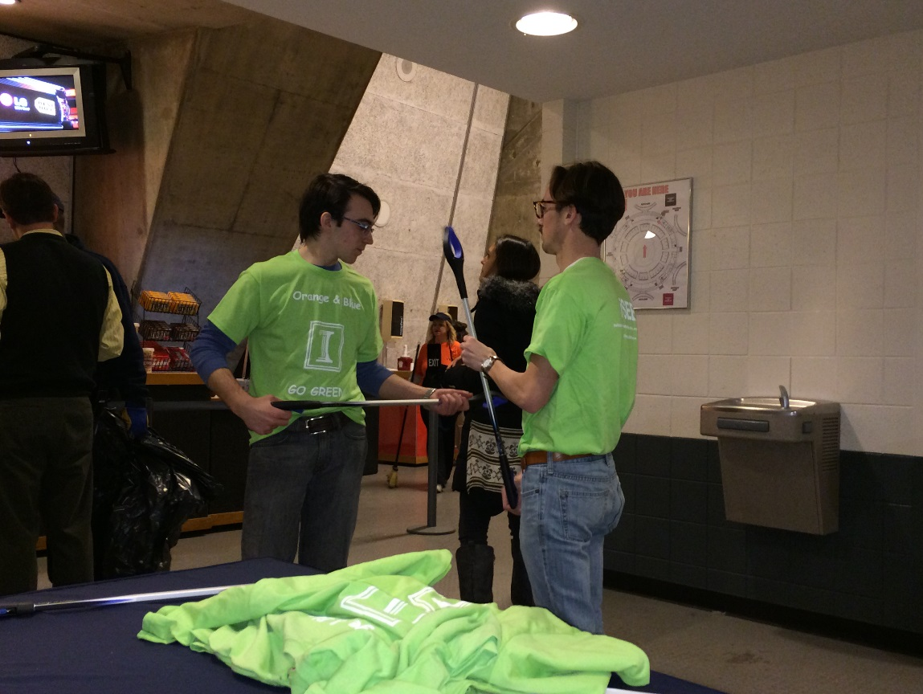

Volunteers stood at each collection point and helped sort the waste and recycling:

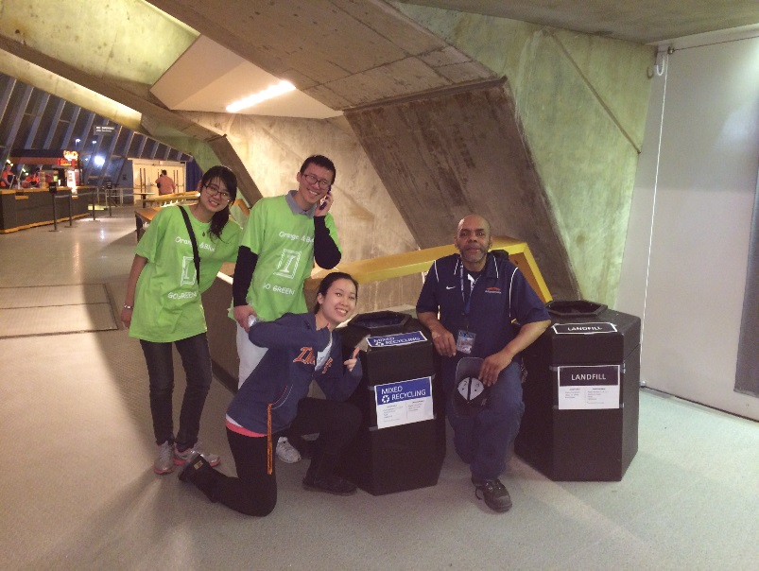 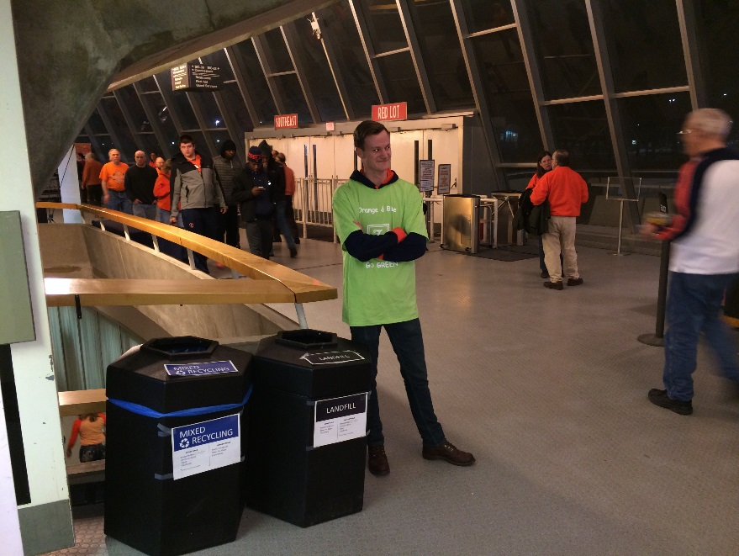

After the game, volunteers stayed to collect the waste into the recycling dumpster:

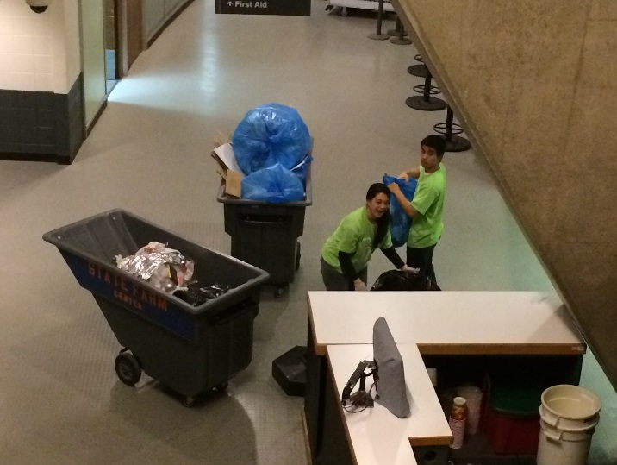 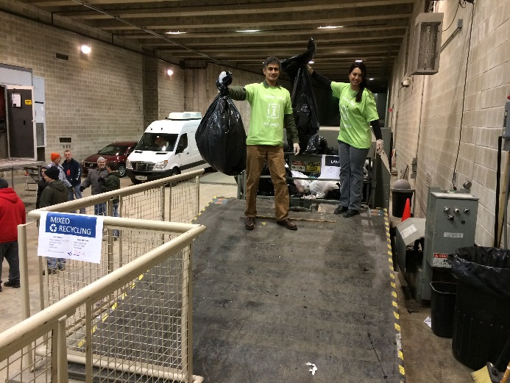

**A financial statement that lists how the funds were specifically utilized**



**Statistics on student involvement/outreach**

For this project the students play the role of educators. Students will stand near each dual-bin system to provide information to the fans about what can be recycled and why it is important. Students will also write articles and publicize the events, increasing the impact and bringing in more volunteers to the cause.

The students ran this event, undert eh guidance of Bart Bartels. They had the following responsibilities:

**FEBRUARY 25, 2014 at 2:00**

Game Day set up

To Do List

* Changes bins from single bins to duel bin systems. One set will be in each entrance – 10 on lower level and 24 on concourse level. Each condiment area will also be turned into a duel bin system-- custodians will provide the additional bins.
* Add signs to the Rebounder’s Club room and the Press Box
* Each recycling bin will have two signs taped to the sides and one to the top
* Each landfill bin will have two signs taped to the sides and one to the top
* Each recycling bin will have the bag replaced with a blue recycling bag
* Each wall sign will be replace with recyclemania signs

February 26, 2014 at 7:00 – half time

Game Day First Shift

* Report to west entrance, give name to the attendant for pass into the arena.
* Inside the west entrance, first 35 volunteers receive a shirt.
* Take a group picture
* Each volunteer takes one entrance (10 on lower level and 24 on concourse level)– assist fans to determine what can be recycled
* Extra volunteers help out in concession areas
* Assist custodians if they desire
* Help out through half time
* Have Fun!

Game Day Second Shift at half time – clean up

* Report to west entrance, give name to the attendant for pass into the arena
* Inside the west entrance, first 35 volunteers receive a shirt
* Take a group picture
* Each volunteer takes one entrance (10 on lower level and 24 on concourse level)- assist fans to determine what can be recycled
* Extra volunteers help out at the concessions
* Assist custodians if they desire
* After the game:
  + Walk through the entire arena and pick up anything that can be recycled
  + Take the signs off the bins and return to usual position
  + Replace wall signs
  + Take all blue bags to the recycling dumpster

There was a lot of publicity, as follows:

* Article in the Green Observer

<http://greenobservermagazine.com/phpsystem/outwithphp.php?q=532753f6f0f33bc17d>

* Information on the iSEE homepage
* UIUC Students for Environmental Concerns newsletter and Facebook page
* iSEE Facebook event
* Information on the F&S Homepage
* Student interviewed on WCIA Channel 3 News at the game
* Inside Illinois news briefs
* Posted on State Farm Center Promotional Sign
* Added to the State Farm Center script and stated during the game
* Article in the News-Gazette on 2.23.14

<http://www.news-gazette.com/living/2014-02-23/ui-take-part-national-competition.html>