How is linking done and what can be done with it?
Linking is a feature that allows you to tie one part of the PDF file to something else. There are two main types of linking, internal and external linking. Internal linking involves attaching one part of the PDF file to another part of the same file. In essence, it allows you to click on a part of the page which will automatically move you to another part of the document. It is especially useful in large documents with a lot of information. They can become cluttered and hard to find what you are looking for, but if you insert internal links, they can make navigation through the document much easier. For example, you could use them on the table of contents and then if you wanted to jump straight to any of the chapters, you could do so just by clicking on their name or page number. The other type of linking, external linking, acts in a similar way, but does not take you anywhere within the document itself. It will open up another window outside of the document that you are in, such as a website. This will also be used in our document to source other websites regarding bike safety, bike rules, and bike repairs. External linking allows things that will not necessarily be covered in the manual to still be referenced so that they are not completely overlooked. It just adds to the ease of finding information with this document that we are preparing.
Now how are these links added? In Adobe Acrobat Professional, you would select the Linking Tool (Adding Internal Links). It may be on one of the tool bars already, if not you can add it to one. If it is, I will look like the icon in the red box in the picture below.
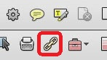
(Adobe Acrobat X Pro – Features)
Once you have opened the Linking Tool you use your cursor, which should have turned into crosshairs (Adding Internal Links), to draw a box around the area where you want the reader to be able to click to use the link. Then an options box will open up where you can either set the link within the document (Go to a page view), open another document on the computer (Open a file) or reference the URL of a website that you would like the link to open (Open a webpage).
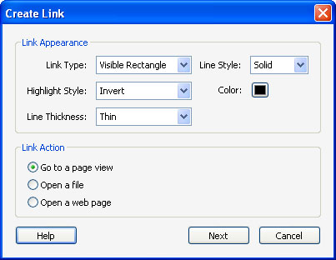
(PDFConverter.com - How to Link PDF)
This box also gives you the option to make the box you drew around the link to be visible or invisible, decide what color it is or change the line style. Then after you have exited out of the linking tool, you can use the link. The links can be set to either show the box that has the link or not. Using an invisible box can keep from making your document seem cluttered. Once you have made these selections another box will appear if you have chosen ‘Go to a page view’.
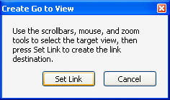
(PDFConverter.com - How to Link PDF)
This box will stay open as you navigate to where you want your link to go to within the document. Once you have your view in the document matching the view you want the link to end at, click ‘Set Link’ and the link will be ready to use as soon as you exit the linking tool.

