**Student Sustainability Committee**

Applying for the **2010 Governor's Sustainability Award**. Submitted on 5/28/10.

**Address**  
607 E. Peabody, Room 163  
Champaign, Illinois 61801

**Contact Information**  
Suhail Barot  
815-260-7961  
[sbarot@illinois.edu](mailto:sbarot@illinois.edu)

**Company Information**  
# of employees: NA  
Parent Co: University of Illinois  
Classification: Educational Institution

**Abstract:**  
The Student Sustainability Committee (SSC) is a sub-entity of the University of Illinois at Urbana-Champaign, with the primary purpose of bringing potential sustainable projects to fruition on the campus of UIUC. Students on the committee, advised by University administrators and faculty members, evaluate and select sustainable projects to fund through a comprehensive three-step project approval process. This approval process, which includes the Inquiry/Proposal/Approval steps, is open to everyone to encourage maximum . Through its selection process, the committee exercises its enormous potential in seeding and developing novel and innovative sustainable practices in construction, building and grounds management, and energy production.

Examples of SSC-aided landmark sustainability projects and initiatives at UIUC: • Photovoltaic array on top of the LEED-Platinum certified Business Instructional Facility, which produces 55,000 kWh of electricity per year. • 25 units of Thin Client computing devices to replace traditional energy-intensive desktop computers, which resulted in a 90% savings in consumed energy. This successful pilot project has resulted in the further expansion of the project for 200 additional units to continue the installation of these efficient devices. • The Solar Decathlon 2009 team from UIUC , which designed and built a 100% solar-powered and energy-efficient that won second place in the international competition in 2009. • A comprehensive overhaul of the water system at various recreational facilities at UIUC. This project is on track to reduce water consumption by 6.5 million gallons annually, which represents over half of the current annual consumption of around 13 million gallons.

# Governor’s Sustainability Award App: Student Sustainability Committee

# How did the Student Sustainability Committee form?

In 2003, an organization of dedicated and passionate students took the first step towards creating a more sustainable campus for the University of Illinois at Urbana-Champaign (UIUC). By successfully crafting a student referendum to create a $2 Cleaner Energy Technologies Fee, the campus began to generate $170,000 annually towards renewable energy and energy efficiency initiatives. The Energy Sub-Committee (ESC) of the Committee on a Sustainable Campus Environment, was formed with the mission to bring the operations of the campus buildings and grounds more in line with accepted principles of sustainability. In 2007, the same student organization, through the use of another student referendum, created the $5 Sustainable Campus Environment Fee. While the original Clean Energy fee focused mainly upon facilitating and funding projects dealing with sustainable energy, the passage of the new fee created an expansion into all areas of sustainable initiatives. With an expanded mandate and range of sustainable projects it could fund, the ESC was transformed into the Student Sustainability Committee (SSC). In 2010, another student referendum raised the Sustainable Campus fee from $5 to $14, expanding the annual funding potential of the SSC to more than $1 million, and greatly increasing the ability of the SSC to nurture and create long-lasting change on the UIUC campus. A survey of similar initiatives at Universities across the US indicated that UIUC had the largest such student funding program in the country.

# What is our purpose?

The main purpose of the SSC is to encourage and facilitate sustainable initiatives on the UIUC campus. As an independent and objective entity at the University, we accomplish this by selectively funding proposals on sustainable projects or initiatives, over a broad spectrum of sustainability issues. These issues encompass, but are not limited to, energy generation, energy efficiency, water conservation, ecological restoration, and sustainable transportation. We actively seek out and encourage the development of non-traditional sustainable projects on the campus, such as projects dealing with the installation of permeable pavement, green roofs, or prairie restorations.

## The main operation method of the SSC can be broken down into three stages:

### Inquiry

The Inquiry stage begins with the submission of a Letter of Inquiry. All projects that are interested in having the SSC fund its proposal must begin the funding process by submitting a 1-2 page letter, with a basic layout of the rationale of the project, and what it hopes to accomplish. For this stage, the members of the SSC will meet several times to discuss the merits of each plan, and decide on whether it seems feasible and realistic enough to merit the submission of a full proposal. Examples of criterion that we base our judgment are impact on sustainability (through metrics such as energy use and carbon emissions reductions, etc), technical and logistical feasibility, innovativeness, availability of external funding sources, and scalability.

### Proposal

The Proposal stage is by invitation only, for projects which pass the evaluation in the initial Inquiry step. Project leaders are encouraged to submit a full proposal to the SSC, which will then be evaluated and voted on by the committee. Proposals are separated into two types: Loans and Grants. The SSC’s direct involvement in the projects is strongest at this stage, as committee members offer potential modifications to the proposals to try and maximize the sustainability benefits that will emerge from the project. When modifications and discussions end, the committee will vote on the projects that it will fund with its annual budget.

### Approval

The Approval stage begins when a project is offered funding from the SSC. Committee members are assigned projects to track, and they routinely communicate with the project leaders to track progress according to the terms laid out in the proposal. After completion, the project’s principals submit a final report, and the process is complete.

## Addition of Loans to Program

An important change to the fundamental funding structure of the SSC this year was the addition of Loan proposals, which are for projects that have a central financial beneficiary and a short payback period. The creation of the revolving loans structure this year by the SSC was a major step forward for the sustainability of its foundational structure, as loan paybacks from the completed projects is anticipated to eventually augment the budget that the SSC has available to spend on sustainability efforts on this campus in the future.

In the 2009-2010 year, the SSC has allocated $229,000 in grants to 7 projects, $330,038 in loans to 4 projects, and $38,635 in grants to funding the development of 7 sustainability-related courses. This year’s projects include, but are not limited to, the creation of a new bike path and bike parking lots, a prairie, a large-scale installation of low-power computing solutions, a geothermal heating system, and an extensive installation of vacancy sensors to reduce power waste.

# Membership of the SSC

The SSC is comprised of 10 student voting members, and 10 advisory staff and faculty members. The passionate and dedicated members, both students and faculty/staff, are multidisciplinary with respect to colleges and majors, as well as ethnicities and backgrounds. Weekly meetings are held to discuss important and pertinent issues for the SSC, which range from the internal operations of the SSC to the statuses of the projects that it funds. The SSC currently falls under the jurisdiction of the Office of Sustainability, which belongs to the Office of the Vice Chancellor for Public Engagement at the University of Illinois at Urbana-Champaign.

Apart from its meetings, where the actual voting and decision-making take place, the members of the SSC work to promote sustainability in all aspects of campus life. This past year, the SSC has collaborated actively with other student groups in sustainability. One example of this would be our collaboration with Students for Environmental Concerns, in the effort to help pass the student referendum for the increase in the Sustainable Campus Environment Fee. Members have also been more directly involved in the funding projects, including volunteering to help plant prairies and tend to the student farm. By reaching out to the community, students, and faculty with emails and newspaper editorials, we not only helped pass the green fee increase, but we also helped spread awareness of our expanded role on this campus, along with the importance of thinking ahead on sustainability.

In addition to media outreach, the SSC has also had a booth at several outreach events this year. These include the Engineering Open House, Green Fair, ExploreACES, and other venues. At these venues, we educate parents, students, and children about the importance of sustainability, as well as our role in sustainability on this campus. At the same time, we try to solicit ideas for innovative and sustainable projects that the campus could undertake, or ideas on how the campus should operate differently regarding sustainability.

## Benefits - Completed Projects

In 2006, the committee allocated $40K for an Energy Audit and Retrofits of the Illini Union. In 2007, the audit was completed through SEDAC, with help of student volunteers. Subsequent retrofits save the Union $28,900 per year in electricity costs, while reducing green house gas emissions by 469 tons per year.

 The new Business Instructional Facility hosts a photovoltaic (PV) array, which converts solar energy into electricity, as part of the LEED®-Platinum design of the building. The 3,700 square foot PV array produces approximately 55,000 kwh of electricity per year, or 5% to 7% of the annual consumption of the new facility. The $245,663 cost of the PV array was partially funded with $81,863 from the Student Sustainability Committee. The building also features two green roofs which received about $180,000 in SSC funding; a majority of the project cost. Both the PV array and green roofs were firsts for this campus.

Thin client computing devices and a server were installed in public access areas and student kiosks for testing and were loaned to other departments to encourage widespread adoption of this technology. These devices have extremely low power consumption and increased lifetime as compared to ordinary desktop computers The Student Sustainability Committee funded the full requested amount of $7,000.

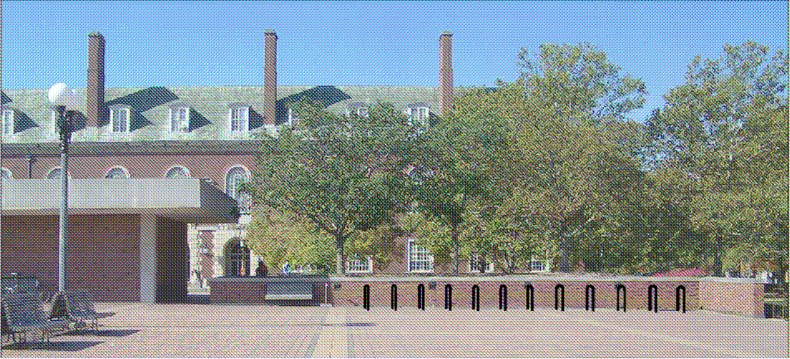 Bicycle parking facilities were installed at the Undergraduate Library, the Agricultural Sciences Engineering Building and Freer Hall. These will encourage bicycle riding, thereby promoting a healthy and less harmful mode of transportation across campus. The Student Sustainability Committee funded the full requested amount of $10,600. Additional funding (more than $50,000) for on-going projects such as creation or a bike-repair facility, more parking and air-pump stations has been recently allocated as well. Bicycle infrastructure has been deteriorating on campus during the last several decades and the SSC is a leader in reversing these trends.

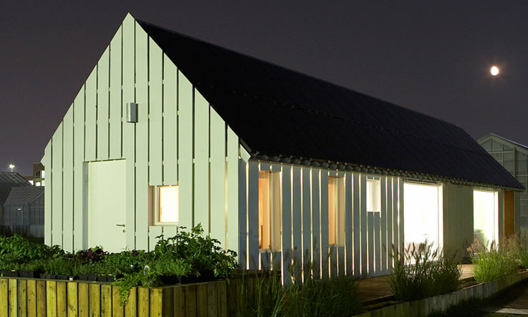 The Solar Decathlon is an international competition to design and build a 100% solar powered house on the National Mall in Washington D.C. every year, at which the University of Illinois won second place in the 2009. The Student Sustainability Committee awarded $20,000 for general expenses and $10,000 towards public education and outreach.

 An Outdoor Wood-fired Boiler system was funded to replace a natural gas heating system at Allerton Park. This replacement eliminates considerable CO2 emissions from the current system and results in substantial cost savings. The use of a renewable resource (wood), obtained from landsape management at the park grounds in place of a non-renewable one (natural gas), combined with the greenhouse gas emissions reduction helps increase campus sustainability. This project was implemented with a grant of $25,500 by the Student Sustainability Committee.

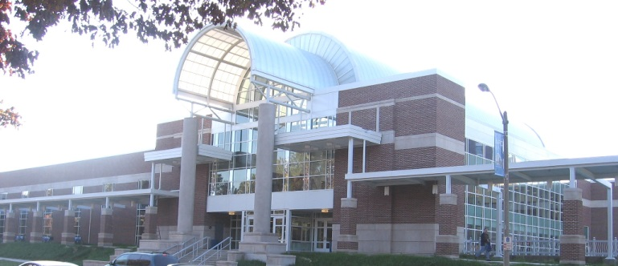 Campus Recreation has proposed a comprehensive upgrade of restroom facilities in all three of their buildings (Activities and Recreation Center, Campus Recreation Center – East and the Ica Arena) with the potential of reducing water consumption by almost 6.5 million gallons annually. Water conserving fixtures installed through this project include pint urinals, dual flush toilets, and low-flow faucet aerators. The Student Sustainability Committee provided an incentive of 30% of the total project cost of $100,000. The Committee also provided a loan of $75,000 for a lighting retrofit, rewiring and occupancy sensor installation at 8 squash and racquetball courts that saved ~$8,000 annually.

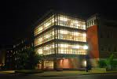 Students in the Department of Mechanical Science and Engineering have been working on projects to improve the sustainability of our campus. In 2009, the Student Sustainability funded them to the amount of $6,000 ($4000 for designing a sump pump water collection and use system, and $2000 for assisting with the retro-commissioning of Siebel Center), which will are high-impact projects and will involve students.

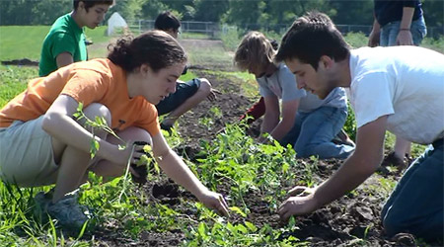 Other projects supported by the Committee include $50,000 in funding for a broad deployment of occupancy sensors in twelve campus buildings (a second equally large phase is planned for the upcoming year, also with Committee support) and the creation of a 10,000 sq. foot prairie garden at the College of Veterinary Medicine. Student fee funds have also supported t the establishment of a 3 acre sustainable student farm that is producing vegetables for consumption in campus residence halls. The farm produced 20,000 pounds of produce last year and is expected to double its output this year, while teaching students about sustainable farming practices and engaging them in the local foods movement.

**Conclusion**

The activities of the Student Sustainability Committee have been a major driver in moving the campus forward on energy and sustainability issues. Many campus initiatives in these areas have been piloted first by the Committee. The Committee has helped advance conversations about improved building standards, distributed energy pricing, and driven the adoption of an aggressive climate action plan. Through is funding of many grassroots campus initiatives, it has helped establish a growing culture of sustainability that is more valuable than the simple sum of all projects conducted. Furthermore, the student engagement it facilitates will be felt across the State in the years to come.