Narrative:
The Illinois Department of Transportation is interested in utilizing suitable areas of Right-of-Ways to produce cellulosic grasses for ethanol and biomass energy. The possibility also exists that this could generate additional revenue to defray the cost of road maintenance, improve the environment and reduce the use of petroleum products. IDOT has implemented an Inter-Agency Agreement with the University of Illinois at Urbana-Champaign to complete a feasibility study. IDOT has completed 2 years of a planned 3 year study.

1) Agronomic study
The agronomic study focuses on the establishment of the plots in order to evaluate the best species for feedstock production in the right-of-way. The site was planted in early May 2012 and and second in May 2013. The rate of success of for the first year of planting was low due to drought conditions. The 2013 planting was more successful with increased management and better weather. The rate of success was much higher with 3 of the 4 species considered established. Big bluestem, indiangrass, and switchgrass were three dominate species for both planting years. One major difference in the rate of success was from multiple applications of a nonselective herbicide applied twice (fall and spring applications) prior to planting. This allowed for identification of desired species, reduced cool-season grass competition, and control of broadleaf weeds with selective herbicides. Sensors have been monitoring soil electrical conductivity changes. Soil samples have been collected to monitor changes in soil organic carbon and salt concentration.. Final soil samples will be collected at the conclusion of the study to determine the effectiveness of these species on improving soil quality.
This portion of the project involved collaboration and coordination between UIUC Department of Crop Sciences, the IDOT sustainability manager, and IDOT roadway maintenance field staff.
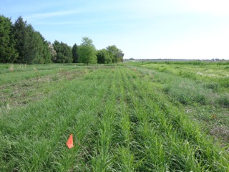
Figure 1. Example of Indian Grass and Big Blue Stem plantings in Rantoul, Illinois (May 22, 2014)

2) Feedstock analysis
The goal of this study is to investigate the use of Illinois highway right-of-ways for energy crop production to generate additional revenue to defray the cost of road maintenance and improve the environment. The generation of revenue is predicated on finding appropriate uses for the harvested biomass. Typical end-uses for such harvested biomass include (a) forage (b) as raw material for combustion (c) advanced thermal conversion processes such as pyrolysis and gasification and (d) biochemical conversion to products such as ethanol or biobutanol among others. Feedstock analysis is the starting point for making rational decisions about potential end-uses, target markets, and techno-economic feasibility studies. Four grasses were analyzed: Big Blue stem, Switchgrass, Miscanthus and Prairie Cordgrass.
This portion of the project involved collaboration and coordination between Illinois Sustainable Technology Center, UIUC Department of Crop Sciences, the Center for Advanced Bioenergy Research, and the IDOT sustainability manager.
  - Forage
Forage analysis of the four feedstocks is complete (data in supplemental attachment). The four grasses do not appear to have much forage value. Based on the characteristics presented the biomass would be classified as Quality Standard 5 (the lowest) as assigned by American forage and Grassland Council (AFGC). Alkali pretreatment can be used to improve digestibility but will have to be supplemented by addition of protein before these materials can be used for forage. Appropriate management for forage quality is a possibility as well. This will require closer analysis of the compositional changes in the plant during growth and possibly fractionation of the plant.
  - Combustion and gasification
Proximate analysis, ultimate analysis, total calorific value, and elemental ash compositions have been completed (data in supplemental attachment). Switchgrass has the highest percentage of ash with big bluestem having the least on a BTU basis. Practical implications are the need to deal with a larger amount of biomass ash when burning switchgrass as compared to big blue stem. The ash composition of switchgrass is also much lower in silica content compared to the other feedstocks. Switchgrass also appears to have higher amounts of potassium and chloride relatively. Typically these elements form volatile compounds and partition to the gas phase. Upon condensation in other parts of the gas handling system, fouling coatings can form as can corrosive liquids. The presence of alkali is also indicative of a high potential for slagging. Switchgrass also has a slightly higher sulfur content. Some form of pretreatment would be required to process all of these materials to avoid problems during combustion. Chromium appears to be present in detectable concentrations in all of the species tested on an as-received basis. This implies that it will accumulate in the ash after combustion. Whether this poses a regulatory issue will be determined.
  - Biochemical conversion for ethanol and butanol fermentation
The four feedstocks have been analyzed as per NREL protocols (data in supplemental attachment). These results provide support for ethanol and butanol fermentation studies, which are described elsewhere in this narrative.

3). Fermentation studies for production of ethanol and butanol
Fermentation experiments were performed using hydrolyzates obtained from acid-pretreatment and enzymatic hydrolysis of cordgrass biomass harvested in 2012. We analyzed sugar concentrations and inhibitor concentrations of the prepared hydrolyzates before fermentation experiments. Clostridium beijerinckii NCIMB 8052 and Saccharomyces cerevisiae SR8 recombinant strains were used for producing butanol and ethanol, respectively. In order to provide quantative results for economic analysis, we calculated yields of butanol and ethanol production from the hydrolyzates. For ethanol production, 230 kg of ethanol was produced from one metric ton of dried cordgrass biomass (Table 1). For butanol production, 74 kg was produced from one metric ton of dried cordgrass biomass (Table 2). The Acetone-Butanol mixture produced from the fermentation can be further converted to biodiesel or jet fuel. We are currently investigating optimal conditions for pretreatment and hydrolysis of plant derived biomass to produce liquid fuels and chemicals. Economic analysis indicates that the use of biomass planted along Illinois right-of-ways can be a sustainable approach for producing biofuels.

Table 1. Ethanol yield by the engineered S. cerevisiae SR8
Sample Biomass # | Plot ID | Biomass  Loading (%) | Ethanol yield  (% g ethanol  /g biomass) | Glucose yield  (% g glucose  /g biomass)
#107 | 107  (IL 102) | 20 | 22.38 ± 0.04 | 37.63
#109 | 109  (PC09-101) | 20 | 23.68 ± 0.01 | 40.48

Table 2. Butanol yield by the wildtype C. beijerinckii NCIMB 8052
Sample Biomass # | Plot ID | Biomass  Loading (%) | ABE yield  (g ABE  /g sugars) | ABE yield  (% g ABE  /g biomass) | Butanol yield  (% g BtOH  /g biomass) | Total sugar yield  (% g sugars  /g biomass)
#107 High Loading | 107  (IL 102) | 20 | 0.29 ± 0.04 | 9.30 ± 0.69 | 6.40 ± 0.12 | 37.3
#107 Low Loading | 107  (IL 102) | 15 | 0.28 ± 0.00 | 10.28 ± 0.33 | 7.41 ± 0.08 | 43.5

- Analysis of implementation scenarios
One aspect of this study has focused on strategic level decision making, including siting of facilities and production, with some prediction of costs. Two recently developed biomass supply chain optimization analysis tools, BioScope and BioFeed, are being used to make strategic and tactical level decisions for reasonable scenarios suggested by IDOT, agronomic experiments, feedstock analysis, or the analysts.
Another aspect of this study has involved planning for the installation of a biomass-fueled space heater for a building at an IDOT maintenance facility near Clinton, IL. The purpose of the installation is to perform a pilot test of IDOT maintenance personnel taking responsibility for the operation and maintenance of a biomass heater in a building that they use. This work involved an assessment of commercially available and appropriate technology, an energy use and heat load analysis of the building, and assessment of IDOT right-of-way land area required to eventually supply biomass for the unit.
It has been estimated that this building will require a heating capacity of approximately 500,000 Btu/hr and that it will consume 17 metric tons per year of biomass for space heating. This is estimated to eliminate approximately 700 gallons per year of propane. Preliminarily, the unit is expected to use fuel derived from local sources. Longer term, IDOT right-of-ways will produce the biomass for this unit. IDOT is planning to identify and set aside 10 acres of IDOT right-of-ways near Clinton, IL for this purpose. Cost estimates for this operation are approximately $21 per metric ton of biomass. Captial costs, however, are currently estimated to be quite high for an indivudual county, perhaps as high as $115 per metric ton. Our team is now working towards determining what the optimal number of counties (or districts) within a region that minimizes total costs by sharing the capital costs across regions—we anticipate significant savings through this sort of cooperation. For illustrative purposes, consider the fact that ROW sites will be distributed in their location and size, as a function of vwgeative cover, slope, and interuptions from crossing roads and other obstacles (Fig. 2). Each of these sites will also have varying biomass yields.
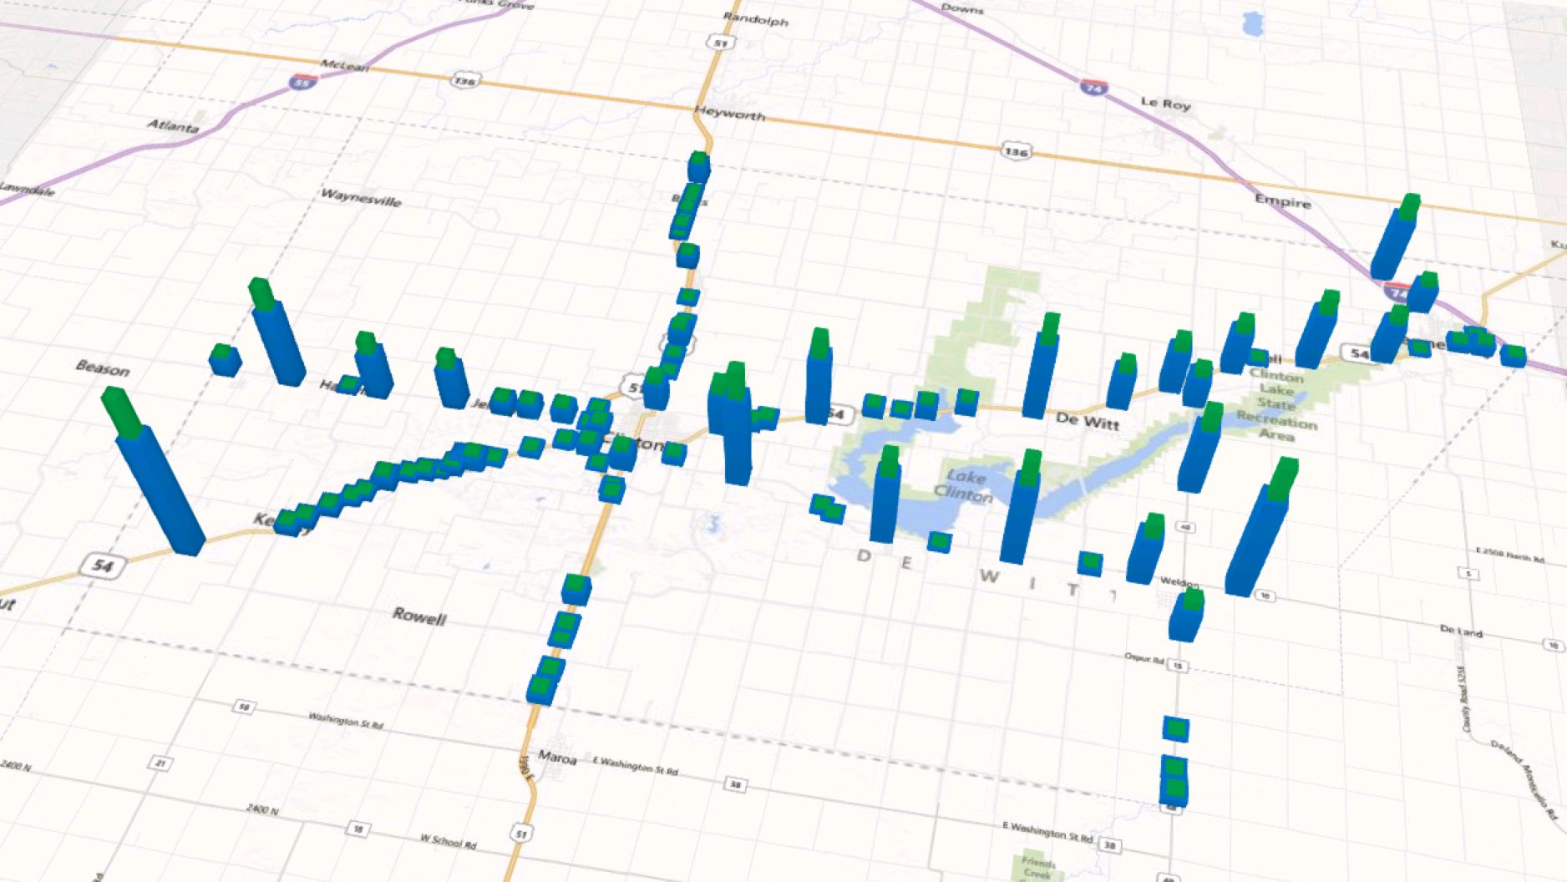
Fig. 2. DeWitt County is displayed here, with bars representing the location of potential ROW areas economically available for harvest. Notice the distributed nature of the ROW areas. The size of the bars represents the area and biomass available at each site.
There is also an opportunity to agressively harvest biomass across the entirety of available ROW areas (Fig. 3). This quantity of biomass can not only supply heating to IDOT depots, but also be cofired in Illinois power plants. When selecting from the large scale power plants within the state of Illinois, it is possible to blend biomass with coal, while never exceeding a 5% blend rate which may be of concern for some operators. Preliminary results suggest cost of baled biomass will range from $35-45/ton, inlcuding harvest operations and transporation and delivery to power plants. Capital costs still need to be considered for this scenario, as described above, but we are currently optimistic that this may provide an attractive opportunity. Power plants may need to consider size reduction for burning—alternatively we are considering size reduction further up the supply chain.
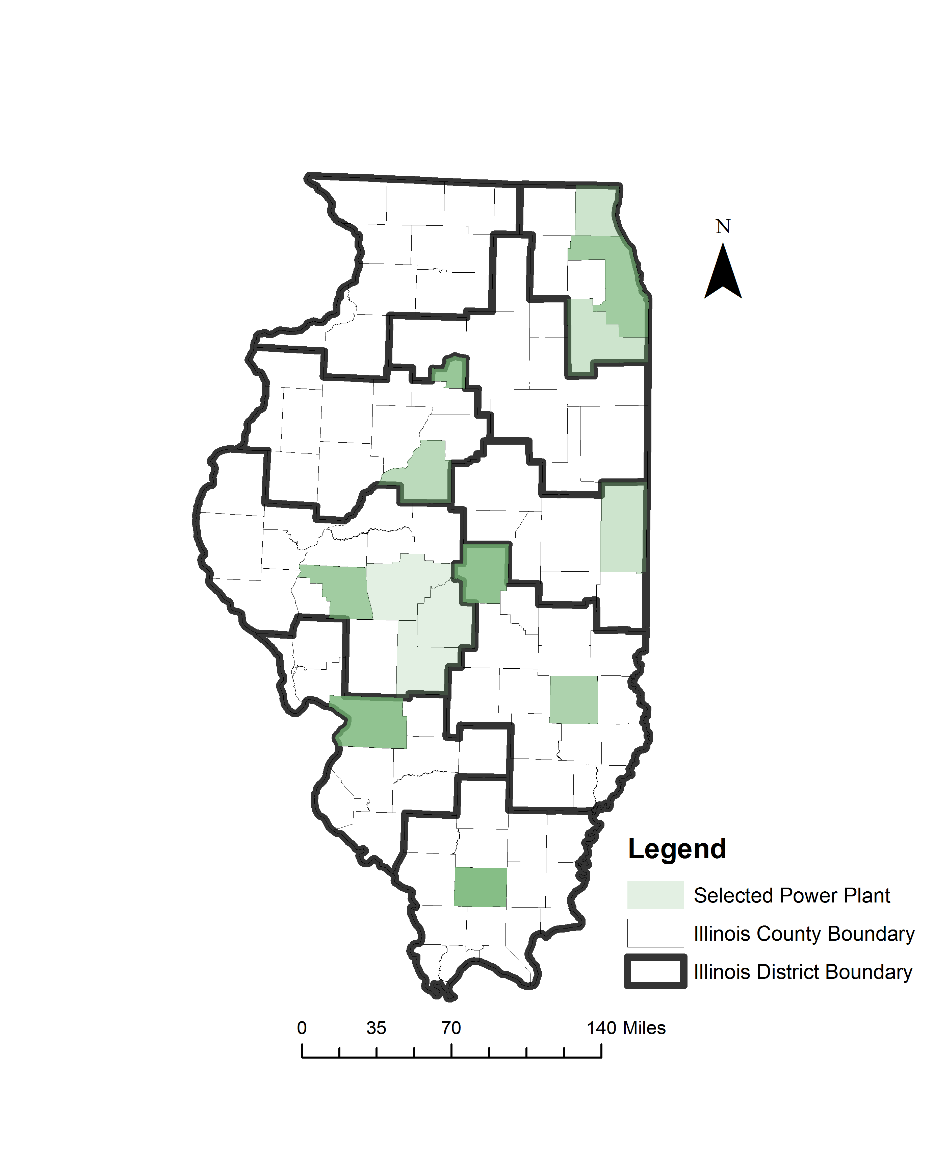
Figure 3. Selected power plants are displayed with shading as located within the top ten optimal Illinois counties.
This portion of the project involved collaboration and coordination between UIUC Department of Agricultural and Biological Engineering, UIUC Department of Urban and Regional Planning, University of Illinois Extension, the IDOT sustainability manager, IDOT roadway maintenance field staff, and it supported 2 ABE graduate students and involved over 30 undergraduate students enrolled in Learning in Community (LINC) through the UIUC College of Engineering.
- Regulatory Compliance: IDOT is not subject to an environmental enforcement action or notice of violation from the U.S. EPA or Illinois EPA.

