“Ballast-Mounted Photovoltaic Modules Blew off the Roof of BIF”: An Urban(a) Legend

As the University of Illinois at Urbana-Champaign considers installing more solar photovoltaic modules on the roofs of buildings, the discussion turns to the type of mounting systems to consider. This discussion often elicits the tale of the modules that were originally installed on the roof of the Business Instructional Facility (BIF) using a ballast-mounted system, that is, a mounting system held down using heavy weights such as concrete blocks. The story goes that a few of the PV modules blew off the roof of the building, and this subsequently led to the modules being installed with a racking system attached to the roof of the building.
This story is an urban legend. On December 23, 2008, Facilities and Services found that most of the first row of modules had been tipped over onto their face (not blown off the roof), even though the winds had not been unusually strong. Furthermore, the mounting system at the time was the same one that exists today, namely one attached to the roof of the building. The modules were never ballast mounted. The photos below show the damage as well as the racking system. Apparently the first row had not been properly secured. It was repaired and has withstood the ravages of the weather for the past 8 years, including a huge wind event on November 17, 2013.
Ballast-mounted systems are in common use throughout the world, and are often the cheapest option on a flat roof. One need look no further than the roof of the MTD Maintenance Facility (803 E. University Ave., Urbana) to see a good example of a large (300 kW) ballast-mounted system, shown below (https://www.cumtd.com/go-green/solar/).

Keith Erickson, Associate Director of Utilities & Energy Services, Director of Utilities Distribution
Morgan Johnston, Associate Director of Facilities and Services, Director of Sustainability for F&S
Scott Willenbrock, Professor of Physics, Provost Fellow for Sustainability

October 2016

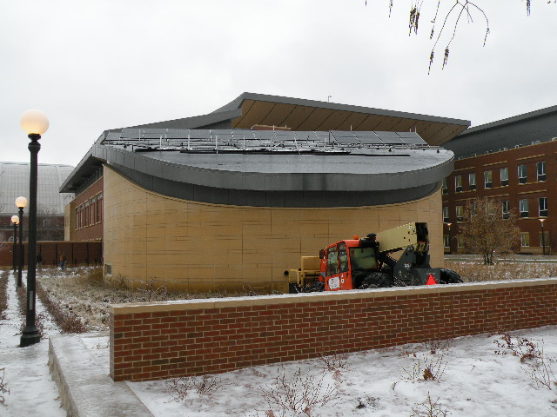
Figure 1 Most of the front row of the BIF solar array was tipped over.
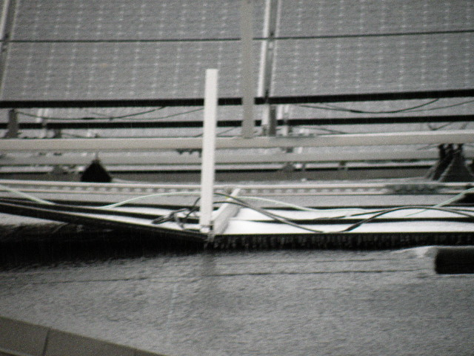
Figure 2 Close-up of the BIF array. The attachments to the roof can be clearly seen in this view.

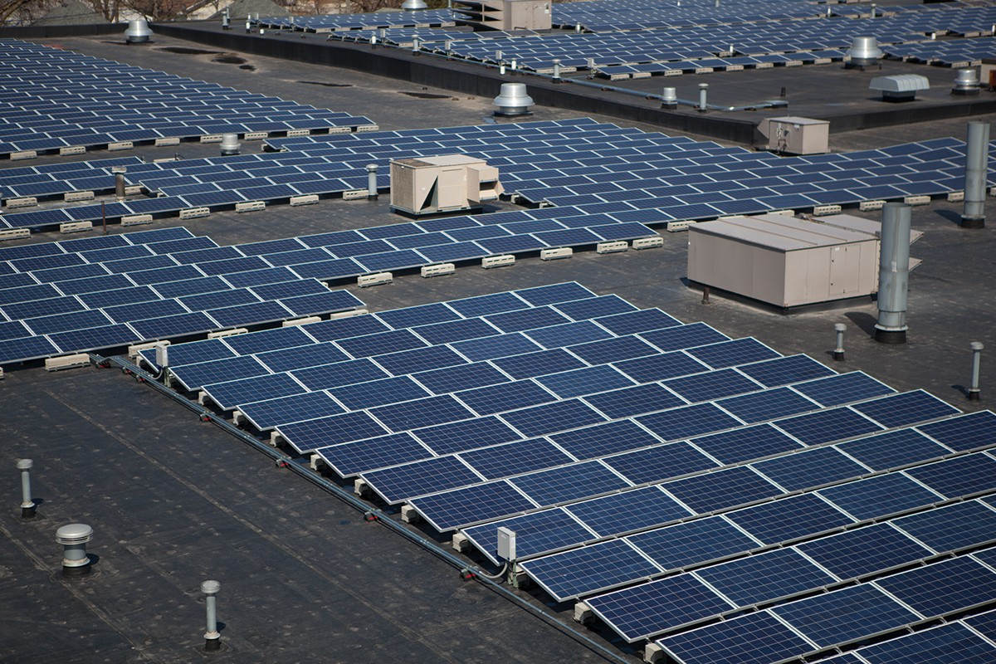
Figure 3 The ballast-mounted solar array on the roof of the MTD Maintenance Facility

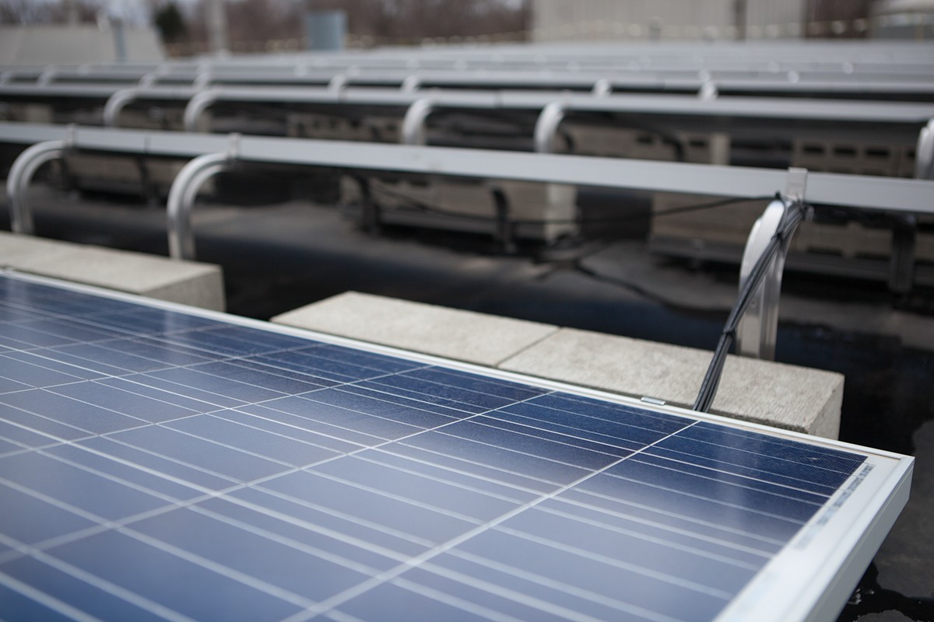
Figure 4 Close-up of the MTD ballast-mounted system.

