Thank you for your commitment to green initiatives at the University of Illinois. One of the ongoing requirements listed in the terms of the funding agreement for your project is the submission of semesterly reports with key information about your project. In addition to this form, please provide additional financial documentation and/or progress photos if available.

Please be as accurate as possible in describing the project (including possible setbacks or challenges in meeting the initial goals of the project). Not fully meeting your project's goals will not disqualify you from making future funding requests as long as your reports are as complete and accurate as possible. If you have any questions, please contact Micah Kenfield, Program Advisor for the Student Sustainability Committee, at kenfield@illinois.edu.
Project Name: Speech and Hearing Building Solar

Date of Report Submission: 2/6/2017

Project Purpose:
Design and install rooftop solar PVs on the Speech and Hearing Sciences Building

Detailed Accounting of Expenditures to Date:
No charges to the account yet.

Project Progress to Date:
F&S Engineering Design Services, led by Robert Halverson, has been meeting with Morgan Johnston and the electrical engineer, Brian Finet. These discussions have revolved around defining the key issues/questions regarding retrofitting existing campus buildings with rooftop solar PVs. As it is not directly related to project design, the time has been allocated to the F&S Engineering Design Services overhead account.

The academic users in the building requested that this solar project be completed in conjunction with a capital project they are planning. That project (U10043) is currently in schematic design.

Due to the SSC discussion at the point of funding this project, I asked Brian to take a look at a scalable system. The SSC funding could install the appropriate infrastructure for additional solar PVs in future years, and as many as funding would allow at this time. He provided the attached sketch. The next F&S meeting is scheduled for February 13.

Student Involvement and Outreach to Date:
This project has involved students through discussions and ideation. The initial proposal came from a student class group, but the materials they selected are no longer available to purchase. One of the key student advocates for rooftop solar, Corey Weil, helped identify the Speech and Hearing Sciences Building as a good option for this effort. Niharika Kishore is working on a proposal for a full scale rooftop solar PV retrofit for several campus buildings to reach the iCAP objective of 12,500 MWh/year of on campus solar generation by 2020. Niharika and Corey have both participated in the F&S discussions to date.

Marketing and Promotion Efforts to Date:
This solar array effort is on the iCAP Portal at https://icap.sustainability.illinois.edu/project/speech-and-hearing-rooftop-solar-pvs.

Additional Comments:
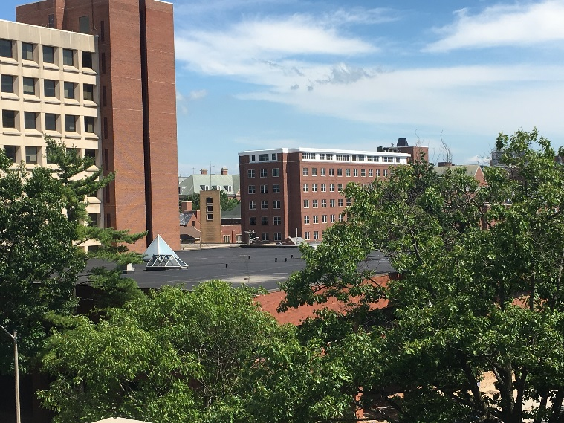
This is a view for the location of the proposed solar array, as seen from the parking deck at Fifth and Daniels.

