Burrill/Morrill Project (Cancelled) Final Report
By Eliana Brown – July 30, 2014

Project purpose

The project’s purpose was to re-envision the campus walkway between Burrill and Morrill Halls as a sustainable, multifunctional landscape.

The Student Sustainability Committee (SSC) awarded $5,434 to the project. Facilities & Services (F&S) intended to pay for concrete work, soil removal, overflow drain installation, sign, and mulch.

Project summary

The Burrill/Morrill walkway is a space with shaded, windy conditions. It has several planters with sparse, mostly non-native species. One portion of the area collects water during rainstorms. The proposal was to introduce native vegetation to the planters and redirect water to one of the planters and convert it into a rain garden.

As was done in a prior SSC project in the walkway, there was an opportunity for students to install plants under the direction of John Marlin. Marlin agreed to serve in an advisory capacity for this project.

Problems encountered

Problem One
The student encountered health issues that postponed the development of a comprehensive planting plan.

Problem Two
An alternate way to acquire a planting plan was sought. Anna Hochhalter, a recent MLA graduate, was hired to develop a site assessment and plan. She met with F&S and accomplished the attached site assessment. Hochhalter relocated for employment and, unfortunately, was not able to continue developing the plan. Another designer was sought but was cost-prohibitive.

Problem Three
During the course of the project, the F&S funding environment shifted. Staff determined that the resources no longer existed for the hardscape changes.

Portion accomplished

Woodland planting
On October 20, 2012, during the iHelp volunteer project, approximately 15 students planted woodland species in the northern planters under the direction of John Marlin.

The species and amounts follow:

Species | Count | Cost
Bluebell | 20 @ $3.00 | $60
Jack-in-the-pulpit (large) | 24 @ $5.00 | $120
Jack-in-the-pulpit (small) | 72 @ $0.50 | $36
Total |  | $216

Site Assessment
As mentioned, Anna Hochhalter completed the attached site assessment.

Photos of the iHelp planting
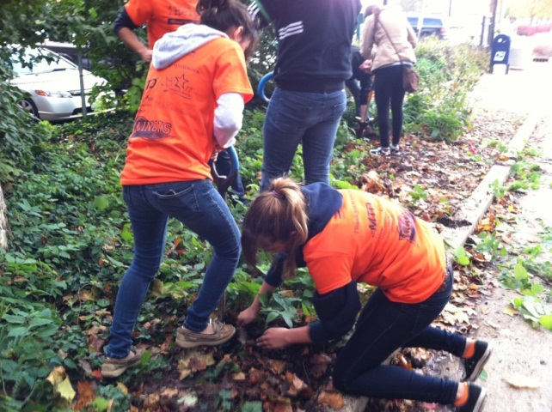
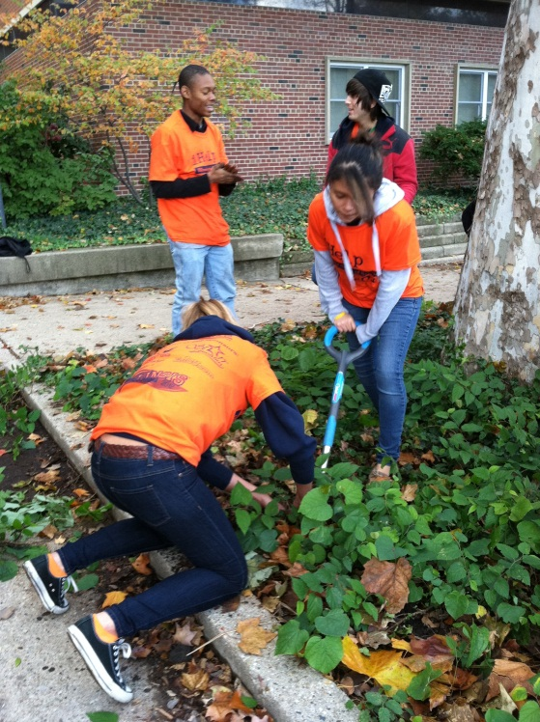

Financial statement that lists how the funds were specifically utilized
A sum of $216 was paid to Marlinworks for the installed woodland plants.

Anna Hochhalter provided an invoice with a charge of $250 for the site assessment. Due to vendor identification complications with Procurement, this amount has not been paid yet. Thus, F&S asks that this amount remain available to process the payment.

The remaining funds ($4968) should be returned to SSC.

Statistics on student involvement/outreach
Approximately 15 students planted woodland species under the direction of John Marlin.

This project was cancelled by Eliana Brown, after consultation with SSC and F&S.

