Proposal No. 06.08.11.MJC
Energy Dashboard Software License and Installation,
System Integration and Configuration, and On-Site Training

Prepared by:  InStep Software, LLC.  Contact: Michael Casey  200 W. Jackson Blvd., 28th Floor  Chicago, IL 60606  312-894-7899 (office)  mcasey@instepsoftware.com | Prepared for:  University of Illinois  Attn: Mike Marquissee  Director – Budget and Resource Planning  Energy Services Division - F&S  Phone: 217-333-4909  Email :mlmarqui@illinois.edu
Submitted By: Michael Casey
Submitted On: June 8, 2011
Reference No. 06.08.11.MJC

Disclaimers

The information contained herein is confidential and proprietary to InStep Software LLC. It may not be disclosed or transferred, directly or indirectly, to any third party without the explicit written permission of InStep Software LLC. All rights reserved. No part of this document may be reproduced, stored in a retrieval system, translated, or transmitted in any form or by any means, electronic, mechanical, photocopying, recording, or otherwise, without the prior written permission of InStep Software, LLC.

Document History

Date Version Description Author
06/08/2011 1.0.1 Original Michael Casey

Table of Contents

Table of Contents 3
1. Proposal Introduction 4
2. Energy Dashboard Software Product Overview 4
3. Integration and Configuration 8
3.1. Summary 8
3.2 Software and Display Components 8
3.3 Project Services 8
3.4. Project Schedule 9
3.5. Client Responsibilities 9
3.6. Progress Reporting 10
3.7. Contractual Change Control 11
4. Technical Support and Maintenance 12
4.1. Support and Maintenance Services 12
4.2. Software Releases 12
5. Pricing 13
6. Terms and Conditions 13
6.1. Software License Terms and Conditions 13
6.2. Payment Terms and Conditions 13

1. Proposal Introduction

InStep Software, LLC is pleased to provide this proposal for our Energy Dashboard Software application.

InStep’s Energy Dashboard Module provides the ability to display energy consumption information in near real-time for energy awareness and supporting energy conservation efforts. The software can be accessed using a local touch screen kiosk or on the intranet or internet using the Energy Dashboard web based access.

UIUC is already using InStep’s eDNA software for collecting, archiving and reporting upon the meter information and utility billing information leading to a very seamlessly integrated solution. The Energy Dashboard Module is an extension of the eDNA and EBS Applications and will allow for seamless integration with the existing InStep products on campus. This will result in the best possible performance, system integration and highest level of reliability. UIUC personnel are intimately familiar in the support of InStep software applications leading to efficiencies in the roll out and maintenance of this software application.

2. Energy Dashboard Software Product Overview

InStep’s Energy Dashboard is an advanced Flash platform based application that provides a highly interactive and simple to use interface for accessing energy related information. The Energy Dashboard can be easily customized for branding specific colors, information and logos. Energy consumption can be displayed in real-time or over any user selected time period with comparisons to prior usage periods. Information can be compared for a single building or across multiple buildings in support of activities like energy savings competitions.

The application main overview display allows users to see an overview of the complete utility university wide footprint. Users can easily select any building that they want to view the utility information for.

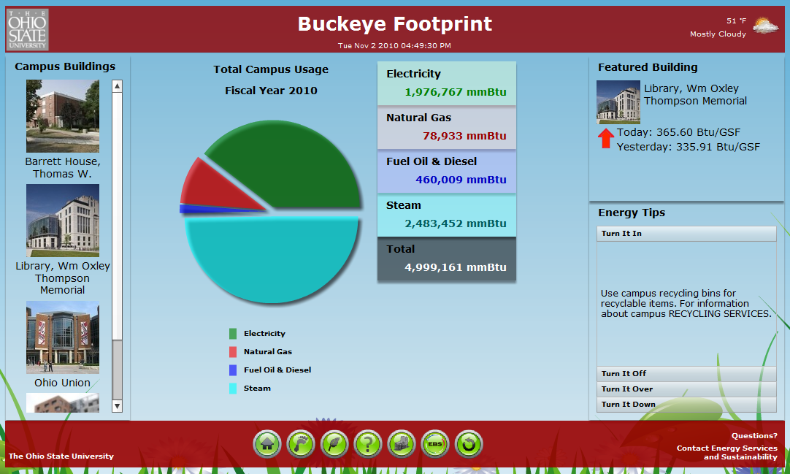

The application building overview displays utility information specific to that particular building.

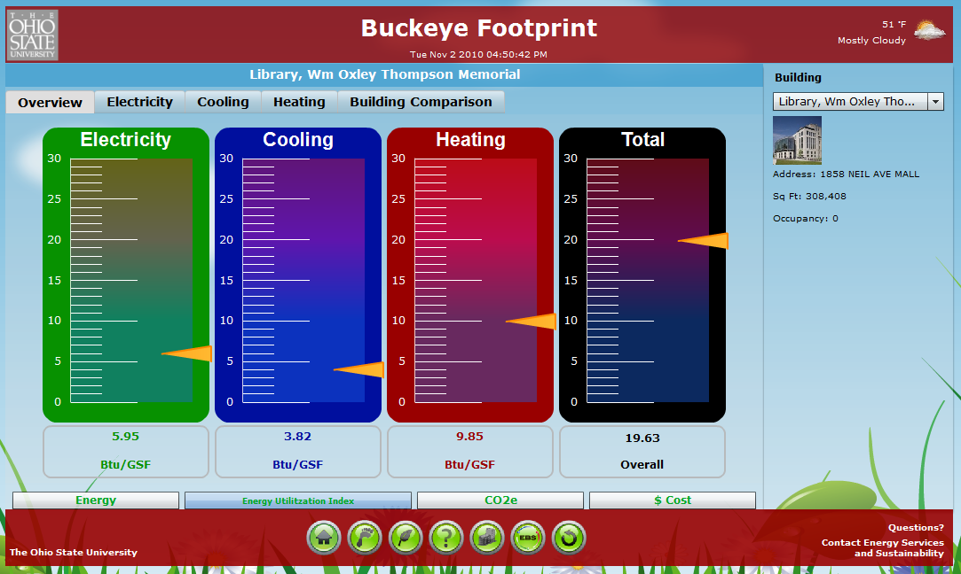

The application provides for the ability to easily compare consumption on a per commodity basis with the prior day, week, month or to a target value.

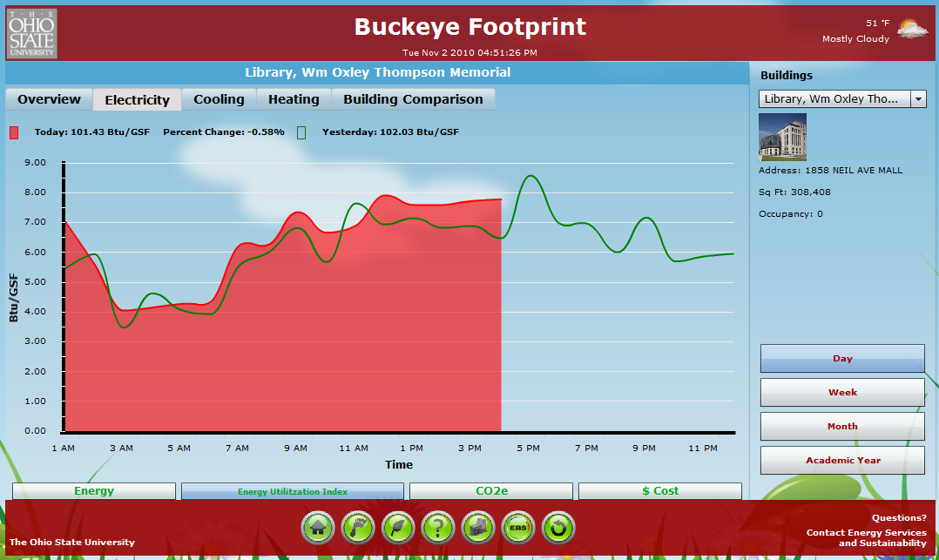

The application provides for the ability to easily compare consumption on a per commodity basis with the prior day, week, month or to a target value.

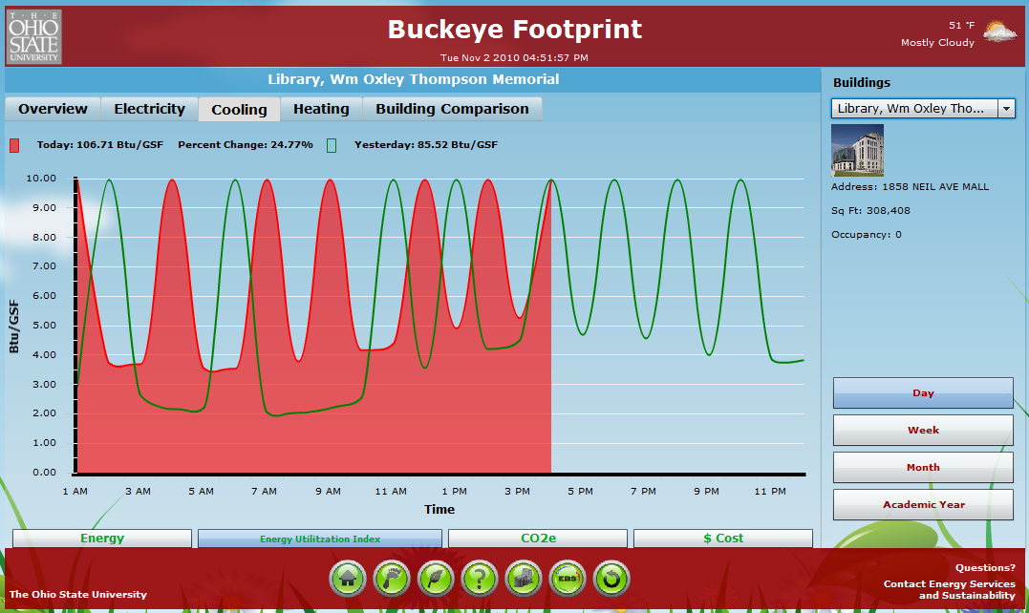

The application provides for the ability to easily compare utility consumption across multiple buildings for comparisons and energy conservation competitions.

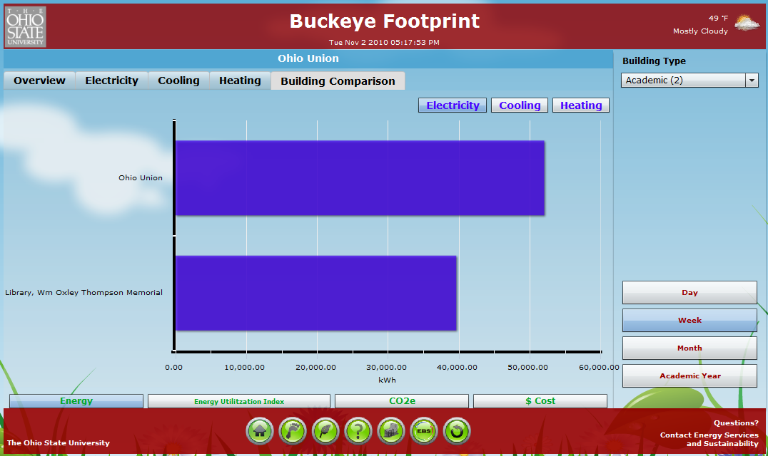
3. Integration and Configuration

3.1. Summary

Table 3.1. Scope of Supply

Item | Description
Supply of Software – Energy Dashboard | Yes
eDNA Interface | Yes
Installation/Configuration/Testing Energy Dashboard Software | Yes
Configuration of Energy Dashboard for unlimited campus buildings at UIUC | Yes
Training (1 Day User/Administrator) | Yes

3.2 Software and Display Components
Table 3.2. Software and Display Components

Item | Description
Energy Dashboard | Single Server (Client Use for Unlimited UIUC Campus Buildings and Users)
eDNA Interface | Included
Ability to Export Data to Excel | Included
Ability to Display Some University-Wide and Power Plant Total Data | Included
Ability to Display CO2 Output Data by Campus or Building | Included
Definition of Terms, Best Practices, FAQ’s, Etc… | Included
Ability to Display and Trend Historical Data by Week, Month or Academic Year | Included

3.3 Project Services

Described within this section are the services that are required to complete the project in an effective manner. This section will also document the tasks that InStep will be providing under this proposal. Please review this Checklist for those performance areas that are currently marked as “Customer Responsibility” and plan accordingly.

Table 3.3 Project Performance Checklist

Project Performance Checklist | Included  With Services Purchase | Quoted As An Option | Customer Responsibility | Not Applicable
Project Management
Project Management | X
Kickoff Meeting | X
Design Review Meeting | X
Project Status Meetings (Teleconference) | X
Engineering Services
Specify required hardware | X
Procure required hardware |  |  | X
Installation of Ethernet backbone |  |  | X
Installation of Hardware |  |  | X
Routing of Ethernet cables |  |  | X
Installation/Configuration of Energy Dashboard Software | X
Customization UIUC Branding (Up to 60 Hours) | X
Testing/Training
System Functionality Testing | X
User/Administrator Training One Day (On-site) | X

3.4. Project Schedule

InStep will work closely with UIUC to design a schedule that meets your needs.

3.5. Client Responsibilities

Client responsibilities will be focused on providing the necessary resources for a successful project. It is important that UIUC personnel provide the following in a timely manner during the course of this project.

- Designation of a project manager
- Provide InStep project team members access to necessary hardware, system software, software media etc. during the installation and application testing phase.

- Feedback by UIUC, if any, on any documents / software submitted by InStep to UIUC for approval or sign-off, should be communicated in writing to within a week of the submission. Any further delay shall have equivalent impact on the project schedule.
- Ensure availability of people and any necessary equipment for testing.
- Provide site specific information as requested.
- Access to UIUC facilities upon request.
- Existing network and system drawings as required.
- Input from operational/IT personnel with detailed technical knowledge of existing UIUC processes and systems.
- Project ownership and overall stake in the success.
- Review of the delivered documentation and provide feedback.
- Promptly release payments to InStep on presentation of valid invoices.

3.6. Progress Reporting

InStep will deliver bi-weekly progress reports to detail completed work and project preparation over the given period. More frequent progress reports can be provided upon request. The report will contain a summary of encountered & resolved along with the detailed description of key issues encountered.

These reports will contain as a minimum:

- Milestones completed this period,
- Milestones due next period,
- Major activities due to start,
- Key issues & status of actions to resolve,
- Exceptions to plan, including:
  - Cause of exception;
  - Remedial action proposed.

InStep and UIUC personnel will work closely and will be in continuous communication throughout the project. Telephone and internet conferences can allow for efficient widespread dissemination of project information to authorized parties.

Web Conferences
Microsoft LiveMeeting is a tool that InStep uses to facilitate good communication with our clients. Live Meeting is a cross-platform that integrates data, audio, and video to allow powerful web meetings with anyone, anywhere, at any time.

Key Live Meeting conference features include:

- Ability by any party to view, annotate, or edit any document online.
- Application and desktop sharing.
- Whiteboarding technology.

3.7. Contractual Change Control

Change Control Management will be applicable whenever UIUC requests for change in the existing scope, SRS, Purchasing Specification, or Software Design Specification.

The Change control activities include request, evaluate, approve or disapprove, and implement changes to the baseline items. Changes encompass both error correction and enhancements. Our configuration management plan defines the following sequence of specific steps:

Requesting Change. Any request for change to the baseline configuration item is to be documented in a given format. The same is to be passed on to the project manager by the requester for consideration.

Evaluating Changes. The project manager on receiving the change request will analyze the impact of the change on the deliverables and also will evaluate the effort required to carry out the change. The UIUC project manager will be responsible for evaluating the impact on the user training and operation process. The finding of the impact analysis is also documented and forms the input for the next activity.

Approving Changes. Based on the results of previous phase, a recommendation would be made to either:

- Approve the change as requested.
- Approve with:
  - delay to completion on phase/project;
  - increase in costs;
  - Combination of above.
  - Approval withheld until compensation of task/phase/project.
  - Approval postponed until completion of task/phase/project.

Implementing Changes. Every approved change request will be taken up for implementation within agreed timeframes. Reviews are completed to ensure the implementation of the change. The changed item is reconfigured and released with a new baseline.

InStep shall prepare a detailed written quotation for each change, and provide it together with the request for change or within one (1) week of the UIUC party requesting a change.
The quotation shall set out the schedule for carrying out the change and a fixed cost (where possible) for doing so and additionally, describe the impact to the cost, risk or schedule of the rest of the work.

Changes to the contract can be agreed in writing by authorized representatives of both parties who shall have the necessary authority to offer and accept the terms of any change. Any changes accepted by UIUC shall be governed by the terms of the project contract.

4. Technical Support and Maintenance

4.1. Support and Maintenance Services

InStep Software will provide maintenance service to endure the performance of the historical system software. Maintenance service shall include:

- Telephone and email consultation associated with technical software questions during normal working hours 8:00 a.m. to 5:00 p.m. CST.

- All enhancements, upgrades, and refinements included in releases to the historical system software which are normally supplied in the course of product development.

- Any changes or updates to the documentation as a result of program maintenance.

- Access to the InStep support site.

4.2. Software Releases

InStep Software provides regular new releases on a planned basis. The enhancements generally contain significant product enhancements. Other releases are provided as software patches on an as-needed basis. The new releases are announced to all licensed customers and are then made available through our support website. These new releases are always backwards compatible and are generally installed by the customers themselves, integration partners, or InStep Software (at an additional expense).

5. Pricing

Table 5.1. Energy Dashboard Pricing

Item | Description | Cost | Qty | Cost
1 | Energy Dashboard (Unlimited Building License) | $45,000.00 | 1 | $45,000.00
2 | Installation/Configuration/Testing/Documentation  (Installation of Energy Dashboard Software) | Included | 1 | Included
3 | Training eDNA Web and Energy Dashboard Software | $2,500.00 | 1 | $2,500.00
4 | Annual Support and Maintenance- Energy Dashboard | $6,750.00 | 1 | $6,750.00
5 | Discount Purchase (Items 1-4) | -$5,000.00 | 1 | -$5,000.00
Total |  |  |  | $49,250.00

The information contained herein is confidential and proprietary to InStep Software LLC. It may not be disclosed or transferred, directly or indirectly, to any third party without the explicit written permission of InStep Software LLC.

6. Terms and Conditions

6.1. Software License Terms and Conditions

InStep is providing a perpetual software license of the Energy Dashboard for the licensed number of buildings. Support and maintenance is an annual agreement with the first year of payment required at the time of purchase. Support and maintenance is based on 15% of the total purchased software licenses.

6.2. Payment Terms and Conditions

All pricing is in US dollars. This pricing is valid for 60 days. Pricing does not include travel, lodging, or shipping costs, which will be billed at actual cost plus a 10% service charge. Pricing does not include any hardware, operating systems, third party licensing or RDBMS databases. All taxes, tariffs, and duties are the responsibility of the purchaser. Payment terms are 100% of the software license cost due with order. 50% services due with order and 50% due upon completion of services.

Please do not hesitate to contact us with any questions or clarification needs. We look forward to the opportunity to work with you on this project.

Best regards,
Michael J. Casey

200 W. Jackson Blvd., 28th Floor
Chicago, IL 60606
P: +1 312 894-7899
F: +1 312 894-7840
mcasey@instepsoftware.com
www.instepsoftware.com

