2011 Final Report

The Student Farm at the University of Illinois

Bruce Branham
Farm Director

Introduction

The Sustainable Student Farm completed it third growing season in 2011. Funding from the SSC has launched the SSF and has continued to provide support as we develop a working model for the SSF on the University of Illinois campus. In 2011, we were given a $40,000 grant to purchase items to improve the productivity of the farm. Below I’ve reviewed the progress made during 2011.

2011 Progress

- Hired two summer interns, Micki Palchick and Megan Schneider . Megan is working at the student farm at the University of Vancouver in the summer of 2012.
- We also hired Tim Smith who began working for us in August of 2011 and continued at the farm until June of 2012. Tim will begin medical school in August of 2012. Having a full-time employee for almost a year was an invaluable insight for us. Having someone who can be trained to use equipment and do more complex tasks makes a huge difference in the efficiency of the farm.
- Delivered 5,400 lbs of vegetables and 75 lbs of herbs to Dining Services earning nearly $19,000 in revenue from Dining Services. In addition, the Farm Stand on the Quad earned nearly $9,000 in sales in 2011.
- With financial support from SSC, the Department of Crop Sciences committed funding to support ½ of a new position at the farm, the Student Farm Educator, for 3 years.
- With the generous support of Dining Services, which provided Hors d’oeuvres using produce from the SSF, we hosted our second Student Farm Open House on September 1, 2011. The event generated significant media coverage and had at least 300 people attend the event.
- The continued support of Dining Services is also critical to our success. Without Dining Services support, we would not be a functioning farm.

Problems and Opportunities for the SSF

In 2011 we had three main problems that reduced overall production. First, weed and pest management without the use of pesticides remains a significant challenge. Far and away, trying to control weeds with hand labor is expensive and difficult to keep up with. We continue to explore new and different methods for weed control. Second, irrigation is critical in hot summers and not having an adequate irrigation system in 2011 caused significant yield loss to blossom end rot in tomatoes and peppers. Third, trying to push outdoor production later into the growing season doesn’t work. Due to the seasonality of demand from Dining Services, we attempted to plant later and push more of the outdoor production into late August and September. What we ended up achieving was a significant reduction in total yield with only a marginal increase in late season yield.
In order to achieve a significant boost in production, we realized that we will need a dedicated agricultural assistant to work year around on the farm to optimize production for Dining Services. Zack Grant does a great job of balancing planning, purchasing, hiring, giving tours, writing reports, and planting, harvesting, tilling, and weeding the farm. However, it is more than full-time job to do all the tasks necessary to produce the vegetable crops needed to make an impact in Dining Services purchasing and food delivery. The Student Farm Educator will still do the planning, purchasing, hiring, provide tours of the farm, manage the ag assistant position, along with plenty of work on the farm.
Finally, we concluded that for Student Farm to be successful, Dining Services must be willing to preserve the excess of our seasonal production. In other words, we can produce thousands of pounds of tomatoes in late July and early August when demand from Dining Services is much reduced. If Dining Services can process and preserve those tomatoes, our sales can go up , outdoor production can be maximized, and Dining Services can benefit by having higher quality, locally-grown preserves. In order to generate sufficient revenue to support the employees on the farm, we need to maximize production in the July-September period when outdoor production peaks.

2011 Proposal

In order to maximize production, we needed to become more mechanized. Replacing hand-hoeing of weeds with mechanical weeding will significantly improve productivity. Using a mechanical transplanter (Figure 1) will increase efficiency compared to hand-transplanting. We proposed purchasing additional equipment to increase our efficiency and production. The Student Sustainability Committee granted us $40,000 to fund equipment and other capital investments in the Student Farm. As an example, we had no way of storing equipment at the SSF. All of the building space was located about 1/3 of mile from the actual farm. Every time a hand-tool or other item was needed someone would have to drive up to the shop to retrieve the needed item. We requested funding from SSC to buy a storage building to be located at the SSF. The storage building was delivered and set up in late December.
We also requested funding to build a washing station to more efficiently process our produce. This funding was leveraged by involving a graduate architecture class under the direction of Dr. Jeff Poss (Figure 2). The class designed and is installing a wash/pack station at the SFF and also designed a transportable farm stand called “Folding Farm”. The Folding Farm was the subject of a WILL news feature that can be heard here or at http://will.illinois.edu/media/mp3/In_My_Backyard120712.mp3. In addition to Folding Farm the class designed an efficient shelving system for our delivery van that can be used to increase the capacity of the van for deliveries to Dining Services or the farmstand on the quad. The wash/pack station grew from a simple wash station to a more elaborate facility to allow washing and packing with multiple workers. Dr. Poss sought and was granted additional funding from the Chancellor’s office to complete this project (see http://uiucsmallstudio.com/ for additional information about this project).
Other items purchased with SSC funding included several implements to improve efficiency. The water wheel transplanter ( Figure 1) has been a very beneficial purchase that we have utilized more than we envisioned. The transplanter allows for rapid, efficient transplanting in uniform rows that permit mechanical tillage for weed control.
Below is a list of items purchased with SSC funding as of 07/31/12.

For the Allis G Tractor
Lely Tine Weeder | $1,250
Buddingh Basket for Allis G | $2,495
For the BCS 853 Walking Tractor
Berta Franco 34" Flail Mower BCS 853 w/Integral Quick Hitch | $1,749
Debris Screen for Diesel Engine | $59
Aldo Biagioli Root Digger Ploww/ Angle Adj. Assay & Drawbar | $280
30" Crimper/Roller w/ Tow Coupler for BCS 853 (Spiral) | $750
J Bolt Kit for Barbell Engine Weights w/Tubular bumbers | $6
For the International 584 Tractor
Reigi 1 Eco Weeder | $3,400
Off Set Hitch | $850
Jang J6-W 6 row planter | $2,750
3-point hitch adater | $189
Rollers | $620
General Equipment purchases
(50) 1.75 Bushel General Purpose Containers | $765
Model P150 3-Point Hook Up Water Wheel Transplanter | $1,635
(3) Super Wheels | $266
(54) Snap-On Spikes E (2x3 1/2") | $270
(18) Snap-On Spikes B (3-1/4 x 5-1/2") | $144
Other equipment | 3286
Shipping costs | 1,073
Total Equipment Purchases | 21,837
Utility Storage Building | 5,804
Vegetable Wash/pack station | 3,000
Gravel for building/straw bales for wind protection, etc | 684
Total Other Purchases | 9,488
Total Funds Expended | 31,325
Funds yet to spend | 8,675

We still have funds remaining to purchase an additional high tunnel for use at the farm. We postponed that purchase to focus on 2012 production, since the assembly of a high tunnel is time and labor intensive. After we hire the agricultural assistant position, we intend to purchase the additional high tunnel. We are very grateful for the support of the Student Sustainability Committee. As of June 30, 2012 we have already produced 35% more revenue from Dining Services sales than at the same time last year. Our Farmstand on the Quad revenue is also up significantly compared to last year.
We are in position to have a record setting year for revenue and food production, despite the difficult growing conditions. We are very grateful for the support of the Student Sustainability Committee as we could not have developed the Student Farm to its present state without your financial backing.

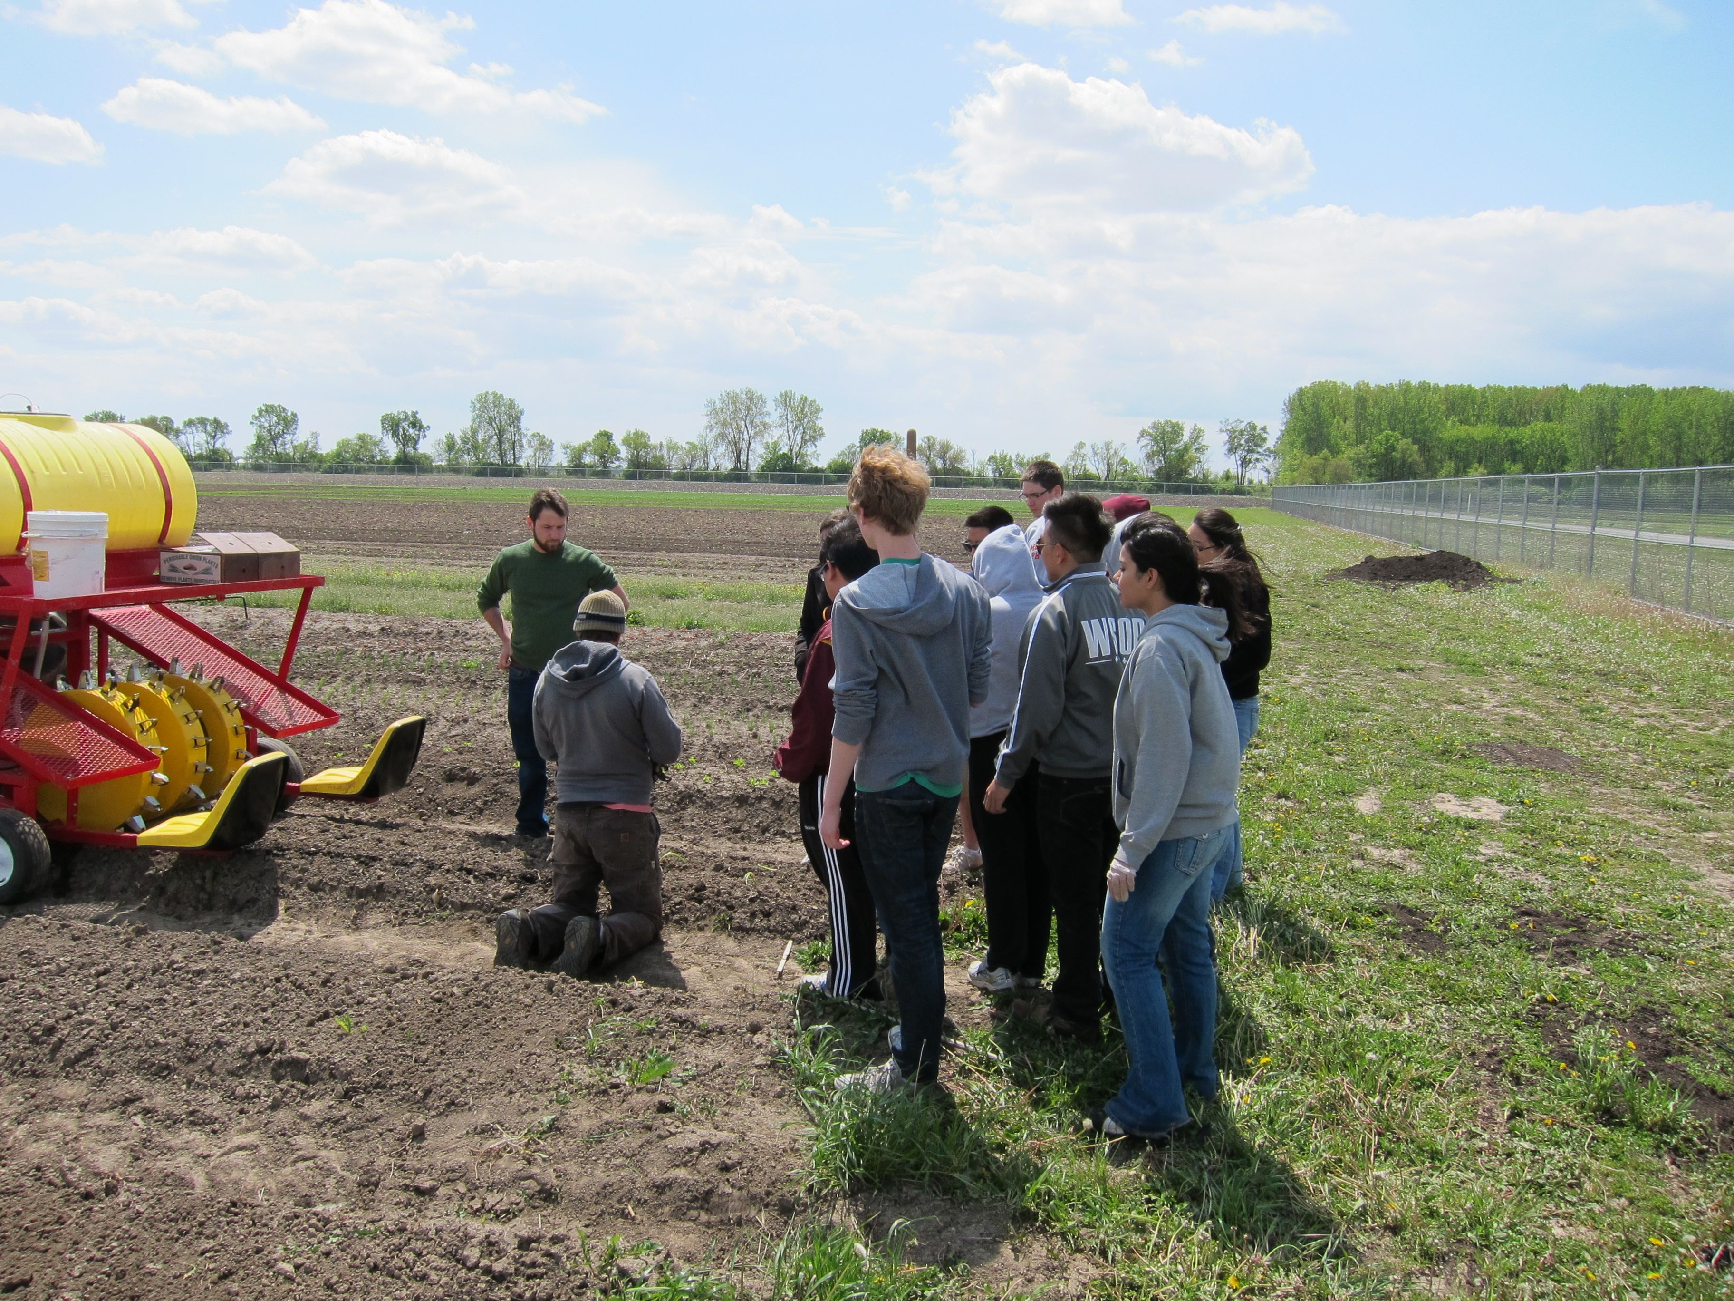

Figure 1. Zack Grant (kneeling), Student Farm manager, demonstrates the use of the new water wheel planter at a SSF work day in April.

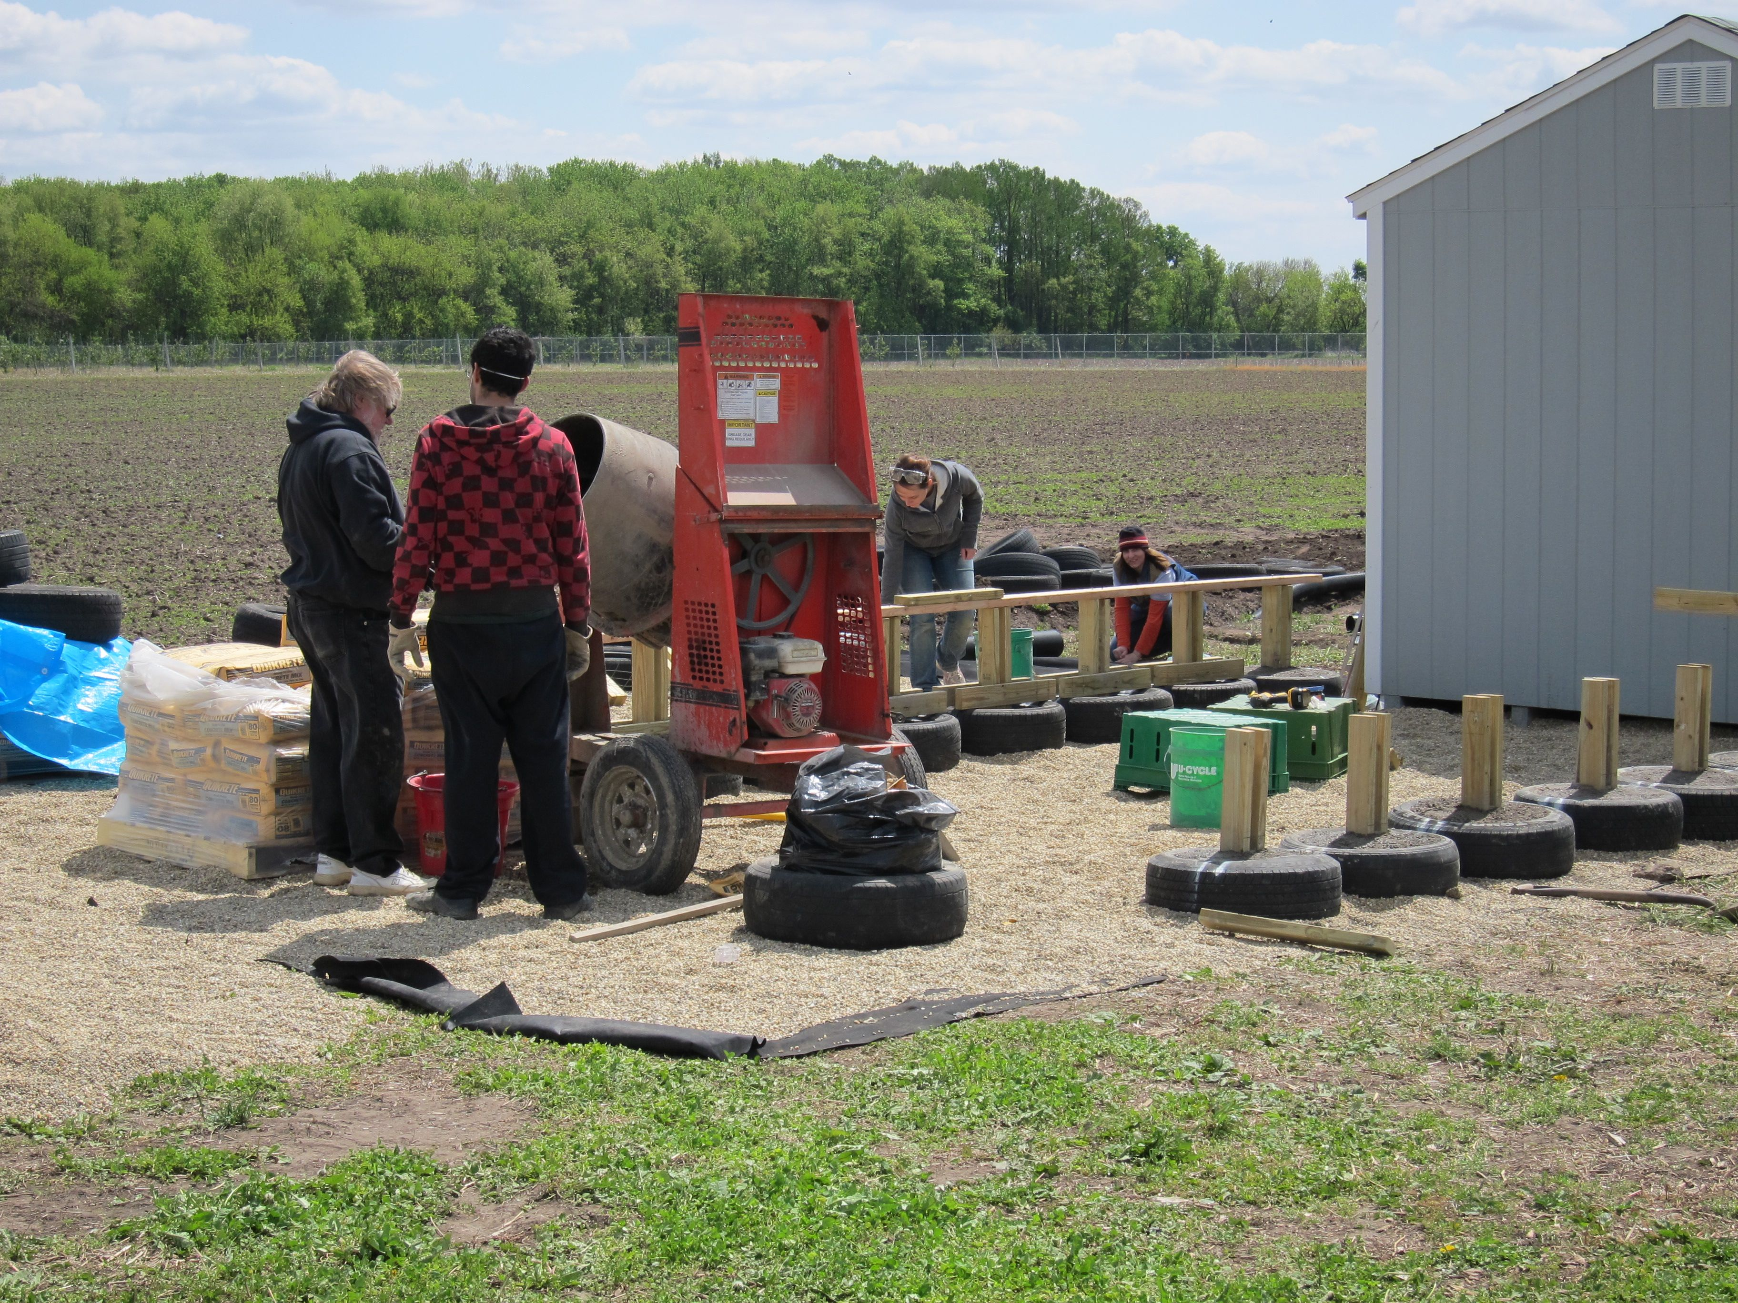

Figure 2. Professor Jeff Poss and a graduate architecture student look over the installation of the wash/pack station designed by Dr. Poss’s graduate architecture class (see http://uiucsmallstudio.com/ for more information).

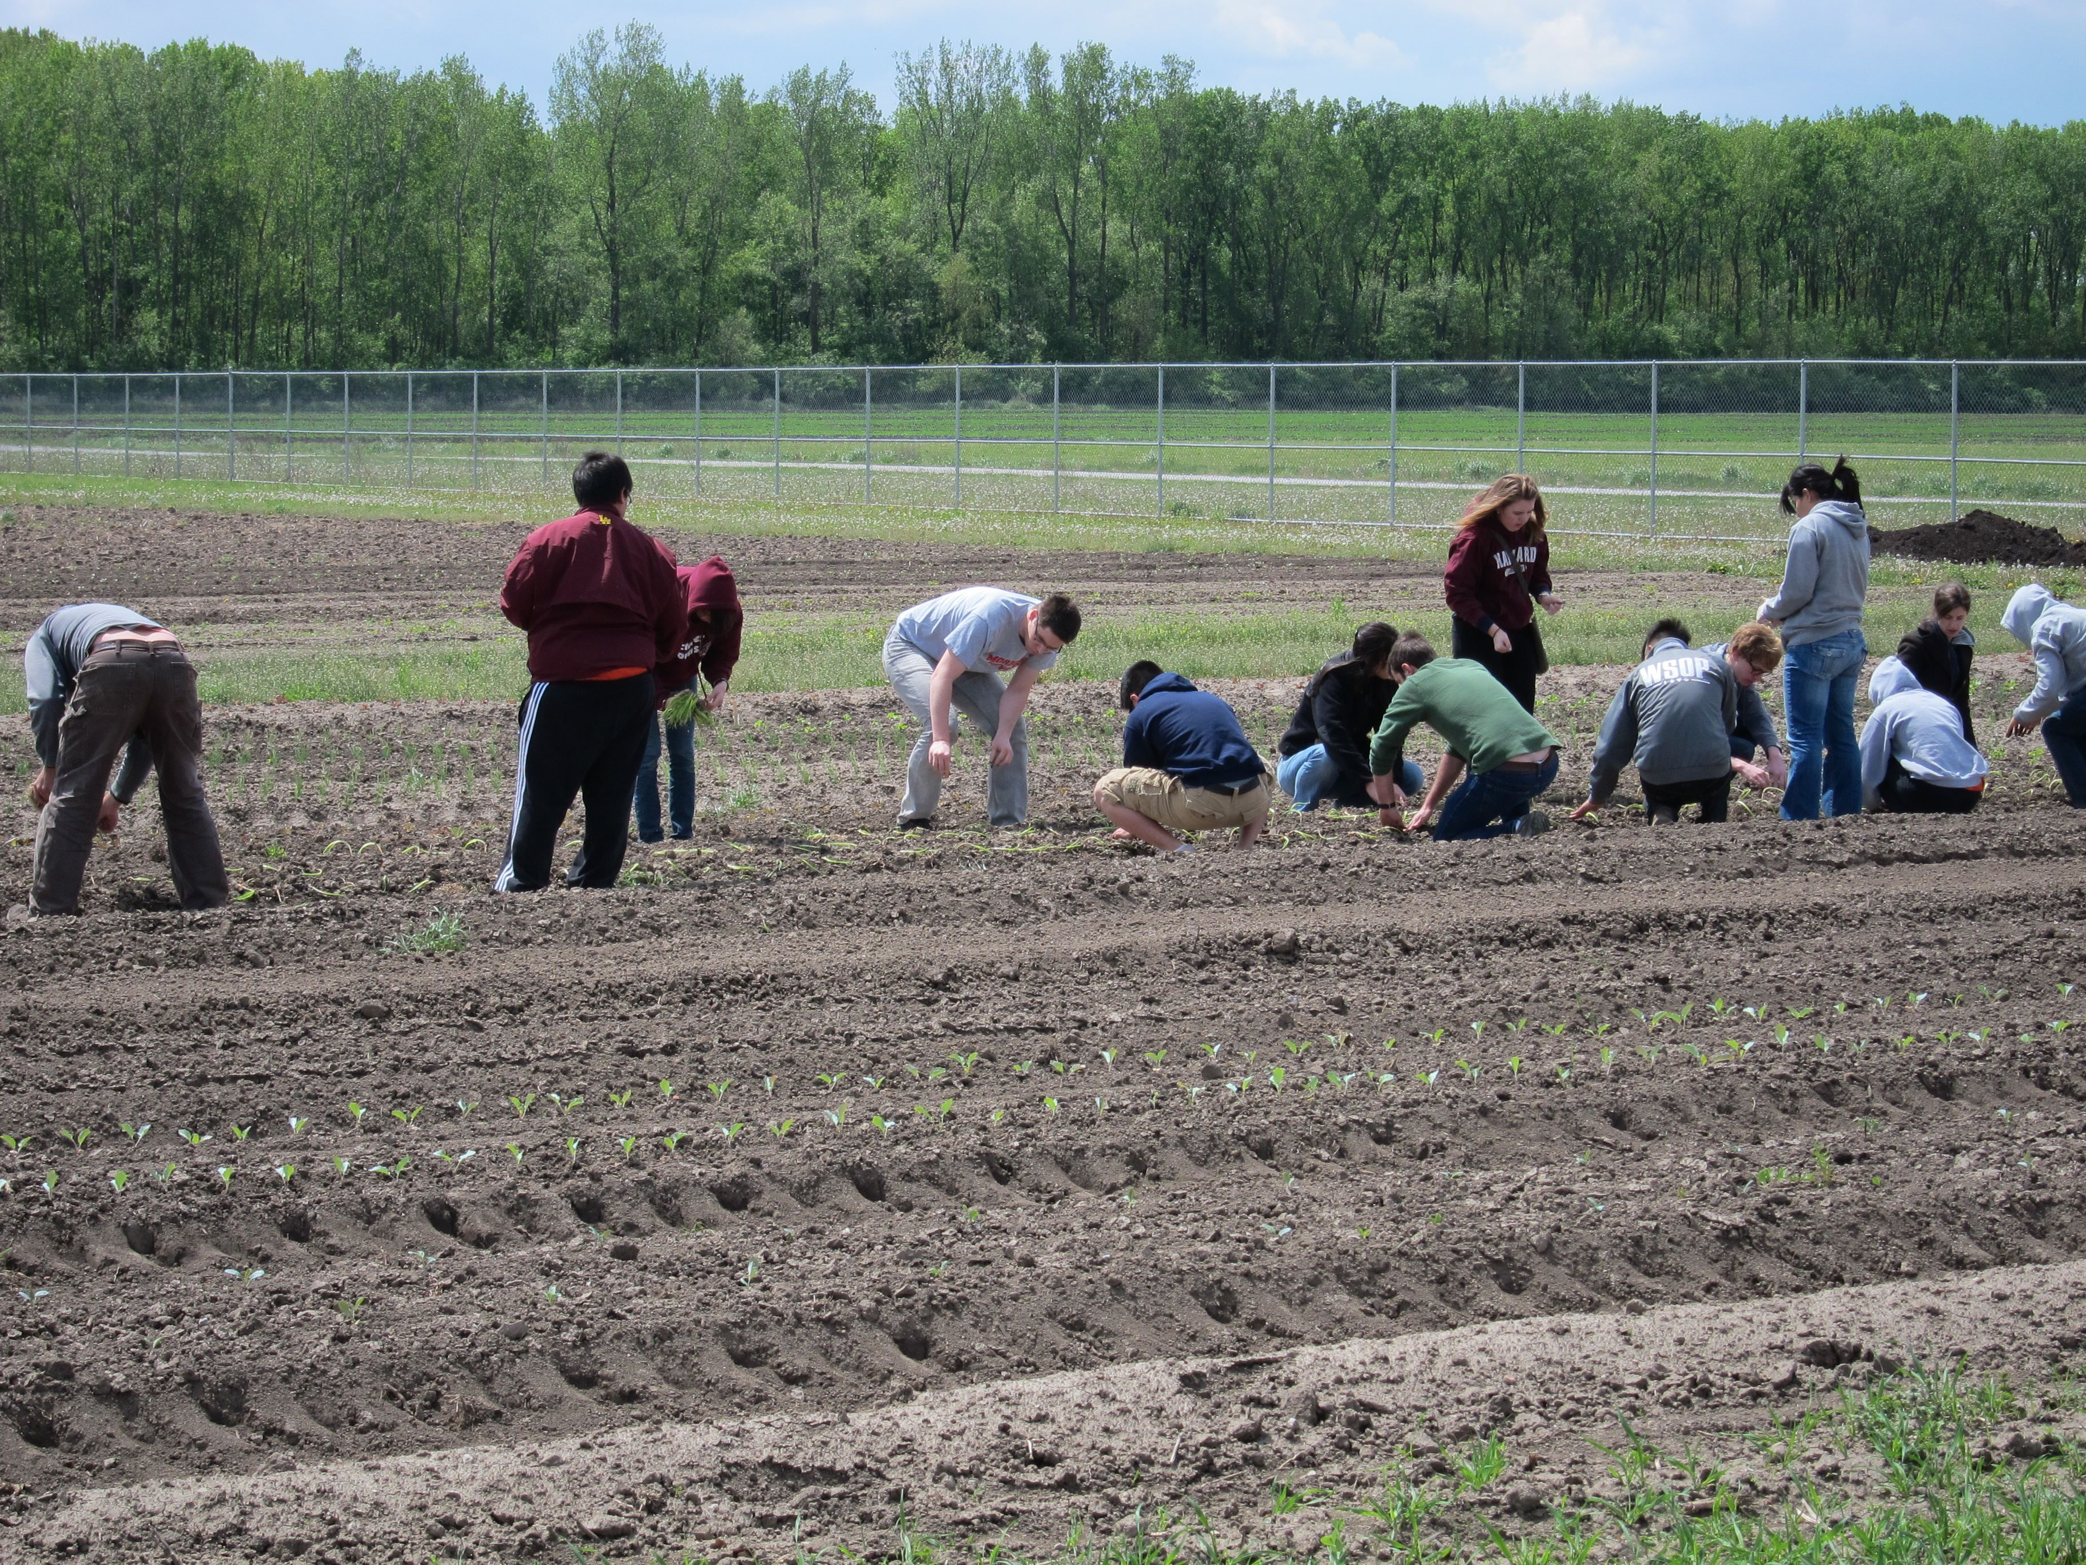

Figure 3. Zack Grant leads a group of volunteers transplanting onions during one of the Spring work days.

