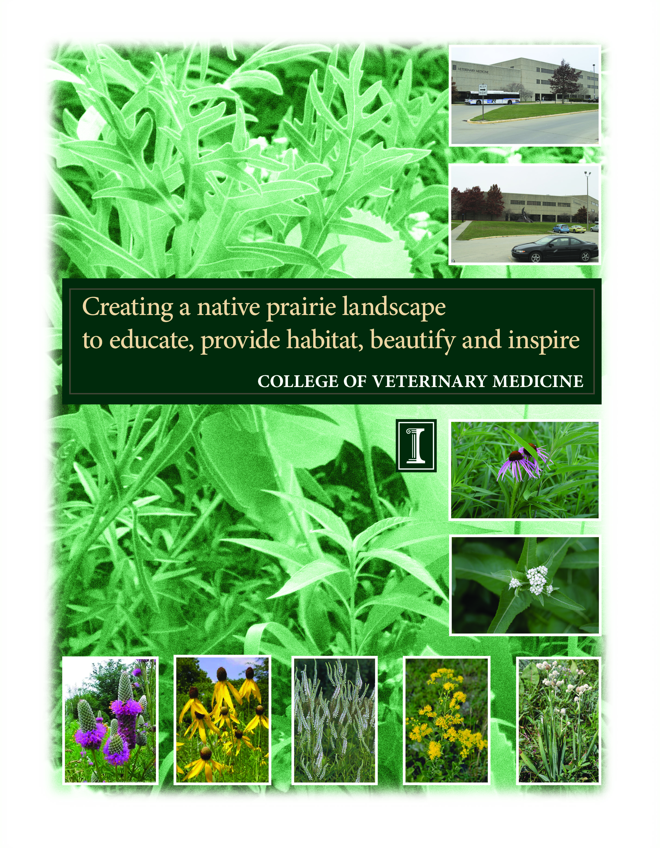
Applicant Information
Project Lead Contact Information
Name: Joseph Kunkel
E-Mail: jakunkel@illinois.edu
Title: Director of Facilities, College of Veterinary Medicine
Department: College of Veterinary Medicine
Phone: (217) 244-3596
Address: 3225 Basic Sciences Bldg.
2001 South Lincoln Ave.
Urbana, IL 61802
Secondary Contact Information
Name: James Ellis
E-Mail: jellis@iilinois.edu
Title: Botanist
Department: State Natural History Survey
Phone (217) 244-5695
Address: MC 652
1816 Oak St.
Champaign, IL 61820

A 2005 report from The Sustainable Campus Landscape Subcommittee provided a Guiding Vision for landscaping on the University of Illinois campus.
“The campus landscape plan should develop a sense of pride with native ecosystems of Illinois, the Prairie State, that fosters both an awareness of prairie vegetation and an understanding of ecological processes that led to its development. The campus landscape should project a patchwork of native plants that collectively represent a vignette of the natural heritage of the Illinois Grand Prairie. The experience of a walk through campus should engage the university community to appreciate its locality in east central Illinois. Along with its capacity to beautify, educate, and inspire, an additional benefit will be decreased maintenance requirements that render a more sustainable campus in the long run.”

The College of Veterinary Medicine, situated at the southern gateway to the University campus, is in an ideal location to implement and support aspects of this overall vision. It is the goal of the college to transform our campus to an example of responsible sustainable environment that can be used as a model for future campus developments.

Currently Veterinary Medicine is involved with two other initiatives for its campus.
No Mow Program: Shortly after the beginning of the 2008 growing season, it was recommended that we could reduce the impact on the environment by eliminating the mowing of many areas. The intent was for Facilities & Services Landscaping crews to only mow close to sidewalks and parking areas. All other area would be allow to grow wild. This program was adopted immediately. We expect to expand the No-Mow program for the 2009 season and possibly include the field on the north side of the Basic Sciences Bldg.
Restoration Ecology (NRES 420) Project: Veterinary Medicine has agreed to sponsor a project for the 2009 spring semester of the Restoration Ecology (NRES 420) course, Anton Endress instructor. The course will provide students with experiences in native ecosystem restoration projects. The outcome will generate site plans for low-maintenance native plantings within an ecologically sustainable context.
I. Project Description
Background
Illinois is the Prairie State, so-called because of the once biologically rich grassland that covered about 60% of our landscape. Today, because of agricultural and urban development, more than 99% of the original prairie is gone. Efforts to conserve the state’s prairie heritage include protection of unplowed remnants, reconstruction of prairie through new plantings and creation of gardens using native prairie plants.

- Our college has a strong affiliation with environmental sustainability and the protection of native animal species. Through research and education, we address issues related to the preservation of natural habitat worldwide and the impact of human activity on the environment and the health of people and animals. In particular, we have a strong and long-standing service and education program, the Wildlife Medical Clinic, devoted to providing medical care for native wild animals and raising awareness of native species in the surrounding public. More than 2,000 ill or injured animals receive care every year through this program, and several birds of prey that we are licensed to keep spend their days in a flight cage on our campus when they are not being displayed for public education talks at local schools and organizations.
Vision and Scope of Work
We propose to install a perennial garden consisting of plants characteristic of native tallgrass prairie in central Illinois. The area suggested for this planting is to the east by the front entrance to the Basic Sciences Building and to the south around the sculpture called “Growing in Illinois,” by Illinois artist Richard Hunt. This garden will be designed to educate, beautify and inspire. It will be a public symbol of our commitment to the native plant species of our ecosystem as well as the native species that rely on that ecosystem.

- Also, by planting a fairly low-maintenance garden, we reap benefits in terms of reduced energy costs for mowing.
Plan of Work
A general site design has been created (Figure X). Plant species characteristics such as height, flowering time and flower color are taken into consideration with the site design. We propose to include about 45 to 50 plant species in the design (see Appendix). Site lines to the sculpture and across corners are also maintained.
Preparation of planting sites should start in early spring by killing the sod with a general glyphosate based herbicide. Two applications may be necessary to ensure a weed-free planting bed. When the existing vegetation is dead, a thin (1-2 inches) layer of shredded wood mulch should be spread over the entire planting area. This will help retain moisture and also help suppress any weeds that may sprout. Prairie plant seedlings should then would be installed in late May or early June, depending on weather conditions. Plants are installed at one and two foot spacing intervals to allow adequate room for future growth. Holes are created using small, drill mounted augers, and plants are then popped from the pot and plugged into the ground ensuring good root to soil contact. All plants should be thoroughly watered immediately following planting. Mulching and planting should take two to three days depending on this size and availability of a planting crew.
Based on plans from the Facilities and Services Planning Division, the proposed planting around the sculpture is approximately 7200 square feet. The island is about 3000 square feet. Roughly based on one-foot centers, we estimate that it will take about 40 cubic yards of mulch and about 10000 prairie plant seedlings. Mulch can be purchased from the Landscape Recycling Center in Urbana if trucks can be secured to haul it to the site. Prairie plant seedlings can be purchased from a local not-for-profit group, Grand Prairie Friends, but a six-month advance notice is needed to facilitate planning. The volume of plants needed might also warrant buying plants from a commercial vendor such as Spence Restoration Nursery in Muncie, IN.
Maintenance
Depending on weather conditions following planting, plants should be periodically watered during the first growing season to ensure survival. This might take 2-3 hours each week. Plantings should be inspected during the first growing season for unwanted weeds. Botanists from the Illinois Natural History Survey can make monthly inspections during the growing season. Weeds can be hand-pulled or spot-sprayed with herbicide depending on the level of infestation. Depending on weeds found, this may take 1-2 hours each week.
In early spring each year, dead plant material should be cut 2-3 inches above ground level and removed from the site to encourage new plant growth and promote a neat and maintained look to the prairie garden. This work should take one day each spring. Ideally, the garden should be burned once every two to three years in the early spring to promote growth of prairie plants, but this practice may be unfeasible due to the proximity of the site to air intake ducts on the Basic Sciences Building. During the second growing season, a top-dressing of mulch should be put down. Mulch should become unnecessary after this.
A border of lawn grass should be maintained between the sidewalk bounding the area and the edge of the prairie garden. Facilities and Services currently mow the lawns and shall continue this task.
II. Budget
The budget below is based on the contracting of a professional landscaper with no volunteer help. It is believed that the actual costs will be greatly reduced from the use of volunteer labor but at this time that cannot be confirmed.
Requested for proposal
Herbicide Application $ 500
Mulch With Installation $ 1,200
Seedlings (10,000 @ $2/each) $20,000
Personnel/planning/labor $ 5,000
Total Requested $26,700
At this time we are only requesting funds for the initial implementation of the project. Future maintenance costs will be supported by Vet med or F&S
Provided by F&S or Vet Med
Maintenance Year 2 $3,000
Annual Maintenance $1,000
At the request of Facilities & Services, Veterinary Medicine will agree to cover the cost of restoring the location back to grass in the future should the project be unsuccessful
III. Timeline
February 2009 Purchase Plant Material
April to July 2009 Planting, Watering
IV. Environmental Impact
A very small beneficial environmental impact derives from the elimination of mowing in the area of the plantings. This project is just an early small step in the larger effort of converting our campus toward more responsible landscaping.
V. Outreach Education
Through on-site signs as well as through opportunities to participate in caring for the prairie, Vet Med faculty, staff and students as well as the general public can learn about the plants and the importance of native prairie. Botanists from the Illinois Natural History Survey can direct these educational efforts.
The location of this project prominently within the Veterinary Medicine campus—and the location of the veterinary complex at a key entry port to the overall university campus—makes this a high-visibility effort. In addition to the many prospective veterinary students and visitors attending lectures, etc., throughout the year, thousands of attendees at the annual Vet Med Open House enter our facilities at this location. The owners of the more than 15,000 animal patients that visit our Veterinary Teaching Hospital each year will also have an opportunity to enjoy and experience this garden. It is our intent to showcase this project as an example of our dedication to a sustainable environment for the University of Illinois.
We would also invite local media to key events related to the creation and maintenance of this new garden in an effort to elevate awareness of the campus sustainability initiative.

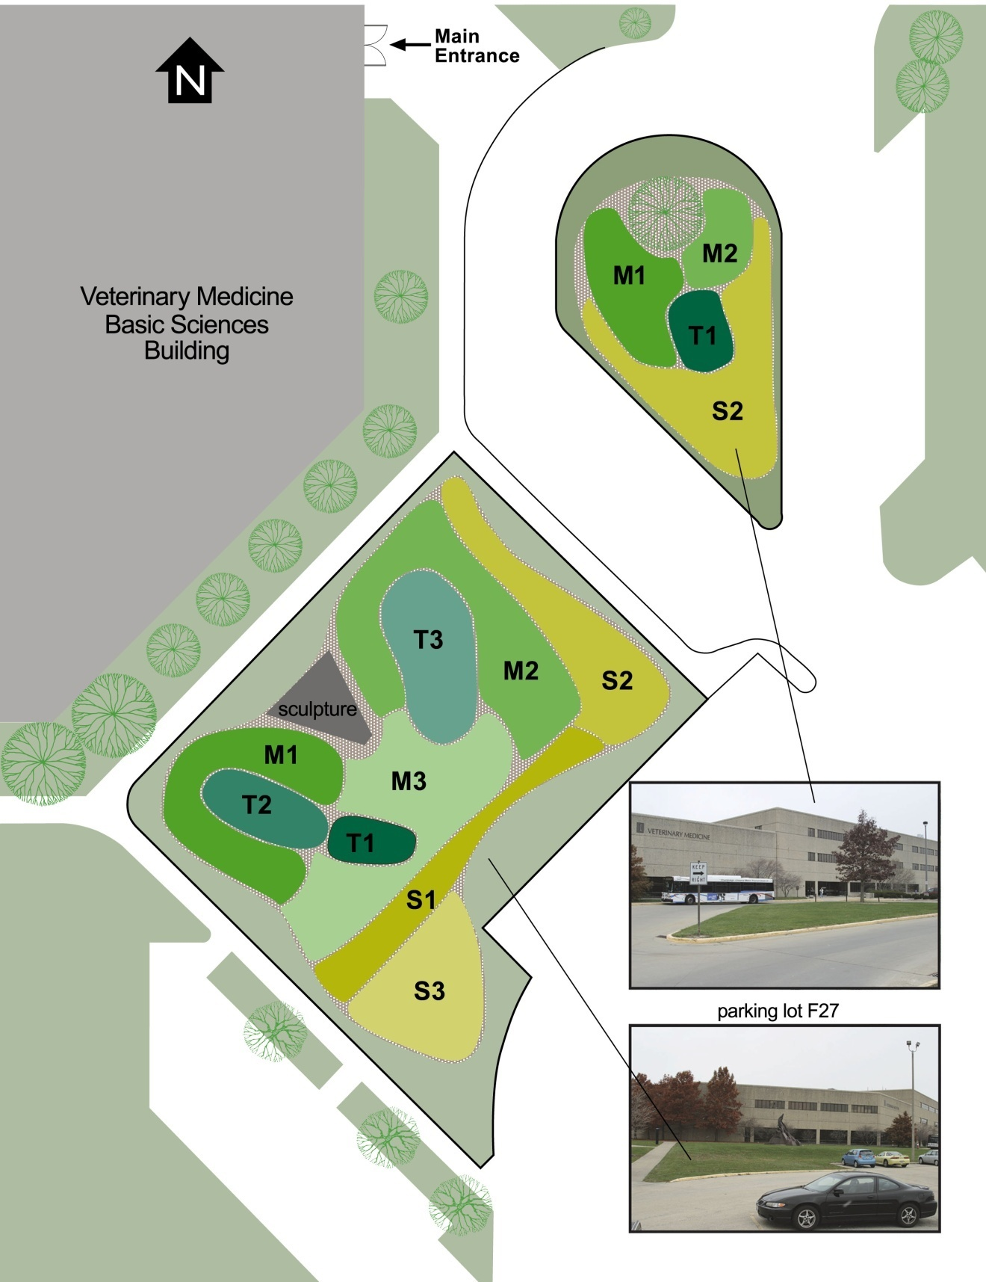
APPENDIX
Suggested species groupings for Vet Med prairie planting:

 | Tall 1 (T1)
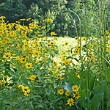 | Silphium terebinthinaceum  (Prairie Dock)
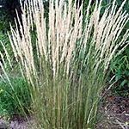 | Sorghastrum nutans  (Indian Grass)
 | Tall 2 (T2)
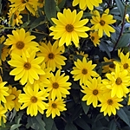 | Heliopsis helianthoides  (False Sunflower)
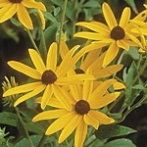 | Rudbeckia subtomentosa  (Brown-eyed Susan)
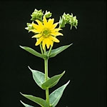 | Silphium integrifolium  (Rosin Weed)
Sorghastrum nutans
(Indian Grass)
 | Tall 3 (T3)
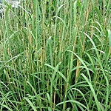 | Andropogon gerardii  (Big Bluestem)
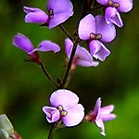 | Desmodium illinoense  (Illinois Tick Trefoil)
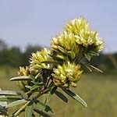 | Lespedeza capitata  (Round-headed Bushclover)
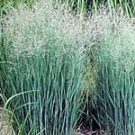 | Panicum virgatum  (Switch Grass)
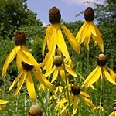 | Ratibida pinnata  (Yellow Coneflower)
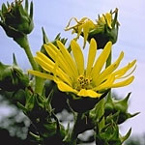 | Silphium laciniatum  (Compass Plant)
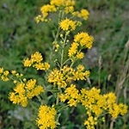 | Solidago rigida  (Stiff Goldenrod)
 | Medium 1 (M1)
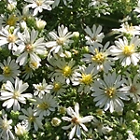 | Aster ericoides  (Heath Aster)
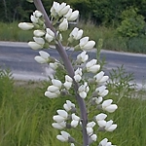 | Baptisia alba  (White Wild Indigo)
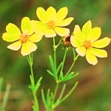 | Coreopsis palmate  (Prairie Coreopsis)
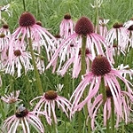 | Echinacea pallid  (Pale Purple Coneflower)
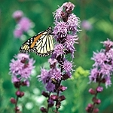 | Liatris aspera  (Rough Blazing Star)
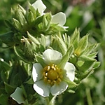 | Potentilla arguta  (Prairie Cinquefoil)
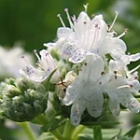 | Pycnanthemum virginianum  (Common Mountain Mint)
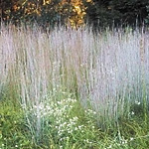 | Schizachyrium scoparium  (Little Bluestem)
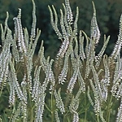 | Veronicastrum virginicum  (Culver's Root)
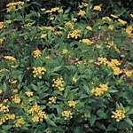 | Zizia aurea  (Golden Alexanders)
 | Medium 2 (M2)
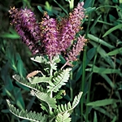 | Amorpha canescens  (Leadplant)
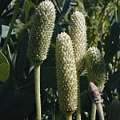 | Anemone cylindrical  (Thimbleweed)
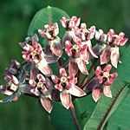 | Asclepias sullivantii  (Sullivant's Milkweed)
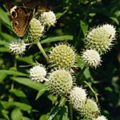 | Eryngium yuccifolium  (Rattlesnake Master)
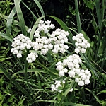 | Parthenium integrifolium  (Wild Quinine)
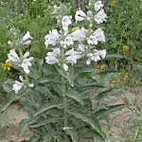 | Penstemon digitalis  (Beardtongue)
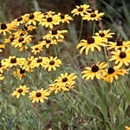 | Rudbeckia hirta  (Black-eyed Susan)
Schizachyrium scoparium
(Little Bluestem)
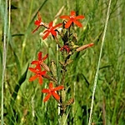 | Silene regia  (Royal Catchfly)
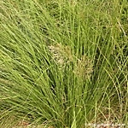 | Sporobolus heterolepis  (Prairie Dropseed)
 | Medium 3 (M3)
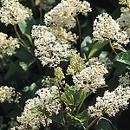 | Ceaonothus americanus  (New Jersey Tea)
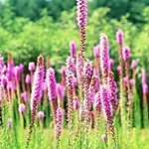 | Liatris pycnostachya  (Blazing Star)
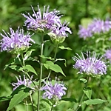 | Monarda fistulosa  (Bee Balm)
Scizachyrium scoparium
(Little Bluestem)
Sporobolus heterolepis
(Prairie Dropseed)
 | Short 1 (S1)
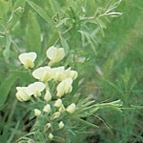 | Baptisia leucophaea  (Cream Wild Indigo)
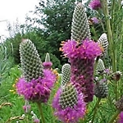 | Dalea purpurea  (Purple Prairie Clover)
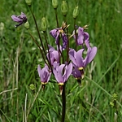 | Dodecatheon meadia  (Shooting Star)
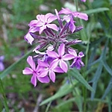 | Phlox pilosa  (Prairie Phlox)
Sporobolus heterolepis
(Prairie Dropseed)
 | Short 2 (S2)
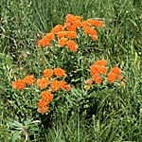 | Asclepias tuberose  (Orange Butterflyweed)
Dalea purpurea
(Purple Prairie Clover)
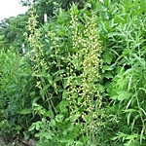 | Heuchera richardsonii  (Prairie Alumroot)
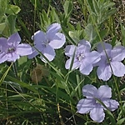 | Ruellia humilis  (Prairie Petunia)
Sporobolus heterolepis
(Prairie Dropseed)
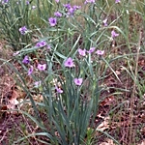 | Tradescantia ohiensis  (Ohio Spiderwort)
 | Short 3 (S3)
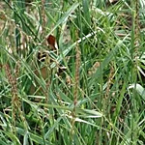 | Bouteloua curtipendula  (Side-oats Grama)
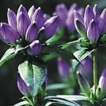 | Gentiana andrewsii  (Bottle Gentian)
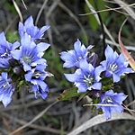 | Gentiana puberulenta  (Downy Gentian)
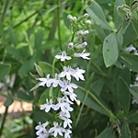 | Lobelia spicata  (Spiked Lobelia)
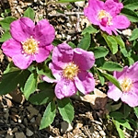 | Rosa Carolina  (Prairie Rose)
Rudbeckia hirta
(Black-eyed Susan)
Sporobolus heterolepis
(Prairie Dropseed)
Zizia aurea
(Golden Alexanders)

