**Main Library Steam Reduction Project Final Report**

By Morgan White – January 6, 2018

**Project purpose**

This project was to reduce the need for burning coal to fulfill the campus steam energy demand, by reducing the steam load at the Main Library. The Library’s annual utility expense is almost $1.3 million with steam accounting for $775,000 of it. Much of the steam distribution equipment is original and in need of replacement.

This project was initiated after the F&S Retrocommissioning (RCx) team completed RCx. The RCx report includes a nice summary of the Main Library’s systems:

“The Main Library houses several departmental library collections as well as study rooms, computer stations, classrooms, offices, and reading rooms. The Main Library that stands today was originally built in three sections with the first, second, and third sections being completed in 1923, 1925, and 1927. The facility has regularly scheduled hours, closing typically by 11pm. There are 27 constant volume air handling units (AHUs) which condition the building. The building’s cooling needs are met by the campus chilled water loop, while the heat in the building is provided by a combination campus steam and hydronic systems. AHUs and heating systems have Siemens PXC and MEC DDC control, while the reheat and radiation devices are pneumatically controlled.”

From [RCx online report](http://www.fs.illinois.edu/docs/default-source/retro/buildingsummary-library.pdf?sfvrsn=2)

**Project summary**

There were three segments of work to be done under this project: Pressure Reducing Valve (PRV) stations, Steam Trap upgrades, and installation of Control Valves. The PRVs and Control Valves were coordinated by F&S Utilities & Energy Services, and the Steam Traps were coordinated by F&S Building Maintenance.

*Initial Project Scope and Budgets:*

1. Pressure Reducing Valve stations (PRV): The cost to replace the PRV stations is approximately $75,000.
   * There are seventeen main PRV stations in the building. The age of the stations vary, with the majority of them being forty plus years old. The building was designed for 2lbs of steam for perimeter radiation and 5lbs for air handler reheats. Several PRV stations are leaking through or are fixed in position and will not adjust with steam pressures ranging from 7 Ibs to 13 Ibs.
     + Mechanical room 2:
   * PRV1: AHU10, 11 and 12 reheat coils
   * PRV2: Radiation for center wing, and east entry
   * PRV3: Heat exchanger 1, 2(Radiation) and 3(Reheats). Move HX3 to PRV1 and combine PR2 and PRV3 together and install an automated control valve to turn on/off radiation with outside air conditions.
     + Mechanical room 444A:
     + PRV12: Serves heat exchanger 8 that serves reheats for AHU18-20, and the two rare book units.
     + 1st Stack Addition Attic:
     + PRV13: South Half of 1st thru 5th stack’s radiation
     + PRV14: North Half of 1st thru 5th stack radiation

*Removal of asbestos from the piping will be required for installation of new PRV stations.

1. Steam Traps: Based on an average cost of $250 per trap, the cost to repair the steam traps is approximately $200,000, based on an estimate of approximately 800 traps.
   * The building steam traps have not been replaced for years and several of them are blowing through. There are approximately 800 traps in the building. With the steam pressure through the PRV station being much higher than the design value, the traps may have been damaged and are need of repair/replacement. This work needs to be done in conjunction or after PRV replacement.
2. Control Valve replacement: The cost of the following is estimated at $155,000.
   * There is a broad style of control valves located in the building with many of these being original equipment and leaking through.
     + Replace the steam radiation valves in the 2nd, 3rd, and 7th additions of the main library. These valves were recently inspected by retrocommissioning and the valves leaking through had maintenance work orders entered to repair or replace them. There are still numerous radiation valves that are of original installation.
     + Install new thermostats and radiation zone control valves, in the 1st through 5th stack additions. The radiators on these zone valves are equipped with manual valves. The majority of these manual valves have been recently replaced. There are still manual valves that leak through and cause overheating of the stacks area. There are approximately 68 of zone valves. The steam supply to these zone valves is from two separate PRV stations, PRV13 and 14. There are isolation control valves on these two steam feeds that are currently under DDC control that shuts off the steam supply when temperature gets above 40F outside. Since there are isolation valves, the savings and benefits for replacing the zones valves will not be as significant.
     + Install isolation control valves on the radiation steam mains that serve the 1st, 2nd, 3rd, and 7th additions. This would allow for more precise summer/winter switchover control, resulting in a reduction of unnecessary steam usage and overheating of the building in mild weather conditions. To achieve this, five control valves will need to be installed on the radiation steam mains and controlled through the DDC system.

*Completed Project Scope and Costs:*

1. Pressure Reducing Valve stations (PRV):
   1. Utilities and Energy Services completed the installation of the PRVs, as described above, on April 27, 2013. F&S replaced steam PRVs (pressure regulating valves) and associated isolation valves serving HVAC equipment at UIUC Library, to reduce and stabilize steam pressure to all control valves to improve comfort and reduce steam consumption. The total cost was $117,009.
2. Steam Traps:
   1. The F&S Building Maintenance division replaced a total of 710 steam traps in the Main Library. The total cost was $249,441.00, and this work was completed in July 2013.
3. Control Valves:
   1. Control Valves were added to the Pressure Reducing Valve systems. The Control Valves allow the steam to be automatically shut off when the outside air temperature is high enough.
   2. This was done in conjunction with a program written at the Direct Digital Control Command Center at F&S.

**Problems encountered**

There was an issue with this project, in that the SSC funding award was not correctly connected with the project managers in Utility and Energy Services. This is an issue that F&S will address for any future funded projects.

The original project scope was three-fold. In summer 2014, F&S relinquished some of the funding and removed the third project scope (Control Valves). In Spring 2016, F&S requested a scope change to add the third scope back into the project, with additional time but not additional funding. This was related to accounts charged internally at F&S for the work completed.

**Pictures of finished project**



Figure - image of thermal loss at steam trap

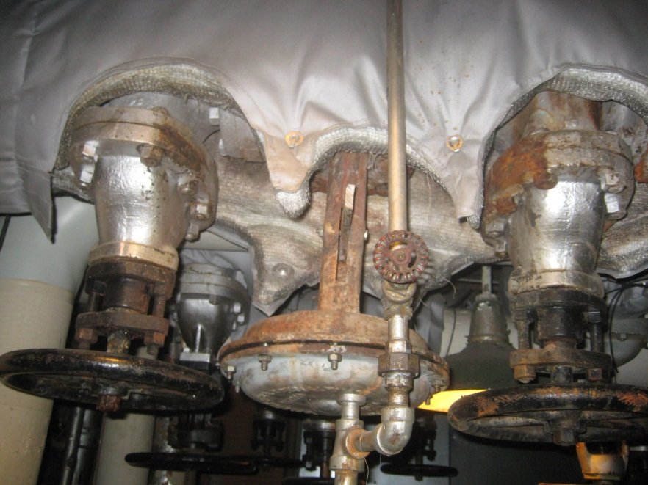

Figure - typical Pressure Reducing Valve before upgrade

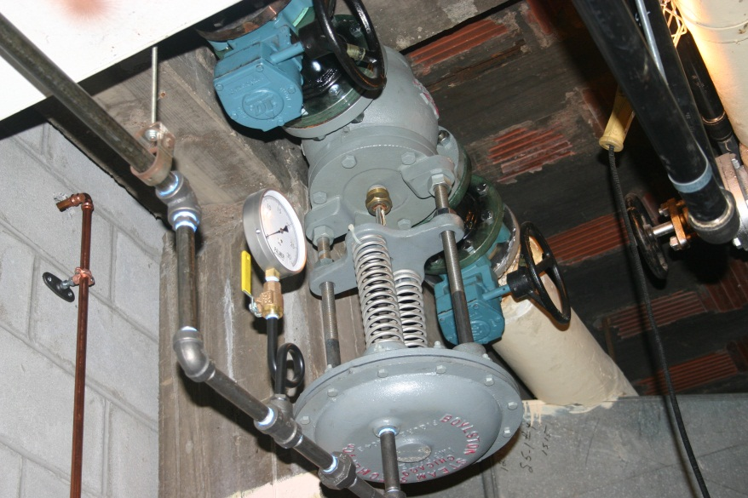

Figure - Typical Pressure Reducing Valve after upgrade

**A financial statement that lists how the funds were specifically utilized**

|  |  |  |  |  |
| --- | --- | --- | --- | --- |
| **Description** | **Building** | **Estimated Cost** | **Total Cost** | **Funded by SSC** |
| Steam Traps | Main Library | $200,000.00 | $249,441.00 | $99,001.79 |
| PRVs | Main Library | $75,000.00 | $117,009.00 | $0.00 |
| Control Valves | Main Library | $155,000.00 | $63,092.96 | $63,092.96 |
|  |  | **$430,000.00** | **$429,542.96** | **$162,094.75** |
|  |  | **original SSC award** | | **$215,000.00** |
|  |  | **total relinquished** | | **$52,905.25** |

The remaining $52,905.25 in funding from the original $215,000 is hereby relinquished to the Student Sustainability Committee.

**Statistics on student involvement/outreach**

This project was approved before SSC started requesting statistics on outreach. In the original proposal, we noted the following: “This is not a highly visible project in that the changes occur in mechanical areas behind the scenes. However, Facilities and Services has a number of student employees that will be involved in the implementation of this project. This project will be included on the F&S website with credit to SSC for the contribution, and the project will be included on the iCAP portal once it is active. If SSC is interested in doing a joint press release about this endeavor, F&S is happy to participate.”

It is true that F&S students participated in this project, but we do not have a method to report on that in more detail for this project. If it also true that the project is on the iCAP Portal.

However, the F&S website was revamped after this project was approved, and there is not currently a project tracking site where the project can be shared. Also, the SSC did not request a press release, and this project does not likely warrant a news item.

On the other hand, the Main Library has a lot of student visitors and better temperature control as provided by this project is highly noticeable.