# *Thank you for your commitment to green initiatives at the University of Illinois. One of the ongoing requirements listed in the terms of the funding agreement for your project is the submission of semesterly reports with key information about your project. In addition to this form, please provide additional financial documentation and/or progress photos if available.*

# *Please be as accurate as possible in describing the project (including possible setbacks or challenges in meeting the initial goals of the project). Not fully meeting your project's goals will not disqualify you from making future funding requests as long as your reports are as complete and accurate as possible. If you have any questions, please contact Micah Kenfield, Program Advisor for the Student Sustainability Committee, at* [*kenfield@illinois.edu*](mailto:kenfield@illinois.edu)*.*

**Project Name:** Speech and Hearing Building Solar

**Date of Report Submission:** 8/25/2017

**Project Purpose:**

Design and install rooftop solar PVs on the Speech and Hearing Sciences Building

**Detailed Accounting of Expenditures to Date:**

We paid $2,677.77 for Engineering Design work by Brian Finet and Kristine Chalifoux at F&S.

**Project Progress to Date:**

The academic users in the building requested that this solar project be completed in conjunction with a capital project they are planning. Construction on that project (U10043) is currently in scheduled to begin in Feb. 2018. I will be seeking a scope change to adjust the schedule, per the building occupants request. The current funding deadline is Jan. 2018.

Per the SSC request, Brian Finet designed a scalable system, so the SSC could choose to fund installation of additional solar PVs in future years. Kristine Chalifoux was able to review the roof structure and she found that the original structure was designed for a heavy roof structure which was subsequently upgraded to a lighter insulation material. Thus, the roof has plenty of capacity for the solar PVs and will not require a formal engineering review by a licensed structural engineering consultant.

The final engineering design should be complete within a month, and then I will share it with the SSC and request the schedule change.

**Student Involvement and Outreach to Date:**

This project has involved students through discussions and ideation. The initial proposal came from a student class group, but the materials they selected are no longer available to purchase. One of the key student advocates for rooftop solar, Corey Weil, helped identify the Speech and Hearing Sciences Building as a good option for this effort. Niharika Kishore completed a proposal for a full scale rooftop solar PV retrofit for several campus buildings to reach the iCAP objective of 12,500 MWh/year of on campus solar generation by 2020. Niharika and Corey both participated in the F&S discussions through May 2017.

**Marketing and Promotion Efforts to Date:**

This solar array effort is on the iCAP Portal at <https://icap.sustainability.illinois.edu/project/speech-and-hearing-rooftop-solar-pvs>.

**Additional Comments:**

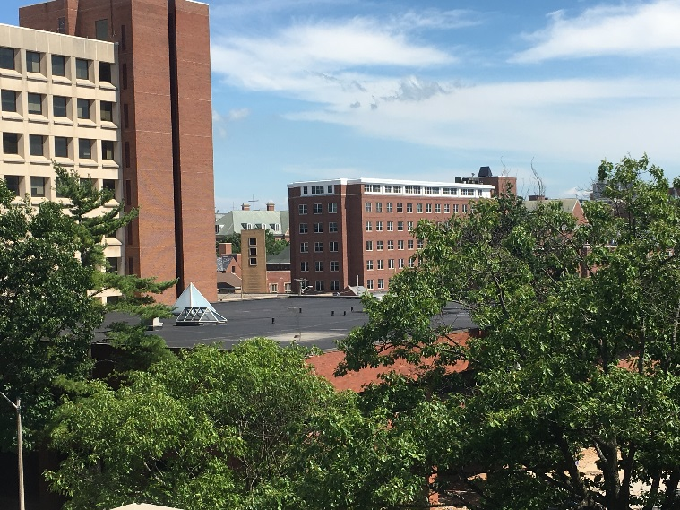

This is a view for the location of the proposed solar array, as seen from the parking deck at Fifth and Daniels.